Set 3: Numeric Operations

Skill 3.1: Declare and/or initialize variables on a single line
Skill 3.2: Apply the fundamental arithmetic operations to int variable types
Skill 3.3: Apply unary operators
Skill 3.4: Apply compound operators
Skill 3.5: Apply PEMDAS to arithmetic operations

Skill 3.1: Declare and/or initialize variables on a single line

Skill 3.1 Concepts

Recall that the assignment operator is the standard equal sign (=) and is used to “assign” a value to a variable.

Consider the following example,

Code
int i = 3; //OK. Assigns the value of 3 to i. Notice the direction of data flow.
3 = i; //Illegal. Data does not flow this way.
double p;
double j = 47.12;
p = j; //OK. Assigns the value of j to p. Both p and j are now equal to 47.12

It is possible to declare several variables of the same type on one line. In the below example, i, x, y, and z are all declared as int type variables.,

Code
int i, x, y, z;

We can also declare and initialize variables on one line. In the example below, w and j, are both declared and initialized. g however is just declared.

Code
int w = 1000, j = 2000, g;

Skill 3.1 Exercise 1

Skill 3.2: Apply the fundamental arithmetic operations to int variable types

Skill 3.2 Concepts

The basic arithmetic operations are as follows,
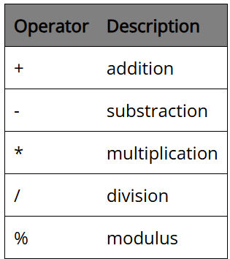

Examples of how each of the above operators can be applied are illustrated below,

Addition | Output
int x = 1;  int y = 2;  int z = x + y;//3 is assigned to z  x = x + z;//4 is re-assigned to x  System.out.println(z);  System.out.println(x + y);  System.out.println(x + 10);  System.out.println(10 + 10); | 3  6  14  20

Subtraction | Output
int x = 1;  int y = 2;  int z = x - y;//-1 is assigned to z  x = x - z;//0 is re-assigned to x  System.out.println(z);  System.out.println(x - y);  System.out.println(x - 10);  System.out.println(10 - 10); | -1  -2  -10  0

Multiplication | Output
int x = 1;  int y = 2;  int z = x * y;//2 is assigned to z  x = x * z;//2 is re-assigned to x  System.out.println(z);  System.out.println(x * y);  System.out.println(x * 10);  System.out.println(10 * 10); | 2  4  20  100

The below example illustrates how int type variables are treated. If the result of the division is a fraction, the decimal places are "cut off" - int variable types do not round.

Division | Output
int x = 1;  int y = 2;  int z = y/x;//2 is assigned to z  x = z/x;//2 is re-assigned to x  System.out.println(z);  System.out.println(x/y);  System.out.println(x/10);  System.out.println(10/10); | 2  1  0  1

Modulus prints the remainder of a division operation. For example, System.out.println(5%3); will print 2. This is because when 5 is divided by 3, the remainder is 2. Modulus gives the remainder. Modulus also handles negatives. The answer to a%b has the same sign as a. The sign of b is ignored.

Modulus | Output
int x = 1;  int y = 2;  int z = x%y;//1 is assigned to z  x = x%z;//0 is re-assigned to x  System.out.println(z);  System.out.println(x%y);  System.out.println(x%10); | 1  0  0

Skill 3.2 Exercise 1

Skill 3.3: Apply unary operators

Skill 3.3 Concepts

The unary operators are operations that require only one operand; they perform various operations such as incrementing/decrementing a value by one, negating an expression, or inverting the value of a boolean.

Incrementing a value by 1

The code below illustrates how to increment the variable x by 1

Code
int x = 1;
x = x + 1;//x is now 2

Incrementing a value by 1 can also be done using the ++ operator,

Code
int x = 1;
System.out.println(x++);//1 is printed to the consol, then x is incremented
System.out.println(++x);//x is incremented first, then it's value, 3, is printed to the consol.
Output
1
3

Notice in the above example that ++ can come before or after the variable. If it comes before the variable, the variable is first incremented then printed. If it comes after the variable, the variable is first printed then incremented.

Decrementing a value by 1

The code below illustrates how to decrement the variable y by 1

Code
int y = 10;
y = y - 1;//y is now 9

Decrementing a value by 1 can also be done using the -- operator,

Code
int y = 10;
System.out.println(y--);//10 is printed to the consol, then y is decremented
System.out.println(--y);//y is decremented first, then it's value, 8, is printed to the consol
Output
10
8

Notice in the above example that -- can come before or after the variable. If it comes before the variable, the variable is first decremented then printed. If it comes after the variable, the variable is first printed then decremented.

Skill 3.3 Exercise 1

Skill 3.4: Apply compound operators

Skill 3.4 Concepts

A compound assignment operator is an operator that performs a calculation and an assignment at the same time. In the below example, x can be re-assigned explicitly using x = x + 5; x can also be re-assigned using the addition compound operator.

Code
int x = 10;
x = x + 5;//x is 15
x += 5;//x is now 20

Compound operators can be applied to all the arithmetic operations. How this is done is illustrated below,
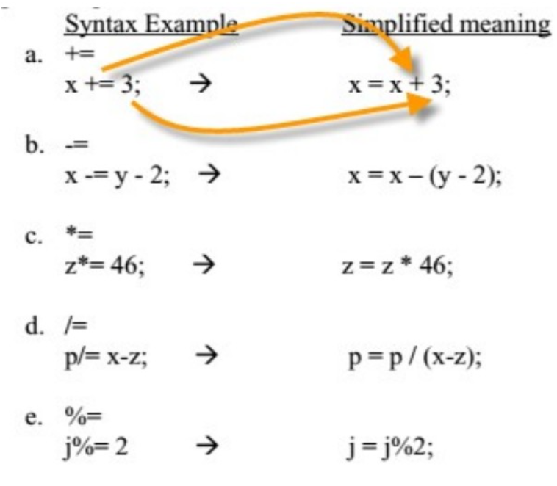
Skill 3.4 Exercises 1

Skill 3.5: Apply PEMDAS to arithmetic operations

Skill 3.5 Concepts

The algebra rule, PEMDAS, applies to computer computations as well. (PEMDAS stands for the order in numeric operations are done. P = parenthesis, E = exponents, M = multiply, D = divide, A = add, S = subtract. Actually M and D have equal precedence, as do A and S. For equal precedence operation, proceed from left to right. A mnemonic for PEMDAS is, “Please Excuse My Dear Aunt Sally)

The example below illustrates PEMDAS

Code
System.out.println(5 + 3 * 4 - 7);
System.out.println(8 - 5 * 6 / 3 + (5 - 6) * 3);
Output
10
-5

Skills 3.5 Exercise 1

