Set 5: Methods of the Math Class

Skill 5.1: Use the java Math class to perform mathematical operations
Skill 5.2: Apply the random() method to create a random integer in a specified range
Skill 5.3: Familiarize yourself with additional methods in the java Math class

Skill 5.1: Use the java Math class to perform mathematical operations

Skill 5.1 Concepts

The math class is a powerful class of methods for performing mathematical computations. An example of how the math class can be applied is illustrated below. The example below computes the square root of 17. The result is assigned to the double variable p because square roots typically do not result in integer values.

Code | Output
double p = Math.sqrt(17);  System.out.println(p); | 4.123105625617661

In the above example,

- double p is the variable to which the result of the Math operation is assigned
- Math. is the notation we use to access the library of Math functions in java
- sqrt(17) is the operation we want to perform on the number 17. In this case, it is the square root.

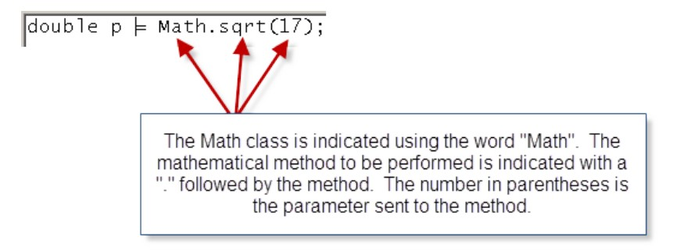
Java provides an extensive library of Math operations. Below is a description of some of them. Notice that each method has a corresponding signature. The signature of a method can be interpreted as follows,

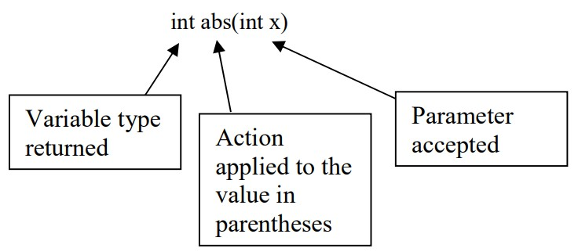

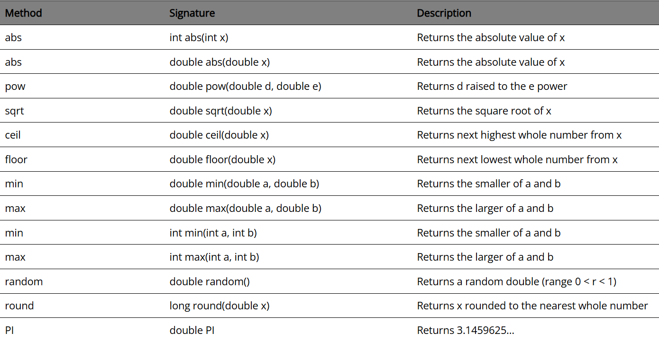

Below are examples of each of the methods described above,

Code | Output
double d = -379.22;  System.out.println(Math.abs(d)); | 379.22
double d = 42.01;  double e = 3.728;  System.out.println(Math.pow(d,e)); | 1126831.027
double d = 2034.56;  System.out.println(Math.sqrt(d)); | 45.106097148833435
double d = 1.4;  System.out.println(Math.ceil(d)); | 2.0
double d = -1.6;  System.out.println(Math.ceil(d)); | -1.0
double d = 1.4;  System.out.println(Math.floor(d)); | 1.0
double d = -1.6;  System.out.println(Math.floor(d)); | -2.0
double d = 7.89;  System.out.println(Math.log(d)); | 2.065596134857783  NOTE: log is base e
double x = 2038.5;  double y = -8999.0;  System.out.println(Math.min(x, y)); | -8999.0
double x = 2038.5;  double y = -8999.0;  System.out.println(Math.max(x, y)); | 2038.5
double a = 148.2;  long aResult = Math.round(a);  System.out.println(Math.round(aResult));  float b = 148.7f;  int bResult = Math.round(b);  System.out.println(Math.round(bResult)); | 148  149  NOTE: The Math.round method in Java returns different datatypes depending on the argument:  - If you pass a float, it returns an int.  - If you pass a double, it returns a long.
System.out.println(Math.PI); | 3.141592653589793
System.out.println(Math.random()); | prints a random double between 0 and 1 where 0 is inclusive, but 1 is not inclusive

Skill 5.1 Exercise 1

Skill 5.2: Apply the random() method to create a random integer in a specified range

Skill 5.2 Concepts

Many applications you will create will require a random number. For example, what if you needed to write a program to generate a number that represented a face from a 6-sided die, or a card from a 52 card deck?

The random() method in the Math class generates a random double type number between 0 and 1, where 0 is inclusive, but 1 is not. The below code is illustrative,

Code | Output
System.out.println(Math.random()); | prints a random double between 0 and 1 where 0 is inclusive, but 1 is not inclusive

To create a number in a different range, say 0 up to 10, simply multiply the result of Math.random() by the desired range. An example is shown below,

Code | Output
System.out.println(Math.random()*10); | prints a random double from 0 up to 10

Recall, however that the random() method returns a double. The below code illustrates how to generate a random int from 0 up to 10,

Code | Output
int randomNumber = (int)(Math.random()*10);  System.out.println(randomNumber); | prints a random int from 0 up to 10

The above examples, illustrate how to scale the random() method to a specified range. The example below illustrates how to shift the range of the random number.

Code | Output
int randomNumber = (int)(Math.random()*10)+100;  System.out.println(randomNumber); | prints a random int from 100 up to 110

Skill 5.2 Exercise 1

Skill 5.3: Familiarize yourself with additional methods in the java Math class

Skill 5.3 Concepts

In addition to the methods above, the java Math class has many more useful methods.

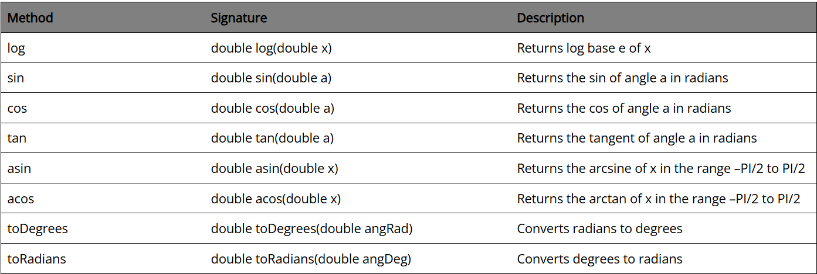

Skill 5.3 Exercises 1

