- Refer to the code below,

public interface Sports {

void method1( );
void method2( );
int method3(double d);
}

public class Baseball implements Sports {

public Baseball( ) { . . . }
public void method1( ) { //some code…}
public void method2( ) { //some code…}
public int method3(double c ) { //some code…}
public int statevar1;
}

public class Football implements Sports {

public Football( ) { . . . }
public void method1( ) { //some code…}
public void method2( ) { //some code…}
public int method3(double c ) { //some code…}
public int statevar1;
}

public class Tester {

public static void main(String[] args) {

Sports x = new Baseball( );
Sports y = new Football( );
x.method2( );
y.method2( );
. . . more code . . .
}
}
- Which methods, if any, in the Sports interface are abstract?

/1
- public class Hockey implements Sports {

//What methods, if any, must we implement here?

}

/1
- Look at the classes Baseball and Football. Both implement method1. Do both implementations have to have identical code? If so, why?

/1
- In the “more code” section of Tester what would the following return?
(x instanceof Sports)

/1
- In the “more code” section of Tester what would the following return?
(y instanceof Football)

/1
- The property of two classes being able to have methods of the same name (but with possibly different implementations) is known as

/1
- Modify the following class so that it will simultaneously inherit the Red class and implement both the Eagle and Bobcat interfaces.

public class Austria { . . . }

/1

This question involves reasoning about 2-dimensional arrays of integers.

public class ArrayTester
{

/** Returns an array containing the elements of column c of arr2D in the same order as
* they appear in arr2D.
* Precondition: c is a valid column index in arr2D.
* Postcondition: arr2D is unchanged.
*/
public static int[] getColumn(int[][] arr2D, int c)
{ /* to be implemented in part (a) */ }

/** Returns true if and only if every value in arr1 appears in arr2.
* Precondition: arr1 and arr2 have the same length.
* Postcondition: arr1 and arr2 are unchanged.
*/
public static boolean hasAllValues(int[] arr1, int[] arr2)
{ /* to be implemented in part (b) */ }

/** Returns true if arr contains any duplicate values;
* false otherwise.
*/
public static boolean containsDuplicates(int[] arr)
{ /* to be implemented in part (c) */ }

/** Returns true if square is a Latin square as described in part (b);
* false otherwise.
* Precondition: square has an equal number of rows and columns.
* square has at least one row.
*/
public static boolean isLatin(int[][] square)
{ /* to be implemented in part (d) */ }
- Write a static method getColumn, which returns a one-dimensional array containing the elements of a single column in a two-dimensional array. The elements in the returned array should be in the same order as they appear in the given column.

The notation arr2D[r][c] represents the array element at row r and column c. The following code segment initializes an array and calls the getColumn method.

int[][] arr2D = {
{ 0, 1, 2 },
{ 3, 4, 5 },
{ 6, 7, 8 },
{ 9, 5, 3 }
};

int[] result = ArrayTester.getColumn(arr2D, 1);

When the code segment has completed execution, the variable result will have the following contents. result: {1, 4, 7, 5}

/4
- Write the static method hasAllValues which returns true if two arrays contain the same values. The values can appear in any order in either array.

/4
- Write the static method containsDuplicates which returns true if an array has any duplicate values.

/4
- Write the static method isLatin, which returns true if a given two-dimensional square array is a Latin square, and otherwise, returns false. In the isLatin method apply the getColumn, hasAllValues, and containsDuplicates helper methods.

A two-dimensional square array of integers is a Latin square if the following conditions are true.

• The first row has no duplicate values.
• All values in the first row of the square appear in each row of the square.
• All values in the first row of the square appear in each column of the square.
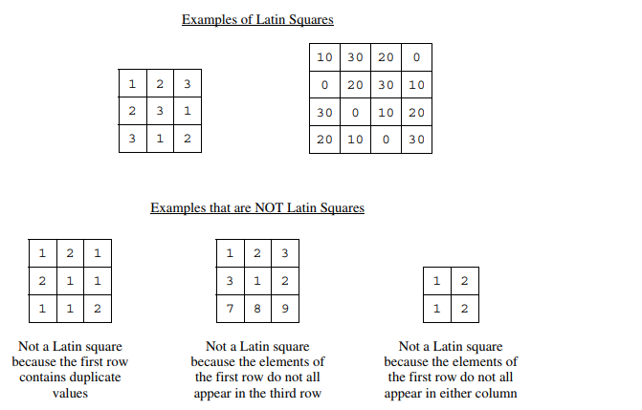

/5

