Getting started on your first project in Netbeans

Open Netbeans. Click on the File option and select New Project | 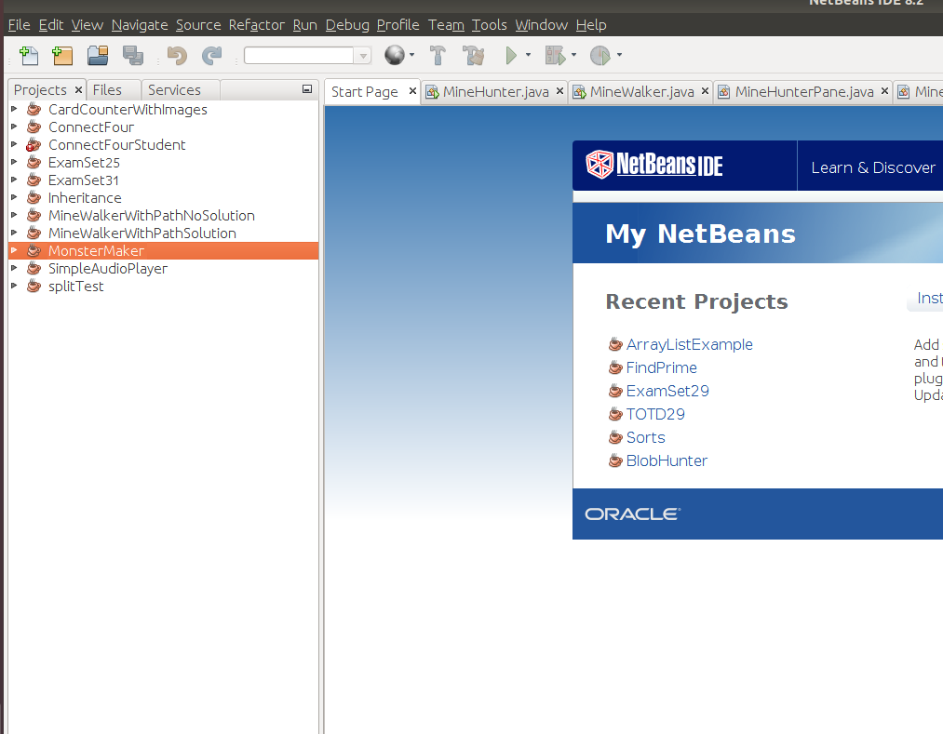
On the next menu, select the Java option.  NOTE: If you are using Netbeans Apache, select the Java using Ant build option  NOTE: If this is your first time opening Netbeans, you will likely need to “activate” this feature.  Once you are done with your selection, click Next | 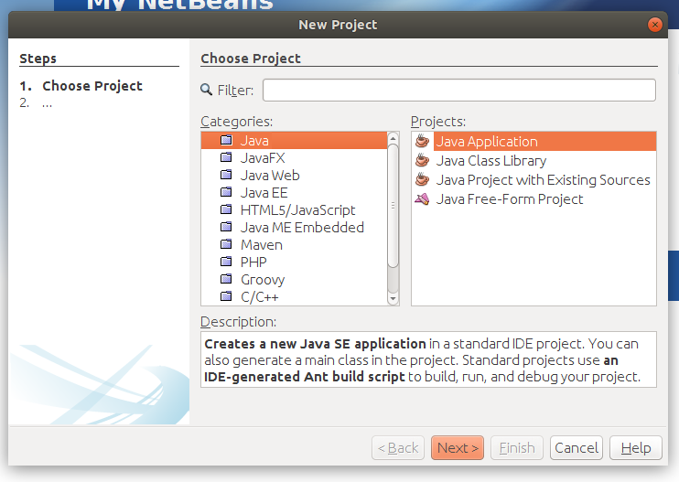
Type the name of the project in the Project Name field.  Note the Project Location. You can also click the Browse button to change the location of where your project is saved.  Click Finish when done. | 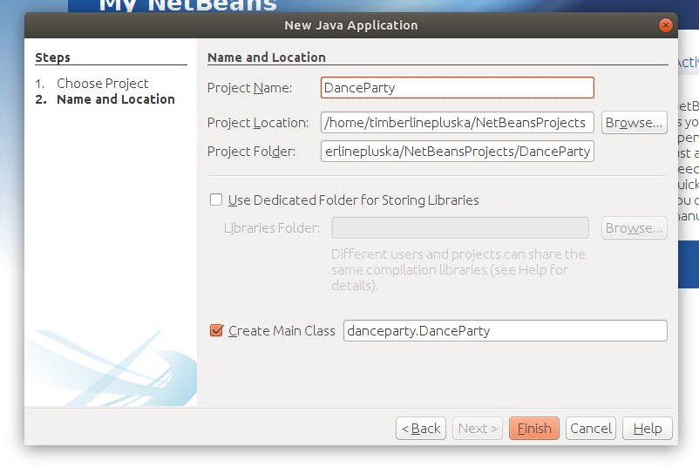
A project should now be created!  Notice, Netbeans created a driver class for you. But, you will be using the one I created for you instead.  Locate the driver class for your project in the Projects window.  Select the driver class for this project, then  The, click on the Edit option and select Delete | 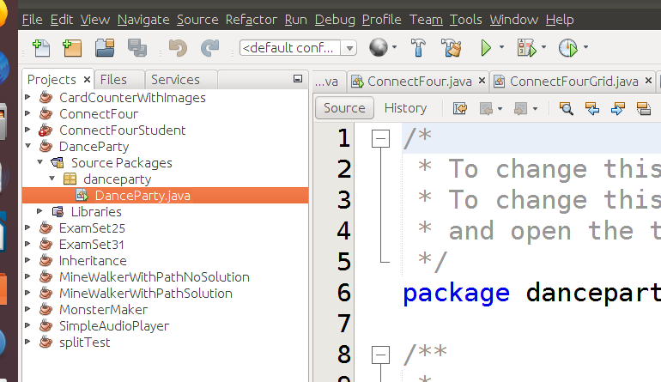
When prompted, select OK | 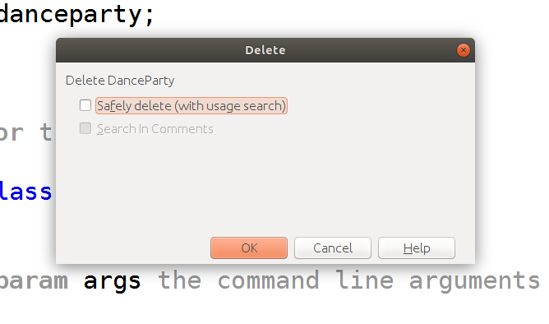
Navigate to the project folder on Github  https://github.com/hpluska/APCompSciA/tree/master/projects/DanceParty/DanceParty  Click on the required DanceParty.java class | 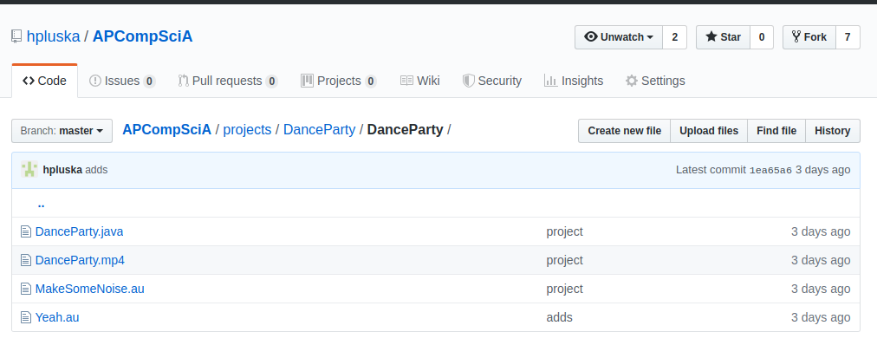
Locate the Raw button and click on it | 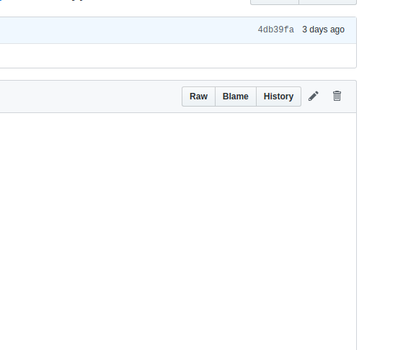
Right click on the file in your browser and select the Save as… option  NOTE: Note the location of your file! I am placing mine on my Desktop | 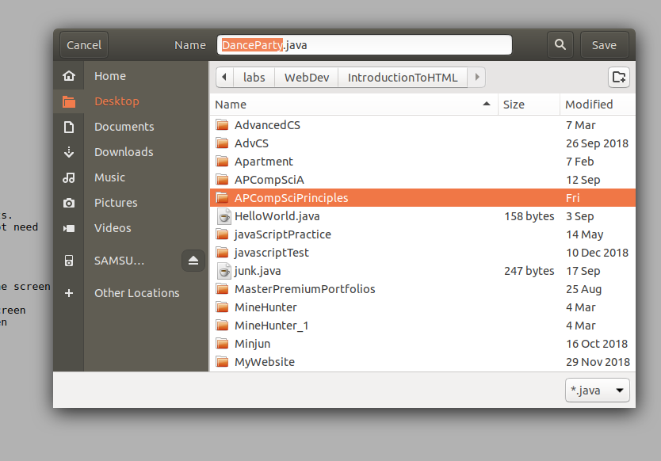
Click the back button on your browser to return to the project folder.  Locate a *.au song file. It doesn’t matter which one. This is the song for your dance party.  Click on the song.  On the next screen right click on the View raw link | 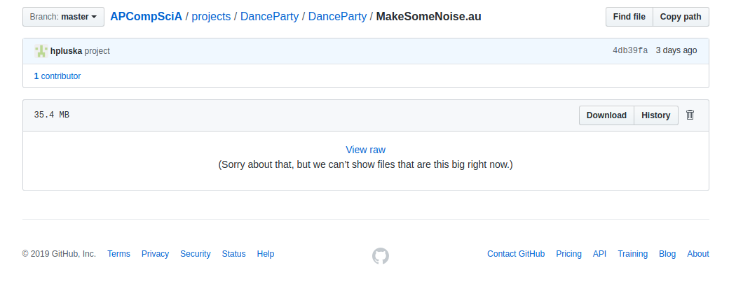
On the next screen, select the Save link as… option  NOTE: Note the location of your file! I am placing mine on my Desktop | 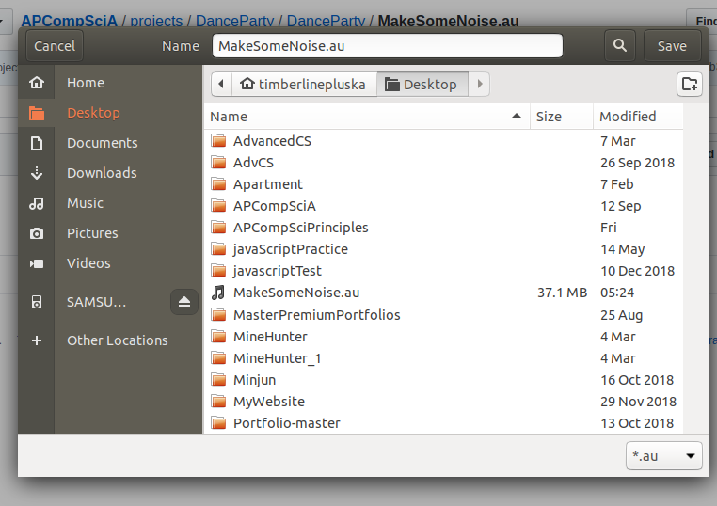
Navigate to where you downloaded your files.  Select the files (or you can select one file at a time). Right click and select the Cut option | 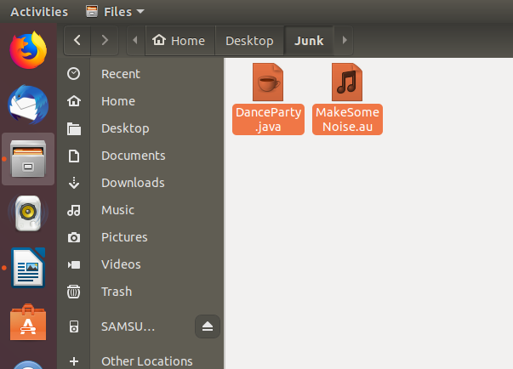
Return to Netbeans.  Select the project folder you created previously.  Click on Edit from the main menu, then select the Paste option | 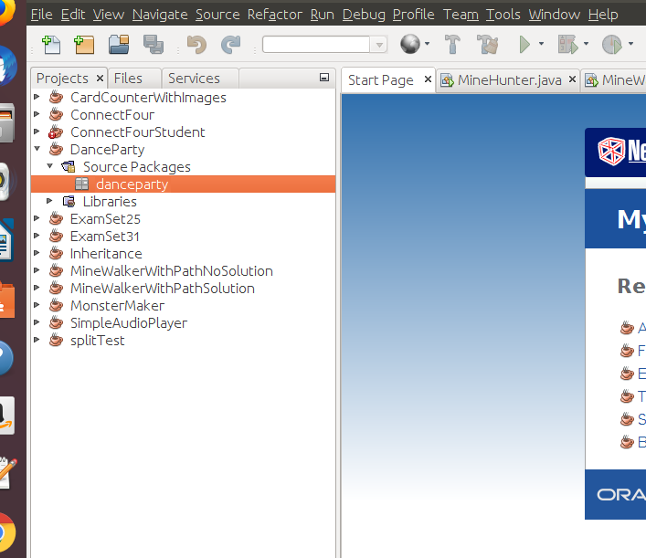
Double click on the DanceParty.java class you just pasted.  Locate the light bulb with the explanation point at the top of the file.  Click on the light bulb and select Change package declaration to dancyparty  At the top of the DanceParty.java class, you should now have the package declaration shown to the left.  NOTE: A package declaration is required of all Netbeans projects. | 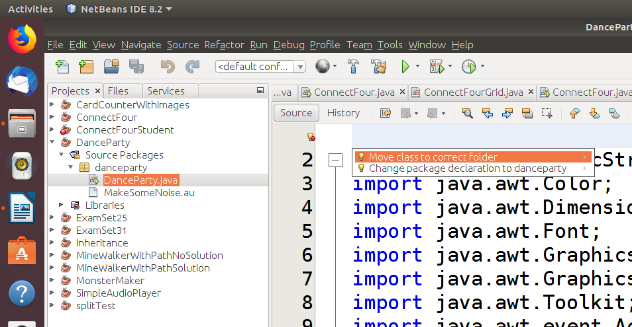  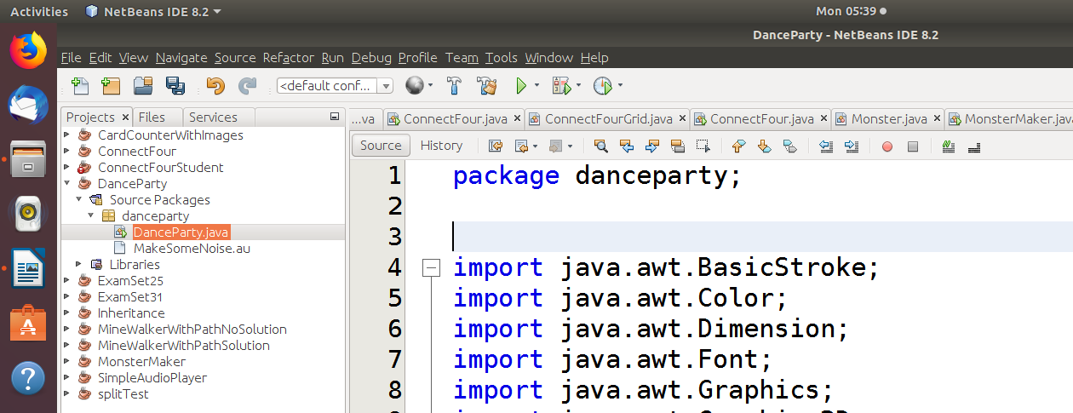
Select the *.au file in the project folder under the Projects tab  Right click on this file an select the Properties option  Locate the little box to the right of the All Files option in the Properties window | 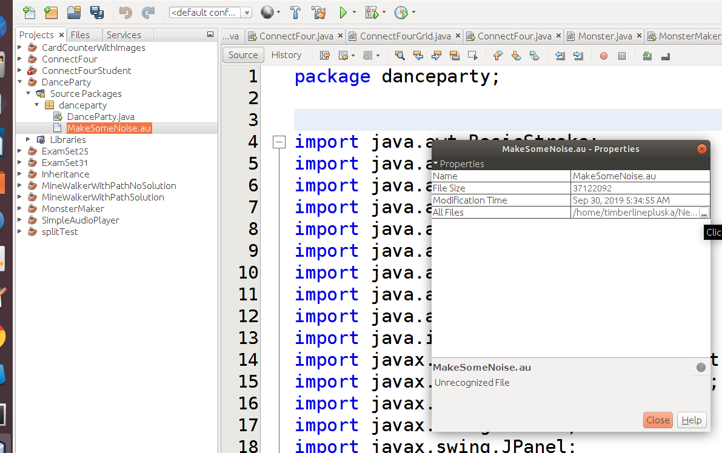
Select the link in the new window.  Press Ctrl-c on your keyboard to copy the link to your clipboard  Click Close on both windows when done | 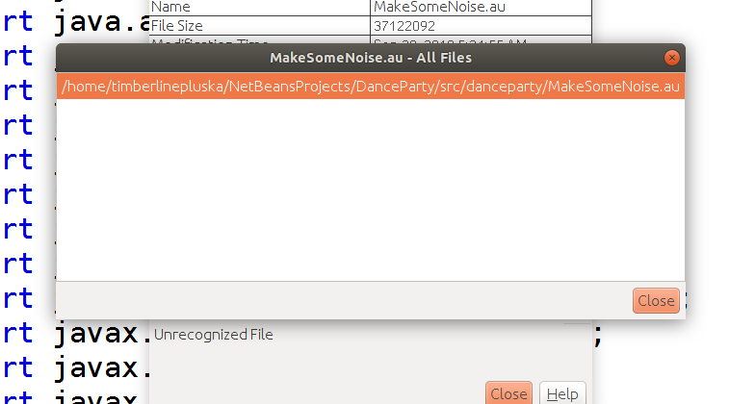
Select the DanceParty.java class under the Projects tab  Locate the playMusic method (It should be at line 134)  Locate the line that specifies the fileName. Replace the reference in quotes with the reference you just copied to your clipboard. You can do this by selecting the text in quotes, then pressing Ctrl-v on your keyboard. | 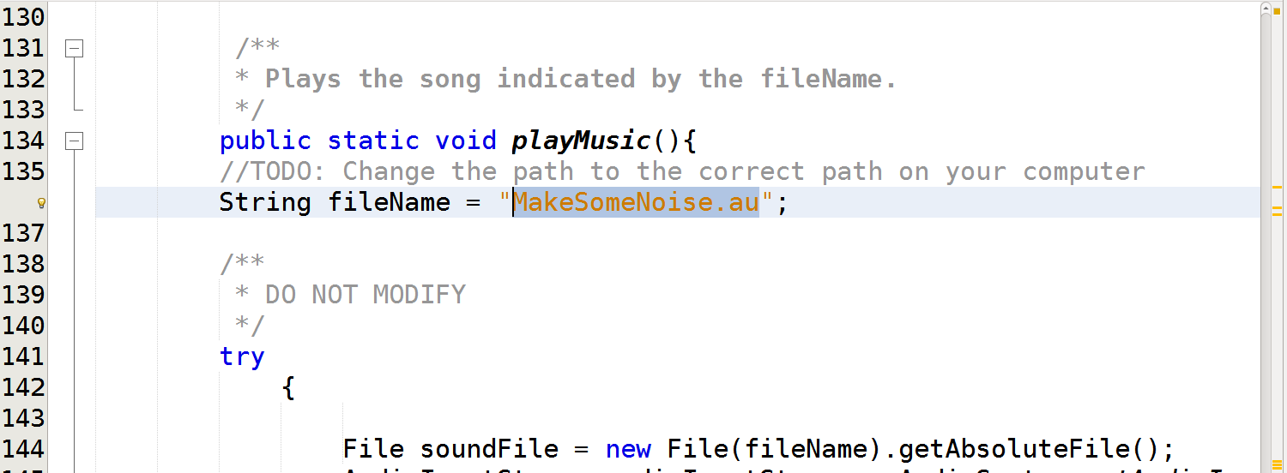
Click the green play button. If a window pops open with some random drawings and music is playing you are ready to start coding! | 