Skill 7.1 Exercise 1
Evaluate whether each of the following is true or false for the conditions below,
x = 11 and y = 5
(( x < 10 ) AND ( y = 6 )
(( x < 10 ) AND ( y = 5 )
(( x > 10 ) AND ( y ≠-3 )
(( x < 10 ) OR ( y = 5 ))
(( x > 10 ) OR ( y = 5 ))

Skill 7.2 Exercise 1
Write each of the following expressions using proper java syntax
(( x < 10 ) AND ( y = 6 )
(( x < 10 ) AND ( y = 5 )
(( x > 10 ) AND ( y ≠-3 )
(( x < 10 ) OR ( y = 5 ))
(( x > 10 ) OR ( y = 5 ))

Skill 7.3 Exercise 1
Indicate what is printed
System.out.println(false && false);
System.out.println(true && false);
System.out.println(false || true);

Skill 7.4 Exercise 1
Refer to the following code to evaluate what is printed.

int x = 79, y = 46, z = -3;
double d = 13.89, jj = 40.0;
boolean b = true, c = false;

System.out.println(true && !false);
System.out.println(!b || c);

System.out.println( ( jj = = 40 ) && !false);
System.out.println( x != 3 );
System.out.println( !(x != 3) );
System.out.println(c || !(d > 0));
System.out.println( !!true );

Skill 7.5 Exercise 1
Declare and initialize an integer a.
Declare and initialize a different integer b.
Declare a boolean c.
Initialize c to !(a = = b).
What is the value of c? True or false?

Skill 7.6 Exercise 1
Refer to the following code to evaluate what is printed.

int x = 79, y = 46, z = -3;
double d = 13.89, jj = 40.0;
boolean b = true, c = false;
System.out.println( b && c || !c);
System.out.println( x == y && !(z < 0) || b && c);
System.out.println( x != y && y==z && b || !c);
System.out.println( x > y || c || b && jj%4 != 0);

Skill 7.7 Exercise 1
Simplify the following
!(A > B || B != A)
! (A == B || (B >= C || B < A))

Skill 7.7 Exercise 2
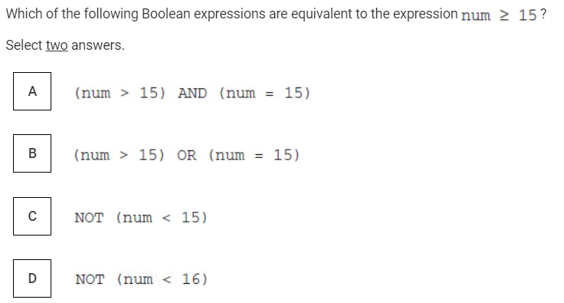
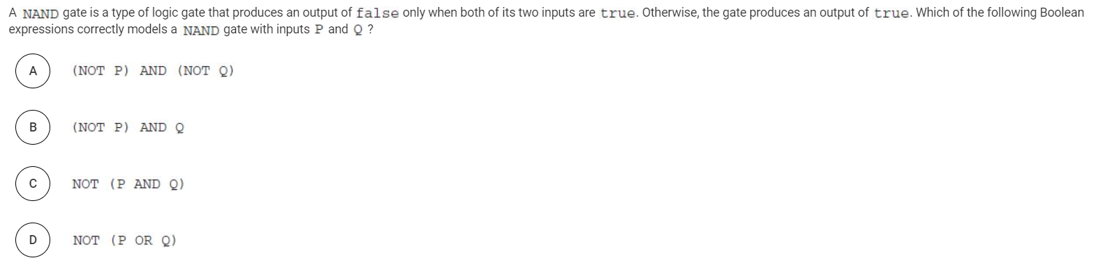

Skill 7.7 Exercise 3
The table below shows the value of an expression base on the values of input1 and input2
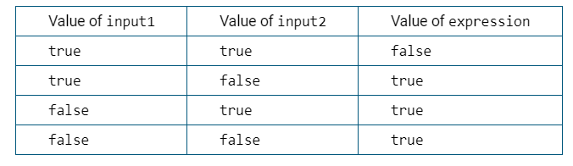
Write an expression in terms of input1 and input2 that would produce the output.

