AP COMPUTER SCIENCE A
Our AP CSA Learning Story
These four Learning Intentions guide the course. The Success Criteria follow the course's instructional topics so each routine assignment has one clear evidence target. Previously learned skills provide context without being automatically reassessed.
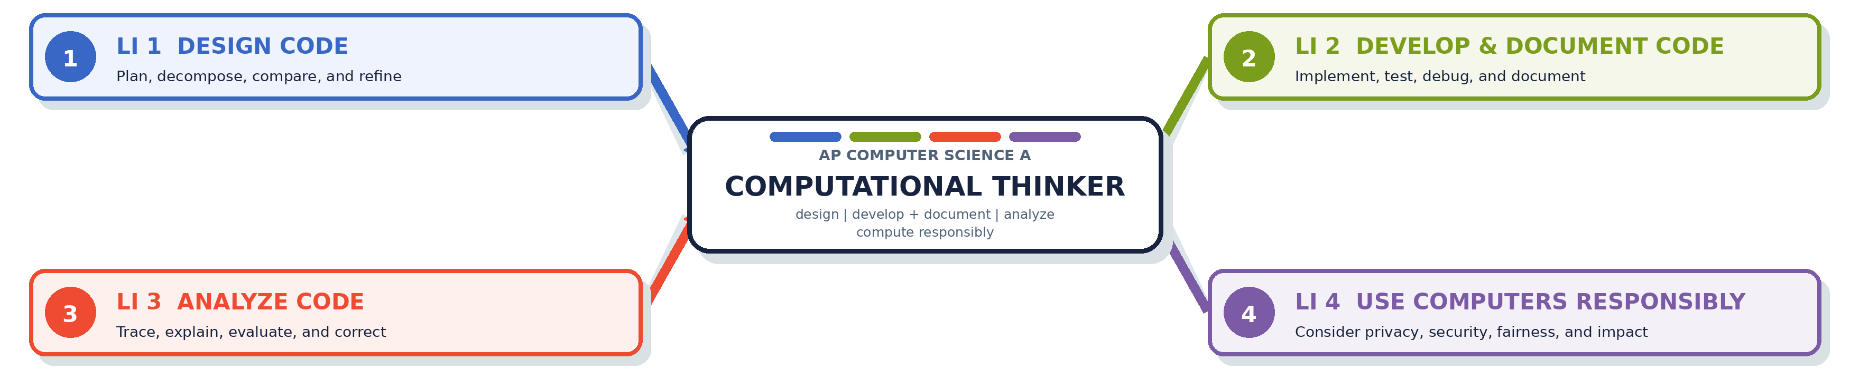
LI 1 DESIGN CODE  I am learning to apply computational thinking to create an algorithm. | LI 2 DEVELOP & DOCUMENT CODE  I am learning to describe the behavior and conditions of a program and write and implement code to achieve a specified result. | LI 3 ANALYZE CODE  I am learning to apply a systematic and intentional methodology to analyze a program for a given purpose or intended outcome. | LI 4 USE COMPUTERS RESPONSIBLY  I am learning to understand the ethical and social implications of computer use on society, the economy, and culture.
COLLEGE BOARD COMPUTATIONAL THINKING PRACTICES College Board identifies five practices students develop throughout the course; these connect to, but are not the same as, our four Learning Intentions.
COMPUTATIONAL THINKING PRACTICE | WHAT IT LOOKS LIKE | STRONG CONNECTIONS
P1 DESIGN CODE | Determine an appropriate program design and develop algorithms. | LI 1
P2 DEVELOP CODE | Write and implement program code. | LI 2
P3 ANALYZE CODE | Determine the result of code or explain why code may not work as intended. | LI 3
P4 DOCUMENT CODE & COMPUTING SYSTEMS | Describe the behavior of code and the conditions that produce specified results. | LI 2 LI 3
P5 USE COMPUTERS RESPONSIBLY | Understand the ethical and social implications of computing systems. | LI 4
HOW TO READ THE TILES Each numbered tile on the next page is one topic-based Success Criterion. Its badges show the Learning Intentions it supports. A routine assignment normally connects to one primary target: the learning it is designed to assess.

OUR AP CSA LEARNING STORY
Success Criteria
Each numbered criterion is a topic-based evidence target. Routine assignments normally connect to one primary criterion.
LI 1 Design Code | LI 2 Develop & Document Code | LI 3 Analyze Code | LI 4 Use Computers Responsibly

SC 0  I can use development tools and version control to organize, track, and submit my programming work.  LI 2 | SC 1  I can develop, test, refine, and compare algorithms to solve a computational problem.  LI 1 LI 3 | SC 2  I can create, compile, and run a Java program that produces clear, correctly formatted output.  LI 2 LI 3
SC 3  I can use variables and appropriate data types to represent, update, and convert information.  LI 2 LI 3 | SC 4  I can use String and char data to represent and manipulate text and explain how characters are encoded.  LI 1 LI 2 LI 3 | SC 5  I can use arithmetic operators, mixed data types, constants, and Math class methods to perform computations.  LI 1 LI 2 LI 3
SC 6  I can create interactive programs that collect, store, and use keyboard input.  LI 2 LI 3 | SC 7  I can create and evaluate Boolean expressions using relational and logical operators.  LI 1 LI 2 LI 3 | SC 8  I can use selection statements to control decisions in a program.  LI 1 LI 2 LI 3
SC 9  I can use for, while, and nested loops to repeat processes and traverse data.  LI 1 LI 2 LI 3 | SC 10  I can store and process collections of data using one-dimensional arrays.  LI 1 LI 2 LI 3 | SC 11  I can create and use classes and objects with constructors, fields, and methods.  LI 2 LI 3
SC 12  I can design classes using encapsulation, method overloading, static members, and appropriate parameter passing.  LI 2 LI 3 | SC 13  I can store and process data organized in rows and columns using two-dimensional arrays.  LI 1 LI 2 LI 3 | SC 14  I can organize related classes and shared behavior using inheritance, polymorphism, abstract classes, and interfaces.  LI 2 LI 3
SC 15  I can anticipate and handle exceptions so a program responds appropriately to errors.  LI 2 LI 3 | SC 16  I can store, modify, and process dynamic collections of data using ArrayLists.  LI 1 LI 2 LI 3 | SC 17  I can trace and explain recursive algorithms and the call stack.  LI 3
SC 18  I can trace, interpret, and compare searching and sorting algorithms, including their behavior and efficiency.  LI 1 LI 3 | SC 19  I can explain how computing affects society, the economy, or culture and apply responsible computing practices.  LI 4

