- Consider the following instance variable and method. Method wordsWithCommas is intended to return a string containing all the words in listOfWords separated by commas and enclosed in braces. For example, if listOfWords contains ["one", "two", "three"], the string returned by the call wordsWithCommas() should be "{one, two, three}".

private List<String> listOfWords;

public String wordsWithCommas() {
String result = "{";

int sizeOfList = /* expression */ ;

for (int k = 0; k < sizeOfList; k++) {
result = result + listOfWords.get(k);

if ( /* condition */ )
{ result = result + ", "; }
}
result = result + "}";
return result;
}
Which of the following can be used to replace the following so that wordsWithCommas will work as intended?

- /* expression */ and

- /* condition */

- Consider the following code segment.

List<String> students = new ArrayList<String>();

students.add("Alex");
students.add("Bob");
students.add("Carl");

for (int k = 0; k < students.size(); k++) {
System.out.print(students.set(k, "Alex") + " ");
}

System.out.println();

for (String str : students) {
System.out.print(str + " ");
}

(a) What is printed when the code above is executed?

- A two-dimensional array of integers in which most elements are zero is called a sparse array. Because most elements have a value of zero, memory can be saved by storing only the non-zero values along with their row and column indexes. The following complete SparseArrayEntry class is used to represent non-zero elements in a sparse array. A SparseArrayEntry object cannot be modified after it has been constructed.

public class SparseArrayEntry {
/** The row index and column index for this entry in the sparse array */
private int row;
private int col;

/** The value of this entry in the sparse array */
private int value;

/** Constructs a SparseArrayEntry object that represents a sparse
* array element with row index r and column index c, containing
* value v.
*/
public SparseArrayEntry(int r, int c, int v) {
row = r;
col = c;
value = v; }

/** Returns the row index of this sparse array element. */
public int getRow() {
return row;
}

/** Returns the column index of this sparse array element. */
public int getCol() {
return col;
}

/** Returns the value of this sparse array element. */
public int getValue() {
return value;
}
}

The SparseArray class represents a sparse array. It contains a list of SparseArrayEntry objects, each of which represents one of the non-zero elements in the array. The entries representing the non-zero elements are stored in the list in no particular order. Each non-zero element is represented by exactly one entry in the list

public class SparseArray {
/** The number of rows and columns in the sparse array. */
private int numRows;
private int numCols;

/** The list of entries representing the non-zero elements of the
* sparse array. Entries are stored in the list in no particular order.
* Each non-zero element is represented by exactly one entry in
* the list.
*/
private List<SparseArrayEntry> entries;

/** Constructs an empty SparseArray. */
public SparseArray() {
entries = new ArrayList<SparseArrayEntry>();
}

/** Returns the number of rows in the sparse array. */
public int getNumRows() {
return numRows;
}

/** Returns the number of columns in the sparse array. */
public int getNumCols() {
return numCols;
}

/** Returns the value of the element at row index row and column
* index col in the sparse array.
* Precondition: 0 ≤ row < getNumRows()
* 0 ≤ col < getNumCols()
*/
public int getValueAt(int row, int col) {
/* to be implemented in part (a) */
}

/** Removes the column col from the sparse array.
* Precondition: 0 ≤ col < getNumCols()
*/
public void removeColumn(int col) {
/* to be implemented in part (b) */
}

// There may be instance variables, constructors, and methods that are not shown.
}

- The following table shows an example of a two-dimensional sparse array. Empty cells in the table indicate zero values
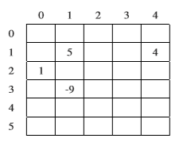
The sample array can be represented by a SparseArray object, sparse, with the following instance variable values. The items in entries are in no particular order; one possible ordering is shown below.

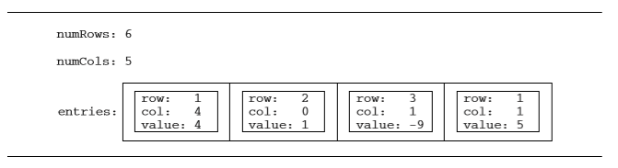
Write the SparseArray method getValueAt. The method returns the value of the sparse array element at a given row and column in the sparse array. If the list entries contains an entry with the specified row and column, the value associated with the entry is returned. If there is no entry in entries corresponding to the specified row and column, 0 is returned.

In the example above, the call sparse.getValueAt(3, 1) would return -9, and sparse.getValueAt(3, 3) would return 0.

Complete method getValueAt below.

/** Returns the value of the element at row index row and
* column index col in the sparse array.
* Precondition: 0 ≤ row < getNumRows()
* 0 ≤ col < getNumCols()
*/

public int getValueAt(int row, int col)

- Write the SparseArray method removeColumn. After removing a specified column from a sparse array:
- All entries in the list entries with column indexes matching col are removed from the list.
- All entries in the list entries with column indexes greater than col are replaced by entries with column indexes that are decremented by one (moved one column to the left).
- The number of columns in the sparse array is adjusted to reflect the column removed.

The sample object sparse from the beginning of the question is repeated for your convenience.

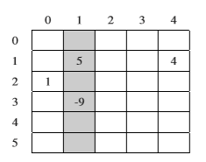
The shaded entries in entries, below, correspond to the shaded column above.

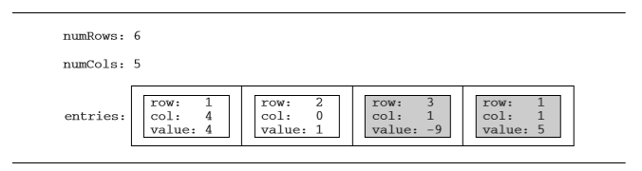
When sparse has the state shown above, the call sparse.removeColumn(1) could result in sparse having the following values in its instance variables (since entries is in no particular order, it would be equally valid to reverse the order of its two items). The shaded areas below show the changes.

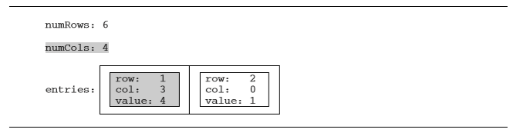

Class information repeated from the beginning of the question

public class SparseArrayEntry

public SparseArrayEntry(int r, int c, int v)
public int getRow()
public int getCol()
public int getValue()

public class SparseArray

private int numRows
private int numCols
private List<SparseArrayEntry> entries
public int getNumRows()
public int getNumCols()
public int getValueAt(int row, int col)
public void removeColumn(int col)

Complete method removeColumn below.

/** Removes the column col from the sparse array.
* Precondition: 0 ≤ col < getNumCols()
*/

public void removeColumn(int col)

