GitHub Workshop Lab Guide

Your Tasks (Mark these off as you go)
- Define key vocabulary
- Create a GitHub account
- Install Git on your computer
- Configure your username and email
- Install Visual Studio code
- Clone a repository
- Complete your assignment with Visual Studio Code
- Push changes to a repository
- Receive credit for this lab guide

- Define key vocabulary

- Open up your browser and search for definitions to the following terms as they relate to “Git”. For example you could type “Git vocabulary”.
- Work with your partner to write definitions for the following terms.

Git

GitHub

repository

local

remote

stage

commit

push

clone

fork

pull

origin/master

- Create a GitHub account

Navigate to the following address,  https://education.github.com/students  Locate the Get Benefits for Students button and click on it. | 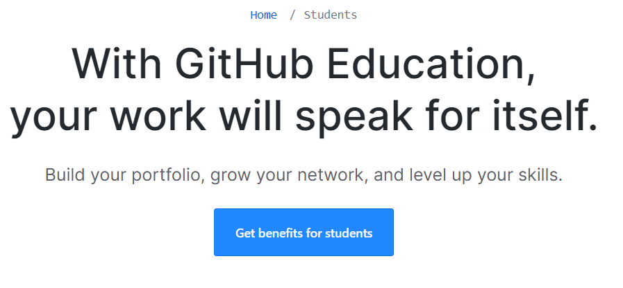
Locate the Create an account link and click on it.  Create your account when prompted | 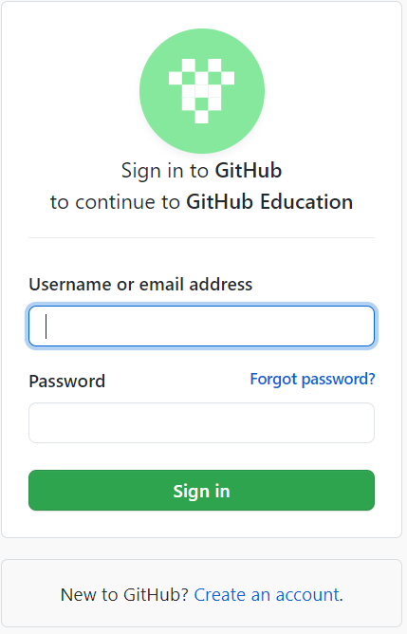

- Install Visual Studio Code
Navigate to https://code.visualstudio.com/download and download Visual Studio Code | 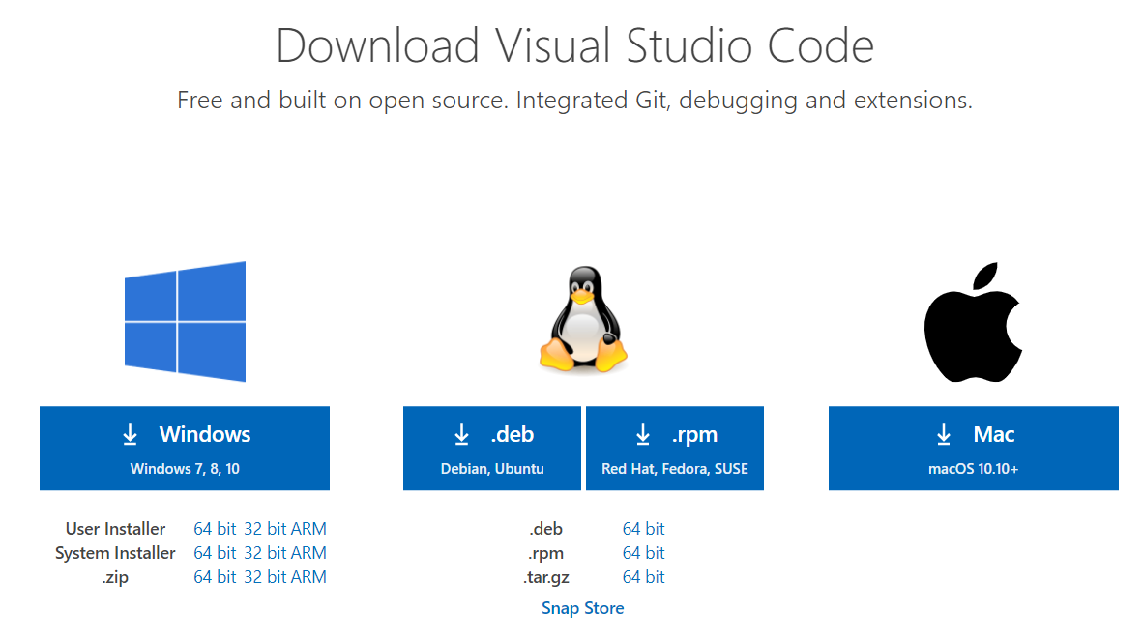
Locate the file and install per your operation system | 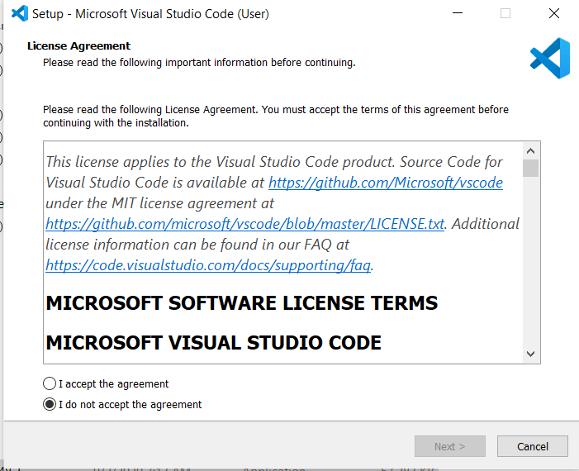

- Configure your username and email

Log in to GitHub and locate your no-reply email  - Click on Settings from your start menu  - In the left menu, click on Emails  - In the Primary Email Address section copy the no-reply email provided in the text | 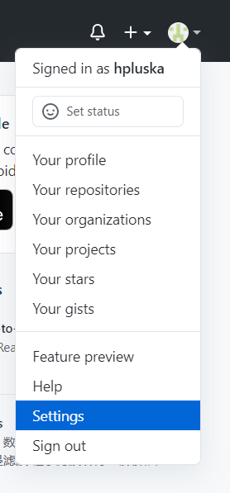  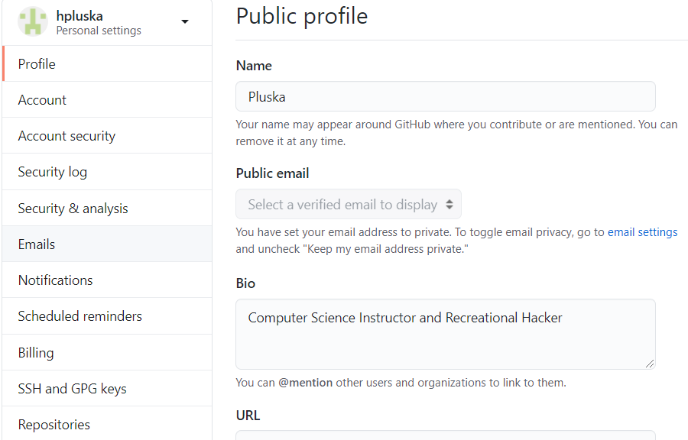  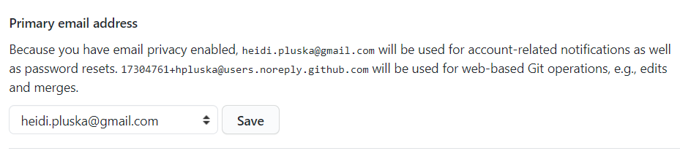
Open a Terminal  - Open Visual Studio Code  - From the menu at the top, select Terminal, New Terminal | 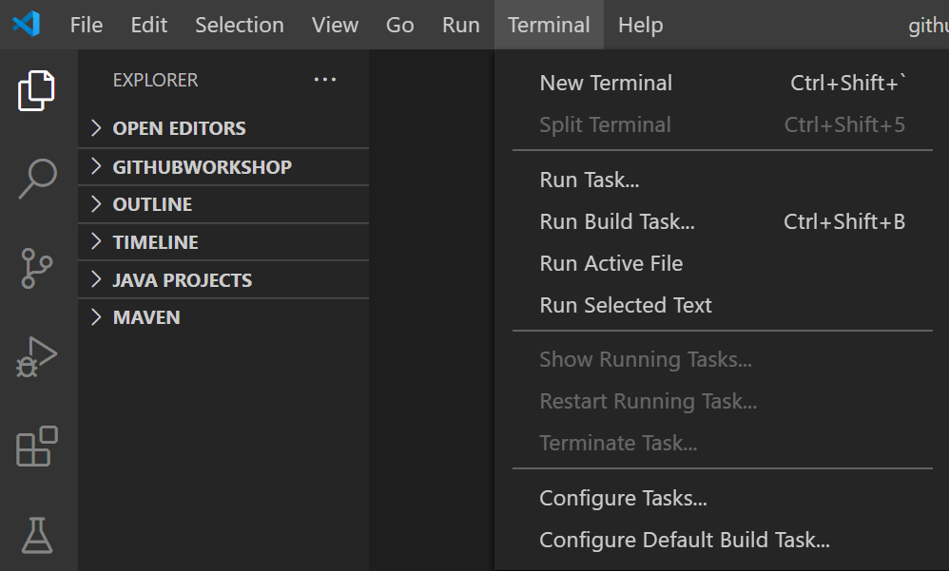
Set the Git commit username and email on your local computer to the ones you used on your GitHub account.  - Locate the terminal window at the bottom of the screen.  - At the terminal prompt, type the following command, paste the email you just copied in between the quotes, then hit Enter.  git config --global user.email "paste the email you just copied here”  - To set your username, copy the following command, type your GitHub username in the quotes, then hit Enter.  git config --global user.name "paste your username here" | 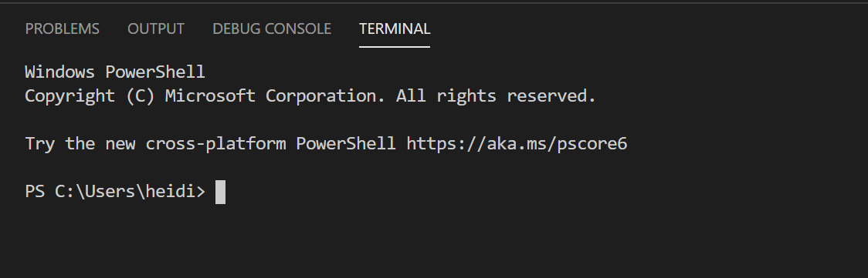

- Clone a repository

Navigate the classroom and locate the assignment. Accept the assignment you have been assigned using the link provided by Pluska. | 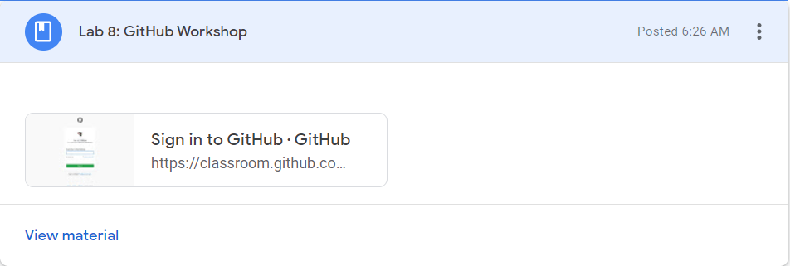
In the GitHub assignment repository you just accepted, locate the Code button and copy the https link | 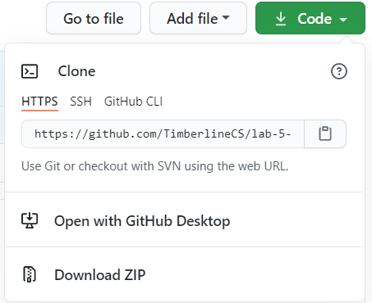
Return to Visual Studio Code  - Click on the Control Source icon in the left menu  - Click on the Clone Repository button | 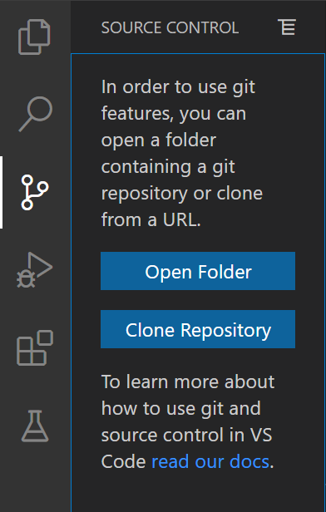
Locate the text box at the top of the window and paste the URL to the repository you just copied, then click Enter | 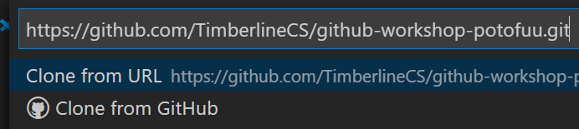
Navigate to where you would like to store the repository.  The click Select Repository Location | 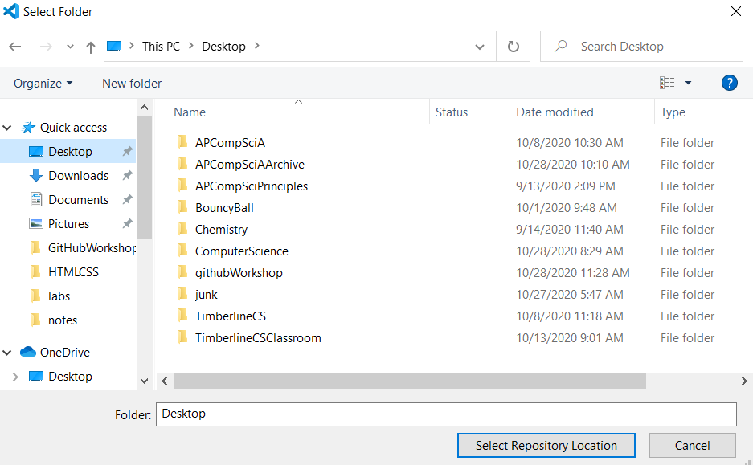  MAKE SURE you know where you save your repository! I recommend creating a folder on your computer called APCSPrinciples and storing all your course content there.
In the bottom right corner of the screen locate the Would you like to open the cloned repository? Window. Click the Open button | 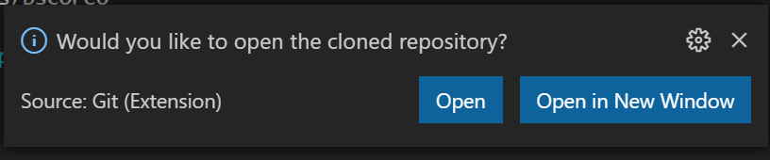

- Complete your assignment with Visual Studio Code

- Locate the README.md file in the left menu and click on it. | 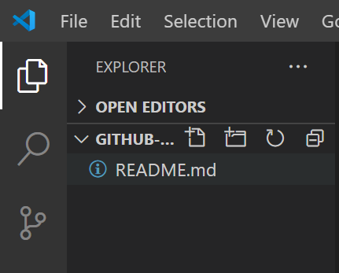
The file you clicked on is now open in the editor window. Answer the prompts. When you are done, type ctrl-s to save your file. You can also save your file by selecting Save from the File menu. | 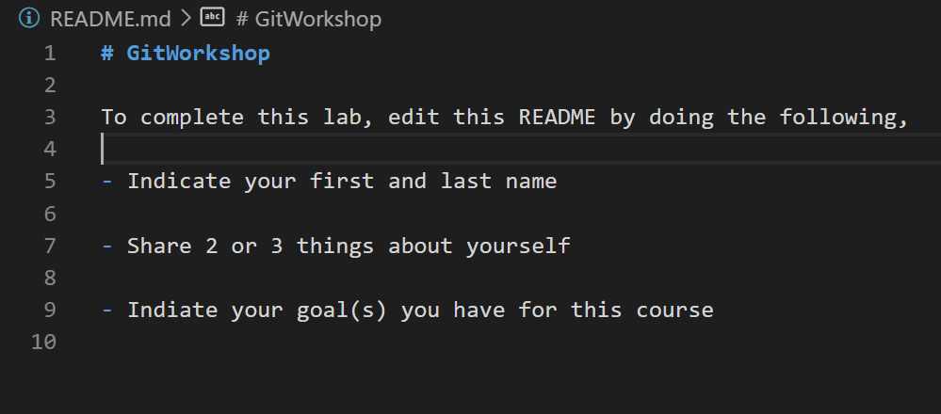

- Push changes to a repository
After you save the file you have changed, a blue circle with a number will appear on the Source Control icon. This means you have 1 pending change to push to GitHub. Click on the source control icon to open the Git menu. | 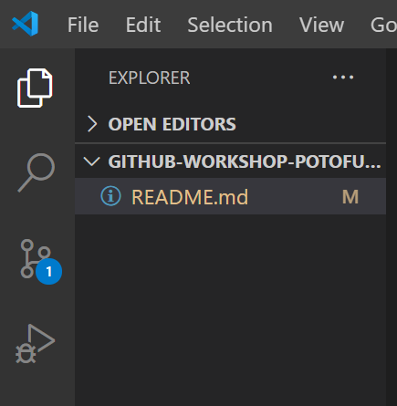
Pushing your work back to GitHub is a three part process – Stage, Commit, Push.  You will notice Visual Studio Code tracks the changes you have made to files. Locate the file you just changed under the Changes tab. Then click the plus sign next to it to stage your changes. | 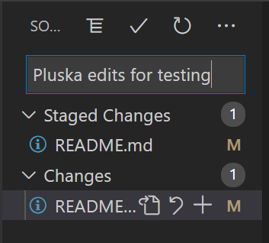
To commit your changes you must first type a message in the dialogue box. This message should be descriptive and brief. Click the check mark when done. | 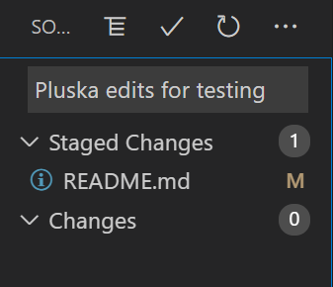
To push your changes back to GitHub, select Push from the Source Control menu. Access this by clicking on the 3 dots.  If you see the warning message, just click OK. You should only see this the first time you push. | 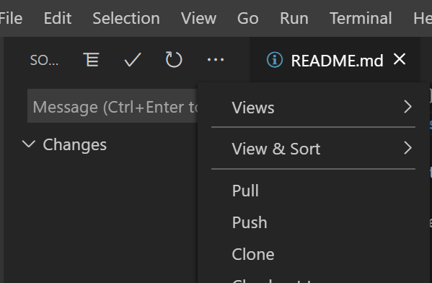  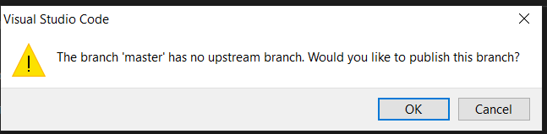
Now return to your GitHub assignment repository and refresh the page. Check out your edited file!  BAM! | 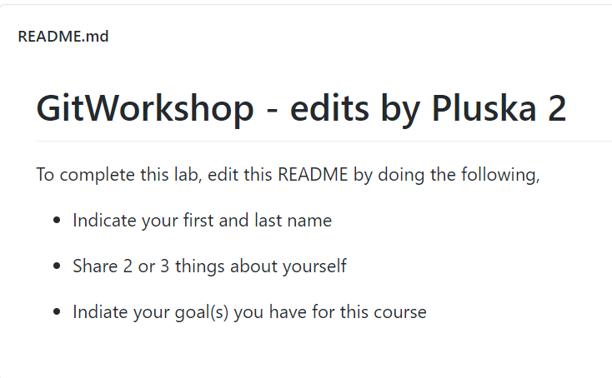

- Receive Credit for this lab guide

Submit this portion of the lab to Google Classroom to receive credit for the lab guide.

