Solving Problems

Your Tasks (Mark these off as you go)
☐ Find the file using the most storage
☐ Sort the files from largest to smallest
☐ Implement a quicksort
☐ Compare algorithms
☐ Receive credit for this lab guide

- Find the file using the most storage

Your device is almost out of storage. Eight files use different amounts of storage. Choose one group member to serve as the computer and hold the File Size Key. How could your partner identify the file using the most storage? Follow these rules:

- Only the computer may look at the File Size Key.
- Your partner may ask the computer to compare only two files at a time. The computer reports only which file is larger; no file sizes may be revealed.
- You may rearrange the file cards and tally comparisons, but you may not record file sizes or comparison results.

Write an algorithm below that another group could implement.

Obtain eight file cards and a File Size Key from your teacher. Choose the computer and implement your algorithm to identify the file using the most storage. Keep track of the number of comparisons and record it below.

- Sort the files from largest to smallest

Brainstorm an algorithm you could use to sort the eight files from largest to smallest. Continue to follow the same roles and comparison rules:

- Only the computer may look at the File Size Key.
- Only two files may be compared at a time. The computer reports only which file is larger.
- You may rearrange the file cards and tally comparisons, but you may not record file sizes or comparison results.

Write an algorithm below that another group could implement.

Implement your algorithm to sort the files from largest to smallest. Keep track of the number of comparisons and record it below.

Using your algorithm, predict how many comparisons it would take to sort 10 files, 20 files, and 100 files. Explain how you made each prediction.

- Implement a quicksort

Quicksort is a comparison-based sorting algorithm that can be much more efficient than a simple sorting method, particularly for large collections. Its efficiency depends on the pivot selected.

Below is the quicksort algorithm as it applies to the file cards:

- Choose one file at random as the pivot and place it aside.  - Compare each remaining file with the pivot. Put files that are larger on the left and files that are smaller on the right. One side may contain more files than the other.  - Choose one group and repeat this procedure. Then do the same for the other group. Keep each pivot between its larger and smaller groups.  - Continue partitioning the remaining groups until no group contains more than one file.  - When every group has been reduced to a single file, the files will be ordered from largest to smallest. | 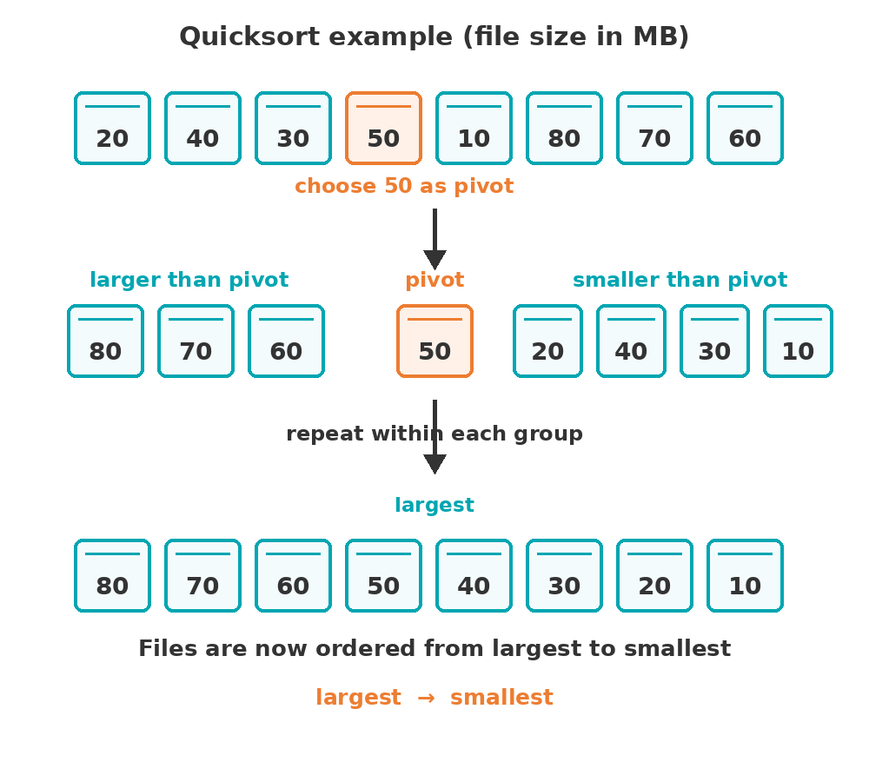

Mix up your file cards and apply the quicksort algorithm above. The computer should continue to reveal only which of two files is larger. Keep track of the number of comparisons and record it below.

- Compare algorithms

How did the number of comparisons used by your original algorithm differ from the number used by quicksort?

If each pivot divided the remaining files as evenly as possible, how many comparisons would quicksort use to order all eight files? Show or explain your reasoning.

If you always chose the largest or smallest remaining file as the pivot, how many comparisons would quicksort use to order all eight files? Show or explain your reasoning.

- Receive credit for this lab guide

Submit this portion of the lab to Google Classroom to receive credit for the lab guide.

