- Refer to the code below,

public interface Sports {

void method1( );
void method2( );
int method3(double d);
}

public class Baseball implements Sports {

public Baseball( ) { . . . }
public void method1( ) { //some code…}
public void method2( ) { //some code…}
public int method3(double c ) { //some code…}
public int statevar1;
}

public class Football implements Sports {

public Football( ) { . . . }
public void method1( ) { //some code…}
public void method2( ) { //some code…}
public int method3(double c ) { //some code…}
public int statevar1;
}

public class Tester {

public static void main(String[] args) {

Sports x = new Baseball( );
Sports y = new Football( );
x.method2( );
y.method2( );
. . . more code . . .
}
}
- Which methods, if any, in the Sports interface are abstract?

method1, method2, method3

/1
- public class Hockey implements Sports {

//What methods, if any, must we implement here?
method1, method2, method3
}

/1
- Look at the classes Baseball and Football. Both implement method1. Do both implementations have to have identical code? If so, why?

No, they only need to implement the method. The methods within each class can be different

/1
- In the “more code” section of Tester what would the following return?
(x instanceof Sports)

true

/1
- In the “more code” section of Tester what would the following return?
(y instanceof Football)

true
/1
- The property of two classes being able to have methods of the same name (but with possibly different implementations) is known as

overriding
/1
- Modify the following class so that it will simultaneously inherit the Red class and implement both the Eagle and Bobcat interfaces.

public class Austria { . . . }

public class Austria extends Red implements Eagle, Bobcat

/1

This question involves reasoning about 2-dimensional arrays of integers.

public class ArrayTester
{

/** Returns an array containing the elements of column c of arr2D in the same order as
* they appear in arr2D.
* Precondition: c is a valid column index in arr2D.
* Postcondition: arr2D is unchanged.
*/
public static int[] getColumn(int[][] arr2D, int c)
{ /* to be implemented in part (a) */ }

/** Returns true if and only if every value in arr1 appears in arr2.
* Precondition: arr1 and arr2 have the same length.
* Postcondition: arr1 and arr2 are unchanged.
*/
public static boolean hasAllValues(int[] arr1, int[] arr2)
{ /* to be implemented in part (b) */ }

/** Returns true if arr contains any duplicate values;
* false otherwise.
*/
public static boolean containsDuplicates(int[] arr)
{ /* to be implemented in part (c) */ }

/** Returns true if square is a Latin square as described in part (b);
* false otherwise.
* Precondition: square has an equal number of rows and columns.
* square has at least one row.
*/
public static boolean isLatin(int[][] square)
{ /* to be implemented in part (d) */ }

- Write a static method getColumn, which returns a one-dimensional array containing the elements of a single column in a two-dimensional array. The elements in the returned array should be in the same order as they appear in the given column.

The notation arr2D[r][c] represents the array element at row r and column c. The following code segment initializes an array and calls the getColumn method.

int[][] arr2D = {
{ 0, 1, 2 },
{ 3, 4, 5 },
{ 6, 7, 8 },
{ 9, 5, 3 }
};

int[] result = ArrayTester.getColumn(arr2D, 1);

When the code segment has completed execution, the variable result will have the following contents. result: {1, 4, 7, 5}

public static int[] getColumn(int[][] arr2D, int c)
{
/* to be implemented in part (a) */
arr2D = arr2D;
int[] result = new int[arr2D.length];

for(int i = 0; i < arr2D.length; i++){
result[i] = arr2D[i][c];
}
return result;

}

/4
- Write the static method hasAllValues which returns true if two arrays contain the same values. The values can appear in any order in either array.

public static boolean hasAllValues(int[] arr1, int[] arr2)
{
int foundValues = 0;
for(int j: arr1){
for(int i: arr2){
if(j == i){
foundValues++;
}
}
}
if(foundValues < arr1.length){
return false;
}
return true;
}

/4
- Write the static method containsDuplicates which returns true if an array has any duplicate values.

public static boolean containsDuplicates(int[] arr)
{
for(int i = 0; i < arr.length; i++){
for(int j = 0; j < arr.length; j++){
if(arr[i] == arr[j] && i !=j ){
return true;
}
}
}
return false;
}

/4
- Write the static method isLatin, which returns true if a given two-dimensional square array is a Latin square, and otherwise, returns false. In the isLatin method apply the getColumn, hasAllValues, and containsDuplicates helper methods.

A two-dimensional square array of integers is a Latin square if the following conditions are true.

• The first row has no duplicate values.
• All values in the first row of the square appear in each row of the square.
• All values in the first row of the square appear in each column of the square.
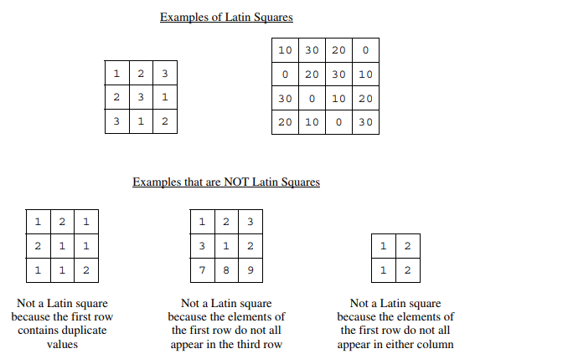

public static boolean isLatin(int[][] square)
{
int col0[] = getColumn(square, 0);

if(containsDuplicates(col0))
return false;

for(int i = 1; i < square[0].length; i++){
int[] colTemp = getColumn(square,i);

if(!hasAllValues(col0,colTemp))
return false;
}

for(int i = 1; i < square.length; i++){

if(!hasAllValues(col0,square[i]))
return false;
}

return true;

}

/5

