Introduction to HTML

Your Tasks
- Describe the purpose of HTML
- Watch the video on how to use HTML
- Write Code to create an HTML page
- Have Ms. Pluska check of Create an HTML page
- Create an Index.html page
- Have Ms. Pluska check of Create an Index.html page
- Practice with HTML
- Add HTML to your index page
- Show your webpage to Ms. Pluska to receive credit for this activity

- Describe the Purpose of HTML

We'll begin our study of web programming by learning the core language for writing web pages: Hypertext Markup Language (HTML). HTML describes the contents of your page, such as headings, paragraphs, images, and lists.
The version of HTML we will learn is the latest and most standard, called HTML5. The pages you will write will work in any modern browser.
- Watch the Video on how to use HTML

Navigate to the following link to learn how to to use HTML to add structure to your webpage

https://youtu.be/Hjl6gbg9kmk

- Write Code to Create an HTML page
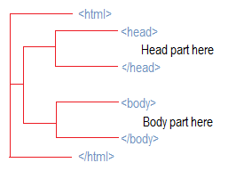
The image to the write shows the basic parts of an HTML page. It is broken down in to two sections: A head and a body. Notice that both of these sections are within another “html” section.

Information in the head section of the page are not displayed to the user. This section typically contains links to external resources needed to make the page run properly.

What appears in the body section however, is displayed on the users browser.

Navigate to the following link.

https://www.w3schools.com/html/html_intro.asp

Locate the “Try Yourself” button and try to modify the code to say “Hello! <<your name>>”.

In the box below, write code that could be used to display, “My first webpage!” in a browser.

- Have Ms. Pluska check off Create an HTML page


Before you continue have Ms. Pluska check off Create an HTML page
Do not continue until you have Ms. Pluska’s (or her designated TA’s) signature ____________

- Create an Index.html page

The landing page for all websites is called the index page. When you navigate to code.org or youtube for example, inside the main website directory there is a page called index. The browswer searches for this page and displays the contents.

The extension .html tells the browser that the page is an html type page. The instructions below describe how to create an Index.html page.

Follow the instructions below to create your index page.

On the desktop of your computer create a new folder called “MyWebsite”. You can do this by right clicking on your desktop and selecting “New Folder” | 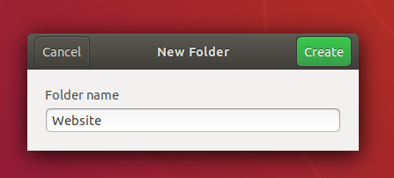
Navigate into the folder you just created.  Locate the waffle in the lower left corner of your screen and click on it. | 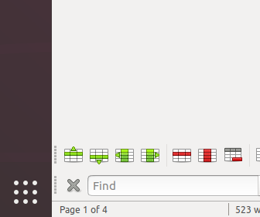
In the search field type “text” to locate the text editor,  Click on the Text Editor to open it up. | 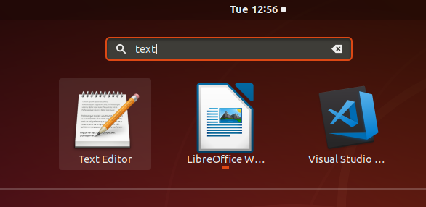
To save your your text file, locate the button with the three lines in the top right portion of the screen, then select the Save As option. | 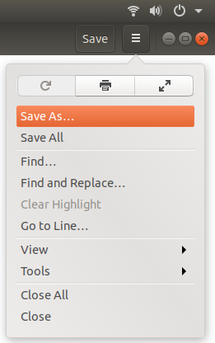
Select the location by navigating to the Website directory you just created.  Change the name of the file to Index.html  The click the save button. | 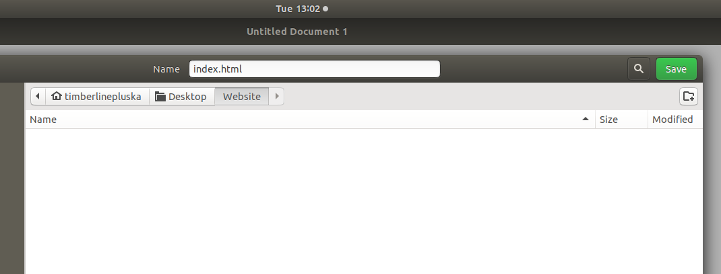

- Have Ms. Pluska check off Create an Index.html page

Before you continue have Ms. Pluska check off Create an Index.html page
Do not continue until you have Ms. Pluska’s (or her designated TA’s) signature ____________

- Define key vocabulary

HTML

HTML Element

HTML Tag

<head> tag

<body> tag

- Receive Credit for the group portion of this lab

- Indicate the names of all group members.
- Have Ms. Pluska check your Exploring Websites lab
- Submit your lab to the needs to be graded folder to receive credit for the group portion of this lab.
- Do not submit your lab until you have Ms. Pluska’s (or her designated TA’s) signature
_______

- Receive Credit for the Individual portion of this lab
To receive credit for the individual portion of this lab, you must complete the following,
Open the Index.html page you just created in your text editor. Implement the required code to make this an official html page.
In the body section of the page, use a header tag (<h1></h1>) to indicate your name, use paragraph tags <p></p> to tell me about yourself.

