Set 0: Understanding data literacy and visualizations

Skill 0.1: I can define data literacy
Skill 0.2: I can explain why data quality matters
Skill 0.3: I can identify bias in data
Skill 0.4: I can explain the importance of data visualizations
Skill 0.5: I can extract information from data visualizations
Skill 0.6: I can differentiate between correlation and causation
Skill 0.7: I can differentiate between data and metadata

Skill 0.1: I can define data literacy

Skill 0.1 Concepts
Data is a powerful tool in computing and in everyday life. It helps people make decisions, identify patterns, and solve problems. To use data well, we need to understand it clearly.
Data literacy is the ability to read, interpret, and communicate with data. This means being able to understand what data shows, think about what it means, and explain it clearly to others.
Data literacy also helps us present information in ways that other people can understand. Even when accurate data is available, poor communication can lead to misunderstanding or poor decisions.
Skill 0.1 Exercise 1

Skill 0.2: I can explain why data quality matters

Skill 0.2 Concepts
In data science, people often use the phrase “garbage in, garbage out.” This means that the quality of the output depends on the quality of the input. If the data we collect is incomplete, inaccurate, irrelevant, or misleading, then the conclusions we make from it will also be weak or misleading.
Even a strong model or algorithm cannot produce good results from poor-quality data. Good data helps us make better predictions, answer questions more accurately, and communicate more reliable conclusions.
Examples of “garbage in, garbage out”

Example 1

Garbage out: Heart disease is the leading cause of death in women.
Garbage in: As of 2021, women made up only 38% of participants in relevant research studies.

This matters because the data may not fully represent the group being studied.

Example 2

Garbage out: 80% of the applicants recommended by a chatbot for a computer science position were white men.
Garbage in: The model was trained on historical hiring data in which most of the hired applicants were white men.

This matters because the model learned from data that did not fairly represent all applicants.

Example 3

Garbage out: “Don’t get vaccinated.”
Garbage in: False or unsupported claims, such as the idea that vaccines cause autism.

This matters because inaccurate data can lead to harmful conclusions.

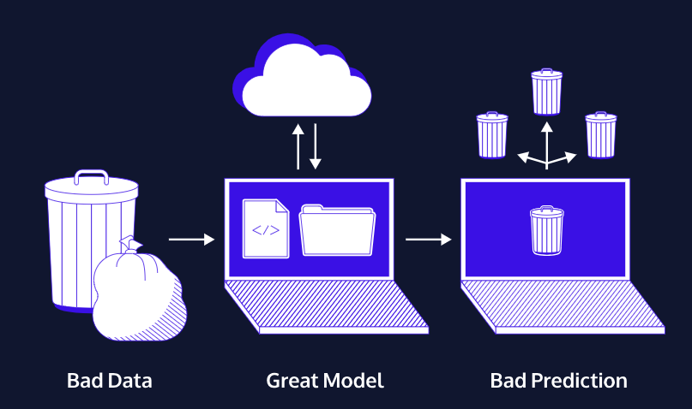

The image above is another example of “garbage in, garbage out.” When a model is trained on bad data, it will make poor predictions, even if the model itself is designed well. A good model cannot fix bad input data.
Part of being data literate means asking whether the data is good enough to support a conclusion. To judge data quality, we should ask questions like:
- Do we have enough data to answer the question?
- Does the data match the exact question we are trying to answer?
- Is the data accurate and trustworthy?
- Is any important information missing?
Good data quality matters because people use data to make decisions. If the data is poor, the decisions based on it may also be poor.
Skill 0.2 Exercise 1

Skill 0.3: I can identify bias in data

Skill 0.3 Concepts

Bias in data happens when some people, groups, perspectives, or outcomes are overrepresented or underrepresented in a dataset. When data is biased, the conclusions we draw from it may be unfair, incomplete, or misleading.

Let’s return to the heart attack example in the previous “garbage in garbage out” example,

Garbage out: Heart disease is the leading cause of death in women.
Garbage in: As of 2021, women made up only 38% of participants in relevant research studies.

This raises an important question: why did the trials include only 38% female participation? If women are underrepresented in medical research, then the data may not fully reflect how heart disease affects women. That makes it harder to understand symptoms, treatments, and outcomes accurately.

There are several reasons bias can appear in data. Sometimes it comes from historical decisions. For example, after the thalidomide tragedy in the 1950s and 1960s, the FDA recommended in 1977 that women who could become pregnant be excluded from early-stage clinical trials. Although this policy was intended to protect women, it also limited what researchers learned about how drugs and conditions affect women’s bodies.

The FDA changed these recommendations in the 1990s, and government-funded clinical trials now must include women and minorities. However, that does not automatically mean all groups are represented fairly or at levels that match the real population.

Bias can also be influenced by culture and media. In movies and television, heart attacks are often shown as something that happens to men, usually with dramatic chest pain. But women can have heart attacks too, and their symptoms are often different. If public understanding is shaped by incomplete or stereotypical examples, that can also affect what people notice, study, and report.

Identifying bias in data means looking carefully at who is represented, who is missing, and how the data was collected. Good data literacy requires us to question whether a dataset gives a fair and complete picture.

Part of practicing good data literacy means asking:

- Who participated in the data?
- Who is left out?
- Who made the data?

Skill 0.3 Exercises 1 and 2

Skill 0.4: I can explain the importance of data visualizations

Skill 0.4 Concepts

Data visualizations are important because they help people understand, analyze, and communicate data more clearly. Charts, graphs, maps, and other visual displays can make patterns, trends, and relationships easier to notice than a list of numbers alone.

Visualizations are also useful because they help people make data-driven arguments. A well-designed visualization can reveal important information, support a claim, and communicate ideas to others in a way that is easier to understand.

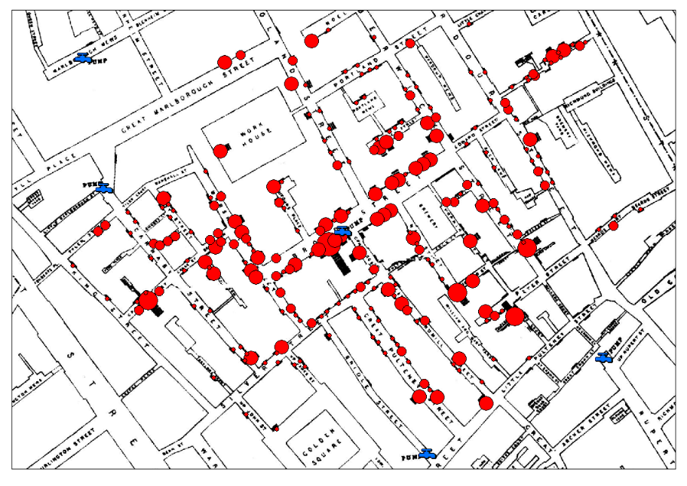
A famous example of the importance of data visualization comes from Dr. John Snow during a cholera outbreak in London in 1854. At the time, many people believed cholera was caused by bad air. Snow instead organized cholera death records by location and placed them on a map. This visualization revealed that many of the deaths were clustered around the Broad Street water pump.

Because Snow visualized the data spatially, he was able to see a pattern that might have been missed in a table or list of records. He also investigated cases that did not seem to fit his theory, which helped strengthen his explanation. For example, one woman who died in another neighborhood had recently visited the Broad Street area and drank water from that pump.

Snow also noticed that nearby groups with a different water source, such as a workhouse and a brewery, had few or no cholera deaths. This gave more support to the idea that the pump was the source of the outbreak.

Snow’s map helped communicate the problem clearly and supported action. After the pump handle was removed, the outbreak ended and did not return as people came back to the area.

This example shows why data visualizations are important: they can help people see patterns, test ideas, communicate evidence, and make informed decisions.

Skill 0.4 Exercise 1

Skill 0.5: I can extract information from data visualizations

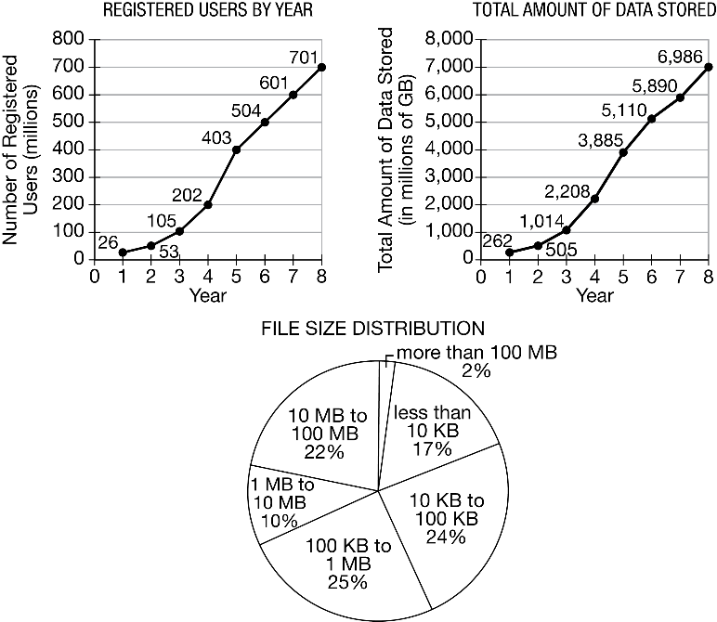
Skill 0.5 Concepts

Data visualizations help us organize information so that patterns and relationships are easier to notice. To extract information from a data visualization, we should look carefully at what is being shown, what variables are being compared, and what patterns we can observe.

When reading a data visualization, it helps to ask:

- What type of visualization is this?
- What does each axis, label, or category represent?
- What values or groups are being compared?
- What patterns, trends, or differences do I notice?
- What conclusion can I support using the visualization?

The graphs above display similar information, but they are arranged differently. When we extract information from a visualization, we should identify the categories, compare the values, and look for patterns. We should also think about how the design of the graph affects what the viewer notices first. A good visualization makes the important information easy to see.

Skill 0.5 Exercises 1 and 2

Skill 0.6: I can differentiate between correlation and causation

Skill 0.6 Concepts

Data visualizations can help us identify facts, patterns, and trends. They help us answer the question, “What does the data show?”

Consider the example below which shows a graph depicting the percentage of teenagers in the workforce since 2000.

Where have all the teenagers gone?
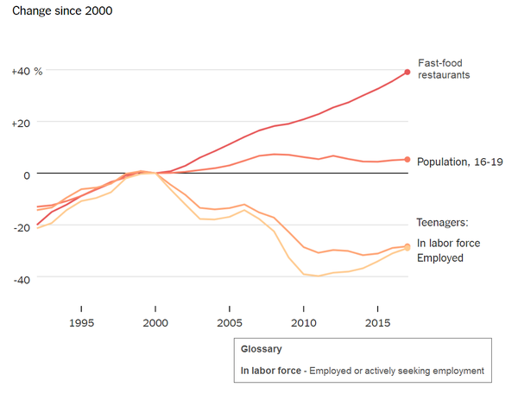

While, we can see from the graph that the percentage of teenagers in the workforce has decreased, identifying a pattern is not the same as proving why that pattern happened. This leads to an important distinction,

- Correlation means that two things appear to be related or occur together.
- Causation means that one thing directly causes another thing to happen.

When we look at a chart or graph, we should first ask:

- What does the data show?
- Why might that be the case?

The first question is about observation. The second question is about interpretation.

Returning to the graph above, the data shows that fewer teenagers are working than in the past. That is an observation based on the chart. A possible explanation is that more teenagers are focusing on school and scholarships. That may be a reasonable idea, but the chart by itself does not prove that this is the cause.

This is why we say correlation does not equal causation. Just because two things happen together does not mean that one caused the other. There may be many possible explanations, and additional evidence is usually needed to understand the true relationship between variables.
When interpreting data, good data readers avoid jumping to conclusions. Instead, they recognize that patterns can suggest ideas, but they do not automatically prove cause and effect.

Skill 0.6 Exercises 1 & 2

Skill 0.7: I can differentiate between data and metadata

Skill 0.7 Concepts

When we work with datasets, it is helpful to know not only the actual data, but also information about that data.
Data is the main information being collected.
For example, a dataset might include students’ test scores, daily temperatures, or the number of hours people spend using a smartphone.

Metadata is data about data. It gives us extra information that helps us understand the dataset better. Metadata can tell us things like:

- where the data came from
- when it was collected
- how much data is included
- how the data is organized

Metadata is different from primary data in several ways:

- it describes the data rather than being the main data itself
- it can often be changed without changing the primary data
- it helps people find, organize, manage, and understand information
- it makes data more useful by providing context

For example, if a spreadsheet lists students’ quiz scores, the data is the actual quiz scores. The metadata might include the date the scores were collected, the name of the class, or the fact that the scores are out of 10 points.
To differentiate between data and metadata, ask:

- Is this the main information being studied?
- Or is this extra information that describes the dataset?

Consider the metadata for the image shown below,


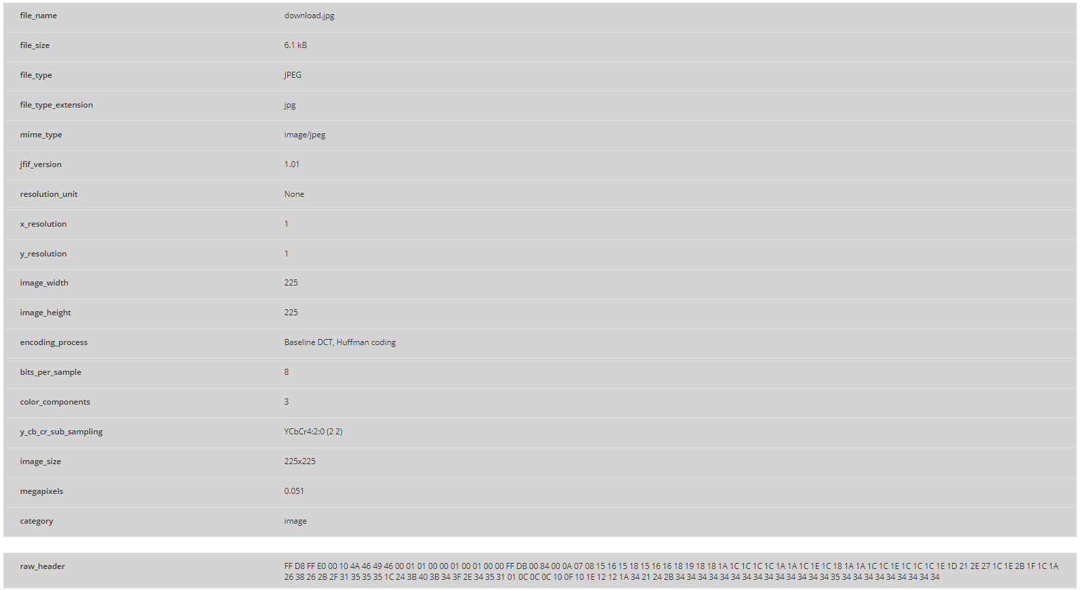

Skill 0.7 Exercises 1 thru 3

