Computing Innovation Exploration Guide

Your Tasks
- Select a computing innovation
- Explain the beneficial and harmful effects of a computing innovation
- Describe the data your innovation uses
- Brainstorm your infographic
- Reference your sources

- Select a computing innovation

A computing innovation is an innovation that includes a computer or program code as an integral part of its functionality. For this project, you will explore a computing innovation of your choice. Your close examination of this computing innovation will deepen your understanding of the big ideas studied in this course.

There have been many computing innovations that have had, are having, and will have, profound impact on our society. Below are a few links to some of the latest innovations,

https://www.technologyreview.com/2021/02/24/1014369/10-breakthrough-technologies-2021/

https://www.itproportal.com/features/top-10-latest-technology-trends-you-must-follow-in-2021/

https://www.valoremreply.com/post/2021_tech_trends/

In addition to the computing innovations showcased in the links above, we have also explored many more through our weekly Ted Talks. Take some time to explore the computing innovations above, then in the space below indicate a computing innovation you would like to explore further.
What is the purpose of your innovation? (~25 words)

- Explain the beneficial and harmful effects of a computing innovation

Computing has global effects – both beneficial and harmful – on people and society.

- Technology enables the collection, use, and exploitation of information about, by, and for individuals, groups, and institutions.
- Widespread access to digitized information raises questions about intellectual property
- The innovation and impact of social media and online access is different in different countries and in different socioeconomic groups.
- Groups and individuals are affected by the “digital divide”. Differing access to computing and the Internet based on socioeconomic or geographic characteristics raises issues of equity, access, and power.
Explain at least one beneficial effect and at least one harmful effect the computing innovation has had, or has the potential to have, on society, economy, or culture. (~250 words)

- Describe the data your innovation uses

The proliferation of computing has created an enormous amount of data. There is data about everything from sensors that track whales in the ocean to data about visitors to web sites. Below is a picture of whale tracking.
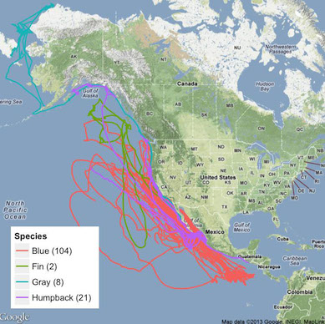

Computers are used in an iterative and interactive way when processing digital information to gain insight and knowledge. Iterative means that computers can go through all data in large data sets to filter and clean it. Combining data sources, clustering data and data classification are part of the process of using computers to process information. Interaction means that people can gain insight and knowledge from translating and transforming digitally represented information. Patterns can emerge when data is transformed using computational tools.

Describe the type(s) of data your innovation uses. (~50 words)
Describe in detail how the computing innovation uses or transforms the data to accomplish it’s purpose. (~150 words)
Describe at least one data storage concern, data privacy concern, or data security concern related to the computing innovation. (~50 words)

- Brainstorm your infographic

An infographic is a collection of imagery, charts, and minimal text that gives an easy-to-understand overview of a topic.

Below are some examples of infographics for different technologies
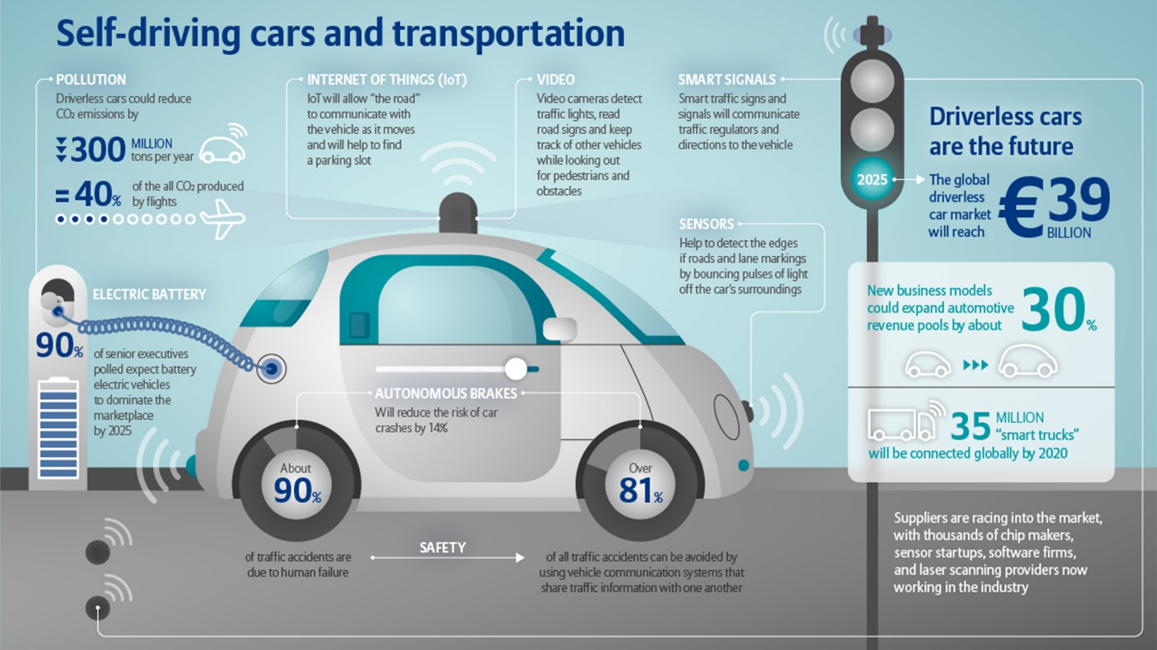
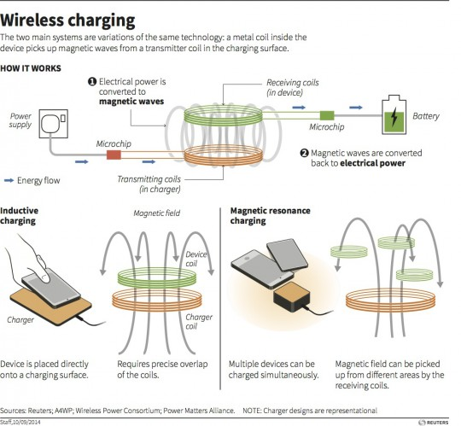
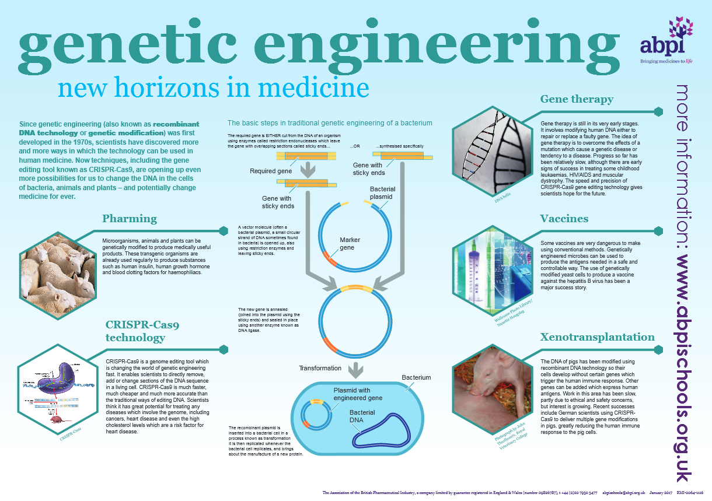

Now that you have explored infographics, you will create an infographic for your computing innovation. The infographic you create must convey the following information,
- The name of your innovation
- The purpose of your innovation
- How your innovation uses data

Feel free to jot down ideas or sketches in the space below:
Brainstorming and notes

- Create your infographic

Your final infographic should use imagery, charts, and minimal text to give an easy-to-understand overview of your topic. Your final infographic should also be created using technology. Below are some useful tools .
Get creative!
https://www.canva.com/
https://piktochart.com/formats/infographics/
https://www.adobe.com/express/
- Reference your sources

Provide a list of at least three online or print sources used to create your infographic and/or support your responses to the prompts provided in project guide.
- At least two of the sources must have been created in 2021
- For each online source, include the permanent URL. Identify the author, title, source, the date you retrieved the source, and, if possible, the date the reference was written or posted.
- For each print source, include the author, title of excerpt/article and magazine or book, page number(s), publisher, and date of publication.
- If you include an interview source, include the name of the person you interviewed, the date on which the interview occurred, and the person's position in the field.
- Include citations for the sources you used, and number each source accordingly.
- Each source must be relevant, credible, and easily accessed.

- Receive Credit for this project guide

Submit this portion of the project to Pluska to receive credit for the project guide

