Introduction to HTML

Your Tasks
- Define key vocabulary
- Write code to create an HTML page
- Explore heading elements
- Explore text formatting elements
- Debug HTML tag errors
- Receive credit for this lab guide

- Define key vocabulary

HTML

HTML Element

HTML Tag

<head> </head> section

<body> </body> section

- Write code to create an HTML page

HTML page structure

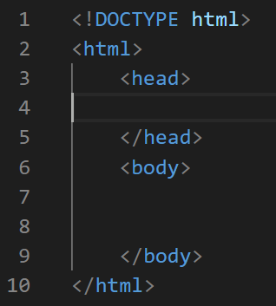
The image to the write shows the basic parts of an HTML page. It is broken down in to two sections: A head and a body. Notice that both of these sections are within another “html” section.

Information in the head section of the page are not displayed to the user. This section typically contains metadata and links to external resources needed to make the page run properly.

What appears in the body section however, is displayed on the users browser. This content is organized in elements.

Elements

An example of a paragraph element is shown below,

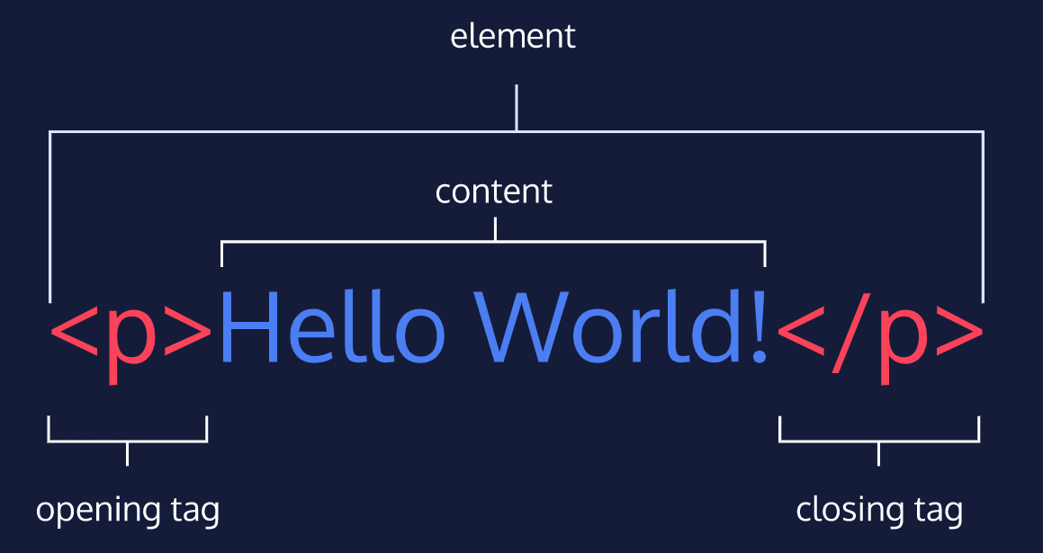
The diagram above displays an HTML paragraph element. As we can see, the paragraph element is made up of:
- An opening tag (<p>)
- The content (“Hello World!” text)
- A closing tag (</p>)
Page title
As aforementioned, the head section contains metadata for the page. Metadata is information about the page that isn’t displayed directly on the web page. Unlike the information inside of the <body> tag, the metadata in the head is information about the page itself.

If you navigate to a website for example, you will notice the tab in which the page is displayed contains specific text related to the page.

For example, if you navigate to http://w3schools.com, the following text is displayed in the tab,



The specific text displayed in the tab for a page is specified in the <title> tag. The <title> tag is always inside of the <head></head> section.

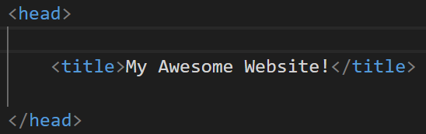
In the space provided, write the basic structure of an HTML page. In the head section, indicate a title for your page. In the body section, include a paragraph element to display your name.

- Explore heading elements

So far, we have seen how to organize content into paragraphs. Another way HTML allows you to organize your code is by using heading elements. A heading is a short piece of text that goes at the top of a section of content, like a title. There a different sizes of headings in HTML. These are designated with the following tags: <h1></h1>, <h2></h2>, <h3></h3>, <h4></h4>, <h5></h5>, <h6></h6>

When the code below is ran, the output to the right is displayed.

Code | Output
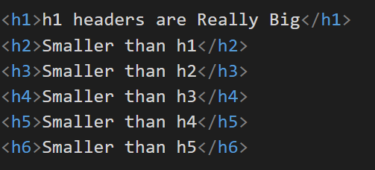 | 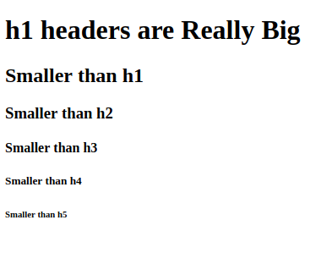

Write code that could be used to create the following output,
Output | Code
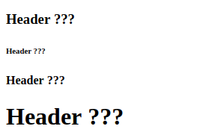

Predict the output of the following code. Do your best to write the font sizes relative to one another.
Code | Output
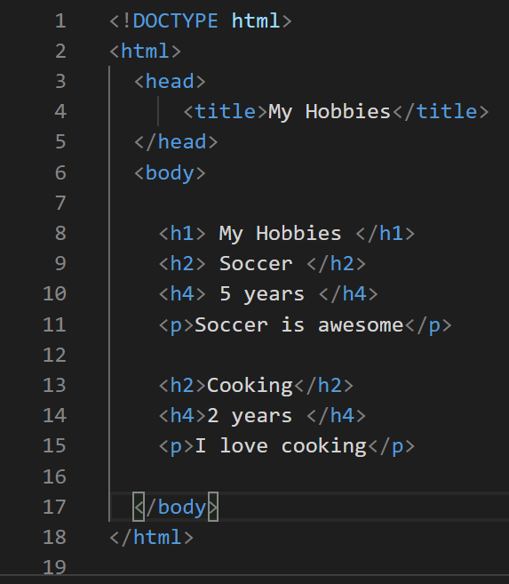

- Explore text formatting elements

Sometimes there is a need to change text by making it appear bold, italicized, subscripted, or superscripted, etc. HTML has many tags which enable us to customize our text. The following illustrates many such tags.

Code | Output
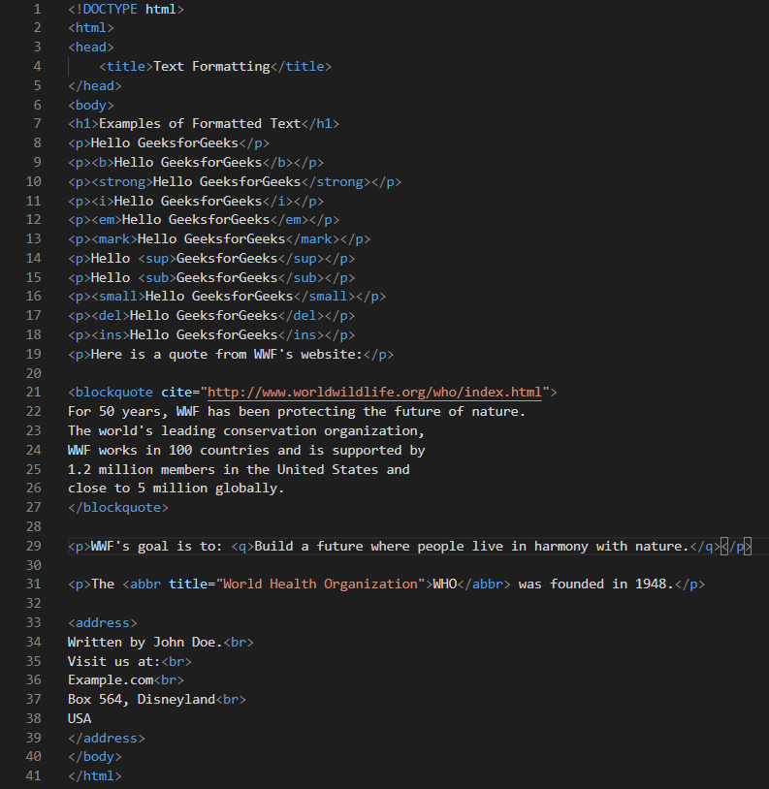 | 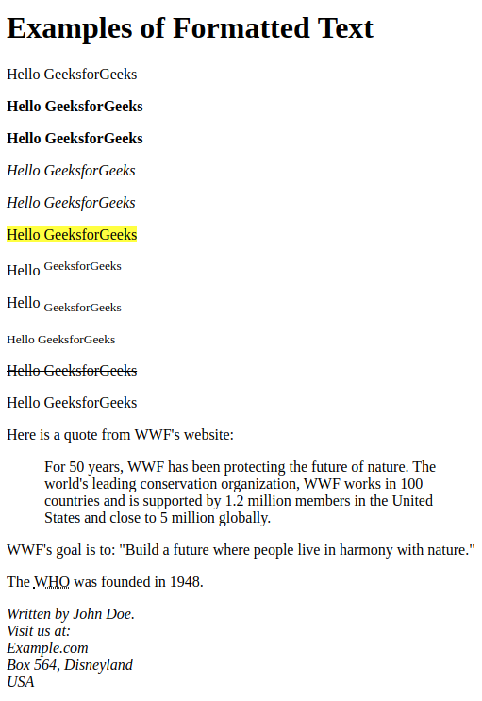

It is impossible to memorize all the possible tags for formatting text. Moreover, new tags are always being incorporated into the HTML library.

Below is a link to an excellent resource that defines the HTML tags,

https://www.w3schools.com/tags/default.asp

Some of the more common tags are below,

Tag | Result |  | Tag | Result
<b> | Bold text |  | <small> | Small text
<strong> | Important/Bold text |  | <delete> | Deleted/Strikethrough text
<i> | Italic text |  | <ins> | Inserted/Underlined
<em> | Emphasized/Italic text |  | <sup> | Subscript text
<mark> | Marked/Highlighted text |  | <sup> | Superscipt text
<br> | Line break (NOTE: This tag does not need a close tag)

The above tags are illustrated below,

Code | Output
<h1>Text Tags</h1>  <p>paragraph</p>  <p><strong>bold</strong></p>  <p><em>italicized</em></p>  <p><mark>highlight</mark></p>  <p>number<sup>superscript</sup></p>  <p>letter<sub>subscript</sub></p>  <p><del>strikethrough</del></p>  <p><ins>underline</ins></p> | 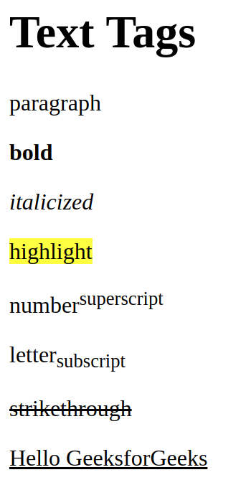

Write code that could be used to create the following output. Use the link https://www.w3schools.com/tags/default.asp as resource as necessary.
Output | Code
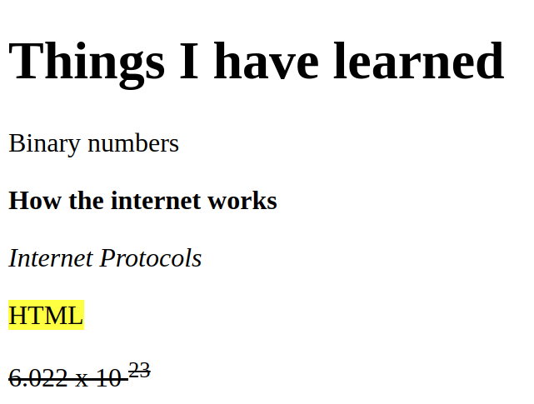

Refer to the tags below to predict the output of the following code.
Code | Output
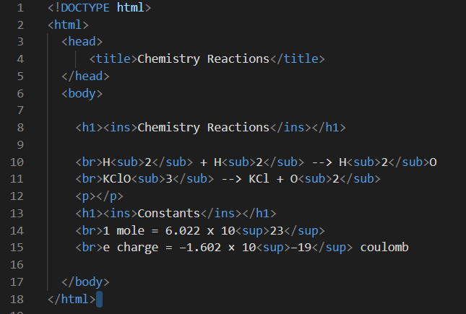

- Debug HTML tag errors

Debugging code is an important skill in computer science. Common errors that occur when you are coding in HTML is forgetting to close a tag. Or simply typing something you did not intend to. Consider the example below,

Code | Output
<h1>h1 headers are Really Big</h1>  <h2>Smaller than h1</h2>  <h3>Smaller than h2  <h4>Smaller than h3<</h4>  <h5>Smaller than h4<h5>>  <h6>Smaller than h5</h6> | 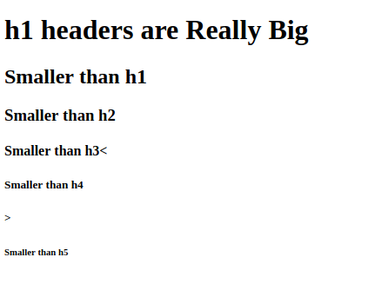

Notice that the h5 header did not display and we extra less than and greater than signs in the text.

Find the errors and circle them. Then, write the code correctly.
Find the errors | Write the corrected code
<h1>h1 headers are Really Big</h1>
<h2>Header 2<</h2>
<h3>Header 3</3>
<p>A paragraph</p>
<p>Another paragraph
<h4>Header 4<</h4>
<h5>Header 5<h5>>
<h1>Header 1</h6>

Find the errors and circle them. Then, write the code correctly.
Find the errors
<!DOCTYPE html>
<html>
<head>

<body>

<h1><ins>Chemistry Reactions</h1>

<p>H<sub>2</sub> + O<sub>2</sup> --> H<sub>2</sub>O
<p>KClO<sub>3</sub> --> KCl + O<sub>2<sub>

<h1><ins>Constants</ins</h1>
<p>1 mole = 6.022 x 10<sup>23<p>
<p>e charge = −1.602 × 10<sup>−19<sup> coulomb</p>

<body>
</head>
</html>
Write the corrected code

- Receive Credit for this lab guide

Submit this portion of the lab to Pluska to receive credit for the lab guide.

