AP COMPUTER SCIENCE PRINCIPLES
Our AP CSP Learning Story
These Learning Intentions guide the course. The Success Criteria follow the course's instructional topics so each routine assignment has one clear evidence target. Previously learned skills provide context without being automatically reassessed.
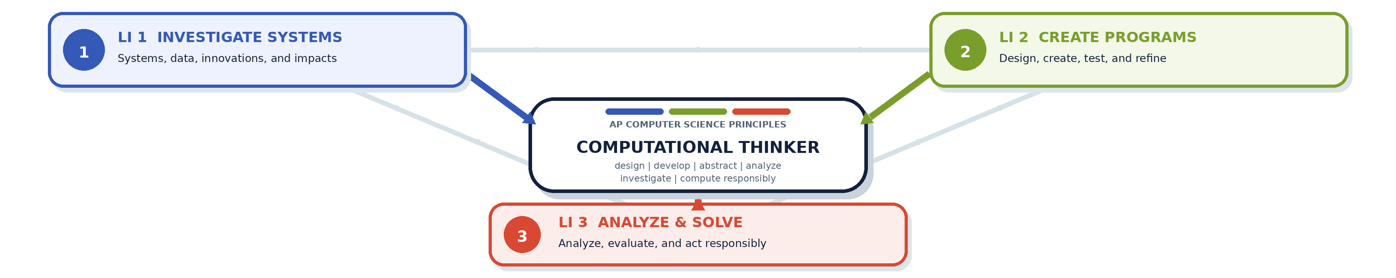
LI 1 INVESTIGATE SYSTEMS  I am learning to investigate computing innovations and apply computational thinking to explain how a system works. | LI 2 CREATE PROGRAMS  I am learning to create a computer program. | LI 3 ANALYZE & SOLVE  I am learning to analyze computational artifacts and develop solutions to computing problems.
COMPUTATIONAL THINKING: THE PRACTICES College Board's six practices describe what computational thinkers do; the Learning Story shows how those practices grow through the three district intentions.
COMPUTATIONAL THINKING PRACTICE | WHAT IT LOOKS LIKE | STRONG CONNECTIONS
P1 COMPUTATIONAL SOLUTION DESIGN | Investigate a task, define its purpose, and design and evaluate possible approaches. | LI 1 LI 2 LI 3
P2 ALGORITHMS & PROGRAM DEVELOPMENT | Represent, develop, implement, and apply algorithms to create a solution. | LI 2 LI 3
P3 ABSTRACTION IN PROGRAM DEVELOPMENT | Use variables, procedures, and data abstractions to manage complexity. | LI 1 LI 2 LI 3
P4 CODE ANALYSIS | Explain, trace, test, evaluate, and correct algorithms and programs. | LI 1 LI 2 LI 3
P5 COMPUTING INNOVATIONS | Investigate how systems, data, and innovations work and affect people. | LI 1 LI 3
P6 RESPONSIBLE COMPUTING | Collaborate and contribute to safe, inclusive, secure, and ethical computing. | LI 1 LI 2 LI 3
HOW TO READ THE TILES Each numbered tile on the next page is one topic-based Success Criterion. Its badges show the Learning Intentions it supports. A routine assignment normally connects to one primary target: the learning it is designed to assess.

OUR AP CSP LEARNING STORY
Success Criteria
Each numbered criterion is a topic-based evidence target. Routine assignments normally connect to one primary criterion.
LI 1 Investigate systems | LI 2 Create programs | LI 3 Analyze & solve

SC 0  I can use development tools and version control to organize, track, and submit my programming work.  LI 2 | SC 1  I can evaluate data, sources, and visualizations for quality, relevance, accuracy, limitations, and bias.  LI 1 LI 3 | SC 2  I can clean, organize, visualize, and interpret one- and two-variable data to identify patterns and support conclusions.  LI 1 LI 3
SC 3  I can explain how big data, open and crowdsourced data, parallel computing, and machine learning generate knowledge and introduce limitations or bias.  LI 1 LI 3 | SC 4  I can explain how bits and bytes represent information and encode, decode, and calculate values using binary numbers.  LI 1 LI 3 | SC 5  I can explain how computers represent integers and real numbers and how finite storage causes overflow, round-off, and precision limitations.  LI 1 LI 3
SC 6  I can explain how text, images, color, and analog information are sampled, encoded, and represented as digital data.  LI 1 LI 3 | SC 7  I can apply and compare lossless and lossy compression techniques and evaluate tradeoffs among file size, quality, and recoverability.  LI 1 LI 3 | SC 8  I can explain how devices and physical media form networks and how bit rate, bandwidth, and latency affect performance.  LI 1 LI 3
SC 9  I can explain how addressing, packets, routers, redundancy, fault tolerance, and protocols work together to move data across the Internet.  LI 1 LI 3 | SC 10  I can evaluate computing innovations for impacts on people and society and make safe, inclusive, secure, and ethical computing choices.  LI 1 LI 2 LI 3 | SC 11  I can investigate a computing problem or task, define its purpose and constraints, and compare possible solution approaches.  LI 1 LI 2 LI 3
SC 12  I can create and explain the foundations of a web program using HTML structure and JavaScript statements, comments, and output.  LI 1 LI 2 LI 3 | SC 13  I can use variables, input, output, data types, arithmetic, and String operations to represent, transform, and communicate program data.  LI 2 LI 3 | SC 14  I can use JavaScript and the Document Object Model to access, create, modify, style, and remove webpage elements.  LI 1 LI 2 LI 3
SC 15  I can create and use functions with parameters and return values to organize code and manage complexity.  LI 1 LI 2 LI 3 | SC 16  I can use event handlers and timers to create responsive, interactive program behavior.  LI 2 LI 3 | SC 17  I can create and evaluate Boolean expressions and use conditional statements to control program decisions.  LI 1 LI 2 LI 3
SC 18  I can use while, for, and nested loops to repeat processes and traverse program data.  LI 1 LI 2 LI 3 | SC 19  I can create, modify, and traverse arrays to organize data and compute results.  LI 1 LI 2 LI 3 | SC 20  I can implement, trace, and compare searching and sorting algorithms and explain their behavior and efficiency.  LI 1 LI 2 LI 3

