Solving Problems

Your Tasks (Mark these off as you go)
☐ Complete the problems
☐ Pair up and reflect
☐ Compare algorithms
☐ Wrap up
☐ Share out
☐ Submit this lab guide

- Complete the prompts

Today we are going to investigate how computer scientists solve problems by defining a task, recognizing patterns and constraints, and comparing possible approaches.

Review the problems below for one minute, and then move around the room and collect the information needed to solve the problems.
 | Prompt | Information
1 | Find a person whose birthday is before yours
2 | Find a person whose birthday is after yours
3 | Find the person whose birthday is the closest before yours
4 | Find the person whose birthday is the closest after yours
5 | Find the person whose birthday is closest to yours
6 | Find the person with an equal number of birthdays before and after theirs
7 | Find the two people with the closest birthdays in the room
8 | Find the shortest period of time in which three people have birthdays
9 | Find the shortest period of time in which four people have birthdays
10 | Find the longest period of time in which no one has a birthday

- Pair up and reflect

Locate the person(s) you found for prompt 5 above – it’s ok if there is more than one. Write their name(s) below. Indicate one fun fact about each person.
Person(s)
Fun fact(s)

Discuss the following prompts with your group. Write your responses below.
Choose one birthday problem from prompts 6–10. Describe the approach you used to solve it. Why did that approach make sense for this problem?
What rules, assumptions, or constraints affected your solution?
How many people are in the room? Based on that number, what is the probability that two people share a birthday? What information or assumptions does your calculation use?
Watch the following video, https://youtu.be/ofTb57aZHZs. How does the video's approach compare with yours? What, if anything, would you revise?

- Compare algorithms
We just thought about whether problems are similar. Now we're going to look at whether we're solving the same problem.
Consider the algorithms below. Use the markers you have been provided to trace the algorithms on your desk.
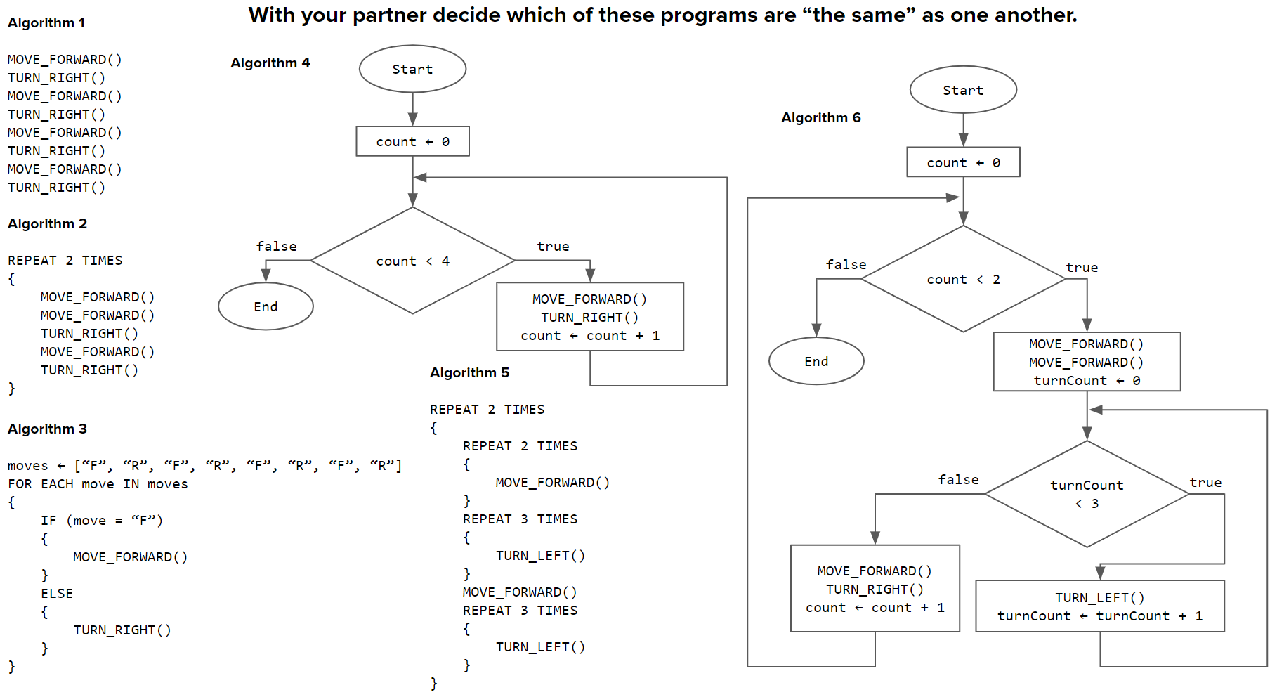

After tracing the algorithms, group those that solve the same problem or produce the same result. How are their approaches similar or different? Which approach is clearest or most efficient? Use evidence from your traces.

- Wrap-up

In the first part of this activity, you investigated a problem by identifying its purpose and constraints. In the second part, you compared possible algorithmic approaches. Define each term below. In your definition of algorithm, explain how more than one algorithm can solve the same problem.
Problem
Algorithm

- Submit this lab guide

Submit this portion of the lab to Google Classroom. Make sure your responses show how you defined a problem's purpose and constraints and compared possible solution approaches.

