Visualizing Data

Your Tasks (Mark these off as you go)
☐ Tell a data story
☐ Obtain a dataset of objects
☐ Identify categorical variables
☐ Tidy the data into a computer readable format
☐ Create visualizations for your data
☐ Analyze your data
☐ Receive credit for this lab guide

- Tell a data story

With a partner, look through the graphs on this site: https://www.nytimes.com/2023/07/26/learning/over-75-new-york-times-graphs-for-students-to-analyze.html

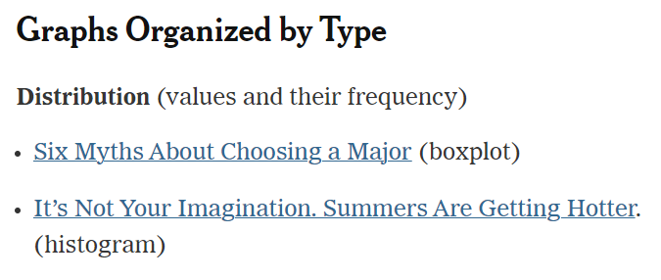
Scroll a bit and you will notice that the graphs are organized by topic and type,

Paste a graph that you and your partner find interesting below.
What do you notice? Share what you are noticing and what this may imply.
What do you wonder? Where could you find the answers to what you wonder?
What’s going on in this graph? Use what you notice. What can you infer from this graph beyond what it shows directly? What’s the deeper story that comes from this graph?

- Obtain a dataset of objects

Locate the datasets of objects you have been provided. Record the data set your group selected.

- Identify categorical variables

Observe the dataset of objects you selected. What do you notice? Do the objects have different colors, shapes, size, design, etc.
What do you wonder? What you wonder about will depend on the dataset of objects you selected. For example, how many are there of each color? How many are there of each shape? Etc. Write what you wonder about as questions below. You must write two questions about your data set.
Question 1:

Question 2:

A categorical variable (also called qualitative variable) is a variable that can take on a fixed number of possible values based on some observed quality. List the categorical variables you identified below.
Categorical variable 1:

Categorical variable 2:

- Prepare the data

It is often said that 80% of data analysis is spent on the process of cleaning and preparing the data. Below is an example of scrunchies organized by color and frequency of wear.
Physical visualization of the dataset | Numerical visualization of the data set
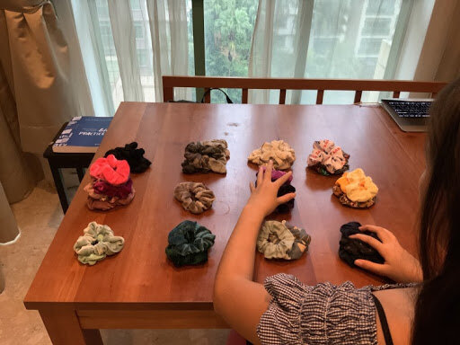 | 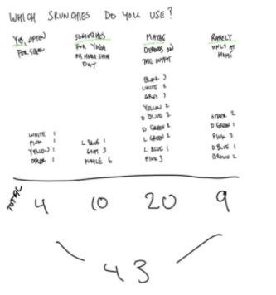
The images above show the physical organization of the data and the total counts of each scrunchy by two categorical variables, Color and Frequency Worn.

Consider the categorical variables you identified above. Organize your objects based on the first categorical variable you identified. Take a picture of your physical visualization and insert this below. Do the same for your second categorical variable.

Refer to your pictures, then create a numerical visualization by counting and recording the number of items in each category. Do this for both of your categorical variables.

- Tidy your data into a computer readable format

Tidy Data has become the standard format for science and business because it allows people to easily turn a data table into graphs, useful for analysis and insight.

There are three interrelated rules that make a dataset tidy,

- Each variable is a column; each column is a variable.
- Each observation is a row; each row is an observation.
- Each value is a cell; each cell is a single value.

Below is an example of initial data collected in spreadsheet, and entered in a typical way that most novices would use (left), and the same data in Tidy Format (right),

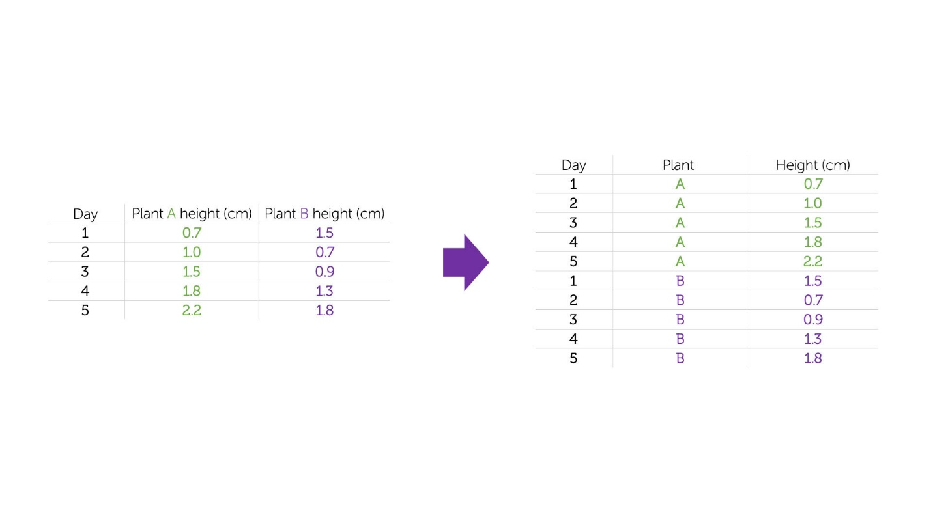
This is clearly the same data, but it now has:

- Three clearly identified variables (days, plant type, and height) each of which has its own column.
- Each row is an independent observation of the variables
- Each cell contains a single value of a single variable

Watch the video below, to learn more,

Tidy Data Tutorial
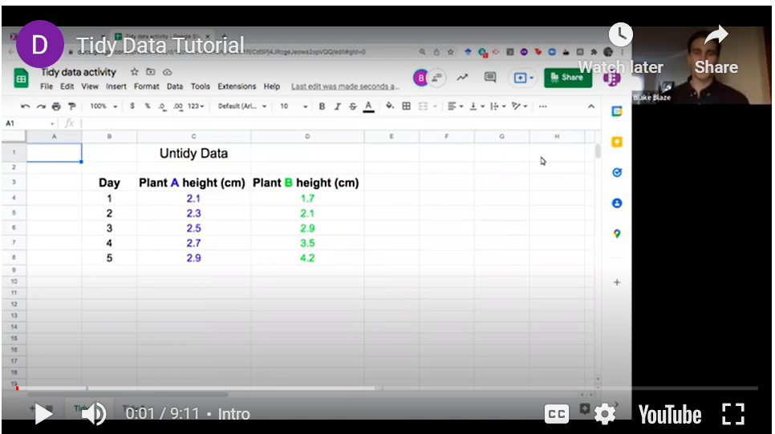
https://youtu.be/fFoK8Rdo4SA?si=GFELBp2hCL8X55zc

Below is an example of how the scrunchy dataset above was organized in a Tidy format using the categorial variables color and frequency worn.

Scrunchy data set in Tidy format
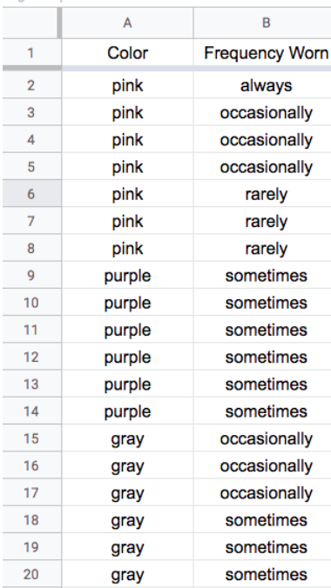

Create a new Google Sheet. Enter your data in a Tidy format as explained in the video and illustrated above. Before creating your graphs, check your dataset for missing values, accidental duplicate entries, inconsistent spelling or capitalization, and categories that mean the same thing. Record one change you made—or explain why no change was needed. Share your sheet and include a link to it below.
Google Sheet link:
Data-cleaning change (or why none was needed):

- Create visualizations for your data

Once you have your data in a Tidy format, it is easy to visualize your data using Google Sheets. Below is an example of how we can visualize the number each color in the scrunchy dataset,

How to visualize the categorical variable, color, in Google sheets
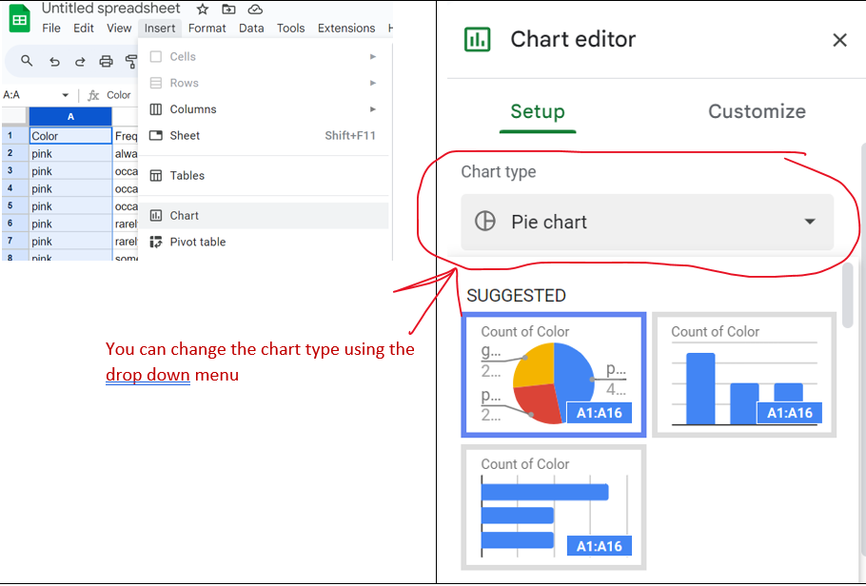

Create two visualizations using the categorical variables you identified above. Choose chart types that make comparisons between categories clear. For each visualization, explain why the chart type is appropriate for the data. Take a screenshot of each visualization and paste it below.

- Analyze your data

Now that you have created your visualizations, revisit your original questions. For each question, state your answer and cite a specific value or pattern from your visualization as evidence.
Question | Answer and Evidence

- Receive Credit for this lab guide

Submit this portion of the lab to Google Classroom to receive credit for the lab guide.

