Skill 0.1 Exercise 1
What is data?
Data is information that is collected and used to learn about something. It can include numbers, words, measurements, observations, or categories.

How can data help you solve problems?
Data can help solve problems by showing patterns, trends, and important facts. It helps people make informed decisions instead of just guessing.

Skill 0.2 Exercise 1
Give another example of “garbage in, garbage out” and explain what could go wrong because of it.
A school uses an AI system to predict which students are at risk of failing a class. The AI is trained on past student data from a large urban district

The AI may treat those patterns as equally meaningful in every school, even though they may not mean the same thing everywhere. For example, in another school, a student might have frequent absences because they live far away and transportation is unreliable, not because they are disengaged or likely to fail. If the AI does not understand that context, it may incorrectly label students as “at risk.” That could cause some students to be unfairly targeted, while other students who truly need help might be missed. This is “garbage in, garbage out” because the AI’s prediction is only as good as the data it was trained on.

Skill 0.3 Exercise 1
Neural Machine Translation (NMT) is trained on example text that exists in the world. Consider the Google Translate that was constructed using NMT.

What is the bias in this translation.
The bias is gender bias.
The Turkish phrases use “o”, which is gender-neutral and can mean he or she. But the translation assigns gendered English pronouns in a stereotypical way:
- cook → she
- engineer → he
- doctor → he
- nurse → she
So the system is reflecting a bias that associates:
- men with jobs like engineer and doctor
women with jobs like cook and nurse
How might Google Engineers modify the translation to remove bias?
They could modify it by making the translation stay gender-neutral when the original text is gender-neutral.
Use more balanced training data so occupations are not mostly paired with one gender.

Skill 0.3 Exercise 2
In 2014, Amazon experimented with using software to screen job applicants. The screening software was trained on a decade of résumés that had been previously rated by employees as part of the hiring process. Below shows the distribution of male and female employees at Amazon in 2014.

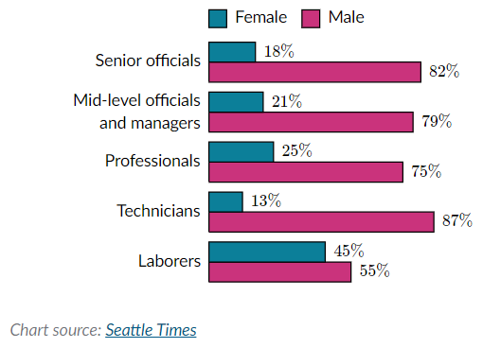
Is it statistically possible that the above results were by chance?
We cannot say for sure from this chart alone whether the results were due to chance, because we do not have enough statistical information. However, the gender imbalance is large enough that it would be unlikely to ignore as random chance, and it suggests the hiring data may have been biased.

How might Amazon better train their software model to avoid “reckless regard” for the rights of female candidates?
Amazon could better train the software by using more balanced training data and by checking the model for gender bias during development.

Skill 0.4 Exercise 1
On January 28, 1986 the Challenger space shuttle carried seven US astronauts who were supposed to deploy a satellite and study Halley’s Comet while they were in orbit. Less than two minutes after takeoff, however, the shuttle exploded, killing all seven crew members. The explosion was caused by a failure of two O-rings: small rubber rings that helped create an airtight seal between the space shuttle and its launch fuel supply. Before the launch, engineers were concerned about how the low-temperature forecast would affect the O-rings’ ability to make a proper seal. The engineers made their arguments in favor of postponing the launch using, in part, a series of data visualizations that showed launch success rates at various temperatures. Tragically, their arguments did not prevent the launch from proceeding.

Below are the visualizations.
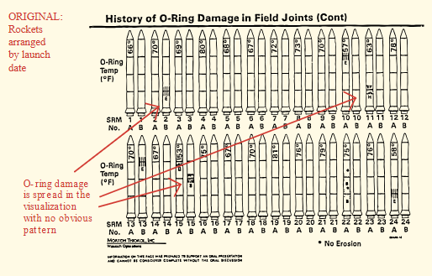

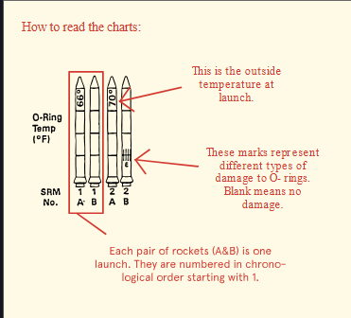 | What is the problem with the visualization?
The main problem is that the visualization made it hard to see the relationship between temperature and O-ring damage.
The rockets were arranged by launch date, not by temperature, so the most important pattern was buried. A viewer had to work too hard to notice that lower temperatures were associated with more O-ring damage

How could the engineers have improved their visualization, and potentially prevented this tragedy?
• arrange data by temperature, not chronology
• use a simpler graph
• make the pattern visually obvious

Skill 0.5 Exercise 1
Participants in a survey were asked how many hours per day they spend reading, how many hours per day they spend using a smartphone, and whether or not they would be interested in a smartphone application that lets users share book reviews.
The data from the survey are represented in the graph below. Each represents a survey participant who said he or she was interested in the application, and each represents a participant who said he or she was not interested.

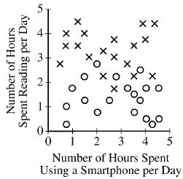

Which correlation is most consistent with the data in the graph?
- Participants who read more were generally more likely to say they are interested in the application.

- Participants who read more were generally less likely to say they are interested in the application.

- Participants who use a smartphone more were generally more likely to say they read more.

- Participants who use a smartphone more were generally less likely to say they read more.

Skill 0.5 Exercise 2
A file storage application allows users to save their files on cloud servers. A group of researchers gathered user data for the first eight years of the application’s existence. Some of the data are summarized in the following graphs. The line graph on the left shows the number of registered users each year. The line graph on the right shows the total amount of data stored by all users each year. The circle graph shows the distribution of file sizes currently stored by all users.

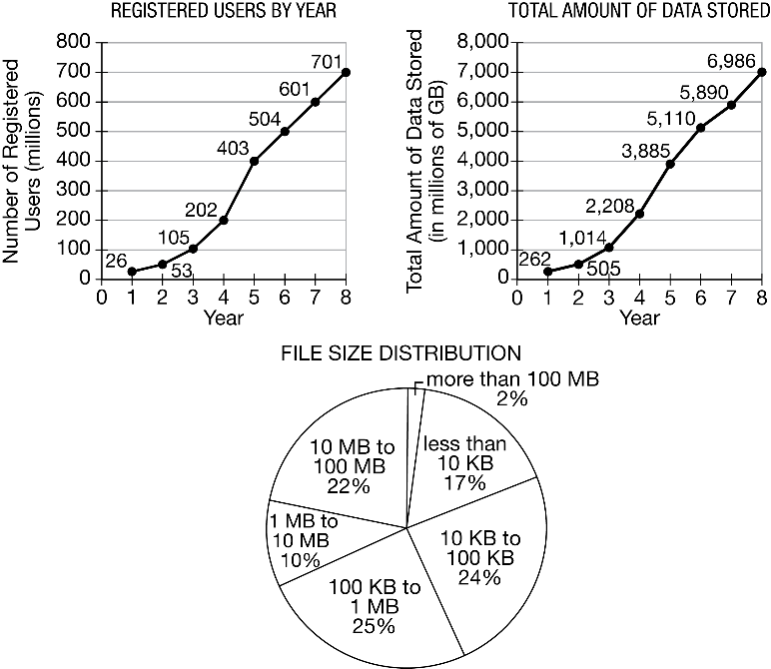

Which of the following correlations is most consistent with the information?

- As the number of users increase, the size of the files stored increases (There is no information about filesize)

- Over 75% of the files stored are 10 MB in size or less.

- As the number of users increase, the amount of data stored per user increases (This is about 10% for all data points)

- 75% of the files stored are at least 100 KB in size.

Skill 0.6 Exercise 1
Refer to the graph below
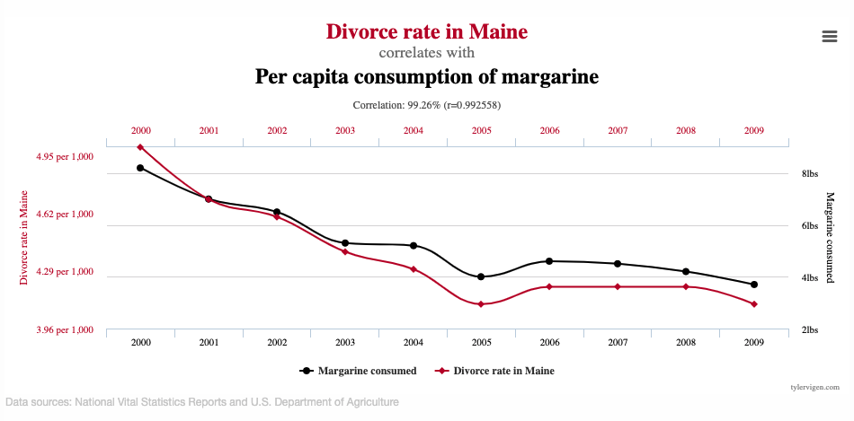
What two variables are being compared in this graph?
Divorce rate and margarine consumption

Does the graph show correlation, causation, or both?
Correlation only

Why does this graph not prove that margarine consumption causes divorce in Maine?
This graph does not prove that margarine consumption causes divorce in Maine because it only shows a correlation between the two variables, not a cause-and-effect relationship. The similar pattern could be caused by coincidence or by other factors, so the graph is not enough evidence to prove causation.

Skill 0.6 Exercise 2
Biologists often attach tracking collars to wild animals. For each animal, the following geolocation data is collected at frequent intervals.
- The time
- The date
- The location of the animal
Identify whether each statement is correlation or causation.
Statement | Correlation/Causation
Wolves travel up to 30 miles per day | Correlation
Wolves and deer travel together | Correlation
Wolves can run up to 40 miles per hour | Causation – we don’t know the frequency at which the data is collected – for how long are they running this fast?
Wolves typically travel at dawn and dusk | Correlation
Wolves typically travel during cooler weather | Causation – temperature data is not collected

Skill 0.7 Exercise 1
A camera mounted on the dashboard of a car captures an image of the view from the driver’s seat every second. Each image is stored as data. Along with each image, the camera also captures and stores the car’s speed, the date and time, and the car’s GPS location as metadata. Which of the following can best be determined using only the data and none of the metadata?
- The average number of hours per day that the car is in use

- The car’s average speed on a particular day

- The distance the car traveled on a particular day

- The number of bicycles the car passed on a particular day

Skill 0.3 Exercise 2
A certain social media Web site allows users to post messages and to comment on other messages that have been posted. When a user posts a message, the message itself is considered data. In addition to the data, the site stores the following metadata.

- The time the message was posted (metadata)
- The name of the user who posted the message (metadata)
- The names of any users who comment on the message and the times the comments were made (metadata)

For which of the following goals would it be more useful to analyze the data instead of the metadata?

- To determine the users who post messages most frequently

- To determine the time of day that the site is most active

- To determine the topics that many users are posting about

- To determine which posts from a particular user have received the greatest number of comments

Skill 0.3 Exercise 3
A digital photo file contains data representing the level of red, green, and blue for each pixel in the photo. The file also contains metadata that describes the date and geographic location where the photo was taken. For which of the following goals would analyzing the metadata be more appropriate than analyzing the data?
- Determining the likelihood that the photo is a picture of the sky

- Determining the likelihood that the photo was taken at a particular public event

- Determining the number of people that appear in the photo

- Determining the usability of the photo for projection onto a particular color background

