Binary Numbers

Your Tasks (Mark these off as you go)
☐ Brainstorm: How many three place patterns can you make with a circle and square
☐ Watch the Circle-Triangle-Square to Binary video
☐ Get acquainted with the virtual Flippy-Do
☐ Use your Flippy-Do to determine all the possible combinations of a binary number for a given number of bits
☐ Determine the base 10 value of all the 8-bit binary numbers with exactly one 1
☐ Practice with conversions
☐ Complete the reflection questions
☐ Receive credit for this lab guide

- Brainstorm: How many three place patterns can you make with a circle and square

In the previous lesson you created 27 different 3-place patterns out of circles, triangles and squares, and tried to define a system of rules to generate all of the patterns.

What if you only had a circle and square? With only a circle and square, how many 3-place patterns are there? A few are started below. How many are there total?
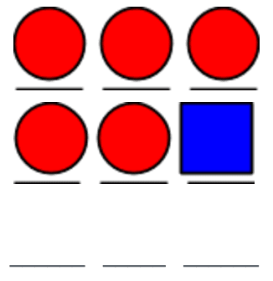

- Watch the Circle-Triangle-Square to Binary Video
To help with the transition from circle-triangle-square to binary check out the following video,
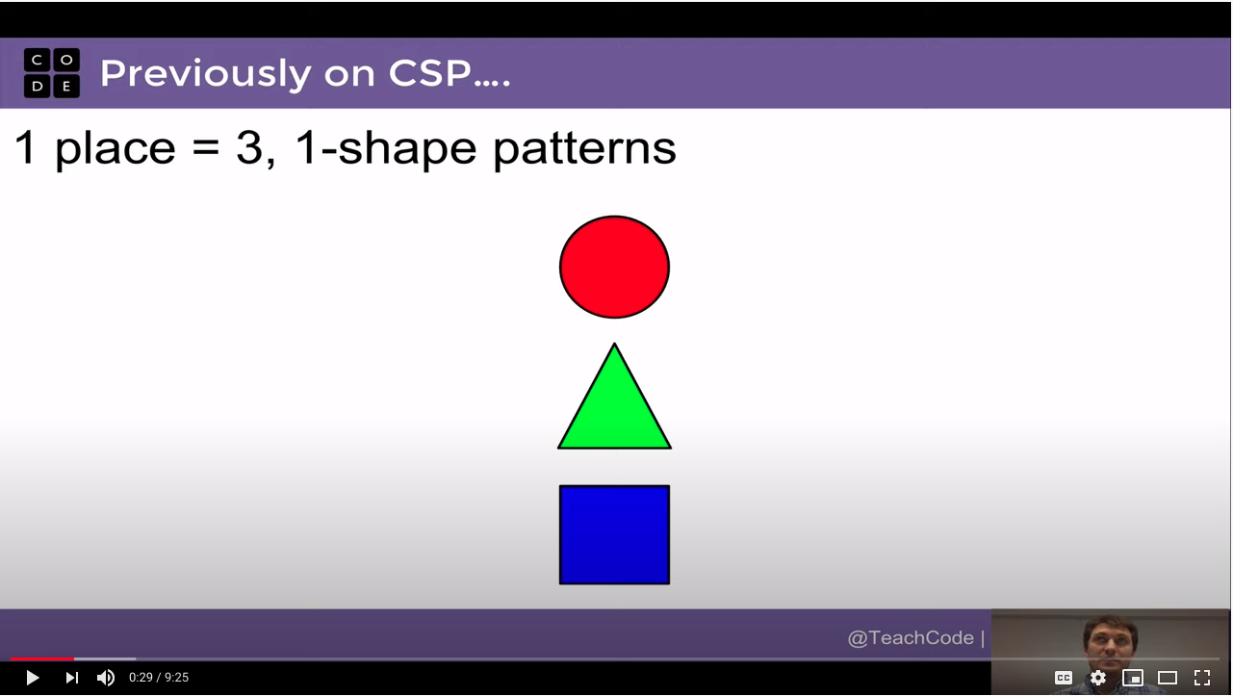
https://www.youtube.com/watch?v=91HLBUjCHbs

- Get acquainted with the virtual Flippy-Do
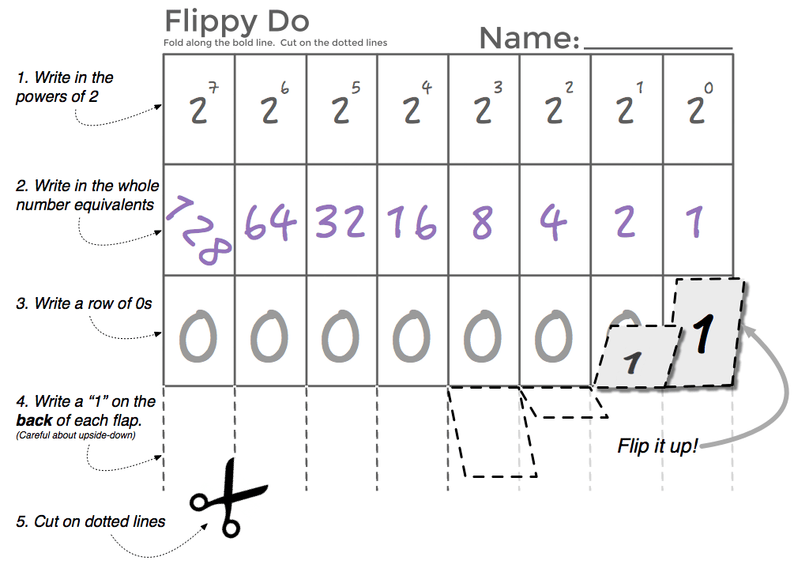
A Flippy-Do is a useful tool for figuring out the decimal equivalent of a base 2 number. An example of a paper Flippy-Do is illustrated to the right.
In this lab we will be using a virtual Flippy-Do! This virtual Flippy Do will allow you to convert any number from base 2 thru 10 to its decimal equivalent. How to use the virtual Flippy Do is illustrated below,

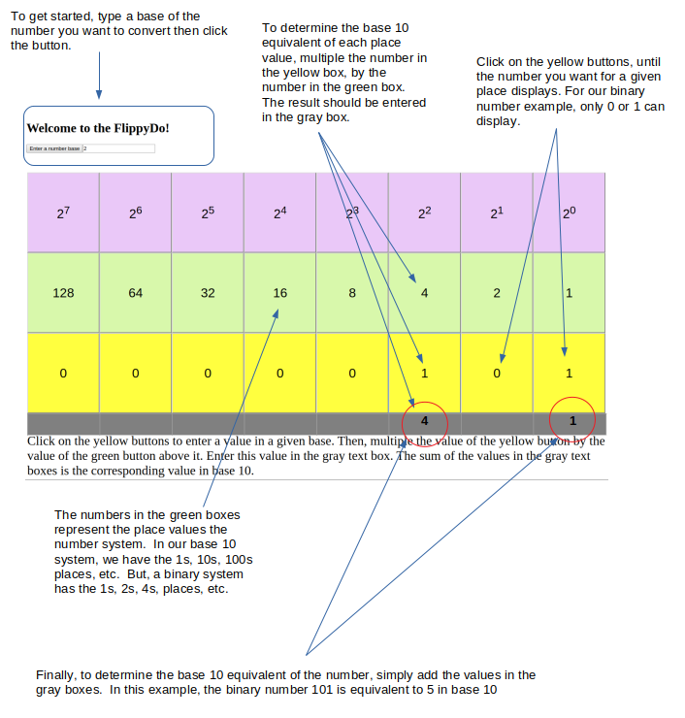
To play with the virtual Flippy-Do follow the link below,
https://timberlinecs.github.io/FlippyDo

- Use your Flippy-Do to determine all the possible combinations of a binary number for a given number of bits

Navigate to the Flippy Do, type the number 2 for base-2 and click the button. You can enter binary numbers by clicking on the yellow buttons. If each yellow button represents a bit, or a binary number. How many possible combinations are there for each number of bits. Refer to the Flippy-Do to figure this out.

2 bits | 3 bits | 4 bits | 5 bits

Write down all the possible combinations of 1s and 0s for a 3 bit system. For each combination, indicate the base-10 equivalent

Combination of 1s and 0s | Base 10 equivalent

- Determine the base 10 value of all the 8-bit binary numbers with exactly one 1

The table below contains every 8-bit number that has exactly one 1 in it. Write down the decimal equivalent next to each one. Do you notice a pattern?

Binary: 8-bit number  (with exactly one 1) | Decimal |  | Binary: 8-bit number  (with exactly one 1) | Decimal
0000 0001 | 1 |  | 0001 0000
0000 0010 | 2 |  | 0010 0000
0000 0100 |  |  | 0100 0000
0000 1000 |  |  | 1000 0000

- Practice with conversions

Using your own binary skills (aided by the flippy do) fill in the decimal and binary equivalents below.
What’s the Decimal Number? |  |  | What’s the Binary Number?
Binary | Decimal |  | Binary | Decimal
100 |  |  |  | 5
101 |  |  |  | 17
1101 |  |  |  | 63
0001 1111 |  |  |  | 64
0010 0000 |  |  |  | 127
1010 1010 |  |  |  | 256*
1111 1111 |  |  |  | 513*
NOTE: a short binary number like 101 is assumed to have leading 0s for all the other bits, like: 00000101. Typically large binary numbers are grouped in 4-bit chunks to improve readability, for example: 0110 0101 1010 |  |  | *NOTE: 256 and 513 exceed the capacity of the flippy-do but you can work it logically following what you know about patterns with binary numbers.

- Complete the reflection questions

There is a simple pattern for determining if a binary number is odd. What is it and why does this pattern occur?

How many bits would you need if you wanted to have the ability to count up to 1000?

How high could you count in binary if you used all 10 of your fingers as bits? (finger up means 1, finger down means 0)

- Receive Credit for this lab guide

Submit this portion of the lab to Pluska to receive credit for the lab guide.

