Storing Numbers

Your Tasks (Mark these off as you go)
☐ Define key vocabulary
☐ Explore place value limitations
☐ Explore the odometer widget
☐ Explore the virtual Flippy-Do 2
☐ Complete the Flippy-Do 2 challenges
☐ Complete the pie challenge
☐ Complete the candy shop challenge
☐ Receive credit for this lab guide

- Define key vocabulary
Overflow error

Rounding error

- Explore place value limitations
Imagine you work at a local store. In the register all you have are nine $10 bills, nine $1 bills, and nine dimes, as shown below.

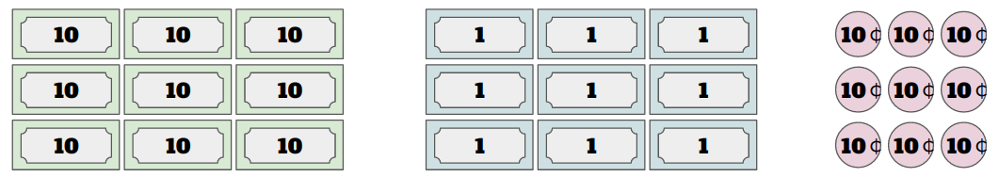

Given the amounts above, discuss with your group the following prompts,

- What’s the largest amount of change that you can give someone?
- What’s the smallest amount?
- What would you do if someone needed .07 cents in change?
- What would you do if someone needed $1.25 in change?

- Explore the odometer widget

We will start exploring large place values to see what happens when a big number gets too big.

Go to the Binary Odometer Widget https://studio.code.org/s/odometer/stage/1/puzzle/1

This is a widget that simulates a car odometer - a device that tracks how far the car has driven (in miles or kilometers). Explore the odometer to understand how it works.
Move the slider at the bottom to set the binary odometer to the highest number possible – as illustrated below. Then let it run!

- What happens to the odometer reading? Does the odometer still show the distance driven by the car?
- How could you modify the odometer so that it still displayed the correct distance?
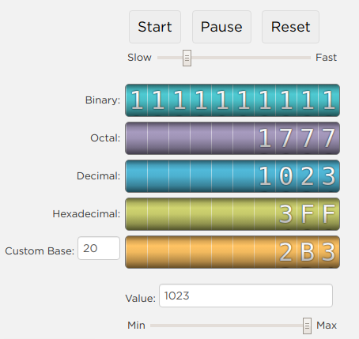

What does the binary odometer show about representing large numbers in computers?

- Explore the virtual Flippy-Do 2

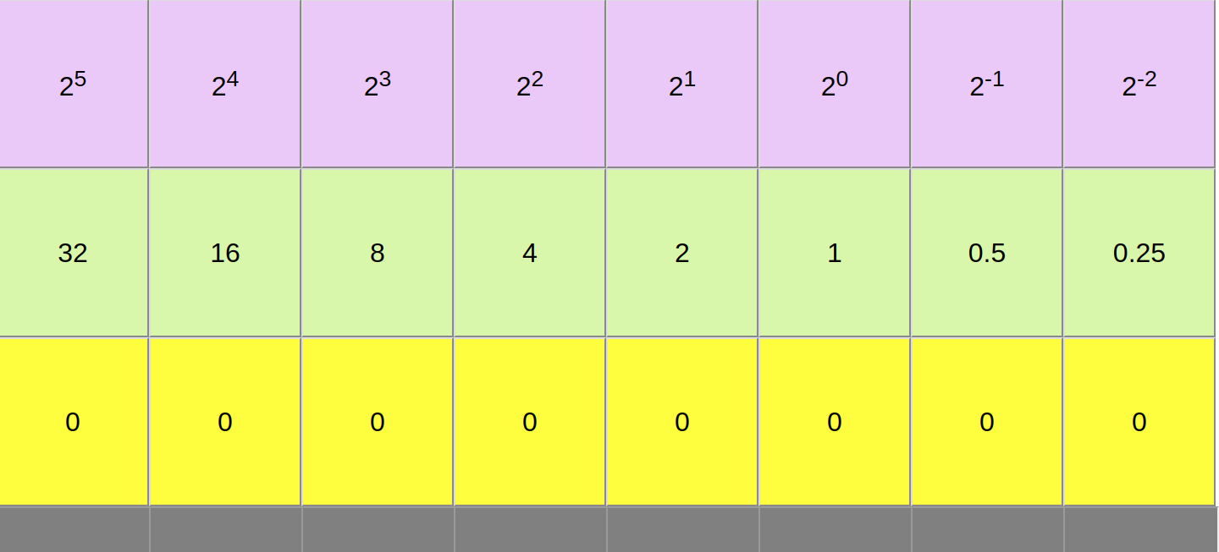
Now that you have started thinking about place value and overflow, we are going to work on a different problem. What happens when there aren’t enough place values to represent a number? You will explore this with a new version of the Flippy Do, the Flippy Do 2! This is illustrated below,

Notice in this version of the Flippy Do we have included negative exponents. This allows us to represent fractions and represent numbers with more precision.

To play with the virtual Flippy-Do 2 follow the link below,
https://timberlinecs.github.io/FlippyDo2/
If 2⁻¹ is .5 and 2⁻² is 0.25, what are the values of 2⁻³, 2⁻⁴, 2⁻⁵?

- Complete the Flippy-Do 2 challenges

Use the Flippy-Do 2 to complete the following challenges

Challenge 1
Make binary equivalents to represent the following amounts
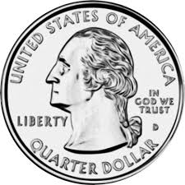

Challenge 2
Is it possible to represent the following amounts using the Flippy-Do 2. How could you modify the Flippy-Do 2 to represent the amount shown?
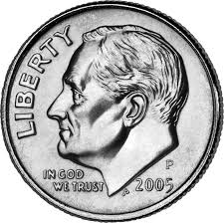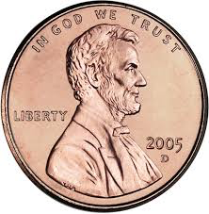

- Complete the pie challenge

Now you will determine how much pie is left at the end of dessert in binary. For each pie, you may need to make a decision about how you want to round the number to fit on the Flippy-Do 2.

For each of the pie’s shown estimate how much pie is left in decimal, then determine the value in binary. You may need to round up or down! The first 2 pies are done for you. Use these as an example to complete the rest.

 | Column 1 | Column 2 | Column 3
Pie | Decimal Estimate of the pie remaining | Nearest binary value | Decimal equivalent
Pumpkin  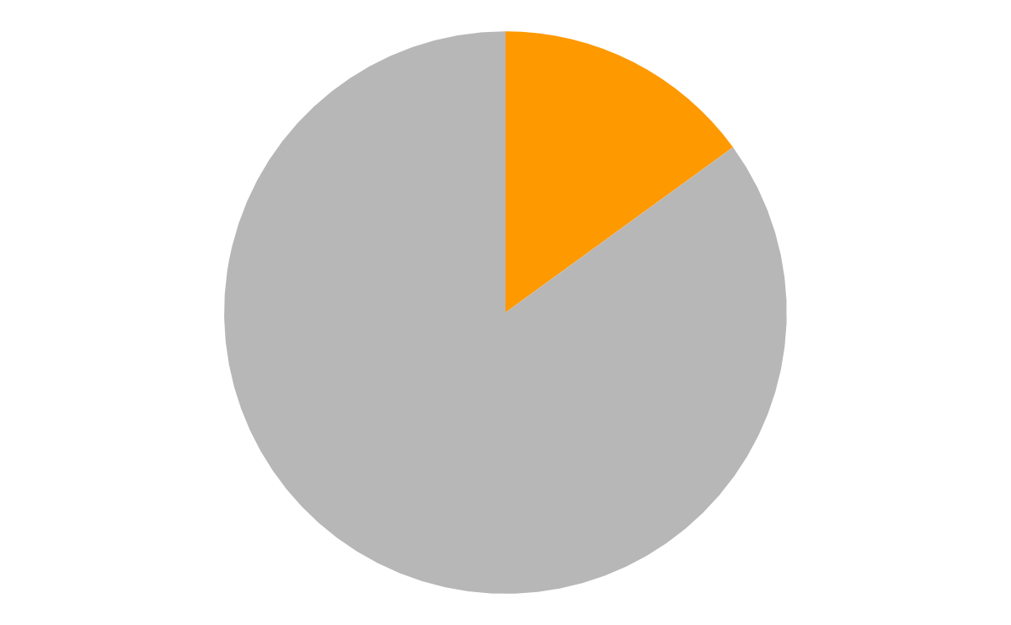 | 0.125 | 0.001 | 0.125
Cherry  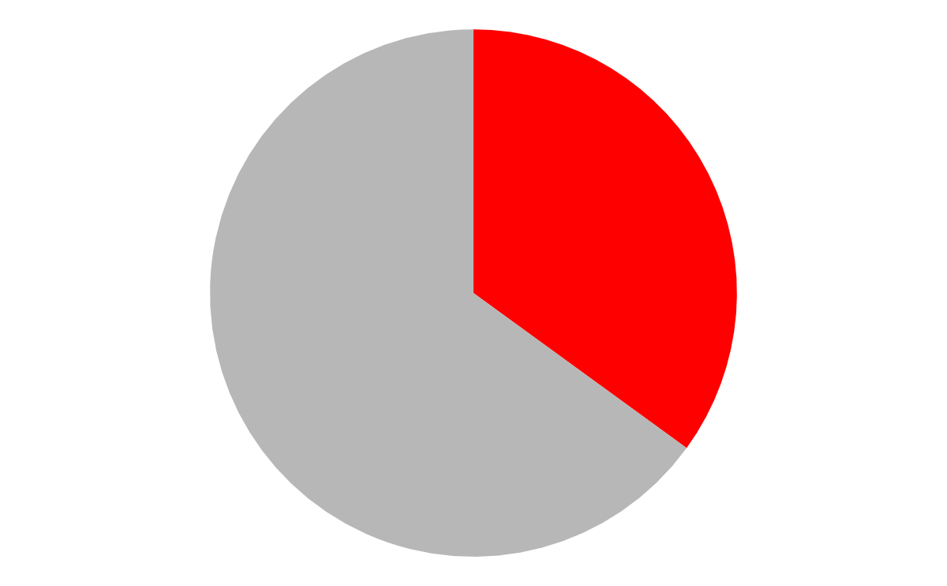 | 0.375 | 0.011 | 0.375
Lemon
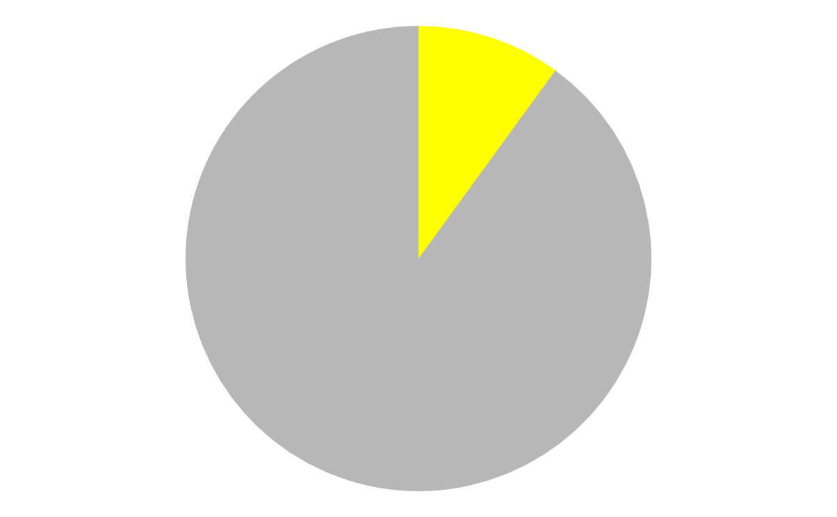

Lime
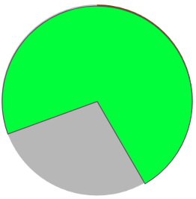

Add all the values in column 1
How do these values compare? If they are different, how could you modify the flippy do make them the same, or closer?

Add all the values in column 3

- Complete the candy shop challenge

You and your partner are opening a candy shop. Here are the prices of 4 of the candies you will be selling. You need to put a binary number into your shop’s computer system to represent the price for each candy. Try to find a binary number to represent each decimal price – do this without the Flippy-Do 2

Candy | Decimal Price | Binary Price | Decimal equivalent
Gummy Bears | $1.44/lb
Chocolate | $4.31/lb
Licorice | $7.09/lb
Mints | $0.51/lb

For each of the values above, how does the precision of the binary representation compare with the decimal representation? Explain.

What does the Flippy-Do 2 show about representing very small numbers in computers?

- Receive Credit for this lab guide

Submit this portion of the lab to Google Classroom to receive credit for the lab guide.

