Skill 4.1 Exercise 1
Consider the settings screen for a user at a website
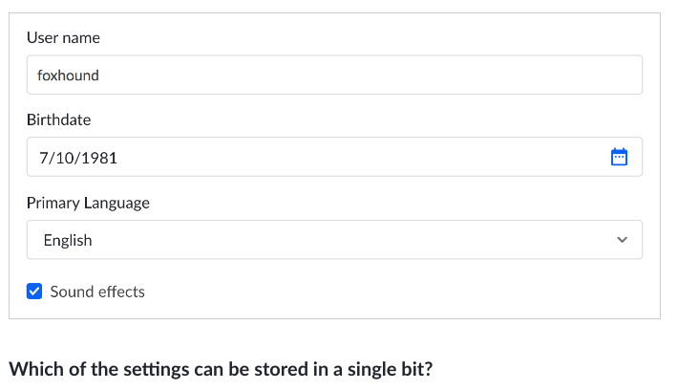

Which of the settings can be stored in a single bit?

Skill 4.2 Exercise 1
The table below illustrates the number of values that can be stored for a given number of bits. Complete the table,
Bits | Values
1 | 2
2 | 4
3 | 8
4
5
6
7
8

Propose a formula that could be used to determine the number of values that can be stored in a given number of bits.

Skill 4.3 Exercise 1
If a single wire can represent 2 different values depending on whether it is on or off. How many wires are needed to represent (a) 4 values? (b) 5 values? (c) 10 values? (d) 28 values? (e) 128 values?

Skill 4.4 Exercise 1
How many bytes long is the binary sequence below?

1011100111011011011010010011010101111111
How many bits are in 8 bytes of information?

Skill 4.5 Exercise 1
Consider the following bytes of data stored in .
(a) How many different values can be stored in each address?
(b) How many different values can be stored in all the addresses combined?
