AP COMPUTER SCIENCE PRINCIPLES
Our AP CSP Learning Story
These Learning Intentions guide the course. The Success Criteria follow the course's instructional topics so each routine assignment has one clear evidence target. Previously learned skills provide context without being automatically reassessed.
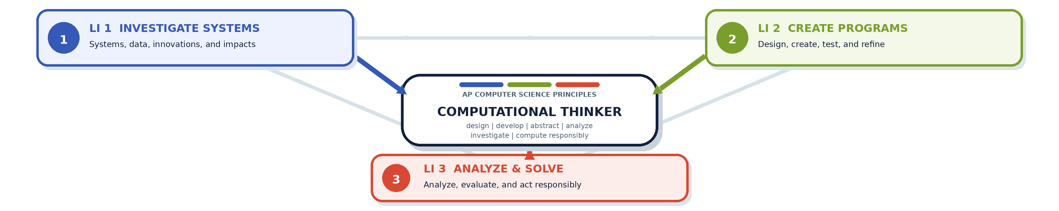
LI 1 INVESTIGATE SYSTEMS  I am learning to investigate computing innovations and apply computational thinking to explain how a system works. | LI 2 CREATE PROGRAMS  I am learning to create a computer program. | LI 3 ANALYZE & SOLVE  I am learning to analyze computational artifacts and develop solutions to computing problems.
COMPUTATIONAL THINKING: THE PRACTICES College Board's six practices describe what computational thinkers do; the Learning Story shows how those practices grow through the three district intentions.
COMPUTATIONAL THINKING PRACTICE | WHAT IT LOOKS LIKE | STRONG CONNECTIONS
P1 COMPUTATIONAL SOLUTION DESIGN | Investigate a task, define its purpose, and design and evaluate possible approaches. | LI 1 LI 2 LI 3
P2 ALGORITHMS & PROGRAM DEVELOPMENT | Represent, develop, implement, and apply algorithms to create a solution. | LI 2 LI 3
P3 ABSTRACTION IN PROGRAM DEVELOPMENT | Use variables, procedures, and data abstractions to manage complexity. | LI 1 LI 2 LI 3
P4 CODE ANALYSIS | Explain, trace, test, evaluate, and correct algorithms and programs. | LI 1 LI 2 LI 3
P5 COMPUTING INNOVATIONS | Investigate how systems, data, and innovations work and affect people. | LI 1 LI 3
P6 RESPONSIBLE COMPUTING | Collaborate and contribute to safe, inclusive, secure, and ethical computing. | LI 1 LI 2 LI 3
HOW TO READ THE TILES Each numbered tile on the next page is one topic-based Success Criterion. Its badges show the Learning Intentions it supports. A routine assignment normally connects to one primary target: the learning it is designed to assess.

OUR AP CSP LEARNING STORY
Success Criteria
Each numbered criterion is a topic-based evidence target. Routine assignments normally connect to one primary criterion.
LI 1 Investigate systems | LI 2 Create programs | LI 3 Analyze & solve

SC 0  I can use development tools and version control to organize, track, and submit my programming work.  LI 2 | SC 1  I can evaluate data quality and interpret visualizations to determine what conclusions the data supports.  LI 1 LI 3 | SC 2  I can clean, visualize, and interpret data to identify patterns, trends, and relationships.  LI 1 LI 3
SC 3  I can explain how large, open, and crowdsourced datasets are created and used to generate knowledge, including their limitations and potential bias.  LI 1 LI 3 | SC 4  I can use place value to encode and decode binary numbers and determine how many values can be represented with a given number of bits.  LI 1 LI 3 | SC 5  I can model how computers store numbers with a finite number of bits and explain overflow, rounding, and precision limitations.  LI 1 LI 3
SC 6  I can encode and decode text and images as digital data and explain how pixels, dimensions, RGB, and hexadecimal values represent information.  LI 1 LI 3 | SC 7  I can apply and compare lossless and lossy compression and explain tradeoffs in file size, quality, and recoverability.  LI 1 LI 3 | SC 8  I can explain how network devices and physical media connect computers and how bit rate, bandwidth, and latency affect performance.  LI 1 LI 3
SC 9  I can design and explain an addressing protocol that uses sender and destination information to deliver messages correctly.  LI 1 LI 3 | SC 10  I can evaluate computing innovations for impacts on people and society and make safe, inclusive, secure, and ethical computing choices  LI 1 LI 2 LI 3 | SC 11  I can investigate a computing problem or task, define its purpose, and compare solutions  LI 1 LI 2 LI 3
SC 12  I can create and explain a basic web program using HTML structure and JavaScript statements, comments, and output.  LI 1 LI 2 LI 3 | SC 13  I can use variables, data types, input, output, concatenation, and type conversion to represent and communicate program data.  LI 2 LI 3 | SC 14  I can use JavaScript and the Document Object Model to access, create, modify, style, and remove webpage elements.  LI 1 LI 2 LI 3
SC 15  I can create and call reusable functions with parameters and return values to perform configurable tasks.  LI 1 LI 2 LI 3 | SC 16  I can use event listeners, event objects, and timers to make programs respond to user actions and time.  LI 2 LI 3 | SC 17  I can use Boolean comparisons and conditional statements to make program decisions.  LI 1 LI 2 LI 3
SC 18  I can write and trace loops, including while and nested loops, to repeat processes and generate results.  LI 1 LI 2 LI 3 | SC 19  I can add, access, modify, and traverse items in arrays to organize data and compute results.  LI 1 LI 2 LI 3 | SC 20  I can design, implement, trace, and compare linear search, binary search, and sorting algorithms, including their efficiency.  LI 1 LI 2 LI 3

