Visualizing One-Column Data

Your Tasks (Mark these off as you go)
☐ Visualize One-Column Data in Google Sheets
☐ Apply the Data Analysis Process to One-Column Data
☐ Receive credit for this lab guide

- Visualize One-Column Data in Google Sheets

In this section we will learn how to visualize data using Google Sheets. Click on the link below to check out the data we will be visualizing. You will need to make a copy of the sheet to complete the tutorial.

https://docs.google.com/spreadsheets/d/1KJjn5v-iF1asspwnMkcwMrb8TU32x5XlB7TzYtu1hpU/edit?usp=sharing

The data set represents the number of female state legislators from all 50 states for 1981 – 2019.

Follow the tutorial below to learn how to use Google Sheets to visualize this data set.

Click on Open with and select Google Sheets | 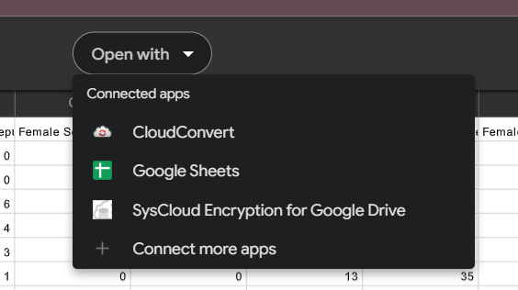
Filter the Female State Legislators dataset for Year by the year you were born.
Select the filter icon in the top menu to create a filter | 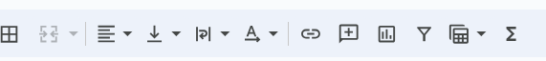
Locate the Year column and click on the filter icon that appears.  Select the Filter by condition option from the main menu  Select the Text contains option from the submenu | 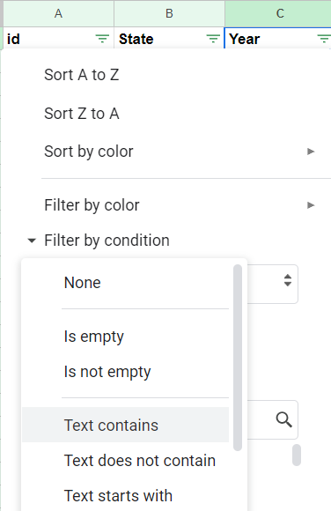
In the Text contains dialog box that appears, type 2005  Then, scroll to the bottom of the window and click OK | 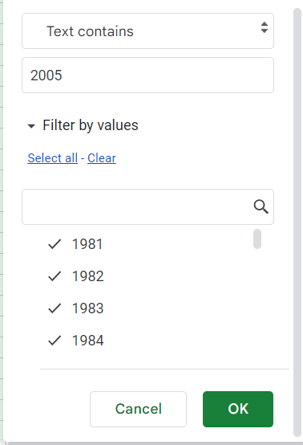
Create a histogram
Locate the last column (column S) and click on the S. This column represents the percentage of females in the legislature for each state.  You can expand this column by grabbing the right edge and dragging. | 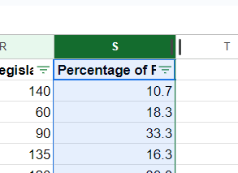
Click on the insert chart icon from the top menu | 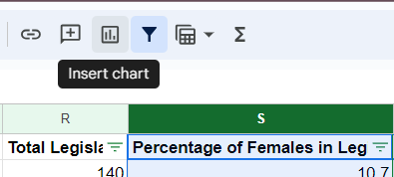
Google will create a suggested chart by default. The recommneded chart is a histogram with a bucket size of 5.  The y-axis of the graph represents the number of states. The x-axis represents the percentage of Females in the legislature. | 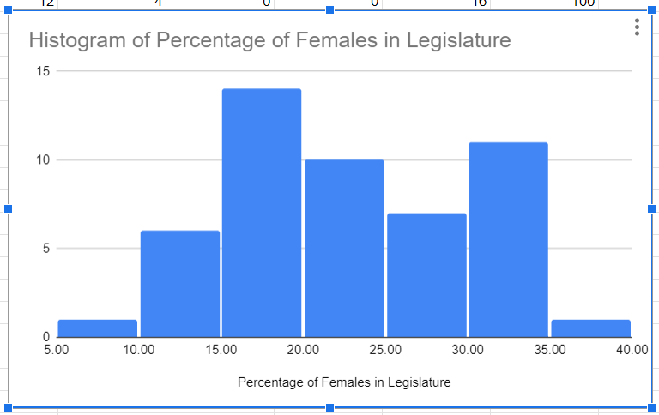
In the Chart editor, click on the Customize tab.  Click the Histogram drop down. From the submenu, select 10 from the Bucket size dropdown. | 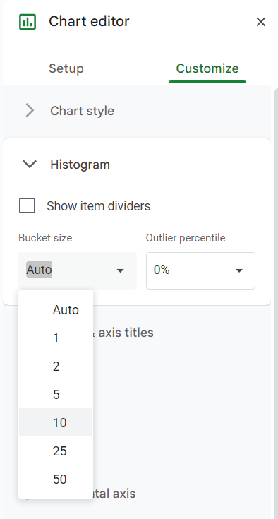
Notice how the graph changes. According to the new graph, 24 states have between 15 and 25% female legislatures. | 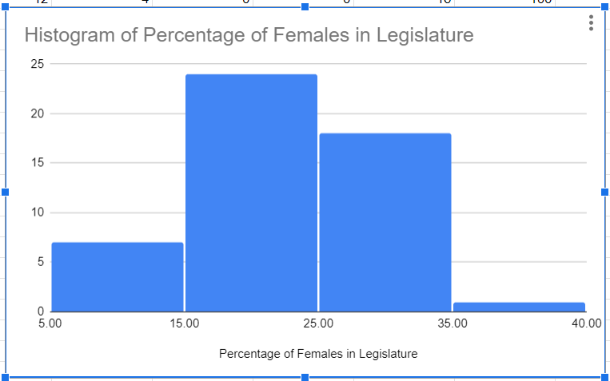
Now, lets change the title to better describe the data we are trying to visualize.  Double click on the title and change the title to “Histogram of Percentage of Females in Legislature in 2005”. | 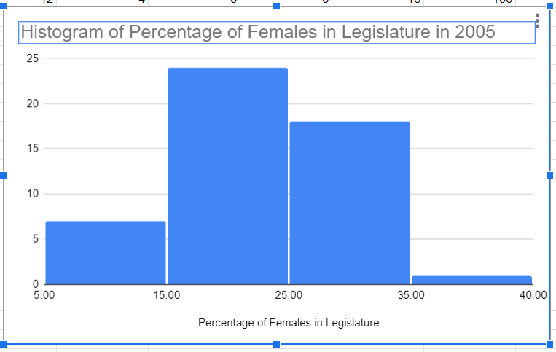
Delete the histogram you created by clicking on the chart, then selecting Delete chart from the menu shown. | 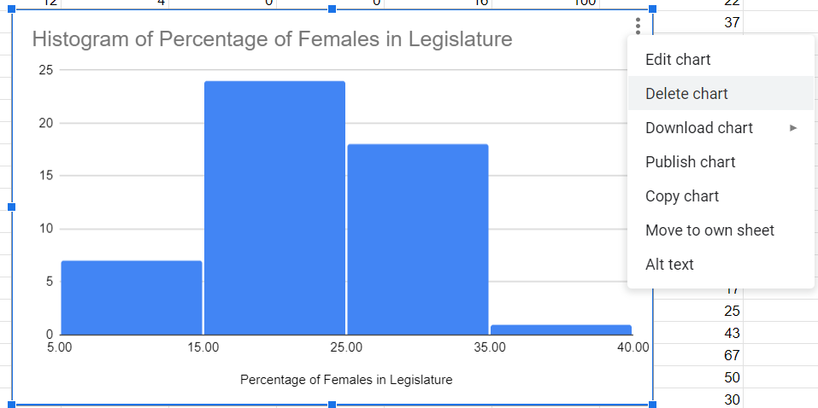
Click on the the filter icon in the top menu to remove the filter. | 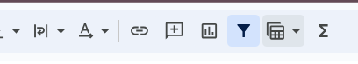
Create a bar/column chart
Select the filter icon in the top menu to create a filter | 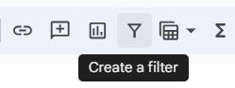
Locate the State column and click on the filter icon that appears.  Select the Filter by condition option from the main menu  Select the Text contains option from the submenu | 
In the Text contains dialog box that appears, type Idaho  Then, scroll to the bottom of the window and click OK | 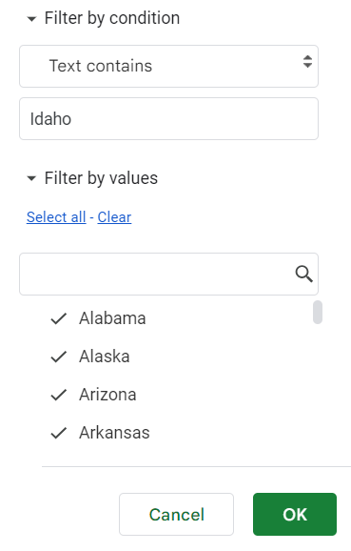
Return to the last column (column S) and click on the S. This column represents the percentage of females in the legislature for Idaho from 2019 to 1981. | 
Click on the insert chart icon from the top menu | 
A histogram is created by default, but this is not the best way to visualize this data.  From the Chart type menu, change the chart type from Histogram to Column by clicking the Column option. | 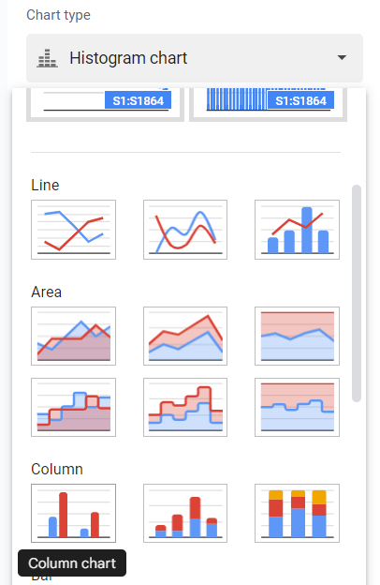
The column chart looks ok. But we can do better. | 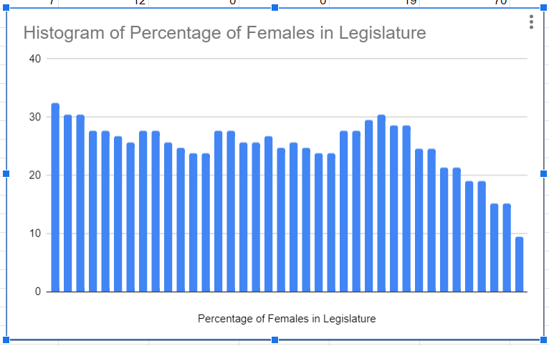
From the Chart editor window, locate the Add X-axis drop down.  Click on the icon to the right of the drop down to Select a data range. | 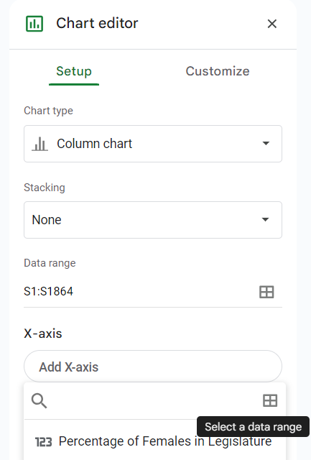
Locate column C and click on it.  Notice the range updates in the Select a data range dialog box.  Click OK. | 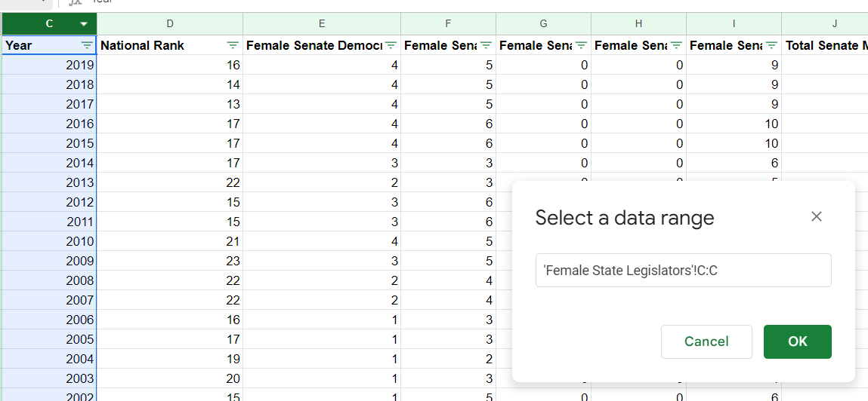
Now we can see the years and the corresponding percentage of female legislators. It would be nice if they were in ascending order however. | 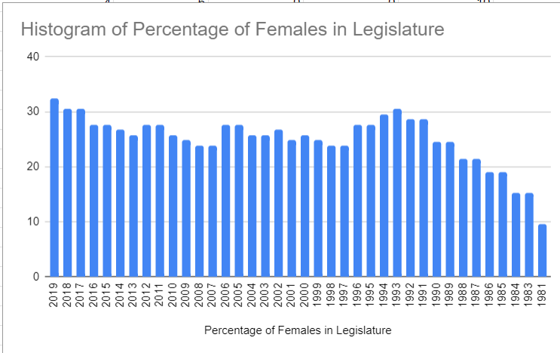
From the Chart editor menu, click on the Customize tab.  Click on the Horizontal axis menu, then check the Reverse axis order box. | 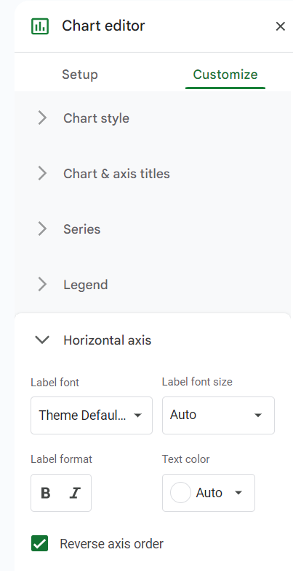
Finally, lets change the title to better describe the data we are trying to visualize.  Double click on the title and change the title to “Percentage of female legislators in Idaho from 1981 to 2019”. | 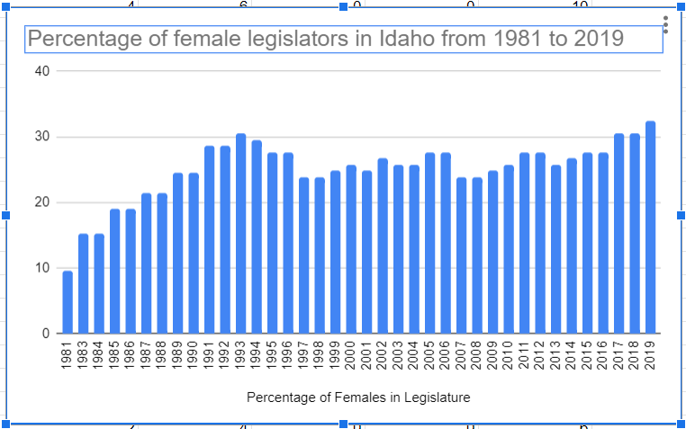
Copy the chart you created by clicking on the chart, then selecting Copy chart from the menu shown. | 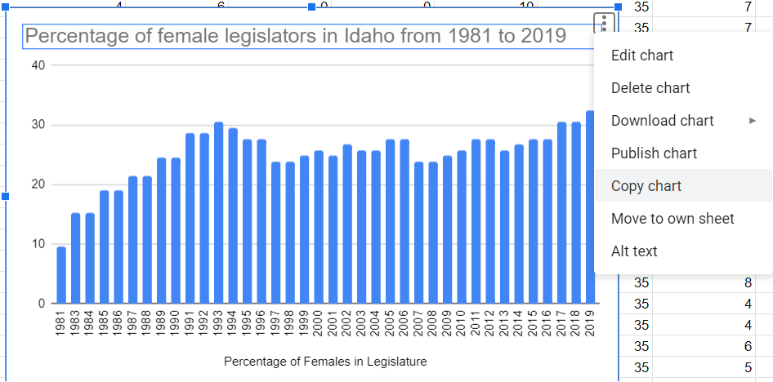

Paste (ctrl-v) the chart you ceated below.

In the tutorial above, you created a histogram that displayed the percentage of females in the legislature in 2005.


Create another histogram that displays the percentage of females in the legislature in 2019. Change the bucket size to 10. Copy and paste your chart below.
In 2005, how many states had between 25 and 35 percent of their legislatures made up of female legislators?
In 2019, how many states had between 25 and 35 percent of their legislatures made up of female legislators?
What do these charts show?
Why might this be the case?
In the tutorial above you created a column chart that showed the percentage of female legislators in Idaho from 1981 to 2019.

Create another column chart that shows the percentage of female legislators from 1981 to 2019 for a different state. Sort the horizontal axis in reverse order and display the years. Copy and paste your chart below.
How does the percentage of female legislatures in Idaho compare to the state you chose over time?
Why might this be the case?

- Apply the Data Analysis Process to One-Column Data

Previously we learned about the data analysis process,
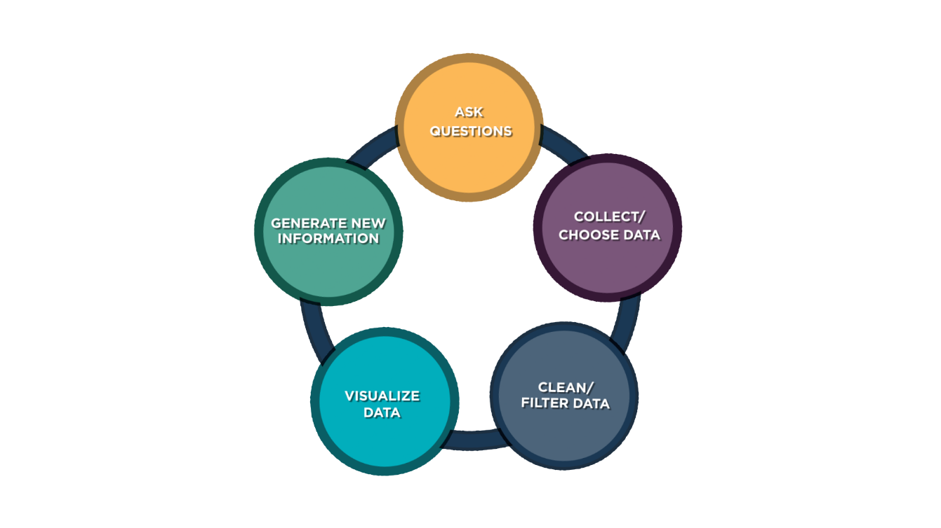
In this portion of the lab, we will use the data analysis process to help guide our collection of data and subsequent visualization. We will then use our visualization to generate new information and ask new questions.

Ask a Question

Think about a question you could ask about your peers? For example, “What brands of shoes do students at Timberline wear?”, “Where do students at Timberline work?”, “Where do students at Timberline want to go to college?”, “Where were students at Timberline born?”, “How tall are students at Timberline?”, “How many pets do students at Timberline have?”, “How far is your commute to school?”, “Where did you travel last summer?”, “What is your favorite restaurant?”

Think of two questions. One question should be qualitative (requires non-numeric data). One question should be quantitative (requires numeric data). Write your questions below.

Collect/Choose Data

To answer your question, you will survey at least 20 students in the class. Collecting this data in Google Sheets will provide an easy way to visualize your data later. Do the following,

- Open Google Sheets
- In cell A1 type “id”
- In cell B1 type a title that reflects the data you are collecting to answer your first question. For example, “Pets” or “Commute”
- In cell C1 type a title that reflects the data you are collecting to answer your second question
- Go around the room (or school) and obtain information from at least 20 people. Ask each person both questions so that each id will correspond to the same person.

When you are done collecting your data copy and paste your data set below.

Clean/Filter Data

It’s possible that the data you collected may need to be “cleaned” before you can visualize it. For example, if you were getting height data and entered “5 ft 4 in”, you will need to convert all your measurements to inches or some other number; If you were getting commute distance data and entered 2 miles or 4 blocks, you will need to convert these into consistent numeric data.

In all cases, if you are using numeric data, you will need to delete the units. These can be indicated on the chart you make in the next section if necessary.

Visualize Data

You will use Google Sheets to visualize your data. Recall, that histograms can only be used to visualize quantitative data and require a “bucket size”, whereas bar or column charts can be used to visualize either qualitative or quantitative data.

Using the tutorial above as a guide create two different charts for visualizing your data. Because you collected both quantitative and qualitative data, you will need to include at least one bar/column chart.

For each chart, you should provide a clear title.

Copy and paste the charts you created below.

Generate New Information

Now that you have created visualization from your data you can more clearly see possible trends. For each chart, indicate what you notice.
Chart 1:

Chart 2:

For each chart, provide and explanation for what you observe.
Chart 1:

Chart 2:

Do the visualizations you created generate any new questions? What do you wonder about?

- Receive Credit for this lab guide

Submit this portion of the lab to Pluska to receive credit for the lab guide.

