Visualizing Two-Column Data

Your Tasks (Mark these off as you go)
☐ Visualize data with a pivot table
☐ Visualize data with a scatter plot
☐ Visualize data about your peers
☐ Receive credit for this lab guide

- Visualize data with a pivot table

In this section we will learn how to visualize two-column data using pivot tables in Google Sheets. Click on the link below to check out the data we will be visualizing. You will need to make a copy of the sheet to complete the tutorial.

https://docs.google.com/spreadsheets/d/1a24wbyRRDkws4cyNWbnppdeYkcdCN2yBqJGjhH5rrc0/edit?usp=sharing

This dataset was created by hand from TheRoot.com, which publishes a list every year ranking the top 100 most influential African-Americans between ages 25-45. This dataset is the 2019 edition.

Follow the tutorial below to learn how to use Google Sheets to visualize this data set.

Create a pivot table
We saw previously that a crosstab chart can be useful for visualizing two-column categorical data. A pivot table is basically the same thing, but allows for the visualization of numerical data as well.  To get started creating a pivot table, locate Pivot table from the Insert menu | 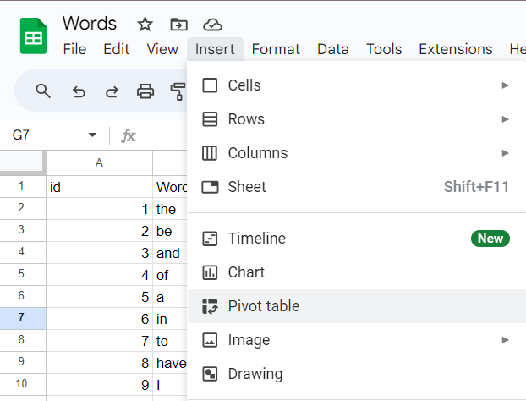
Make sure the New sheet option is selected, then click Create. | 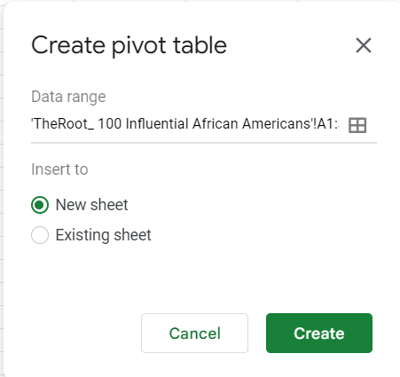
Rows go down the table. You can think of rows like y values.  Click on the Add button next to the Rows option and select Sector | 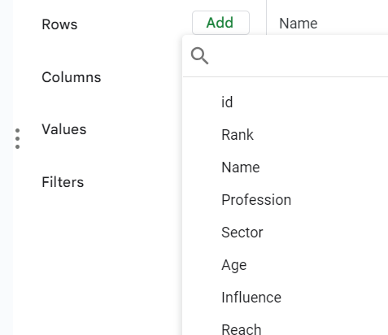
Columns go across the table. You can think of columns like x values.  Click on the Add button next to the Columns option and select Age. | 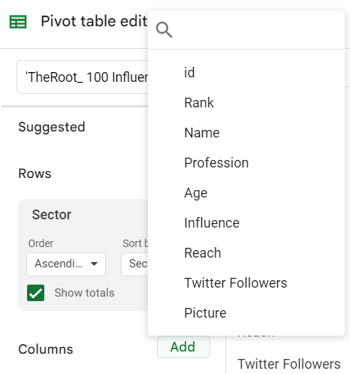
To add values to our table, click on the Add button next to the Values option and select Sector. | 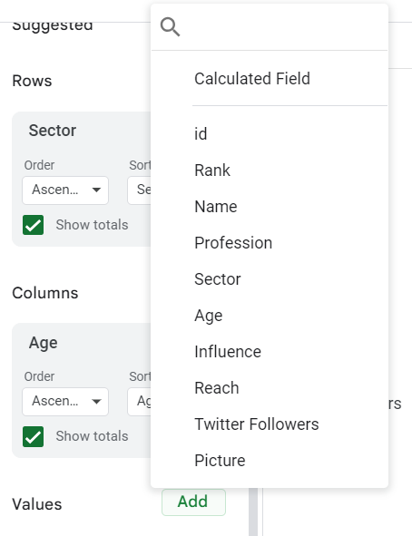
From the Summarize by drop down make sure CountA is selected. Note, this option is used for counting non-numeric data. | 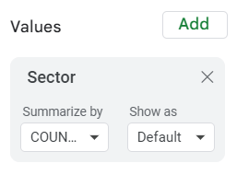
Close the Pivot table editor by clicking on the x | 
A screen shot of the table you selected is shown to the right.  According to the table four of the 100 most influential African-Americans are 39 year old and work in the community sector. | 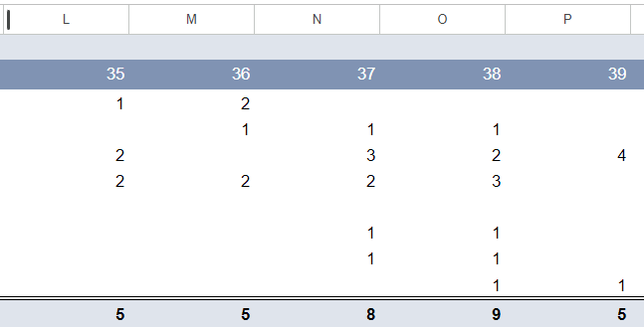

The pivot table you created above shows categorical relationships for the top 100 most influential African-Americans between ages 25-45. In what sector do most the individuals work? (HINT: look at the grand totals for the sectors on the far right of the chart. )
What is the most common age? (HINT: look at the totals for the ages on the bottom of the cart.)

Create a pivot chart from the words data set below,

https://docs.google.com/spreadsheets/d/1lQSi_AI1oMkjSZ84Z1qdH1WJTjd85gCMnIas5mLKk20/edit?usp=sharing

For the Rows select Length, for the Columns select Part of Speech, for the Values select Length. From the Summarize by dropdown, select Count. Note, Count is used for counting numeric data.

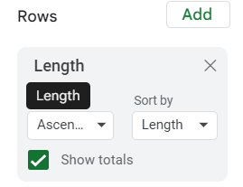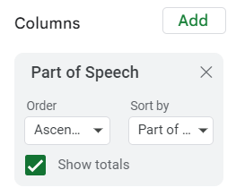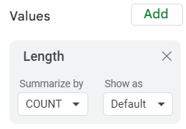
Take a screen shot of your chart and paste it below. The entire chart may not fit, but a portion is ok.
Which part of speech shows up most often in this data set?
Which part of speech seems to be longest, on average?
Which part of speech seems to be shortest, on average?
About how long is a typical noun?

Create a pivot chart from the favorite classes data set below,

https://docs.google.com/spreadsheets/d/1I96iawdEiCzO_F5bHNgtaQ3VaNVRWl4DJJgmmUXz6pQ/edit?usp=sharing

For the Rows select Grade, for the Columns select Favorite Class, for the Values select favorite Class. From the Summarize by dropdown, select CountA. Note, CountA is used to count non-numeric values.

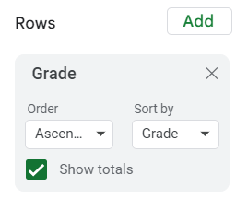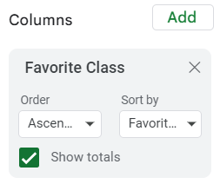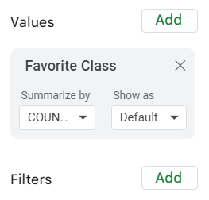
Take a screen shot of your chart and paste it below. The entire chart may not fit, but a portion is ok.
Which class do Seniors like the most?

Which grade likes History the most?
What is one other interesting pattern you can see in this diagram?

- Visualize data with a scatter plot

In this section we will learn how to visualize two-column data using scatter plots in Google Sheets. Click on the link below to check out the data we will be visualizing. You will need to make a copy of the sheet to complete the tutorial.

https://docs.google.com/spreadsheets/d/14akcZxGGoF2Tk6A-PRrg_AUw3GVMAzbNbCRyfb2xlp4/edit?usp=sharing

This data set about penguins was created by the Palmer Station LTER in Antarctica.

Follow the tutorial below to learn how to use Google Sheets to visualize this data set.

Create a scatter plot
We saw previously that scatter charts are useful for visualizing large datasets with numerical data.  Let’s begin be exploring the relationship between bill length and flipper length. Locate these two columns in the spread sheet.  You can select them by holding down the Ctrl key then clicking the D and F columns. | 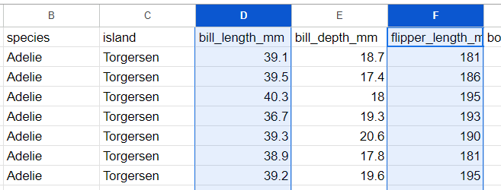
Next, select the chart icon from the menu. | 
A scatter chart should be created by default. If not, select the Chart type option, then scroll a bit to find the Scatter option. | 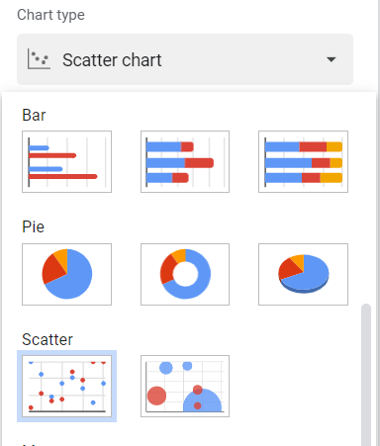
The default chart looks pretty good, but notice the values are concentrated in a small area in the vertical (y-range). | 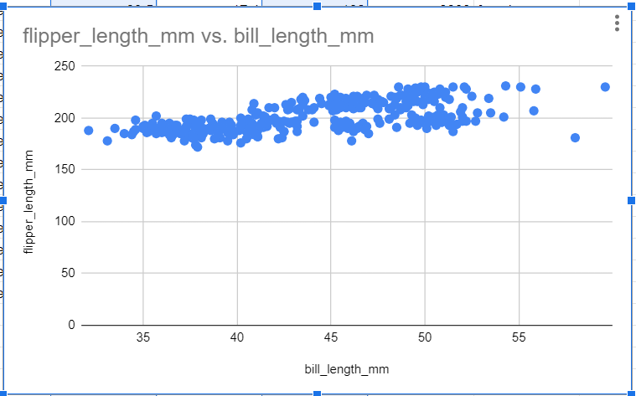
Click on Customize in the Chart editor window. Locate the Vertical axis option. Change the Min value to 150. | 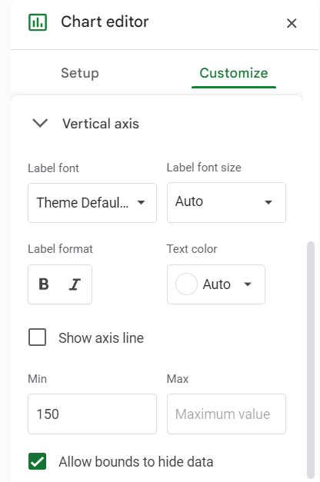
Each dot on the chart represents a different combination of flipper length and bill length for each penguin.  Notice that as the bill length increases, the flipper length increases. This is called a positive correlation. | 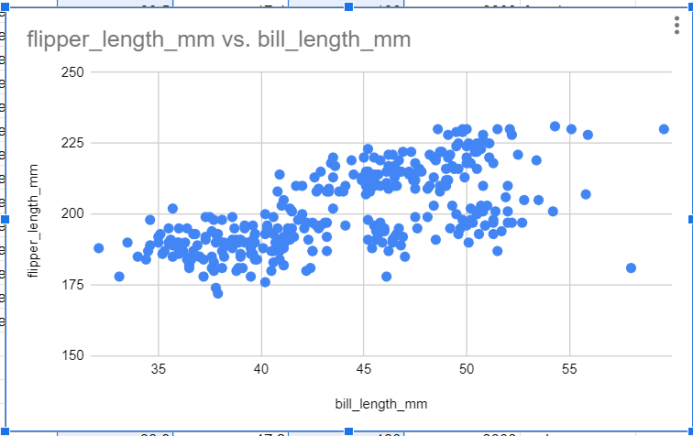
Click on cell A1, the click on the filter icon |   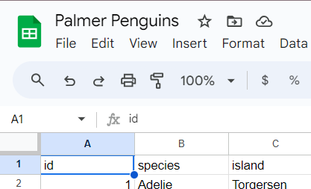
Click on the filter icon next to sex | 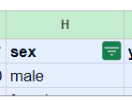
Select the Filter by values option. Then, click on female to deselect it. Click OK when doen. | 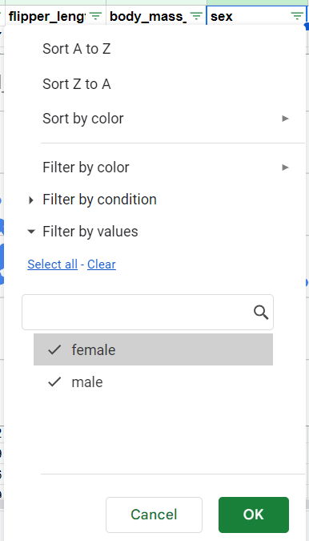
If all went well, your graph should like the one shown to the left. | 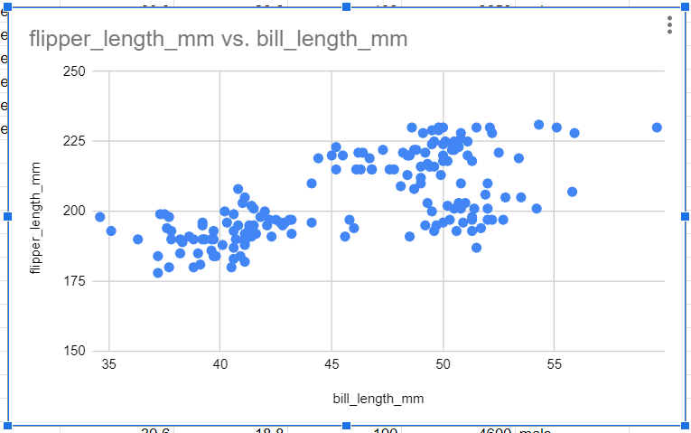
Delete the chart you created by selecting Delete chart from the 3 dot menu. | 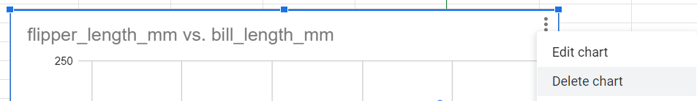
Remove the filter by clicking on the filter icon. | 

Click on the link below to open the US States spreadsheet

https://docs.google.com/spreadsheets/d/12wdkGAsCnw7_ECHcsi0VoQSlb0XZ_ja2dDlJRXaAhT8/edit?usp=sharing

Create a scatter plot the compares Median Household Income and Percent Adult College Graduates (columns S and U)

Take a screenshot of your plot and paste it below.
What is the range of incomes on this chart?
What is the range of percentages of adult college graduates?
Do you see a relationship between income and percent of adult college graduates? What is this relationship called?
Create a scatter plot that compares Percent in poverty and Percent Adult College Graduates (columns T and U). Take a screenshot of your plot and paste it below.
Do you see a relationship between poverty and percent of adult college graduates? What is this relationship called?

- Visualize data about your peers

In our last lab, you collected data about your peers. You were instructed to ask 20 peers two questions – one qualitative and one quantitative. In this section, you will create a chart to visualize your data.

You will use Google Sheets to visualize your data. Recall, that pivot charts are useful for visualizing categorical or non-numeric data. Since you collected both numeric and non-numeric data, you will need to use a pivot chart to visualize your data.

Using the tutorial above as a guide create a pivot chart for the data you collected.

Take a screen shot and paste the pivot chart you created below.
Now that you have created a visualization from your data, can you see any trends? For example, if you asked people their favorite color and gpa, do people who have a higher gpa tend to like a different color? Describe your observations below.

- Receive Credit for this lab guide

Submit this portion of the lab to Google Classroom to receive credit.

