Set 1. Exploring One-Column Data

Skill 1.1: Discuss the importance of visualizing data
Skill 1.2: Review the data analysis process
Skill 1.3: Differentiate between quantitative and qualitative
Skill 1.4: Visualize one column data
Skill 1.5: Clean dirty data

Skill 1.1: Discuss the importance of visualizing data

Skill 1.1 Concepts

Skill 1.1 Exercise 1

The previous exercise helped us understand the way data visualizations can serve to,

- Answer questions
- Look at lots of data at once
- See patterns that are "invisible" if you just look at a data set

Today we're going to learn how to make two different types of visualizations

Skill 1.2: Review the data analysis process

Skill 1.2 Concepts

The data analysis process starts with identifying a problem that can be solved with data. Once you’ve identified this problem, you can collect, clean, process, and analyze data. The purpose of analyzing this data is to identify trends, patterns, and meaningful insights, with the ultimate goal of solving the original problem. This is summarized below,

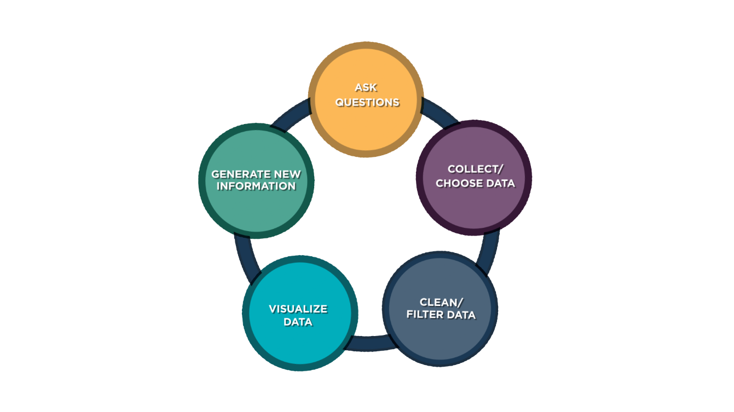

The video below discusses how the data analysis process is used to help oceanographers study artic sea ice,


https://www.youtube.com/watch?v=uzESOw7tmzw

Skill 1.2 Exercise 1

Skill 1.3: Differentiate between quantitative and qualitative

Skill 1.3 Concepts

At its simplest, data can be broken down into two different categories: quantitative data and qualitative data. But what’s the difference between the two? And how can we visualize them?

Quantitative data refers to any information that can be quantified, counted or measured, and given a numerical value.

Qualitative data is descriptive in nature, expressed in terms of language rather than numerical values.

Examples of qualitative and quantitative data are shown below. And as you can see, both provide immense value for any data collection and are key to truly finding answers and patterns.
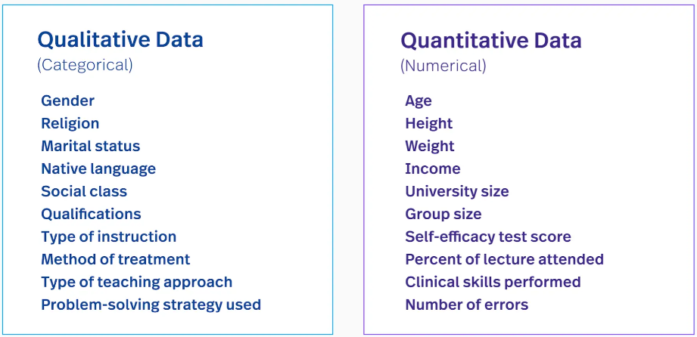

Skill 1.3 Exercise 1

Skill 1.4: Visualize one-column data

Skill 1.4 Concepts

Determining the type of data we want to visualize is the first step in the data visualization process. In a previous exercise you determine whether the data stored in a given column is qualitative or quantitative. If the data we want to visualize is qualitative, a bar or column chart should be used.

Bar Charts count how many times each value in the column appears and make a bar or column at that length.

Let’s revisit the dog data, https://docs.google.com/spreadsheets/d/1dy2TrqRqXNcq-0k4ciLcATcPINv8u1eNPWhbJRuYYjU/edit?usp=sharing

Below is a snippet from this data table,
Most of the values for each dog in these columns are different. A bar graph would not display very useful information.

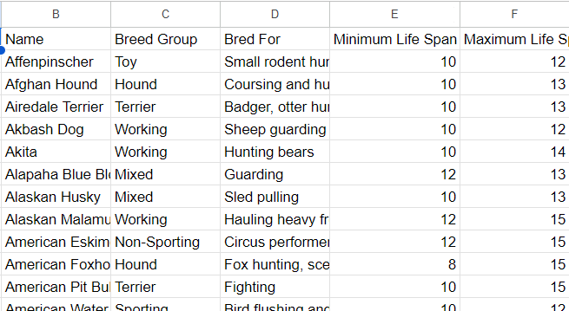

Many of the values in this column are repeated. A bar graph can be used to count the number of times each value appears.

Notice in the table above that Name, Breed Group, and Bred For columns all store qualitative data. The most of the values in the Name and Bred For columns are different for every dog and displaying them as a bar graph would not communicate very useful information. The Breed Group column on the hand, has values that are repeated. We can use a bar graph to visualize how many times each value is repeated. This is illustrated below,

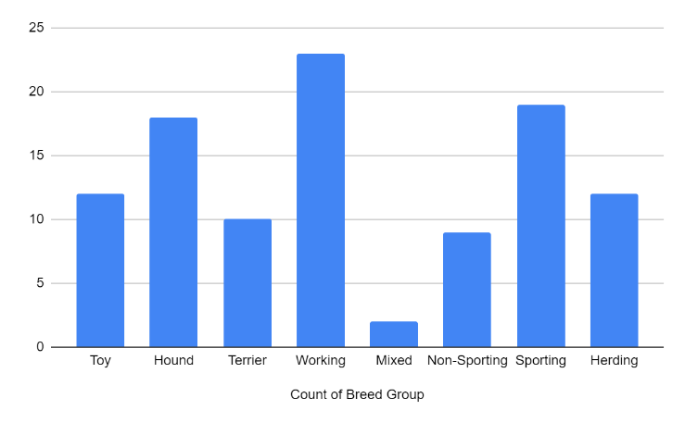 | 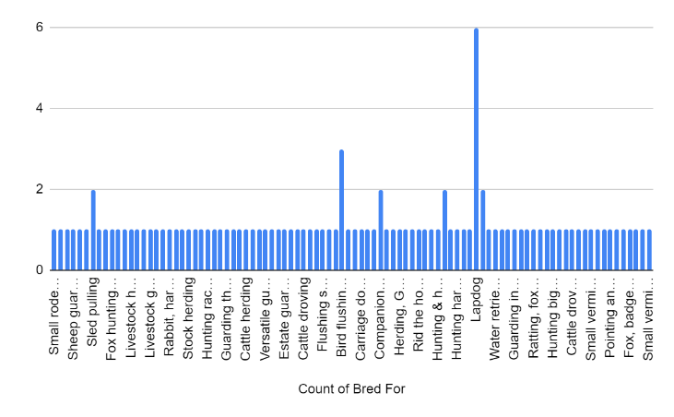

Notice what happens when we try to plot the Minimum Lifespan as a bar graph. A different line is created for every dog! Visualizing this data as bar chart is difficult to read.

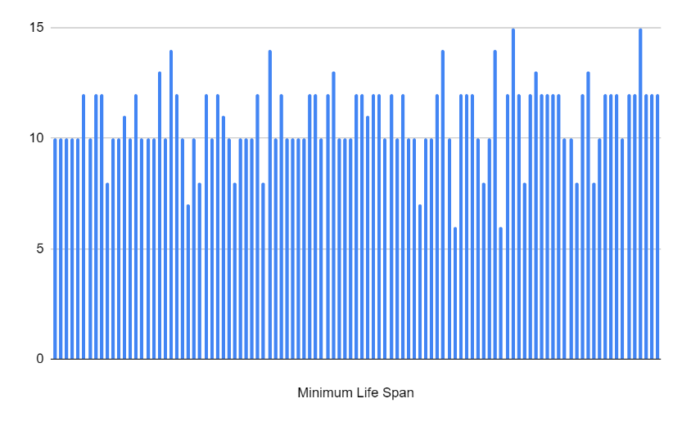

The data above, because it is quantitative, is better visualized as a histogram.

Histogram Charts are similar to a bar chart, but first all numbers in a range or "bucket" are grouped together. For example, the chart below has a bucket size of 2 so dogs with a minimum lifespan of 10 or 11 would all be placed in the same bucket.

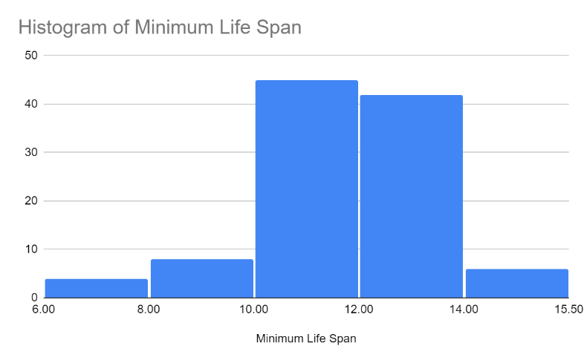
Histograms can only be created with numeric data but can be useful when a normal bar chart may be difficult to read.

Below is a summary of the types of information we can get from bar and histogram charts.

Information we can get from bar and histography charts.
Bar Charts | Histogram Charts
- What value(s) are most common in this column?  - What value(s) are least common in this column?  - What is the unique list of values in this column? | - What range of value(s) are most common in this column?  - What range value(s) are least common in this column?  - What ranges of values do or do not appear in this column?

Skill 1.4 Exercise 1

Skill 1.5: Clean dirty data

Skill 1.5 Concepts

We've started to explore how to use charts to visualize one column data, but there are often times challenges with doing this. One challenge that often occurs with survey data is “dirty” data. The data set below for example represents data collected via a student survey. Notice that there are several instances where students typed a word (or String) instead of an integer to represent a number; there are also instances where students abbreviated their favorite subject (CS instead of Computer Science for example).

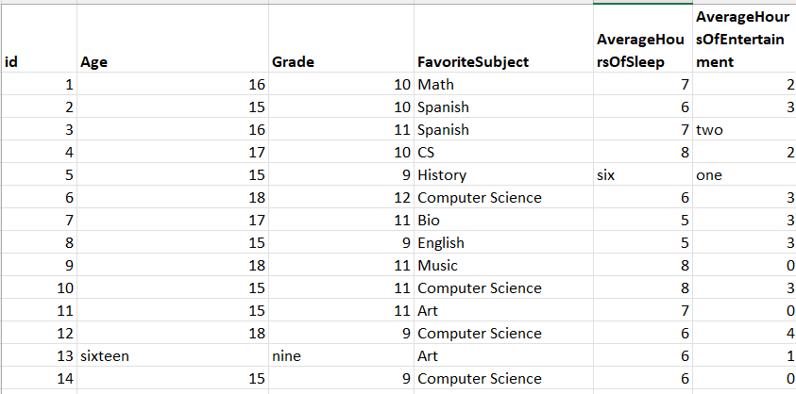

Before we can adequately analyze the data, we must first clean it – the third step in the data analysis process. Data cleaning is the process of fixing or removing incorrect, corrupted, incorrectly formatted, duplicate, or incomplete data within a dataset.

Skill 1.5 Exercise 1

