Skill 1.1 Exercise 1
For each data set below, identify the largest number and the smallest number.
100010 636256 9898989 12121212 789123 123800 8907618

9875671 10101010 98111111 8787877 98989891

9876512 6780987 1237659 89898910 7424048 76654321

8787856 7659999 99887766 78956430 12914651

9999988 1628760 2222290 10926382 9187656 10987654

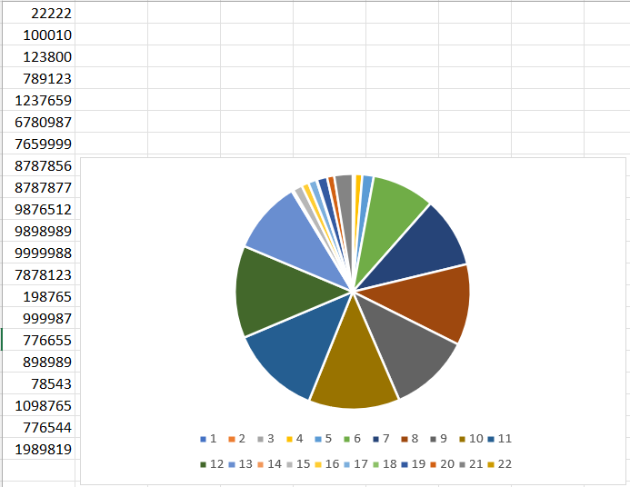
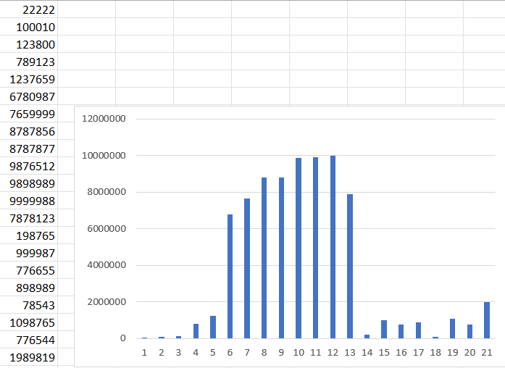
Skill 1.1 Exercise 2
For which data set was it easiest to identify the largest and smallest number? Why?
Why do people make visualizations out of data?

Skill 1.2 Exercise 1
List the steps in the data analysis process.

Skill 1.3 Exercise 1
Below is a portion of a data set that contains information about different dog breeds. For each column, indicate whether it stores quantitative or qualitative data.

Breed Name | Breed Group | Bred For | Min Life | Max | Min Height | Max Height | Min Weight | Max Weight | Temperament
Affenpinscher | Toy | Small rodent hunting, lapdog | 10 | 12 | 9 | 12 | 6 | 13 | Stubborn, Curious, Playful, Adventurous, Active, Fun-loving
Afghan Hound | Hound | Coursing and hunting | 10 | 13 | 25 | 27 | 50 | 60 | Aloof, Clownish, Dignified, Independent, Happy
Airedale Terrier | Terrier | Badger, otter hunting | 10 | 13 | 21 | 23 | 40 | 65 | Outgoing, Friendly, Alert, Confident, Intelligent, Courageous

Column | Data type (quantitative/qualitative)
Breed Name
Breed Group
Bred For
Min Life
Max Life
Min Height
Max Height
Min Weight
Max Weight
Temperment

Skill 1.4 Exercise 1
Open the dog data set, https://docs.google.com/spreadsheets/d/1dy2TrqRqXNcq-0k4ciLcATcPINv8u1eNPWhbJRuYYjU/edit?usp=sharing

For each column indicate whether the data would be best visualized using a bar chart, histogram chart, or neither.
Column | Histogram, Bar, or Neither
Name
Breed Group
Bred For
Minimum Life Span
Maximum Life Span
Minimum Height
Maximum Height
Minimum Weight
Maximum Weight
Temperament
Image

For each column you indicated as best being visualized as a histogram, indicate a corresponding bucket size that would be suitable for visualizing the data.
Column | Bucket Size

Skill 1.5 Exercise 1
The data below was collected from students using a survey. Indicate how you would clean the data by crossing out the incorrectly formatted data and replacing it with what was intended.

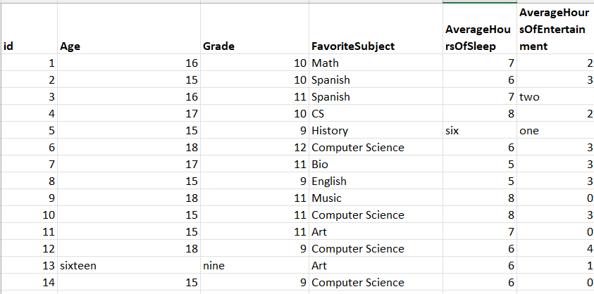
You are a developer and have been asked to create a web-based form to collect the above data. What could you do to better ensure the user entered clean data?

