Skill 2.1 Exercise 1
Consider the following questions. For each question, (1) indicate what type of data you would need to collect to answer the question and (2) how you think you would analyze it.
Which hour of the day are students at Timberline the happiest? | (1)
 | (2)
Do taller people have a longer arm span? | (1)
 | (2)
Do students with higher gpa’s sleep longer? | (1)
 | (2)
What type of shoes do sophomores, juniors, and seniors wear? | (1)
 | (2)

Skill 2.2 Exercise 1
Refer to the crosstab chart below to answer the following.
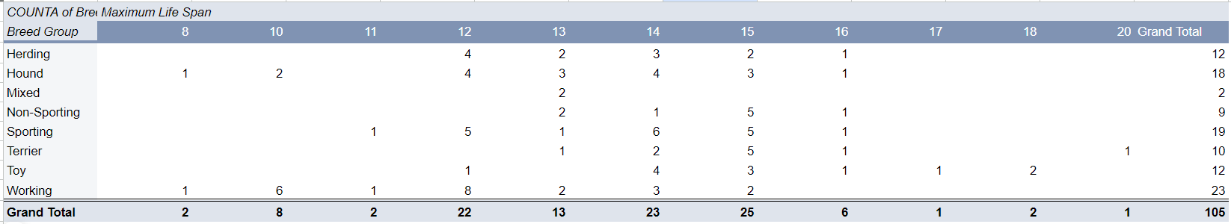
Which breed has the shortest life span?

What is the most common maximum life span for "Working" breeds?

Skill 2.2 Exercise 2
Below is a portion of a data set that displays information about shows on Netflix. Here is a link to the complete dataset - https://docs.google.com/spreadsheets/d/1i5RAuRurZ-57mchZ6k0EghvrJlaTw0BUbbGtAJKF1JI/edit?usp=sharing
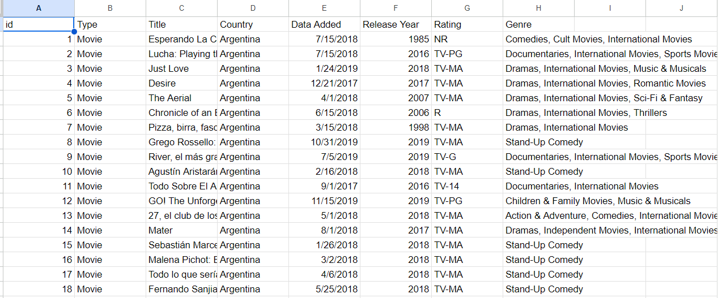
Which column(s) could be visualized using a bar graph?
Which column(s) could be visualized using a histogram?
Which columns could be used to create crosstab chart? Note, there are several combinations that could work.
What would the crosstab chart show?

Skill 2.3 Exercise 1
Below is a portion of a data set that contains information about different dog breeds.

Breed Name | Breed Group | Bred For | Min Life | Max | Min Height | Max Height | Min Weight | Max Weight | Temperament
Affenpinscher | Toy | Small rodent hunting, lapdog | 10 | 12 | 9 | 12 | 6 | 13 | Stubborn, Curious, Playful, Adventurous, Active, Fun-loving
Afghan Hound | Hound | Coursing and hunting | 10 | 13 | 25 | 27 | 50 | 60 | Aloof, Clownish, Dignified, Independent, Happy
Airedale Terrier | Terrier | Badger, otter hunting | 10 | 13 | 21 | 23 | 40 | 65 | Outgoing, Friendly, Alert, Confident, Intelligent, Courageous

Identify two columns that could be compared using a scatter plot.

Skill 2.3 Exercise 2
Their research on Working Hours(Opens in a new window) includes this chart that compares productivity (GDP per hour worked) to the average number of hours worked per person.
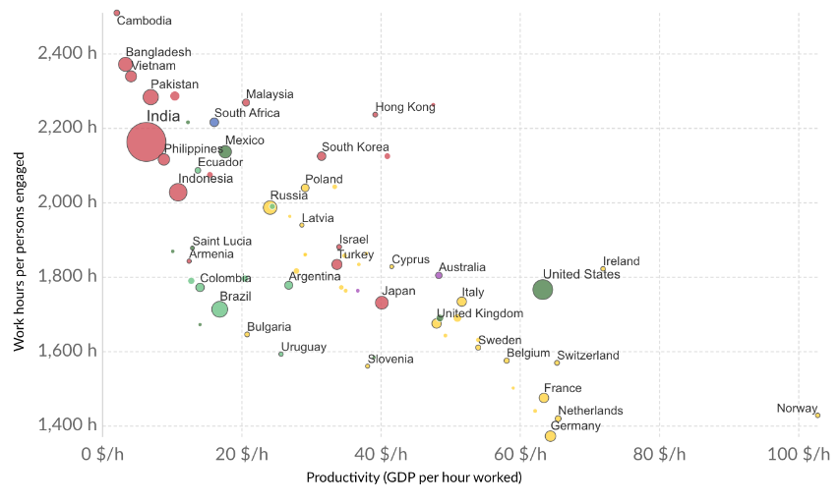
What is the correlation between hours worked and GDP per hour worked?
Recently, a large group of companies trialed a “4 day work week”. Based on this plot, can you predict the outcome? Check out this article to learn more, https://www.npr.org/2024/02/27/1234271434/4-day-workweek-successful-a-year-later-in-uk

Skill 2.4 Exercise 1
For the first exercise on this ticket out the door, you were asked what type of data you would collect to answer different questions. For each question indicate the best visualization (crosstab or scatter plot).
Question | Crosstab or Scatter Plot
Which hour of the day are students at Timberline the happiest?
Do taller people have a longer arm span?
Do students with higher gpa’s sleep longer?
What type of shoes do sophomores, juniors, and seniors wear?

