Skill 3.1 Exercise 1
What is meant by Big Data?
Watch the videos below. As you watch, identify examples of Big Data.
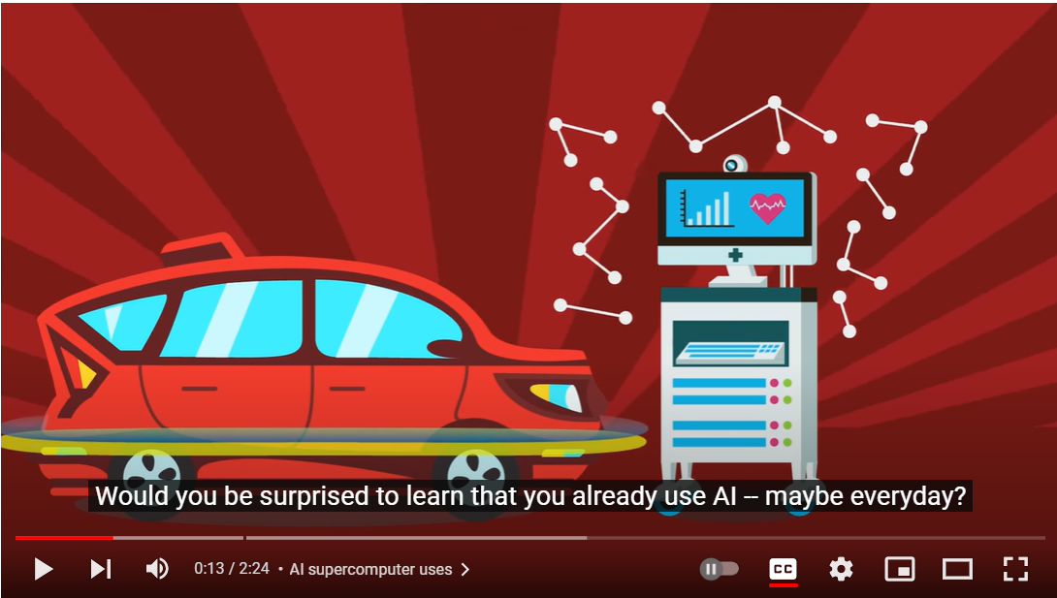 | 
https://www.youtube.com/watch?v=1XGo8K1boH4 | https://www.youtube.com/watch?v=bMrDHtGHFR4
Examples of Big Data: | Examples of Big Data:

Skill 3.2 Exercise 1
How do parallel computing solutions to improve the efficiency processing big data?
Under what conditions is a parallel computing solution not possible?

Skill 3.2 Exercise 2
A computer has two processors that are able to run in parallel. The table below indicates the amount of time it takes either processor to execute four different processes. Assume that none of the processes is dependent on any of the other processes.
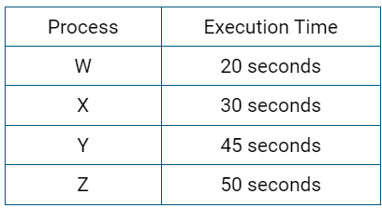
A program is used to assign processes to each of the processors. Which of the following describes how the program should assign the four processes to optimize execution time?
- Processes W and X should be assigned to one processor, and processes Y and Z should be assigned to the other processor.
- Processes W and Y should be assigned to one processor, and processes X and Z should be assigned to the other processor.
- Processes W and Z should be assigned to one processor, and processes X and Y should be assigned to the other processor.
- Process Z should be assigned to one processor, and processes W, X, and Y should be assigned to the other processor.

Skill 3.3 Exercise 1
Which of the following applications is most likely to benefit from the use of crowdsourcing?

- An application that allows users to convert measurement units (e.g., inches to centimeters, ounces to liters)
- An application that allows users to purchase tickets for a local museum
- An application that allows users to compress the pictures on their devices to optimize storage space
- An application that allows users to view descriptions and photographs of local landmarks

Skill 3.3 Exercise 2
Which of the following are true statements about how the Internet enables crowdsourcing?

I. The Internet can provide crowdsourcing participants access to useful tools, information, and professional knowledge.
II. The speed and reach of the Internet can lower geographic barriers, allowing individuals from different locations to contribute to projects.
III. Using the Internet to distribute solutions across many users allows all computational problems to be solved in reasonable time, even for very large input sizes.

Skill 3.4 Exercise 1
Listen to the audio clip below.

https://www.npr.org/2018/04/20/597972310
Explain how Citizen Science is being applied to contribute to scientific research and solve a problem.

Skill 3.4 Exercise 2
A small team of wildlife researchers is working on a project that uses motion-activated field cameras to capture images of animals at study sites. The team is considering using a “citizen science” approach to analyze the images. Which of the following best explains why such an approach is considered useful for this project?

- Distributed individuals are likely to be more accurate in wildlife identification than the research team.
- The image analysis is likely to be more consistent if completed by an individual citizen.
- The image analysis is likely to require complex research methods.
- The image analysis is likely to take a longer time for the research team than for a distributed group of individuals.

Skill 3.5 Exercise 1
A researcher wants to publish the results of a study in an open access journal. Which of the following is a direct benefit of publishing the results in this type of publication?

- The researcher can allow the results to be easily obtained by other researchers and members of the general public.
- The researcher can better anticipate the effect of the results and ensure that they are used responsibly.
- The researcher can ensure that any personal information contained in the journal is kept private and secure.
- The researcher can prevent copies of the research from being accessed by academic rivals.

Skill 3.6 Exercise 1
Andy is using machine learning for an algorithm that classifies photos of restaurant meals by category (such as "sandwich", "curry", or "salad").

He trains a neural network on a large open database of photos of restaurant meals. He then tests the network on local restaurants and notices that the Ethiopian restaurant meals aren't classified correctly.
What time of learning machine learning model is Andy probably using?
What's the best way to improve the machine learning algorithm's ability to recognize Ethiopian meals?

Skill 3.6 Exercise 2
Creating a Machine Learning (ML) model isn’t as hard as you think! Follow the steps below to create and test an ML model.

- Navigate to https://machinelearningforkids.co.uk/
- Click on the Get started button
- Click the Try it now button
- Click Add a new project
- Decide on a name for your project (cat detector, money detector, mood detector, etc.) and enter it
- Select recognizing images for the Project Type
- Select In your web browser for the Storage
- Click CREATE
- Click on the project landing area that is created
- Click on the Train button to start training your model
- Click on the Add new label button, you can call this label whatever you want for example (sad, happy, angry, etc). You need at least two labels for example: Happy and Not Happy
- Draw pictures, use your webcam, or find pictures on the Internet to train your model (You need at least images for each label)
- When you are done, click on the Back to project link
- Click on the Learn and Test button
- Click on the Train new machine learning model button
- Test out your model with your webcam, drawing, or link to an image

What was the name of the Machine Learning Model you created?
The results of your model are reported as a percentage. How accurate was your model with the image you tested? Indicate the percentage.
How might you improve your model?

Skill 3.7 Exercise 1
A national bank opts to use machine learning for deciding whether to award loans to applicants. The engineers create the algorithm by training a neural network on their large database of previous loan applications and decisions (made by loan officers). After they start using the algorithm for new loan applicants, they receive complaints that their algorithm must be biased, because all the loan applicants from a particular zip code are always denied. Explain?

Skill 3.7 Exercise 2
A software company is designing a mobile game system that should be able to recognize the faces of people who are playing the game and automatically load their profiles. Which of the following actions is most likely to reduce the possibility of bias in the system?
- Testing the system with members of the software company’s staff

- Testing the system with people of different ages, genders, and ethnicities

- Testing the system to make sure that the rules of the game are clearly explained

- Testing the system to make sure that players cannot create multiple profiles

