Skill 3.1 Exercise 1
What is meant by Big Data?
Big Data refers to data sets that are so large or complex that traditional methods of storing and processing them are not adequate. These data sets can reveal patterns and knowledge that may not be visible in smaller data sets.
Watch the videos below. As you watch, identify examples of Big Data.
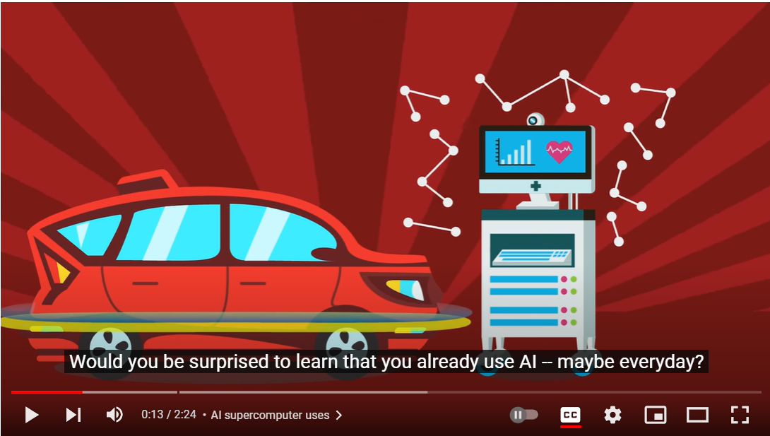 | 
https://www.youtube.com/watch?v=1XGo8K1boH4 | https://www.youtube.com/watch?v=bMrDHtGHFR4
Examples of Big Data:  • Billions of online videos and users' viewing histories used to recommend similar videos.  • Medical data and sensor data from self-driving cars processed with AI. | Examples of Big Data:  • DNA and genetic-sequencing data used to identify an illness that doctors could not diagnose from symptoms alone.  • GPS, population, and health data used to track disease spread and determine where vaccines are needed.

Skill 3.2 Exercise 1
How do parallel computing solutions to improve the efficiency processing big data?
Parallel computing divides independent parts of a problem among multiple processors so that the parts run at the same time. This can reduce the total execution time compared with completing every part one at a time.
Under what conditions is a parallel computing solution not possible?
A parallel solution is not possible when the work cannot be separated into independent tasks, such as when one step must wait for the result of an earlier step before it can begin.
Mix the batter → Bake the cake → Cool the cake → Frost the cake

Skill 3.2 Exercise 2
A computer has two processors that are able to run in parallel. The table below indicates the amount of time it takes either processor to execute four different processes. Assume that none of the processes is dependent on any of the other processes.
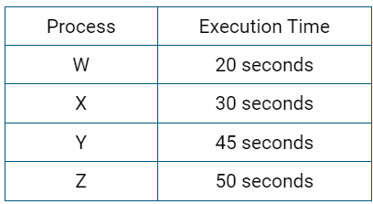
A program is used to assign processes to each of the processors. Which of the following describes how the program should assign the four processes to optimize execution time?
- Processes W and X should be assigned to one processor, and processes Y and Z should be assigned to the other processor.
- Processes W and Y should be assigned to one processor, and processes X and Z should be assigned to the other processor.
- Processes W and Z should be assigned to one processor, and processes X and Y should be assigned to the other processor.
- Process Z should be assigned to one processor, and processes W, X, and Y should be assigned to the other processor.
Answer: (c). W + Z takes 70 seconds, while X + Y takes 75 seconds. Because both processors work at the same time, the program finishes in 75 seconds, which is the shortest possible time.

Skill 3.3 Exercise 1
Which of the following applications is most likely to benefit from the use of crowdsourcing?

- An application that allows users to convert measurement units (e.g., inches to centimeters, ounces to liters)
- An application that allows users to purchase tickets for a local museum
- An application that allows users to compress the pictures on their devices to optimize storage space
- An application that allows users to view descriptions and photographs of local landmarks
Answer: (d). Many users can contribute descriptions and photographs of landmarks in their own communities.

Skill 3.3 Exercise 2
Which of the following are true statements about how the Internet enables crowdsourcing?

I. The Internet can provide crowdsourcing participants access to useful tools, information, and professional knowledge.
II. The speed and reach of the Internet can lower geographic barriers, allowing individuals from different locations to contribute to projects.
III. Using the Internet to distribute solutions across many users allows all computational problems to be solved in reasonable time, even for very large input sizes.

Answer: I and II only. Statement III is false because distributing work does not make every computational problem solvable in a reasonable amount of time.

Skill 3.4 Exercise 1
Listen to the audio clip below.

https://www.npr.org/2018/04/20/597972310
Explain how Citizen Science is being applied to contribute to scientific research and solve a problem.
The Stream Tracker project asks volunteers to visit small streams and use a phone app to report each stream's location and whether it is flowing, dry, or frozen
. Combining observations from many people gives scientists data about streams that are too numerous and too small to monitor with a small research team or satellites. Researchers can use the data to improve maps and forecasts of water availability.

Skill 3.4 Exercise 2
A small team of wildlife researchers is working on a project that uses motion-activated field cameras to capture images of animals at study sites. The team is considering using a “citizen science” approach to analyze the images. Which of the following best explains why such an approach is considered useful for this project?

- Distributed individuals are likely to be more accurate in wildlife identification than the research team.
- The image analysis is likely to be more consistent if completed by an individual citizen.
- The image analysis is likely to require complex research methods.
- The image analysis is likely to take a longer time for the research team than for a distributed group of individuals.
Answer: (d). A distributed group can classify the large number of photographs more quickly than the small research team working alone.

Skill 3.5 Exercise 1
A researcher wants to publish the results of a study in an open access journal. Which of the following is a direct benefit of publishing the results in this type of publication?

- The researcher can allow the results to be easily obtained by other researchers and members of the general public.
- The researcher can better anticipate the effect of the results and ensure that they are used responsibly.
- The researcher can ensure that any personal information contained in the journal is kept private and secure.
- The researcher can prevent copies of the research from being accessed by academic rivals.
Answer: (a). Open access allows other researchers and members of the public to obtain and build upon the results more easily.

Skill 3.6 Exercise 1
Andy is using machine learning for an algorithm that classifies photos of restaurant meals by category (such as "sandwich", "curry", or "salad").

He trains a neural network on a large open database of photos of restaurant meals. He then tests the network on local restaurants and notices that the Ethiopian restaurant meals aren't classified correctly.
What time of learning machine learning model is Andy probably using?
Andy is probably using supervised learning because the model is trained with meal photos that have known category labels.
What's the best way to improve the machine learning algorithm's ability to recognize Ethiopian meals?
Add many accurate, clearly labeled photos of Ethiopian meals to the training data, including meals from local restaurants and a variety of dishes, lighting conditions, and camera angles. Then retrain and test the model.

Skill 3.7 Exercise 1
A national bank opts to use machine learning for deciding whether to award loans to applicants. The engineers create the algorithm by training a neural network on their large database of previous loan applications and decisions (made by loan officers). After they start using the algorithm for new loan applicants, they receive complaints that their algorithm must be biased, because all the loan applicants from a particular zip code are always denied. Explain?
The model learned from past decisions made by loan officers. If those historical decisions were biased, or if applicants from that zip code were underrepresented or frequently denied in the training data, the model can repeat that pattern. The zip code may also act as a proxy for factors such as race or income. The bank should audit the data and outcomes, use more representative training data, and test the model for unfair patterns before relying on it.

Skill 3.7 Exercise 2
A software company is designing a mobile game system that should be able to recognize the faces of people who are playing the game and automatically load their profiles. Which of the following actions is most likely to reduce the possibility of bias in the system?
- Testing the system with members of the software company’s staff

- Testing the system with people of different ages, genders, and ethnicities

- Testing the system to make sure that the rules of the game are clearly explained

- Testing the system to make sure that players cannot create multiple profiles
Answer: (B). Testing with people of different ages, genders, and ethnicities makes it more likely that the system will work accurately across a diverse population.

