String Operations

Your Tasks (Mark these off as you go)
- Define key vocabulary
- Print formatted text to the console
- Implement functions from the JavaScript String library
- Receive credit for this lab guide

- Define key vocabulary

String variable

Concatenate

- Print formatted text to the console

Recall that escape sequences are used to signal an alternative interpretation of a series of characters. In JavaScript, a character preceded by a backslash (\) is an escape sequence.
Below are some commonly used escape sequences in JavaScript

\t: Inserts a tab
This sequence inserts a tab in the text where it’s used.

\n: Inserts a new line
This sequence inserts a new line in the text where it’s used.

\': Inserts a single quote
This sequence inserts a single quote character in the text where it’s used.

\": Inserts a double quote
This sequence inserts a double quote character in the text where it’s used.

\\: Inserts a backslash
This sequence inserts a backslash character in the text where it’s used.
Below are a few examples of how escape sequences can be implemented,

Code | Output
var msg = "Here is one line \n and here is another";  console.log(msg); | 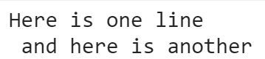
console.log("What is the \"right\" way?"); | 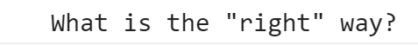
var msg2 = "Everything\t\tis\t\ttabbed";
console.log(msg2);

Write code that could be used to print the alphabet to the console exactly as shown – using just ONE console.log statement.
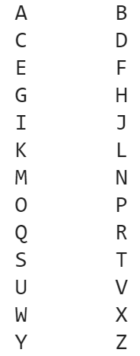

- Implement functions from the JavaScript String library
The String object class in JavaScript provides a library of functions which are useful for manipulating String type variables. To access these functions, we can use the "dot" notation. How to implement several useful functions from the String JavaScript library are illustrated below.
.length
Code | Output | Explanation
var theName = "Donald Duck";  var len = theName.length;  console.log(len); | 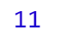 | The length of the String including white space is printed.

.substring()
The substring() function can be used to indicate the portion of the String we want to retrieve. In computer science counting begins at 0. In the String “Sparky the dog”, the character assignments are as follows,
Position | 0 | 1 | 2 | 3 | 4 | 5 | 6 | 7 | 8 | 9 | 10 | 11 | 12 | 13
Letter | S | p | a | r | k | y |  | t | h | e |  | d | o | g

The substring function can accept one or two parameters. Both implementations are illustrated below.

Code | Output | Explanation
var myPet = "Sparky the dog";  var smallPart = myPet.substring(4);  console.log(smallPart); | 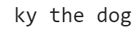 | Everything starting at index 4 is printed
var smallPart2 = myPet.substring(4,12);  console.log(smallPart2); | 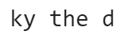 | Everything between index and 4 and 12 (not inclusive is printed.

.toLowerCase()

The function “toLowerCase()” converts all characters to lower case (small letters)

Code | Output
var phrase ="Where is my car?";
var phraseLower = phrase.toLowerCase();
console.log(phraseLower);

.toUpperCase()
The function “toUpperCase()” converts all characters to upper case (capital letters)
Code | Output
var phrase ="Where is my car?";  var phraseUpper = phrase.toUpperCase();  console.log(phraseUpper); | 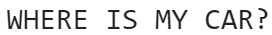

.charAt

The charAt function can be applied to return a character at a specified index. Consider the following example,

Code
var somePhrase = "Sparky the dog";
var firstLetter = somePhrase.charAt(0);
var lastLetter = somePhrase.charAt(somePhrase.length-1);
console.log("The first letter is " + firstLetter + ". The last letter is " + lastLetter + ".");
Output

Consider the words below,

Bicycle
Car
Popcorn

Write code that extracts the first half and second half of each word, then recombines the halves such that the last half is printed first followed by the first half.

The result that should appear when your program is ran is shown below. NOTE: the final result should be all lower case.

* yclebic
* arc
* cornpop

Consider the word below,

TIMBERLINE

Write code that could be used to select two random letters from the word (use Math.random() for this) and swap them. The final word should be printed in all lowercase.

For example if randomIndex1 = 3 and randomIndex2 = 5, the word should be printed as follows,

timrebline

- Receive Credit for this lab guide

Submit this portion of the lab to Pluska to receive credit for the lab guide. Once received, your completed code challenges will also be graded and will count towards your final lab grade.

