Navigate to your website directory | 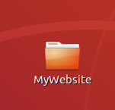
Inside this directory, create another directory called Styles  Your main website directory should have the structure like that shown on the right | 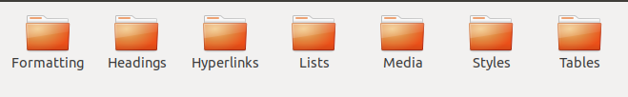
Open your text editor – be sure to use the same text editor you used to create your HTML pages - and create a file in the Styles directory you just created called StyleSheet.css | 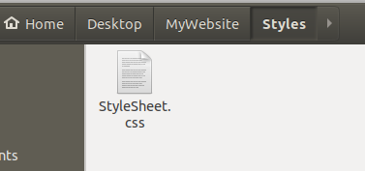

Now return to your main website directory and create another directory called IntroToCSS. Your main website directory should now look as follows,

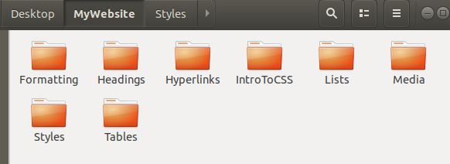

Be sure to have a separate directory for each assignment up to this point

Open your text editor and create a file in the IntroToCSS directory you just created called Index.html

