|  |  |  |  |
| --- | --- | --- | --- |
|  |  | **Card Dealer** |  |

|  |
| --- |
| **Your Tasks (Mark these off as you go)** |
| * Get familiar with the machine language commands * Practice with the Machine Language Commands * Write an algorithm to search for a card * Write an algorithm to bring the min card to the front * Write an algorithm to sort the cards from low to high * Receive credit for this lab guide |

* **Get familiar with the machine language commands**

Here are the beginnings of a low-level language you can use to create programs for a “Human Machine” to solve problems with playing cards.

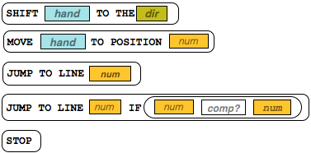

The 5 commands you can use are shown to the right. **See the *Reference Guide*** **provided for descriptions of what these commands do.**

Some of these commands might seem unusual, but we can write programs with just these commands to control the “human machine’s” hands to touch or pick up the cards, look at their values, and move left or right down the row of cards.

In addition to the above commands, we have an additional command called **SWAP** - see description below.



The SWAP command swaps the positions of the cards currently being touched by the left and right hands. After a swap the cards have changed positions but hands return to original position.

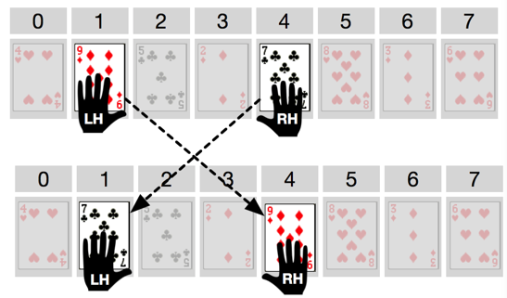

There are 6 commands total in the language available for you to use. These are shown below.

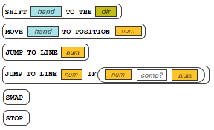

* **Practice with machine language commands**

For this activity, you should assume this standard initial setup. Here is a diagram for an 8-card setup:

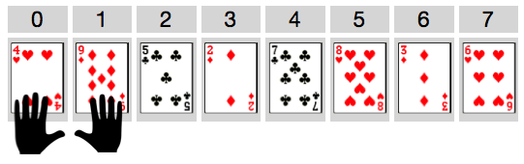

* There will be some number of cards with random values, lined up in a row, face up.
* Positions are numbered starting at 0 and increasing for however many cards there are.
* The left and right hands start at positions 0 and 1 respectively.

Get to know the Human Machine Language by acting out the following examples with a partner. For each of the examples you should:

* Lay out a row of **8** **cards** randomly in front of you to test out the program.
* Have one partner read the instructions in sequence starting at line 1, and the other partner act out each command as the human machine.
* Use the [***code reference***](https://docs.google.com/document/d/1r1wVwte_DVU-UXkD7lH2cN0Jpp5mTV526wCkWYnSnXI/edit?usp=sharing) to answer your questions and verify you’re interpreting the code correctly.
* Give a brief description of what the program does, or its ending state.

|  |  |
| --- | --- |
| **Example Program** | **What does it do?** |
|  | *Note: this one has a problem, can you find it?* |
|  |  |
|  |  |
|  |  |

* **Write an algorithm to search for a card**

Using only the Human Machine Language design a program to find the card with a specified value. When the program stops, the left hand should be touching the specified card. Your program must stop if one of the following conditions is met,

* The left hand is touching the specified card
* The card is not found

Use the hand position values to check whether the position is 0 or the largest position in the list - you can assume that you know how big the list is ahead of time. For example, if the last position is 7, then the comparison: **IF RHPos eq 7** would tell you that the right hand was as the end of the list.

|  |
| --- |
| Once you have figured out an algorithm that works, write your algorithm below. |
|  |

* **Write an algorithm to bring the min card to the front**

Using only the Human Machine Language design an algorithm to find the smallest card and move it to the front of the list (position 0). All of the other cards *must remain in their original relative ordering.*

**END STATE:** When the program stops, the smallest card should be in position 0. The ending positions of the hands do not matter, the ending positions of the other cards do not matter. *As a challenge:* try to move the min-to-front and have all other cards be in their original relative ordering.

Cards BEFORE:

0 1 2 3 4 5 6 7

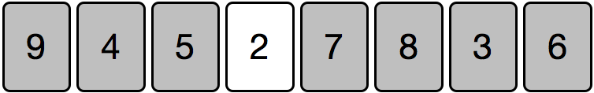

Cards AFTER (may not be in this order)  
 0 1 2 3 4 5 6 7

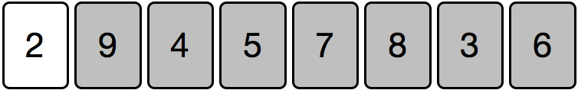

|  |
| --- |
| Once you have figured out an algorithm that works, write your algorithm below. |
|  |

* **Write an algorithm to sort the cards from low to high**

Using only the Human Machine Language design an algorithm to sort the cards from low to high.

**END STATE:** When the program stops, the cards should be sorted from smallest to highest

|  |
| --- |
| Once you have figured out an algorithm that works, write your algorithm below. |
|  |

* **Receive Credit for this lab guide**

Submit this portion of the lab to Pluska to receive credit for the lab guide. Once received, your completed code challenges will also be graded and will count towards your final lab grade.