|  |  |  |  |
| --- | --- | --- | --- |
|  |  | **Fake News Site** |  |

|  |
| --- |
| **Your Tasks (Mark these off as you go)** |
| * Write code to hide or remove elements on a webpage  Modify the style of elements on a webpage  * Write code to modify the text on a webpage * Write code to modify an attribute * Write code to create an element * Receive credit for this lab guide |

* **Write code to hide or remove elements on a webpage**

In a previous lesson we learned how to select and modify attributes on a simple webpage. As it turns out you can do this on any page using the console available to you on any browser.

To access the element you wish to modify, simply right click on the element and select inspect,

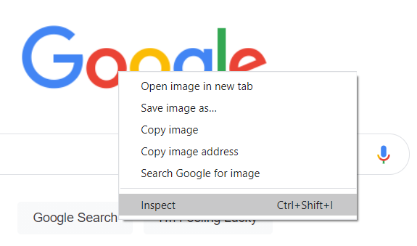

As you click on the HTML elements in the in Elements tab, you can see the elements on the corresponding HTML page highlight. In the below example, I have selected the Google logo.

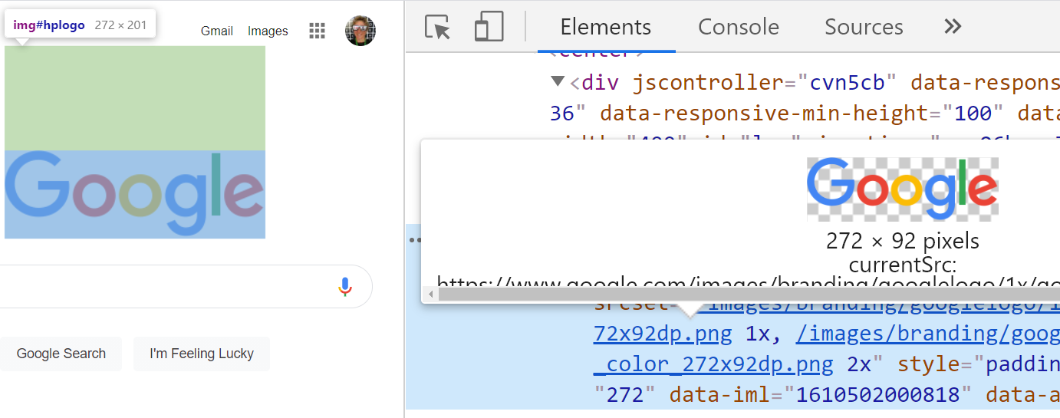

If you look closer at the HTML that is creating this image, you should see some things that look familiar. For example, in the below screen shot below, we can see an *img* tag, along with a corresponding *id* and *src* attribute.

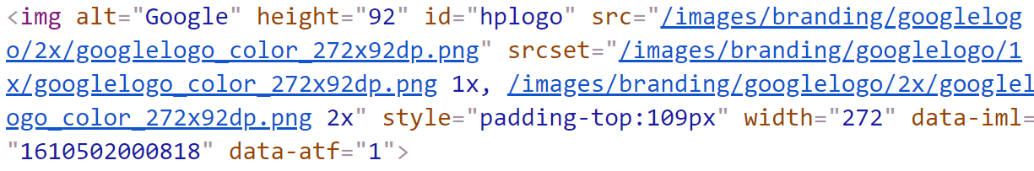

Using the console, we can apply the JavaScript we have learned to modify this image. To access the console, click on the console tab,

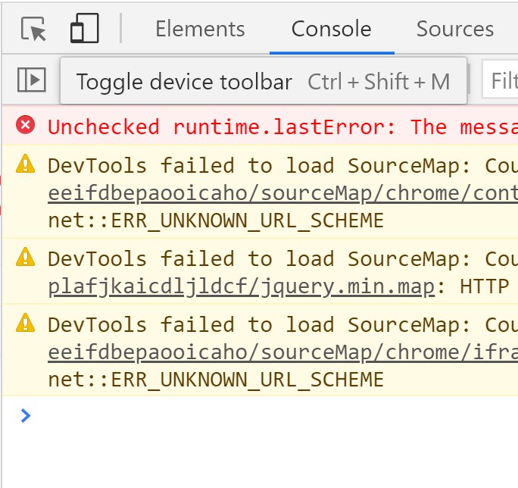

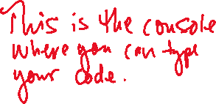

Now consider what happens when you start to type some code in the command line. The code below for example, hides the Google logo!

|  |
| --- |
| document.getElementById("hplogo").hidden = "true"; |

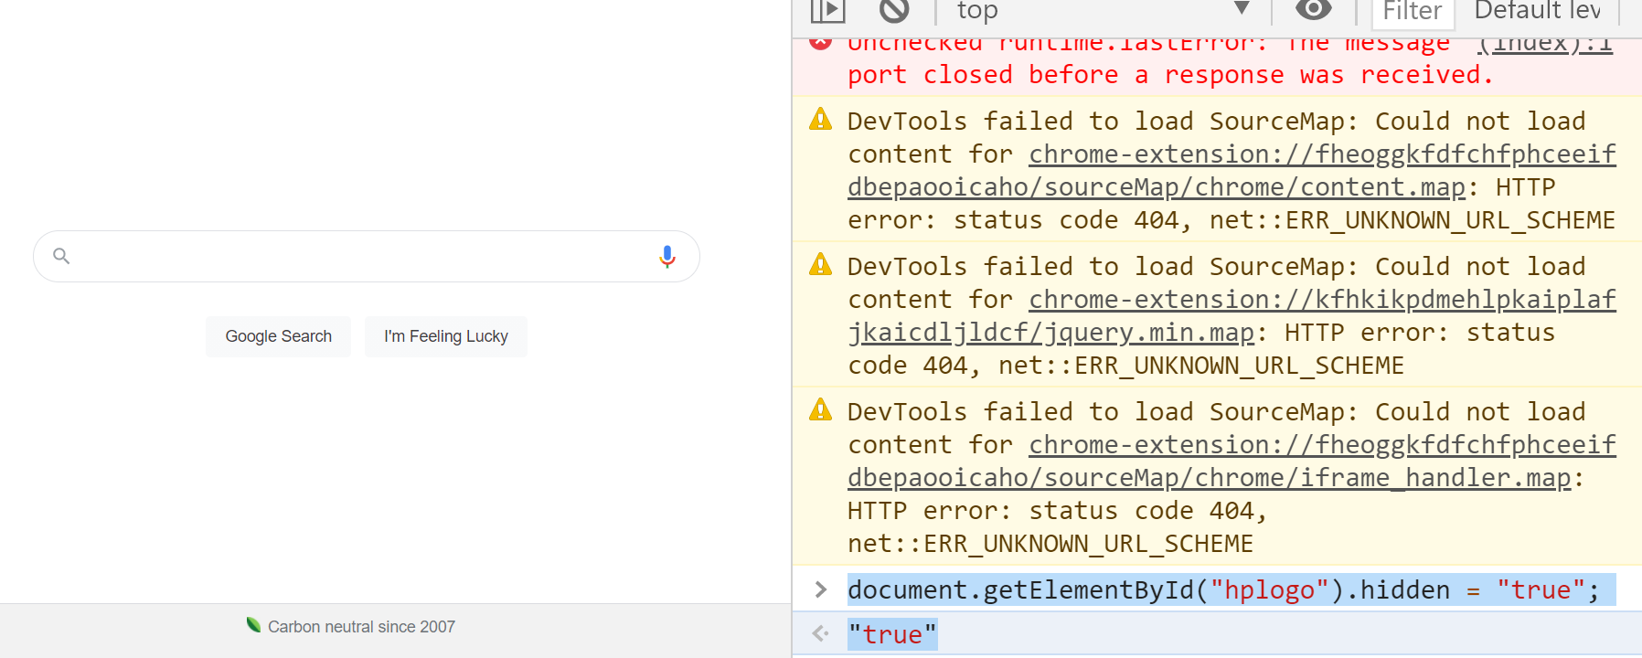

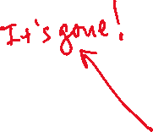

The following code code also be used to remove the same element,

document.getElementById("hplogo").remove();

|  |
| --- |
| Navigate to the google homepage (http://google.com) or to a website your frequent. Right click on different elements and locate an element with an id attribute. Write code to hide and remove different elements on the page. Copy and paste your code below. |
|  |

* **Modify the style of elements on a webpage**

As a review, let’s consider how we can modify the style of different elements on a webpage. Below are some examples,

Font Color

To change the color of text we use the *.color* property. This is illustrated in the following example. Notice that we simply typed the color “red” and the browser new how to interpret it. Modern browsers support 140 named colors, which are listed here, https://htmlcolorcodes.com/color-names/

|  |  |
| --- | --- |
| <div id="menu">  <img id = "burgerImage" src = "burger.jpg">  <h1>BBQ BACON BURGER</h1>  <p class="item">BBQ Bacon Burger</p>  <a href="#"  id="button">ORDER NOW</a>  </div> | |
| **Code** | **Output** |
| var content = document.getElementById("menu");  content.style.color = "red"; |  |

Background Color

To change the background color of an element we use the *.backgroundColor* property.

|  |  |
| --- | --- |
| <div id="menu">  <img id = "burgerImage" src = "burger.jpg">  <h1>BBQ BACON BURGER</h1>  <p class="item">BBQ Bacon Burger</p>  <a href="#"  id="button">ORDER NOW</a>  </div> | |
| **Code** | **Output** |
| var content = document.getElementById("menu");  content.style.color = "red";  content.style.backgroundColor = "Gainsboro"; |  |

Dimensions

The width and height of elements can also be specified. When specifying the width or height of an element you can either indicate the value in pixels (px) or as a percentage (%). If you are resizing an image, it is best to resize only one of the dimensions to ensure it scales and doesn’t appear distorted.

You may be wondering why we would want to define the dimensions as percentages. When you consider the diversity in screen sizes, percentages make sense, because different screen sizes will render sizes specified in pixels differently.

|  |  |
| --- | --- |
| <img id = "burgerImage" src = "burger.jpg"> | |
| **Code** | **Output** |
| var image = document.getElementById("burgerImage");  image.style.width = "100px"; |  |
| var image = document.getElementById("burgerImage");  image.style.width = "20%"; |  |

Font Size

The size of font can be specified with the *.fontSize* property. Just as with the width and height, we can also specify the font relative to the screen we are on by using units *em* as opposed to pixels (px). If you specify the *fontSize* to 2 em, the font will appear 2x as large. If you specify the *fontSize* to 1.5 em, the font will appear 1.5x as large, etc.

|  |  |
| --- | --- |
| <div id="menu">  <img id = "burgerImage" src = "burger.jpg">  <h1>BBQ BACON BURGER</h1>  <p class="item">BBQ Bacon Burger</p>  <a href="#"  id="button">ORDER NOW</a>  </div> | |
| **Code** | **Output** |
| var content =  document.getElementById("menu");  content.style.fontSize = "2em"; |  |

Font Style

There are three basic font styles you can apply to text: normal, italic, or oblique. These can be applied with the *.fontStyle* property.

|  |  |
| --- | --- |
| <div id="menu">  <img id = "burgerImage" src = "burger.jpg">  <h1>BBQ BACON BURGER</h1>  <p class="item">BBQ Bacon Burger</p>  <a href="#"  id="button">ORDER NOW</a>  </div> | |
| **Code** | **Output** |
| var content = document.getElementById("menu");  content.style.fontStyle = "oblique"; |  |

Borders

Borders can be applied to any element using the *.border* property. For a border to appear however requires that you specify three values: style, thickness, and color.

There are three different styles you can apply: dotted, dashed, solid. The thickness can be specified in pixels (px) or em. The color can be specified as before.

|  |  |
| --- | --- |
| <div id="menu">  <img id = "burgerImage" src = "burger.jpg">  <h1>BBQ BACON BURGER</h1>  <p class="item">BBQ Bacon Burger</p>  <a href="#"  id="button">ORDER NOW</a>  </div> | |
| **Code** | **Output** |
| var content = document.getElementById("menu");  content.style.border = "dotted 2em green"; |  |

|  |
| --- |
| Navigate to the google homepage (http://google.com) or to a website your frequent. Right click on different elements and locate an element with an id attribute. Write code to modify different elements on the page. Try changing the font, the borders, etc. Copy and paste your code below. |
|  |

* **Write code to modify the text on a webpage**

Recall, that if the element you are trying to modify contains text, you can also change the text with JavaScript using the innerHTML method.

Let’s consider an example of how to change the innerHTML for elements where a default id is NOT provided.

If there is no id provided with the element you want to edit, you can easily create your own. In the example below, I want to edit the headline on CNN, but there is not an id associated with it. By right-clicking and selecting Edit as HTML however, I can add my own id.

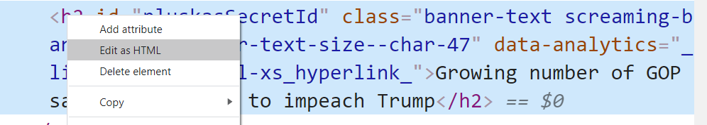

Check it out! I now have my secret id.

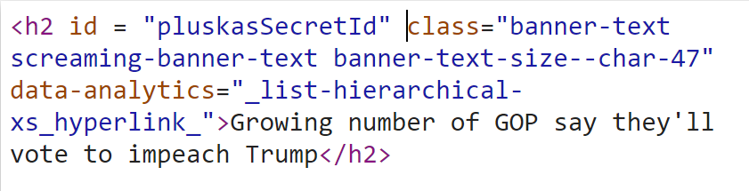



Now, let’s change the headline.

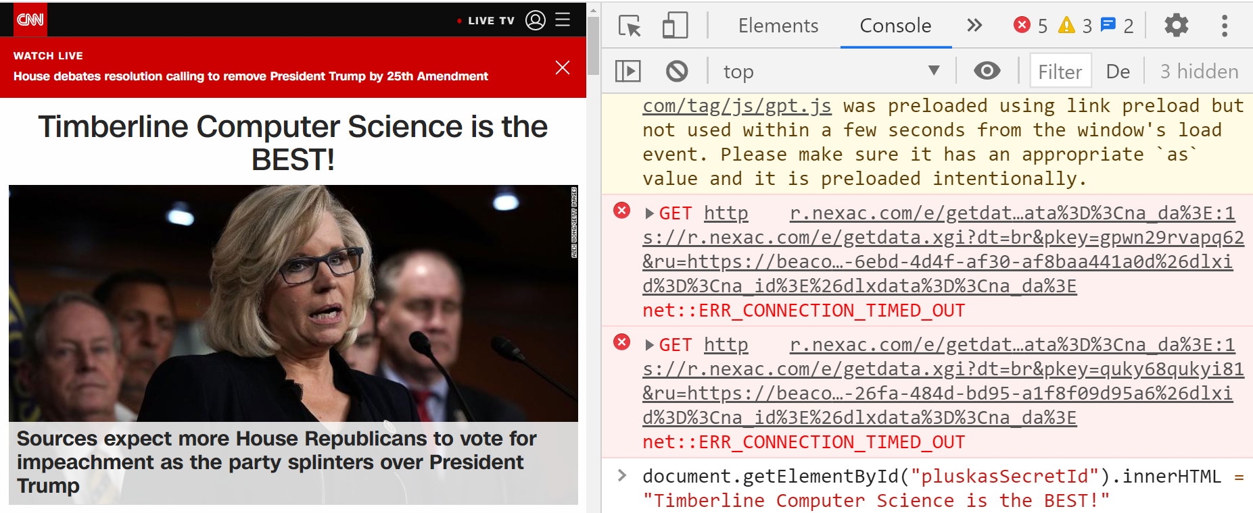

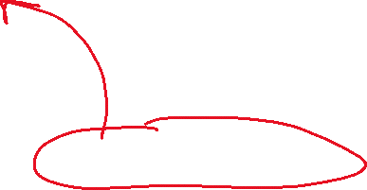

|  |
| --- |
| Navigate to the google homepage (http://google.com) or to a website your frequent. Add an id to a text element, then use JavaScript to modify the text. Copy and paste your code below, |
|  |

* **Write code to modify an attribute**

Attributes for HTML elements can be selected using the same *selectElementById* method we used previously. And, just as we saw above, if the element does not have an id, we can easily add our own.

Below, I added the id “pluskaHacker” to an image on the CNN site.

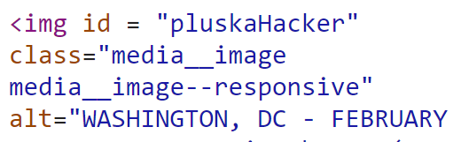

Now, time to change the image. Because we do not have access to the server of the computer, we will need to get the address of the image. To do this, do a google image search. When you find an image, right click on the image and select, “Open image in new tab”.

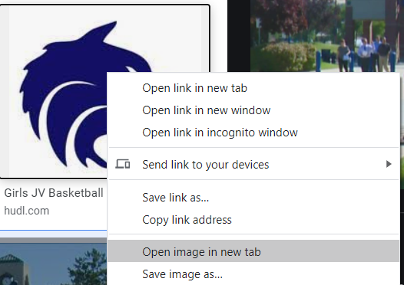

If the image opens in a new tab, select “Copy image address”. Use this image address as the src reference.

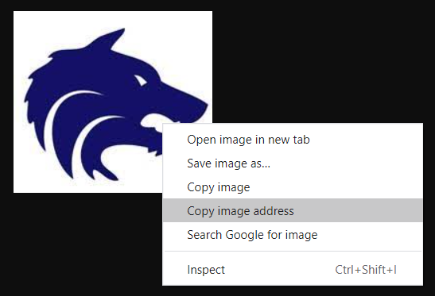

Below is the result of few images I modified on the CNN website.

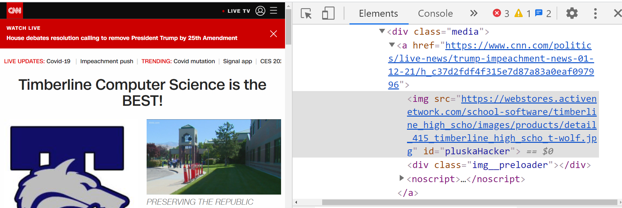

|  |
| --- |
| Navigate to the google homepage (http://google.com) or to a website your frequent. Locate an img tag and add and id attribute if necessary. Next, browse the internet for an image. Once you find an image, right click and select “copy image address”. Select the image and change the src attribute with the image. Copy and paste your final code below, |
|  |

* **Write code to create an element**

The *.createElement(tagName)* method creates a new element based on the specified tag name. However, it does not append it to the document. It creates an empty element with no inner HTML.

To create an element and add it to the web page, you must assign it to an element that already exists on the DOM. We call this process appending. The *.append* method will add the element as the last child node.

The following code (1) creates a new paragraph element and assigns the element to a variable called *myParagraph*, (2) adds text to the new element’s *innerHTML*, and (3) appends it to the body of the document:

|  |
| --- |
| var myParagraph = document.createElement('p');  myParagraph.innerHTML = "The text inside paragraph";  document.body.append(myParagraph); |

In our previous lessons we have learned how to control elements on the page by accessing their id’s. In the example above, the paragraph we created does not have an *id* associated with it. To specify an id we can use the id property as follows,

|  |
| --- |
| myParagraph.id = "p1"; |

Now that we have associated an *id* to our new element, we can modify it using the same techniques we learned before. In the below example, the background of the new paragraph we created is changed to *seagreen*.

|  |
| --- |
| Document.getElementById(“  document.getElementById("p1").style.backgroundColor = "seagreen"; |

Below is working example from the CNN website,

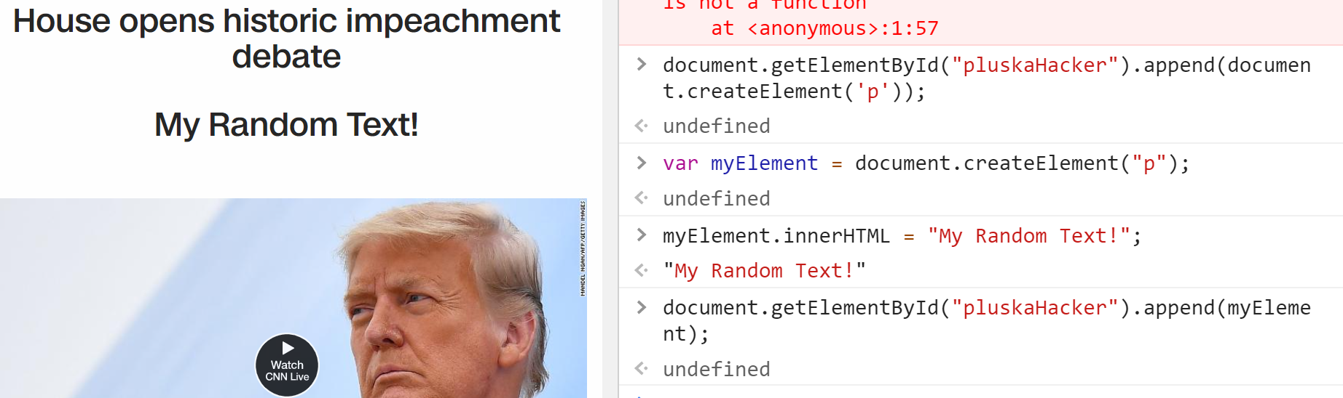



|  |
| --- |
| Navigate to the google homepage (http://google.com) or to a website your frequent. Create some new elements on the page. Trying adding text, positioning, styling them. Copy and paste your final code below, |
|  |

* **Receive Credit for this lab guide**

Submit this portion of the lab to Pluska to receive credit for the lab guide.

