|  |  |  |  |
| --- | --- | --- | --- |
|  |  | **Hyperlinks** |  |

|  |
| --- |
| **Your Tasks** |
| * Define key vocabulary * Write code to create an internal link in your website * Write code to create an external link * Write code to create a hyperlink in a new window * Write code to create a hyperlink to a location on the same page * Receive credit for the group portion of this lab |

* **Define key vocabulary**

hyperlink

|  |
| --- |
|  |

href attribute

|  |
| --- |
|  |

anchor tag <a>

|  |
| --- |
|  |

target attribute

|  |
| --- |
|  |

bookmark

|  |
| --- |
|  |

* **Write code to create an internal link in your website**

Most websites are made up of many pages which are linked together. In our previous lesson we learned how to create a link from one page to another within a website. Recall that to create a link requires an anchor tag <a> and a *href* attribute. How to create a link from one page to another is illustrated below,

|  |  |
| --- | --- |
| **MyWebiste** |  |
| Index.html  houses.html |
| 1. The <a> tag wraps the text that you want to turn into a clickable link. a is short for anchor. 2. The *href* attribute, short for hypertext reference, determines where your link should go to. In this case, houses.html. 3. The closing tag ends your link | |

|  |  |
| --- | --- |
| Write code that could be used to create a link to FavThings.html from the Index.html page. | |
| **File Structure** | **Code** |
| |  | | --- | | **MyWebsite** | | Index.html  FavThings.html | |  |
| |  | | --- | | **MyWebsite** | | Index.html   |  | | --- | | **Files** | | |  |  | | --- | --- | | **AboutMe** | **Videos** | | FavThings.html | Dog.mp4 | | | |  |
| **MyWebsite** |  |
| |  |  | | --- | --- | | **Home** | **Files** | | Index.html | |  | | --- | | **AboutMe** | | FavThings.html | | |  |

* **Write code to create an external link**

An external link is a link to a page outside of your website. To create an external link to a page, simply replace the contents of *href* attribute with the the url of the site you want to direct your users. The text between the anchor tags (<a> </a>) should also be replaced with a descriptive name of the link. Below is an example,

|  |  |
| --- | --- |
| **MyWebsite** | **Link to external site** |
| Index.html | <a href=”[http://youtube.com](http://youtube.com/)” >Click here to go to YouTube!</a> |

|  |  |
| --- | --- |
| Write code that could be used to create links to the following websites from the Index.html page. | |
| **Website** | **Code** |
| Netflix |  |
| Reddit |  |

* **Write code to create a hyperlink in a new window**

If you want to direct your user to a link outside your current website, it is good practice to open this page in a window. You can do this using a attribute called target. By specifying the target as “_blank”, you can force the link to open in a new window. Below illustrates how to do this.

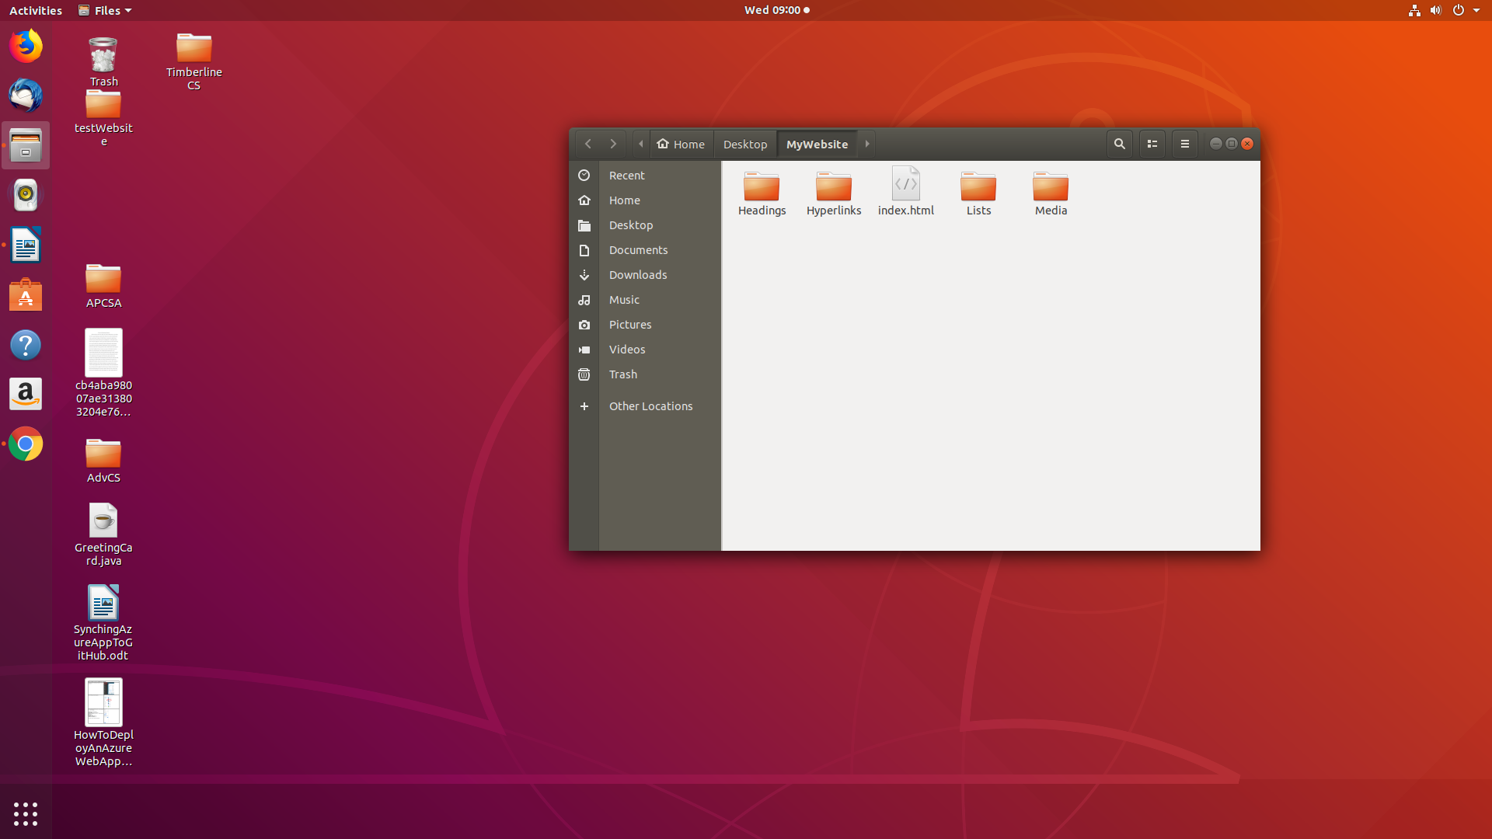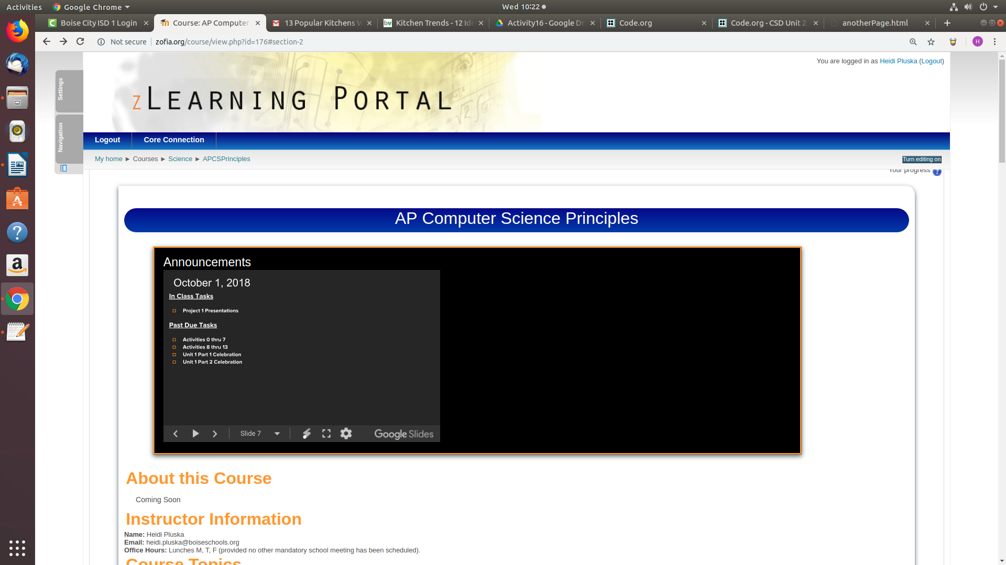

|  |
| --- |
| <a href = “../index.html” target=”_blank”> A link to my hyperlinks page</a> |

|  |  |
| --- | --- |
| Write code that could be used to create links to the following websites from the Index.html page. Have each website open in a new window. | |
| **Website** | **Code** |
| Espn |  |
| Google |  |

* **Write code to create a hyperlink to a location on the same page**

Hyperlinks can also be used to navigate within a page. Links to sections within a page are also referred to as bookmarks. Consider the links below. Notice the reference for each link is proceeded by the *#* sign. This tells the browser that the reference is to the current page. The location of the reference is specified by the *id* attribute.



|  |
| --- |
| <ul>  <li><a href="#tedTalks">Ted Talks</a></li>  <li><a href="#knowledgeCelebrations">knowledge celebrations</a></li>  <li><a href="#labs">labs</a></li>  </ul>  <h1 id="tedTalks">Ted Talks</h1>  <ul>  <li>  <a href="https://www.ted.com/talks/raffaello_d_andrea_meet_the_dazzling_flying_machines_of_the_future?utm_campaign=tedspread&utm_medium=referral&utm_source=tedcomshare">Week 0: Dazzling Flying Machines of the Future</a>  </li>  <li>  <a href="https://www.ted.com/talks/maurice_conti_the_incredible_inventions_of_intuitive_ai">Week 1: The Incredible Inventions of Intuitive AI</a>  </li>  </ul> |

|  |  |
| --- | --- |
| Consider a webpage with the following sections, “My Hobbies”, “Proudest moments”, “Favorite vacations”. Rewrite the code between the <body></body> tags so that the items listed under the *Menu* heading link to the correct locations on the page. | |
| <!DOCTYPE html>  <html>  <head>  </head>  <body>  <h1>Menu</h1>  <ul>  <li>Favorite things</li>  <li>Proudest moments</li>  <li>Favorite places</li>  </ul>  <h1> Favorite things</h1>    <h1> Proudest moments </h1>    <h1> Favorite places</h1>    </body>  </html> |  |

* **Receive Credit for this lab guide**

Submit this portion of the lab to Pluska to receive credit for the lab guide.