|  |  |
| --- | --- |
| **Activity Guide - Broadcast Battleship Rules** |  |

**Overview**

Today you’ll be playing a crazy version of the classic board game, Battleship. In the classic game, the board is 10x10, but here we play with a 3x3 board. The classic game is a guessing game for two people. Here are the rules for our multi-person version of the game.

**Goal: Win the most games!**

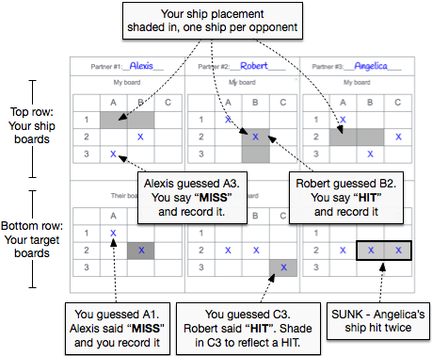**Game Objective**

* The object of Battleship is to try and sink another player's ship before they sink yours.
* The other player's ship is somewhere on his/her board
* Each turn, you try to guess your opponent’s ship location by calling out a coordinate on the grid.
* The other player also tries to hit your ship by calling out coordinates.
* You maintain and mark two grids:
  1. Your *Ship Boards* - where you record shots fired against you.
  2. Your *Target Boards* - where you record the shots you fired against others.

**Starting a New Game**

* Each player places a ship on their board - one ship for each opponent
* A ship occupies two contiguous squares on the grid - vertically or horizontally. NO Diagonal placement.
* Once the guessing begins, the players may not move the ships.

**Playing the Game**

The diagram shows an example of a game in progress between 4 players - you, Alexis, Robert and Angelica. You can see how you might mark the board.

* Players try to guess their opponent’s ship locations by calling out coordinates.
* The opponent responds with "HIT" or "MISS" as appropriate.
* Both players should mark their grid with separate markings for hit or miss.
* When both of the squares that represent one ship have been hit, that should be announced as "HIT AND SUNK!". As soon as all of one player's ships have been sunk, the game ends.