|  |
| --- |
| **Set 9. Addressing the Internet** |

|  |
| --- |
| **Skill 9.01: Explain the purpose of IP addresses**  **Skill 9.02: Identify a valid IP4 address and the limitations**  **Skill 9.03: Identify a valid IPv6 address and why it is needed**  **Skill 9.04: Differentiate between static and dynamic IP addresses**  **Skill 9.05: Interpret an IP address** |

|  |
| --- |
| **Skill 9.01: Explain the purpose of IP addresses** |

**Skill 9.01 Concepts**

The **Internet Protocol (IP)** is one of the core protocols in the layers of the Internet, as you might guess from its name. It's used in all Internet communication to handle both addressing and routing.

The protocol describes the use of **IP addresses** to uniquely identify Internet-connected devices. Just like homes need mailing addresses to receive mail, Internet-connected devices need an IP address to receive messages.

When a computer sends a message to another computer, it must specify the recipient's IP address and also include its own IP address so that the second computer can reply.

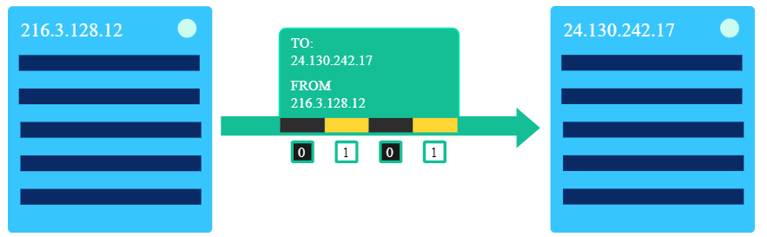

Watch the video below through 4:10 to learn more about the role of IP addresses in Internet communication,

|  |
| --- |
|  |
| <https://www.youtube.com/watch?v=5o8CwafCxnU&feature=youtu.be> |

[**Skill 9.01 Exercises 1 thru 3**](https://hpluska.github.io/APCompSciPrinciples/ticketOutTheDoor/set9/Set9TicketOutTheDoorAPCompSciPrinciples.pdf)

|  |
| --- |
| **Skill 9.02: Identify a valid IP4 address and the limitations** |

**Skill 9.02 Concepts**

There are two versions of the Internet Protocol in use today:

* IPv4, the first version ever used on the Internet
* IPv6, a backwards-compatible successor

In the IPv4 protocol, IP addresses look like this:

**74.125.20.113**

Each IP address is split into 4 numbers, and each of those numbers can range from 0 to 255:

**[0-255].[0-255].[0-255].[0-255]**

We write those numbers in decimal, but the computer stores them in binary, like so:

**01010101 01010101 01010101 01010101**

Each number can represent 28 values, thanks to the 8 bits. That's also why we often call them "octets."

Overall, that's 232 possible values: 4, 294, 967, 296 possible IPv4 addresses.

That's a lot! But remember, in the beginning, we said there are more than four billion devices connected to the Internet? Well, we're reaching the limit of possible IP addresses. It's time for plan B.

**[Skill 9.02 Exercise 1](https://hpluska.github.io/APCompSciPrinciples/ticketOutTheDoor/set9/Set9TicketOutTheDoorAPCompSciPrinciples.pdf)**

|  |
| --- |
| **Skill 9.03: Identify a valid IPv6 address and why it is needed** |

**Skill 9.03 Concepts**

Back when the Internet protocols were first invented, the creators didn't anticipate how popular it would become and that there would eventually be more than 232 devices wanting to connect to the Internet.

When it became obvious in the 1990s that the IPv4 addresses were running out, the IPv6 protocol was proposed with a much longer addressing scheme.

Here's an IPv6 address:

**2001:0db8:0000:0042:0000:8a2e:0370:7334**

Notice the letters in those numbers, like d and b in 0db8? Those are hexadecimal numbers, which means that the IPv6 address is much longer than it looks. Let’s do some math to see exactly how much longer.

In the IPv6 addresses scheme there are 8 hexadecimal numbers, and each number is 4 digits long. So, for each number that is 164 possibilities. If we combine all 8 numbers, we end up with 1632 possible addresses! That’s 340 undecillion!

**340,282,366,920,938,000,000,000,000,000,000,000,000**

**[Skill 9.03 Exercise 1](https://hpluska.github.io/APCompSciPrinciples/ticketOutTheDoor/set9/Set9TicketOutTheDoorAPCompSciPrinciples.pdf)**

|  |
| --- |
| **Skill 9.04: Differentiate between static and dynamic IP addresses** |

**Skill 9.04 Concepts**

One way to find out your computer's IP address is by searching Google for "IP address". Google knows your IP address, since your computer sends a message to the Google computers as soon as it loads google.com.

Your IP address might be different tomorrow than it is today. Each ISP (Internet Service Provider) has a range of addresses they can assign, and they might give you a different one of those addresses each time they see your computer pop up on the network. That's called a dynamic IP address.

Switching to a different Wi-Fi network will definitely give you a new IP address, since each Wi-Fi provider has its own range of addresses that it can give out.

Computers that act as servers, like the computers that power Google.com, often have static IP addresses. That makes it easier for computers to quickly send search requests to the Google servers. If you tried out the IP address below, you will find yourself on the Google homepage.

**74.125.20.113**

[**Skill 9.04 Exercise 1**](https://hpluska.github.io/APCompSciPrinciples/ticketOutTheDoor/set9/Set9TicketOutTheDoorAPCompSciPrinciples.pdf)

|  |
| --- |
| **Skill 9.05: Interpret an IP address** |

**Skill 9.05 Concepts**

Both IPv4 and IPv6 addresses are hierarchical. For simplicity, let's examine the hierarchy of IPv4 addresses.

Consider this IP address:

**24.147.242.217**

The first sequence of bits identifies the network and the final bits identify the individual node in the network.

That IP address could break down into these 2 parts:

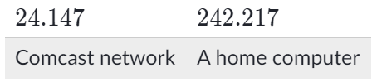

The first two octets (16 bits) identifies a network administered by the Comcast (an Internet Service Provider). The last two octets (the final 16 bits) identifies a home computer on that Comcast network.

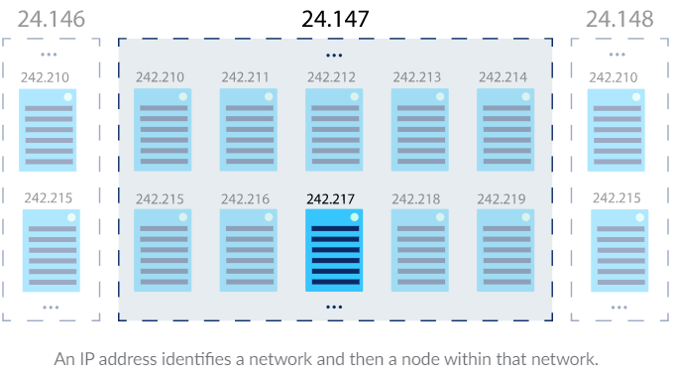

If the last two octets were different, then the IP address would point at a different computer on the Comcast network. If the first two octets were different, then the IP address might belong to a completely different network administrator.

The Internet Protocol uses this hierarchical addressing scheme to make it easier to route messages from source to destination. Once a message arrives at the network, a network router can take care of sending it to the individual node. The next lesson on routing dives into more details on how that works.

Subnets

Network administrators can break IP addresses into further subnetworks (subnets) as needed.

Starting with this IP address:

141.213.127.13

That could break down into 3 parts:

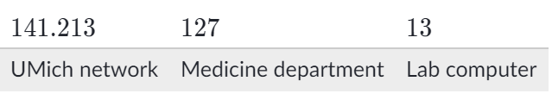

The first two octets identify the entire network for the University of Michigan, the third octet identifies the UMich Medicine department's network, and the fourth octet identifies an individual lab computer in that department's network.

Adding further levels to the address hierarchy can improve the efficiency of routing within the network.

Splitting octets

In actuality, IP addresses are often split in the middle of the octets.

To understand how that works, let's represent the previous IP address in binary instead:

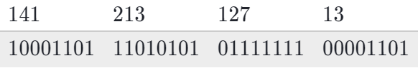

All together, that translates into these 32 bits:

10001101110101010111111100001101

The first 16 bits could route to all of UMich, the next 2 bits could route to a specific UMich department, and the final 14 bits could route to individual computers.

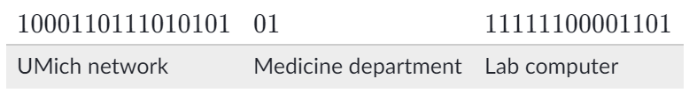

This hierarchy gives UMich the ability to differentiate between 22 (4) departments and 214 (16,384) computers within each department.

Splitting octets might seem confusing at first, but computers store the IP addresses as binary anyways, so it is all the same to them.

As we've just seen, the ability to create hierarchical levels at any point in the IP address allows for greater flexibility in the size of each level of the hierarchy.

**[Skill 9.05 Exercise 1](https://hpluska.github.io/APCompSciPrinciples/ticketOutTheDoor/set9/Set9TicketOutTheDoorAPCompSciPrinciples.pdf)**