|  |
| --- |
| **Set 13. Introduction to HTML** |

|  |
| --- |
| **Skill 13.01: Explain the purpose of HTML**  **Skill 13.02: Describe the HTML page naming convention**  **Skill 13.03: Describe the structure of an HTML page**  **Skill 13.04: Explain the structure and purpose of an element**  **Skill 13.05: Explain the child-parent relationship of elements**  **Skill 13.06: Add a title to an HTML page**  **Skill 13.07: Add comments to an HTML page** |

|  |
| --- |
| **Skill 13.01: Explain the purpose of HTML** |

**Skill 13.01 Concepts**

We'll begin our study of web programming by learning the core language for writing web pages: **Hypertext Markup Language (HTML)**. HTML describes the contents of your page, such as headings, paragraphs, images, and lists.

The version of HTML we will learn is the latest and most standard, called HTML5. The pages you will write will work in any modern browser.

Watch the video below to learn more,

|  |
| --- |
|  |
| <https://youtu.be/Hjl6gbg9kmk> |

|  |
| --- |
| **Skill 13.02: Describe the HTML page naming convention** |

**Skill 13.02 Concepts**

Before you begin coding in HTML you must first create an HTML file. You can name your HTML file whatever you want as long as the name follows the rules below,

* All HTML files must end with an *.html extension. For example, Index.html, MyPage.html
* The name of the file cannot have spaces
* The only allowed special character is the underscore “_”

Although it is not a requirement it is always a good practice to name your html files using *upper camel case*. Upper camel case is a naming convention that indicates the separation of words with a capital letter instead of spaces. Consider the following examples,

|  |
| --- |
| UpperCamelCase.html  MyWebPage.html |

**[Skill 13.02 Exercise 1](https://hpluska.github.io/APCompSciPrinciples/ticketOutTheDoor/set16/Set16TicketOutTheDoorAPCompSciPrinciples.pdf)**

|  |
| --- |
| **Skill 13.03: Describe the structure of an HTML page** |

**Skill 13.03 Concepts**

Once you have created your HTML page, you can start coding!

All HTML documents must start with a <!DOCTYPE> declaration. This declaration is not an HTML tag. It is "information” you need to provide to the browser about what document type to expect.

In HTML 5, the declaration is simple:

|  |
| --- |
| <!DOCTYPE html> |

The <!DOCTYPE> declaration is NOT case sensitive. The following examples are also acceptable,

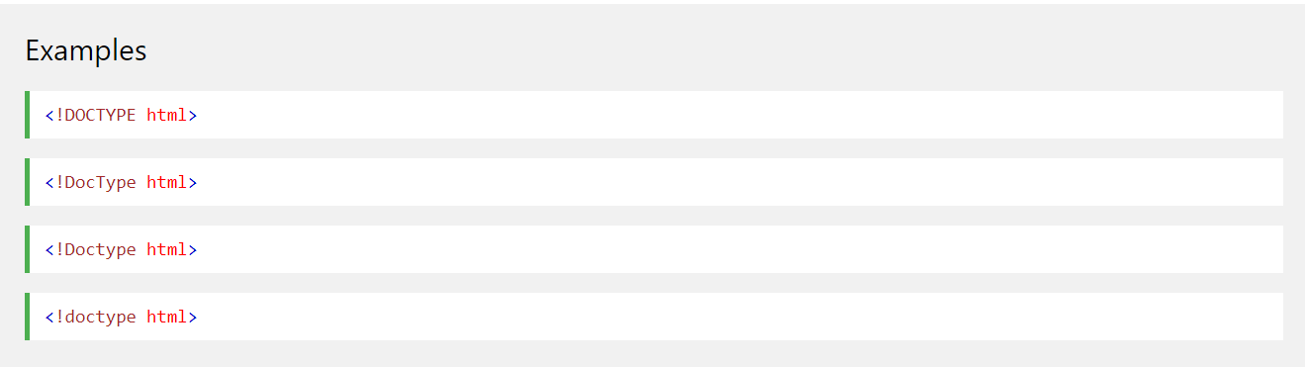

All HTML pages are constructed in hierarchy of *HTML tags.* The <html> tag represents the root of an HTML document. It is also the container for all other HTML elements. All HTML tags are contained with the greater than and less than symbols, “< >”

The <html> tag has a corresponding open and close component.

|  |
| --- |
| <!DOCTYPE html>  <html>    </html> |

The <html> </html> section of your HTML page is divided into two more sections: a head and a body. Each of the sections are denoted with corresponding open and closing tags,

|  |
| --- |
| <!DOCTYPE html>  <html>  <head>  </head>  <body>  </body> </html> |

Information in the head section of the page are not displayed to the user. This section typically contains links to external resources needed to make the page run properly.

What appears in the body section however, is displayed on the users browser.

**[Skill 13.03 Exercise 1](https://hpluska.github.io/APCompSciPrinciples/ticketOutTheDoor/set16/Set16TicketOutTheDoorAPCompSciPrinciples.pdf)**

|  |
| --- |
| **Skill 13.04: Explain the structure and purpose of an element** |

**Skill 13.04 Concepts**

HTML is composed of elements. These elements structure the webpage and define its content. Let’s take a look at how they’re written.

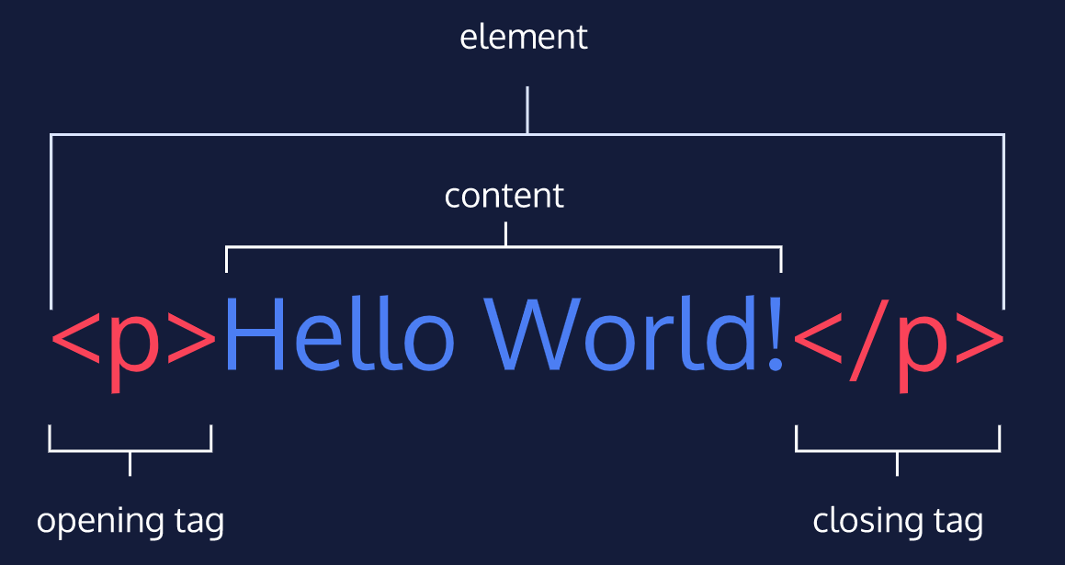

The diagram above displays an HTML paragraph element. As we can see, the paragraph element is made up of:

* An opening tag (<p>)
* The content (“Hello World!” text)
* A closing tag (</p>)

A tag and the content between it is called an HTML element. There are many tags that we can use to organize and display text and other types of content, like images.

Let’s quickly review each part of the element pictured:

* HTML element (or simply, element) — a unit of content in an HTML document formed by HTML tags and the text or media it contains.
* HTML Tag — the element name, surrounded by an opening (<) and closing (>) angle bracket.
* Opening Tag — the first HTML tag used to start an HTML element. The tag type is surrounded by opening and closing angle brackets.
* Content — The information (text or other elements) contained between the opening and closing tags of an HTML element.
* Closing tag — the second HTML tag used to end an HTML element. Closing tags have a forward slash (/) inside of them, directly after the left angle bracket.

The elements we want to display to the user must formatted between the <body></body> tags,

|  |
| --- |
| <!DOCTYPE html>  <html>  <head>  </head>  <body>  <p>Hello World!<p>  </body> </html> |

**[Skill 16.04 Exercises 1](https://hpluska.github.io/APCompSciPrinciples/ticketOutTheDoor/set16/Set16TicketOutTheDoorAPCompSciPrinciples.pdf)**

|  |
| --- |
| **Skill 13.05: Explain the parent-child relationship of elements** |

**Skill 13.05 Concepts**

HTML is organized as a collection of family tree relationships. As you saw in the last example, we placed <p> tags within <body> tags. When an element is contained inside another element, it is considered the child of that element. The child element is said to be nested inside of the parent element.

|  |
| --- |
| <body>  <p>Hello World!<p>  </body> |

In the example above, the <p> element is nested inside the <body> element. The <p> element is considered a child of the <body> element, and the <body> element is considered the parent. You can also see that we’ve added a tab of indentation (using the tab button) for better readability.

Since there can be multiple levels of nesting, this analogy can be extended to grandchildren, great-grandchildren, and beyond. The relationship between elements and their ancestor and descendent elements is known as hierarchy.

Let’s consider a more complicated example that uses some new tags:

|  |
| --- |
| <body>  <div>  <h1>Sibling to p, but also grandchild of body<h1>  <p>Sibling to h1, but also grandchild of body</p>  </div>  </body> |

In this example, the <body> element is the parent of the <div> element. Both the <h1> and <p> elements are children of the <div> element. Because the <h1> and <p> elements are at the same level, they are considered siblings and are both grandchildren of the <body> element.

Understanding HTML hierarchy is important because child elements can inherit behavior and styling from their parent element.

**[Skill 13.05 Exercises 1](https://hpluska.github.io/APCompSciPrinciples/ticketOutTheDoor/set16/Set16TicketOutTheDoorAPCompSciPrinciples.pdf)**

|  |
| --- |
| **Skill 13.06: Add a title to an HTML page** |

**Skill 13.06 Concepts**

As aforementioned, content in the head section of the page is not displayed to the user. The head section contains metadata for the page. Metadata is information about the page that isn’t displayed directly on the web page. Unlike the information inside of the <body> tag, the metadata in the head is information about the page itself.

What kind of metadata about the web page can the <head> element contain?

If you navigate to a website, you will notice the tab in which the page is displayed contains specific text related to the page.

For example, if you navigate to <http://w3schools.com>, the following text is displayed in the tab,



The specific text displayed in the tab for a page is specified in the <title> tag. The <title> tag is always inside of the <head>.

|  |
| --- |
| <!DOCTYPE html>  <html>  <head>  <title>My Coding Journal</title>  </head>  <body>  </body> </html> |

If we were to open a file containing the HTML code in the example above, the browser would display the words My Coding Journal in the title bar (or in the tab’s title).

**[Skill 13.06 Exercises 1](https://hpluska.github.io/APCompSciPrinciples/ticketOutTheDoor/set16/Set16TicketOutTheDoorAPCompSciPrinciples.pdf)**

|  |
| --- |
| **Skill 13.07: Add comments to an HTML page** |

**Skill 13.07 Concepts**

Comments are segments of code that you can add to your program that are ignored by the browser. They are extremely important for both testing and documenting your code. As we move through the course, you will realize the importance of comments and documenting your code.

Comments in HTML documents, must be begin with <!-- and end with -->. Everything in between will be ignored by the browser.

|  |
| --- |
| <!-- This text will be ignored by the browser --> |

**[Skill 13.07 Exercises 1](https://hpluska.github.io/APCompSciPrinciples/ticketOutTheDoor/set16/Set16TicketOutTheDoorAPCompSciPrinciples.pdf)**