|  |
| --- |
| **Set 15. Hyperlinks** |

|  |
| --- |
| **Skill 15.01: Reference internal pages**  **Skill 15.02: Create an internal link to a page**  **Skill 15.03: Create a link to an external page**  **Skill 15.04: Create a hyperlink in a new window**  **Skill 15.05: Create a hyperlink to a location on the same page** |

|  |
| --- |
| **Skill 15.01: Reference internal pages** |

**Skill 15.01 Concepts**

So far, all the contents of your website have been on one page. Most websites however include many pages. The links within your webpages can send users to different websites or to different pages within your site.

Just like with images, the pages you include with your website are separate files and will need to be referenced correctly to be displayed. Webpages are referenced using the *href* attribute - short for hypertext reference. This tells the tag the location of the page to load.

Consider the following file structure. Index.html is in the same folder as Contact.html. The following code could be used to reference Contact.html from the Index.html page.

|  |  |
| --- | --- |
| **MyWebsite** | href = “Contact.html” |
| Index.html  Contact.html |

Now consider an example where the *Contact.html* file we are trying to reference is stored in a directory that is different than *Index.html*. In the file structure below, we have created a directory called *Info* and placed the Contact.html page inside it. The following code could be used to reference the *Contact.html* page from the *Index.html* page.

|  |  |
| --- | --- |
| **MyWebsite** | href = “Info/Contact.html” |
| Index.html   |  | | --- | | **Info** | | Contact.html | |

Finally consider the situation below. *Index.html* and *Contact.html* are both in separate directories in the *MyWebsite* directory. Inside the *Home* directory we have an *Index.html* page and inside the *Info* directory we have our image *Contact.html* page we want to reference. To do this, we must first “backout” of the *Home* directory, then enter the Info directory. The “. .” syntax is used to backout of a directory.

|  |  |  |
| --- | --- | --- |
| **MyWebsite** | | href = “../Info/Contact.html” |
| **Home** | **Info** |
| Index.html | Contact.html |

**[Skill 15.01 Exercise 1](https://hpluska.github.io/APCompSciPrinciples/ticketOutTheDoor/set18/Set18TicketOutTheDoorAPCompSciPrinciples.pdf)**

|  |
| --- |
| **Skill 15.02: Create an internal link to a page** |

**Skill 15.02 Concepts**

To link the content of your pages to one another you will use an anchor tag <a></a>.

To tell the browser the location and name of the file to display, you need to use the *href* attribute. The *href* attribute is added to the *a* tag inside the brackets.

How the *a* tag can be used to create a link to another page in your website is illustrated below,

|  |  |
| --- | --- |
| **Media** |  |
| Index.html  houses.html |
| 1. The <a> tag wraps the text that you want to turn into a clickable link. A is short for anchor. 2. The href attribute, short ofr hypertext reference, determines where your link should go to. In this case, houses.html. 3. The closing tag ends your link | |

**[Skill 15.02 Exercise 1](https://hpluska.github.io/APCompSciPrinciples/ticketOutTheDoor/set18/Set18TicketOutTheDoorAPCompSciPrinciples.pdf)**

|  |
| --- |
| **Skill 15.03: Create a link to an external page** |

**Skill 15.03 Concepts**

An external link is a link to a page outside of your website. To create an external link to a page, simply replace the contents of *href* attribute with the the url of the site you want to direct your users. The text between the anchor tags (<a> </a>) should also be replaced with a descriptive name of the link. Below is an example,

|  |  |
| --- | --- |
| **MyWebsite** | **Link to external site** |
| Index.html | <a href=”[http://youtube.com](http://youtube.com/)” >Click here to go to YouTube!</a> |

**[Skill 15.03 Exercise 1](https://hpluska.github.io/APCompSciPrinciples/ticketOutTheDoor/set18/Set18TicketOutTheDoorAPCompSciPrinciples.pdf)**

|  |
| --- |
| **Skill 15.04: Create a hyperlink in a new window** |

**Skill 15.04 Concepts**

If you want to direct your user to a link outside your current website, it is good practice to open this page in a window (or tab). You can do this using a attribute called target. By specifying the target as “_blank”, you can force the link to open in a new window (or tab). Below illustrates how to do this.

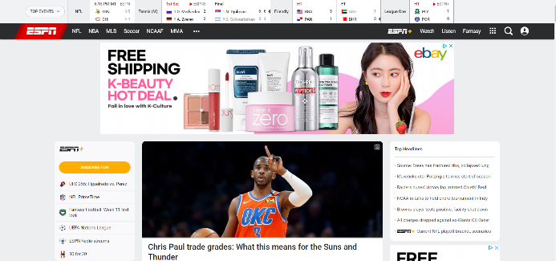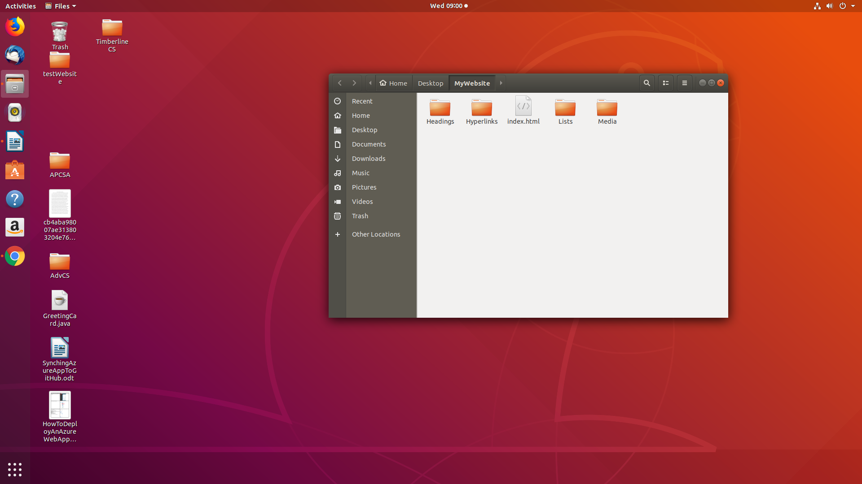

|  |
| --- |
| <a href = “http://espn.com” target=”_blank”> A link to espn that opens in a new tab</a> |

**[Skill 15.04 Exercise 1](https://hpluska.github.io/APCompSciPrinciples/ticketOutTheDoor/set18/Set18TicketOutTheDoorAPCompSciPrinciples.pdf)**

|  |
| --- |
| **Skill 15.05: Create a hyperlink to a location on the same page** |

**Skill 15.05**

Hyperlinks can also be used to navigate within a page. Links to sections within a page are also referred to as *bookmarks*. Consider the links below. Notice the reference for each link is proceeded by the *#* sign. This tells the browser that the reference is to the current page. The location of the reference is specified by the *id* attribute.

|  |
| --- |
| <ul>  <li><a href="#tedTalks">Ted Talks</a></li>  <li><a href="#knowledgeCelebrations">knowledge celebrations</a></li>  <li><a href="#labs">labs</a></li>  </ul>  <h1 id="tedTalks">Ted Talks</h1>  <ul>  <li>  <a href="https://www.ted.com/talks/raffaello_d_andrea_meet_the_dazzling_flying_machines_of_the_future?utm_campaign=tedspread&utm_medium=referral&utm_source=tedcomshare">Week 0: Dazzling Flying Machines of the Future</a>  </li>  <li>  <a href="https://www.ted.com/talks/maurice_conti_the_incredible_inventions_of_intuitive_ai">Week 1: The Incredible Inventions of Intuitive AI</a>  </li>  </ul> |

**[Skill 15.05 Exercise 1](https://hpluska.github.io/APCompSciPrinciples/ticketOutTheDoor/set18/Set18TicketOutTheDoorAPCompSciPrinciples.pdf)**