|  |
| --- |
| **Set 29: If Statements** |

|  |
| --- |
| **Skill 29.01: Interpret program flow charts**  **Skill 29.02: Interpret If-Statement pseudocode**  **Skill 29.03: Write and If-Statement in JavaScript**  **Skill 29.04: Write a complex If-Statement** |

|  |
| --- |
| **Skill 29.01: Interpret a program flow charts** |

**Skill 29.01 Concepts**

Programs are said to have a "flow of execution". You start by executing some line of code and then the next and so on. A flow chart is a common visual that's used to represent the various paths of execution that your program might take. Many people use them to help plan. Below is an example.

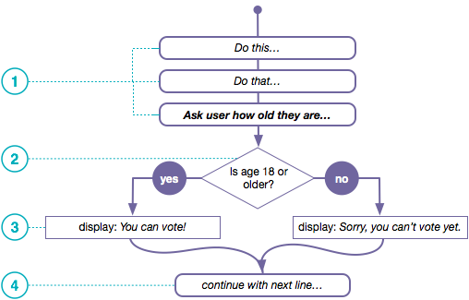

1. The flow chart above depicts a program executing one line after another until it gets to a point where it needs to make a decision.
2. In order to determine which path to take you state some condition. It should be a Boolean expression - something that evaluates to *true* or *false*. Here we have a simple comparsion of two values: the person's age and the number 18.
3. The program does one thing if the condition is true, and something else if the condition is false.
4. The program can continue a single thread of execution after the condition as well.

**[Skill 29.01 Exercises 1 thru 3](https://hpluska.github.io/APCompSciPrinciples/ticketOutTheDoor/set29/Set29TicketOutTheDoorAPCompSciPrinciples.pdf)**

|  |
| --- |
| **Skill 29.02: Interpret If-Statement pseudocode** |

**Skill 29.02 Concepts**

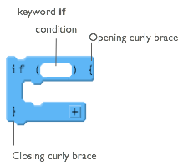*if* statements are the lines of code you need to change the flow while you're program is running. You can write code that makes a decision that determines which lines of code should be run next.

At the right is a diagram showing the elements of a basic *if* statement in JavaScript.

There are two basic parts to an if-statement.

1. A condition to be evaluated (A Boolean expression that evaluates to true or false)
2. Code that should run if the expression was true - enclosed in curly braces

Each row in the table below presents a small program that uses if-statements and robot commands. Trace the code and plot the movements of the robot for the 3 scenarios shown to the right of the code. If the robot is directed to move onto a black square, it “crashes” and the program ends. If the robot doesn’t crash, then draw a triangle showing its ending location and direction.

There are a few patterns to the ways if-statements are typically used:

* Basic If-statements
* Sequential If-statements
* Nested If statements
* Combinations of all of the above

Each section below presents an example of one of these common patterns. For each type **study, and make sure you understand, the example** and why each of the 3 scenarios ends up in the state shown.

|  |
| --- |
| **EXAMPLE: Basic If-statement** |
|  |

|  |
| --- |
| **EXAMPLE: Sequential If-statements** |
|  |
| **EXAMPLE: Nested If-Statements** |
|  |

[**Skill 29.02 Exercises 1 thru 3**](https://hpluska.github.io/APCompSciPrinciples/ticketOutTheDoor/set29/Set29TicketOutTheDoorAPCompSciPrinciples.pdf)

|  |
| --- |
| **Skill 29.03: Write and If-Statement in JavaScript** |

**Skill 29.03 Concepts**

In javascript, if statements take the following form.

|  |
| --- |
| if(true){      console.log(“This message will print!”);  }  //Prints “This message will print!”; |

Notice in the example above, we have an if statement. The if statement is composed of:

* The if keyword followed by a set of parentheses () which is followed by a code block, or block statement, indicated by a set of curly braces {}.
* Inside the parentheses (), a condition is provided that evaluates to true or false.
* If the condition evaluates to true, the code inside the curly braces {} runs, or executes.
* If the condition evaluates to false, the block won't execute.

**[Skill 29.03 Exercise 1](https://hpluska.github.io/APCompSciPrinciples/ticketOutTheDoor/set29/Set29TicketOutTheDoorAPCompSciPrinciples.pdf)**

|  |
| --- |
| **Skill 29.04: Write a complex If-Statement** |

**Skill 29.04 Concepts**

If-Statements can include more than one boolean statement in the parentheses. For example, what if we wanted to evaluate the username and password of a potential user? We could write the following,

|  |
| --- |
| if(username == un && password == pw){      console.log(“You’re in!”);  } |

In fact any of the boolean expressions you experimented with in the previous lesson can be placed in between the parentheses following the if statement. For example,

|  |
| --- |
| var x = 79;  var y = 46;  var z = -3;  var w = 13.89;  var y = 40.0;  if(y/2 > w && w != x){       console.log(“True”);  } |

**[Skill 29.04 Exercises 1](https://hpluska.github.io/APCompSciPrinciples/ticketOutTheDoor/set29/Set29TicketOutTheDoorAPCompSciPrinciples.pdf)**