|  |
| --- |
| **Set 3. Machine Learning** |

|  |
| --- |
| **Skill 3.1: Differentiate between artificial intelligence (AI) and machine learning (ML)**  **Skill 3.2: Identify the types of machine learning**  **Skill 3.3: Identify bias in predictive algorithms**  **Skill 3.4: Identify bias in facial recognition**  **Skill 3.5: Identify bias in language translation** |

|  |
| --- |
| **Skill 3.1: Differentiate between artificial intelligence (AI) and machine learning (ML)** |

**Skill 3.1 Concepts**

In simplest terms, AI is computer software that mimics the ways that humans think in order to perform complex tasks, such as analyzing, reasoning, and learning. Machine learning, meanwhile, is a subset of AI that uses algorithms trained on data to produce models that can perform such complex tasks. The relationship between AI and ML can be visualized as follows,

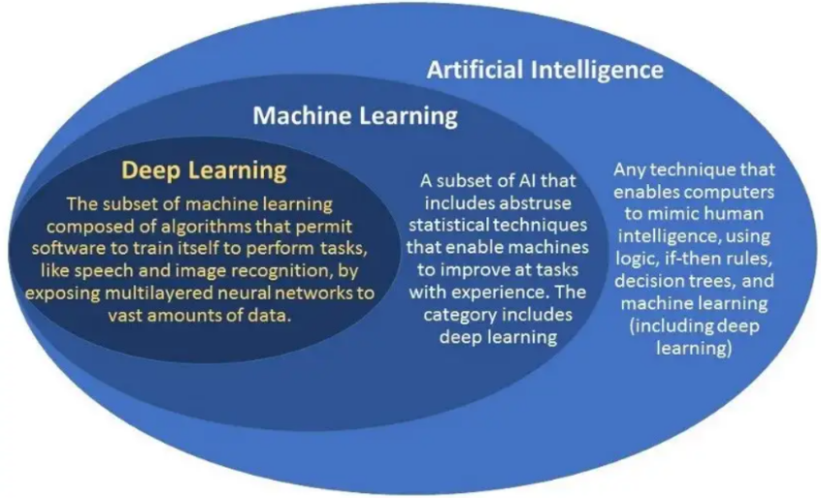

While AI is a general term used to describe projects where a machine is doing something that would normally require human intelligence, it doesn’t say anything about how you get the machine to do that thing. ML is just one technique out many that you can use to make an AI project. Let’s consider the following example,

Deep Blue – In 1997, a computer called Deep Blue beat the world champion Garry Kasparov at a game of chess. Deep Blue was an AI project, but it was not an ML system. Deep Blue did not learn how to play chess or how to win; it was programmed. That is, people coded the system with rules of the game, and more importantly, the strategies for winning. The computer wasn’t smarter than Kasparov, but it could follow more instructions and test out more possible moves quicker than he could.

Watson – In 2011, a computer called Watson beat Jeopardy! Champions Ken Jennings and Brad Rutter. Unlike Deep Blue, Watson was an ML system. It learned how to play the game show by being trained with the questions from every Jeopardy! Episode going back to the 1960s, as well as by playing lots of practice matches against human competitors.

People still build AI systems like Deep Blue today, because simple AI systems that follow step-by-step instructions written by people can still be useful. However, ML can be used to build AI systems that do more complex and sophisticated jobs.

|  |
| --- |
| **Skill 3.2: Identify the types of machine learning** |

**Skill 3.2 Concepts**

Machine Learning is an application of Artificial Intelligence that enables systems to learn from vast volumes of data and solve specific problems. It uses computer algorithms that improve their efficiency automatically through experience.

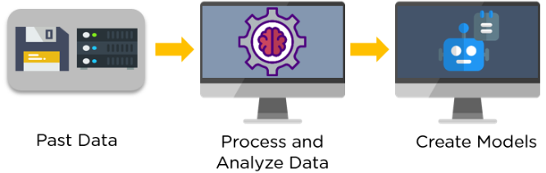

There are primarily three types of machine learning: Supervised, Unsupervised, and Reinforcement Learning.

Supervised Learning

Supervised learning is a type of machine learning that uses external labeled data to train machine learning models. In labeled data, the output is already known. The model just needs to map the inputs to the respective outputs.

An example of supervised learning is to train a system that identifies the image of an animal. Below, you can see that we have our trained model that identifies the picture of a cat.

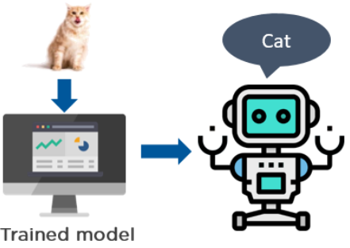

A few of the top supervised learning applications are weather prediction, sales forecasting, stock price analysis.



Unsupervised Learning

Unsupervised learning is a type of machine learning that uses unlabeled data to train machines. Unlabeled data doesn’t have a fixed output variable. The model learns from the data, discovers the patterns and features in the data, and returns the output.

Depicted below is an example of an unsupervised learning technique that uses the images of vehicles to classify if it’s a bus or a truck. The model learns by identifying the parts of a vehicle, such as a length and width of the vehicle, the front, and rear end covers, roof hoods, the types of wheels used, etc. Based on these features, the model classifies if the vehicle is a bus or a truck.

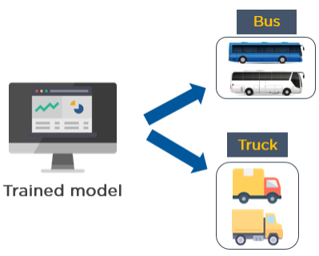

One of the applications of unsupervised learning is customer segmentation. Based on customer behavior, likes, dislikes, and interests, you can segment and cluster similar customers into a group.

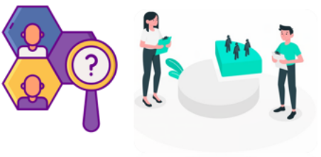

Reinforcement Learning

Reinforcement Learning trains a machine to take suitable actions and maximize its rewards in a particular situation. It uses an agent and an environment to produce actions and rewards. The agent has a start and an end state. But, there might be different paths for reaching the end state, like a maze. In this learning technique, there is no predefined target variable.

An example of reinforcement learning is to train a machine that can identify the shape of an object, given a list of different objects. In the example shown, the model tries to predict the shape of the object, which is a square in this case.

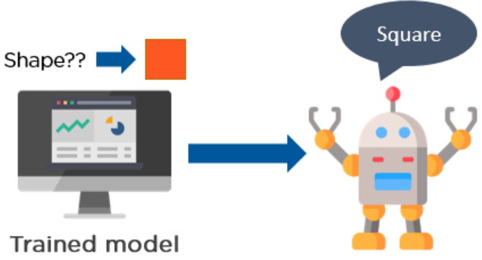

Reinforcement learning follows trial and error methods to get the desired result. After accomplishing a task, the agent receives an award. An example could be to train a dog to catch the ball. If the dog learns to catch a ball, you give it a reward, such as a biscuit.

Reinforcement Learning methods do not need any external supervision to train models.

Reinforcement learning problems are reward-based. For every task or for every step completed, there will be a reward received by the agent. If the task is not achieved correctly, there will be some penalty added.

Reinforcement learning algorithms are widely used in the gaming industries to build games. It is also used to train robots to do human tasks.



[**Skill 3.2 Exercise**](https://hpluska.github.io/APCompSciPrinciples/ticketOutTheDoor/set0/Set0TicketOutTheDoorAPCompSciPrinciples.pdf) **1**

|  |
| --- |
| **Skill 3.3: Identify bias in predictive algorithms** |

**Skill 3.3 Concepts**

A machine learning algorithm can make a prediction about the future based on the historical data it's been trained on. But when that training data comes from a world full of inequalities, the algorithm may simply be learning how to keep propagating those inequalities.

Below are some noteworthy examples.

Criminal Justice

In the criminal justice system, a risk assessment score predicts whether someone accused of a crime is likely to commit another crime. A low-risk defendant is deemed unlikely to commit another crime, while a high-risk defendant is deemed very likely to commit another crime. Risk assessments are used at various stages in the system, from assigning bond amounts to determining sentences.

Computer algorithms are increasingly being used to come up with the risk assessment scores, since a computer algorithm is cheaper to employ than a human and can be based on much more data.

In 2016, the investigative agency ProPublica analyzed the scores from an algorithm used in Florida on 7,000 people over a two year period and checked whether those people actually did commit subsequent crimes.

They discovered that the algorithm *underestimated* the likelihood that white defendants would re-offend but *overestimated* the likelihood for Black defendants:

Hiring Decisions

Big companies receive hundreds of applications for each job role. Each application must be screened to decide if the applicant should be interviewed. Traditionally, screening is done by recruiters in the HR department, but it's a tedious task and risks subjecting applicants to the biases of the human recruiter.

Many companies are starting to automate screening with algorithms powered by machine learning, with the hope of increasing the efficiency and objectivity of the process.

A screening algorithm reviews an applicant's résumé and assigns a score that predicts the applicant's fit for the job role.

In 2014, Amazon experimented with using software to screen job applicants. However, they discovered that the software preferred male candidates over female candidates, penalizing résumés that contained the word "women's" (as in "women's chess club") and downgrading graduates from all-women colleges. How did software become sexist?

The screening software was trained on a decade of résumés that had been previously rated by employees as part of the hiring process.

As a result, in 2014, Amazon employees were largely male:

[**Skill 3.3 Exercise**](https://hpluska.github.io/APCompSciPrinciples/ticketOutTheDoor/set0/Set0TicketOutTheDoorAPCompSciPrinciples.pdf) **1**

|  |
| --- |
| **Skill 3.4: Identify bias in facial recognition** |

**Skill 3.4 Concepts**

Facial recognition services use machine learning algorithms to scan a face and detect a person's gender, race, emotions, or even identity.

Here's an example output from a facial recognition service,

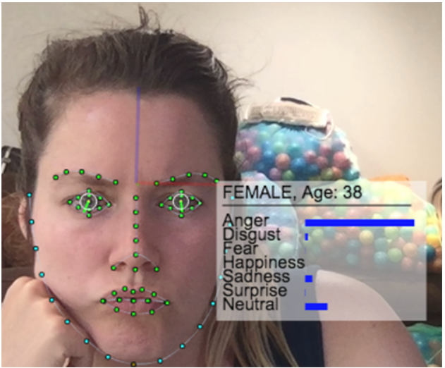

Unfortunately, facial recognition algorithms vary in their performance across different face types. MIT researcher Joy Buolamwini discovered that she had to wear a white mask to get a facial recognition service to see her face at all. More on that below,

|  |
| --- |
|  |
| <https://youtu.be/UG_X_7g63rY> |

[**Skill 3.4 Exercise**](https://hpluska.github.io/APCompSciPrinciples/ticketOutTheDoor/set0/Set0TicketOutTheDoorAPCompSciPrinciples.pdf) **1**

|  |
| --- |
| **Skill 3.5: Identify bias in language translation** |

**Skill 3.5 Concepts**

The complexity of human language has always posed challenging problems for computer scientists interested in speech recognition, textual understanding, translation, and natural language generation.

Rule-Based Machine Translation (RBMT)

The quest for translation algorithms started in the 1960s with Rule-Based Machine Translation. RBMT algorithms rely on a grammar describing the structure of each language plus a dictionary of words. To translate a sentence, they try to parse it based on that language's grammar, convert that grammatical structure to the target language, and translate the words using the dictionary.

RBMT algorithms require the work of expert linguists to craft the grammar, yet their translations still fail to capture the complexity of human language. Researchers sought better options.

Statistical Machine Translation (SMT)

In the 1990s, computers suddenly had access to much more natural language data. There were millions of digitized textual documents, like books and news articles, and many of them had been translated into multiple languages.

The Harry Potter series has been translated into more than 70 languages, so computers can infer the translation of "owl" just by comparing those many translations.



All that new data enabled the approach of Statistical Machine Translation. SMT algorithms break a sentence down into smaller segments, look for existing translations of those segments, and propose the most probable translation of the full sentence.

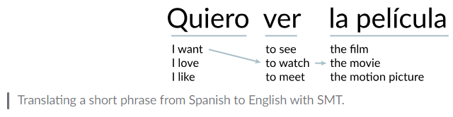

With a small training data set, SMT algorithms produce *worse* results than RBMT algorithms. However, with big data, SMT algorithms can produce fairly fluent sentences, or at least, fluent phrases within sentences.

Neural Machine Translation (NMT)

In recent years, the new algorithm on the block is Neural Machine Translation. NMT is a machine learning algorithm that uses neural networks on enormous amounts of data. When trained well and with enough data, those algorithms can learn how to produce sentences that are fluent from start to finish.

[**Skill 3.5 Exercise**](https://hpluska.github.io/APCompSciPrinciples/ticketOutTheDoor/set0/Set0TicketOutTheDoorAPCompSciPrinciples.pdf) **1**