|  |
| --- |
| **Set 8. Converting Analog Data to Binary** |

|  |
| --- |
| **Skill 8.01: Define analog and provide an example of an analog signal**  **Skill 8.02: Explain how sampling can be applied to approximate an analog signal**  **Skill 8.03: Explain the process of quantization**  **Skill 8.04: Explain how an analog signal is stored in binary**  **Skill 8.05: Describe the limitations of reconstructing an analog signal**  **Skill 8.06: Summarize the steps required to convert and reconstruct an analog signal to and from binary** |

|  |
| --- |
| **Skill 8.01: Define analog and provide an example of an analog signal** |

**Skill 8.01 Concepts**

The real world is **analog**, a continuous stream of varying data.

Just look around you, beyond your computer or phone. There's an infinite amount of visual information. If you zoom into one part of your visual field, you can notice more and more details.

Now sing a little song to yourself. That's an infinite stream of audio information. Your voice is constantly changing in big and little ways, microsecond by microsecond.

Analog data is infinitely detailed. Computers can only store digital data, finite data in a binary representation.

So how can we capture the wondrous analog world of our senses and convert it into digital data? We can use a process of sampling, quantization, and binary encoding.

An example of an analog signal, is a waveform representing a sound:

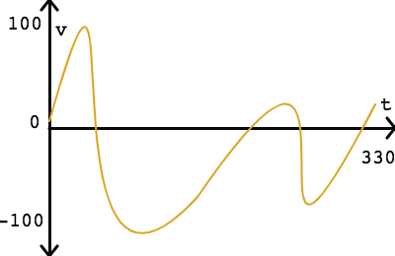

All analog signals are continuous both in the time domain (x-axis) and in the amplitude domain (y-axis). That means that there is a precise value for every possible value of time, even as specific as "1.2345 seconds", and that value may be as precise as "47.8291824806423964 volts".

Analog signals are continuous and can be represented as waves. And as such, have the following characteristics:

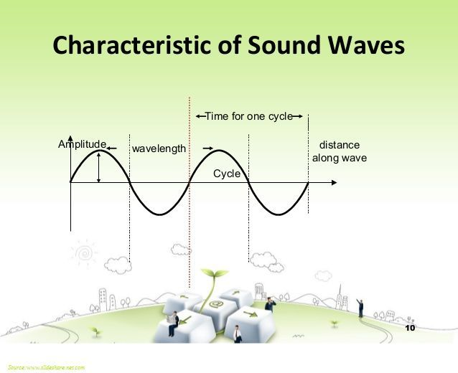

**Frequency**, another characteristic of analog signals, is defined as the number of times a signal cycles per second.

**[Skill 8.01 Exercise 1](https://hpluska.github.io/APCompSciPrinciples/ticketOutTheDoor/set4/Set4TicketOutTheDoorAPCompSciPrinciples.pdf)**

|  |
| --- |
| **Skill 8.02: Explain now sampling can be applied to approximate an analog signal** |

**Skill 8.02 Concepts**

The first step in the process of digitizing an analog signal is **sampling**. Sampling is the process where we take a sample at regular time intervals. This step reduces the continuous time domain into a series of discrete intervals.

In the analog signal shown, time varies from 0 to 330 milliseconds, consider the results if we were to take a sample every 30 seconds,

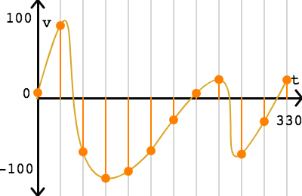

That gives us 12 samples of the signal between 0 and 330 milliseconds.

Now we can express the signal as a series of sampled points:

(0, 7)

(30, 95.98676803710936)

(60, -71.43289186523432)

(90, -106.55949554687498)

(120, -97.21617085937501)

(150, -70)

(180, -29.045472375000003)

(210, 6.171340345703143)

(240, 24.439022283203116)

(270, -74.45763529492186)

(300, -31.31245312500002)

(330, 24)

The inverse of the sampling interval is the **sampling rate**: the number of samples in a second (or other unit of time). For example, a sampling interval of 30 milliseconds corresponds to a sampling rate of 33.33 samples per second.

A sufficient sampling rate depends on the frequency of the analog signal. Where frequency is the number of times a signal cycles per second. This

According to the Nyquist-Shannon sampling theorem, a sufficient sampling rate is anything larger than twice the highest frequency in the signal. The frequency is the number of cycles per second and measured in Hz (hertz). If a signal has a maximum frequency of 500 Hz, a sufficient sampling rate is anything greater than 1000 Hz.

A typical sampling rate for music recordings is 48 kHz (48,000 samples per second). That's a little over double the highest frequency that humans can hear, 20 kHz. If the audio only contains human speech, as is often the case for phone calls, a much smaller sampling rate of 8 kHz can be used since 4kHz is the highest frequency in most speech.

**[Skill 8.02 Exercise 1](https://hpluska.github.io/APCompSciPrinciples/ticketOutTheDoor/set4/Set4TicketOutTheDoorAPCompSciPrinciples.pdf)**

|  |
| --- |
| **Skill 8.03: Explain the process of quantization** |

**Skill 8.03 Concepts**

After sampling, we are still left with a wide range in the amplitude domain, the y values. The next step of quantization reduces that continuous amplitude domain into discrete levels.

For our simple signal, where amplitude varies from about -100 to 100 volts, we can apply a quantization interval of 25 volts:

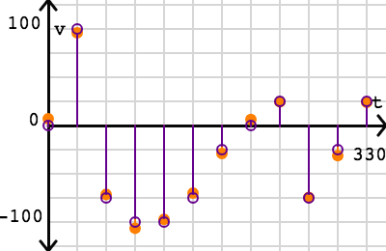

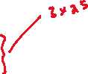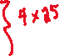

Now the 12 points all have y values that are multiples of 25:

(0, 0)

(30, 100)

(60, -75)

(90, -100)

(120, -100)

(150, -75)

(180, -25)

(210, 0)

(240, 25)

(270, -75)

(300, -25)

(330, 25)

But, notice, only those points that are exactly a multiple of 100 are represented as intended. All the other points are estimated,

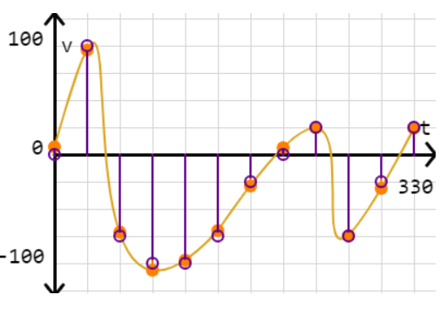

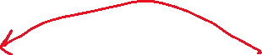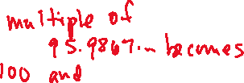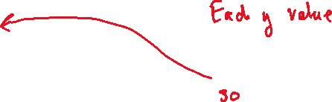

The ideal quantization interval depends on our use case and physical constraints. If there is enough space to represent thousands of different y values, then we can use a very small quantization interval. If there is limited space, then we can use a large interval. **Decreasing the quantization value, increases the precision of the stored value.**

The quantizing step always introduces some amount of quantization error, which is measured by comparing the actual signal value with the quantized value at each sampled point. However, some level of quantization is always necessary for storing analog data in digital form, due to the finite nature of a computer's memory and its numeric precision.

**[Skill 8.03 Exercise 1](https://hpluska.github.io/APCompSciPrinciples/ticketOutTheDoor/set4/Set4TicketOutTheDoorAPCompSciPrinciples.pdf)**

|  |
| --- |
| **Skill 8.04: Explain how an analog signal is stored in binary** |

**Skill 8.04 Concepts**

That brings us to the final step: binary encoding. If there is a limited set of quantized y values, the computer does not need to store the actual value. Instead, it can store a much smaller value that represents the quantized y value.

For this signal, a quantization interval of 25 resulted in 9 possible y values. We can map the 9 values to the binary numbers 0000 - 1001:

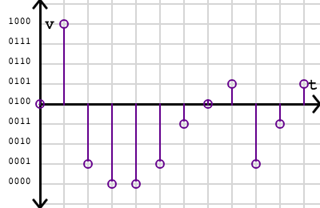



We can then encode the signal into this binary sequence:

0100 1000 0001 0000 0000 0001 0011 0100 0101 0001 0011 0101

For a computer to understand that sequence, our digitized version would also need to include a description of how the sequence was sampled and quantized.

This encoding uses 4 bits per sample. The number of bits per sample is also know as the **bit depth**. The lowest bit depth is 1, which can only describe 2 values (0 or 1). The standard bit depth for telephone calls is 8 bits (256 values) and the recommended bit depth for YouTube music videos is 24 bits (over 16 million values).

**[Skill 8.04 Exercise 1](https://hpluska.github.io/APCompSciPrinciples/ticketOutTheDoor/set4/Set4TicketOutTheDoorAPCompSciPrinciples.pdf)**

|  |
| --- |
| **Skill 8.05: Describe the limitations of reconstructing an analog signal** |

**Skill 8.05 Concepts**

We often store analog signals in digital storage so that we can reproduce them later, like playing back an audio file or displaying an image. When a device wants to convert a digitized signal back into an analog signal, it will attempt to reconstruct the original continuous signal.

For this signal, a simple reconstruction strategy could interpolate a smooth curve through the quantized points:

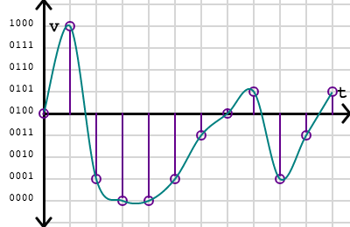

How well does that match the original? We can overlay the curves to see the difference visually:

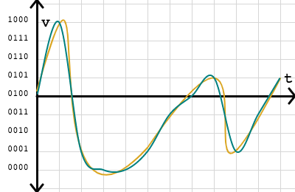

The reconstructed signal looks very close to the original, but misses a few details. **If we can decrease the sampling interval (or increase the sampling rate) and lower the quantization interval, we can bring the reconstructed curve closer to the original signal**. We could also use different strategies for reconstructing the signal.

**[Skill 8.05 Exercise 1](https://hpluska.github.io/APCompSciPrinciples/ticketOutTheDoor/set4/Set4TicketOutTheDoorAPCompSciPrinciples.pdf)**

|  |
| --- |
| **Skill 8.06: Summarize the steps required to convert and reconstruct an analog signal to and from binary** |

**Skill 8.06 Concepts**

The first step in converting an analog signal to binary involves sampling. Sampling is the process of converting an infinite signal to a finite sequence. The second step is quantization. In quantization, the values in the sequence are approximated according to a quantization interval. Finally, the values are encoded into bits for storage on a computing device. At some later point, a device can interpret those bits to attempt a reconstruction of the original infinite stream of continuous values.

Whenever we convert analog data to digital data, whether it's audio or visual, our goal is to sample data with enough precision so that we can reconstruct it later at the desired quality level but not exceed our data storage capacity.

Land-line telephones use relatively low sampling rates and bit depths, since the data must travel over telephone lines, whereas movie directors record film at very high sampling rates and bit depths, so that they may replay it on giant screens later.

**[Skill 8.06 Exercise 1](https://hpluska.github.io/APCompSciPrinciples/ticketOutTheDoor/set4/Set4TicketOutTheDoorAPCompSciPrinciples.pdf)**