Set 11. Relationship between wavelength, frequency, energy, and light

Skill 11.01: Understand the relationship between wavelength, frequency and light “color”
Skill 11.02: Understand the relationship between energy, wavelength, and frequency
Skill 11.03: Explain how the photoelectric effect contradicts the wave nature of light

Skill 11.01: Understand the relationship between wavelength, frequency, and light color

From fireworks to stars, the color of light is useful in finding out what’s in matter. The emission of light by hydrogen and other atoms has played a key role in understanding the electronic structure of atoms. Trace materials, such as evidence from a crime scene, lead in paint or mercury in drinking water can be identified by heating or burning the materials and examining the color(s) of light given off in the form of bright-line spectra.
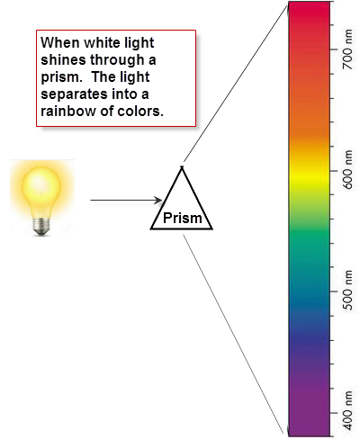
Skill 11.01. Problem 1
Refer to the figure shown to the right. Identify the range of wavelengths associated with each color. The “Reds” have already been filled in.
Color Range | Wavelengths
Reds | 680–740
Oranges

Yellows

Greens

Blues

Violets

Light consists of electromagnetic waves. Electromagnetic waves are characterized by their wavelength and frequency:

- The wavelength, λ (lambda) is the distance between identical points on successive waves.
- The frequency, ν (nu), is the number of waves that pass through a particular point in one second.
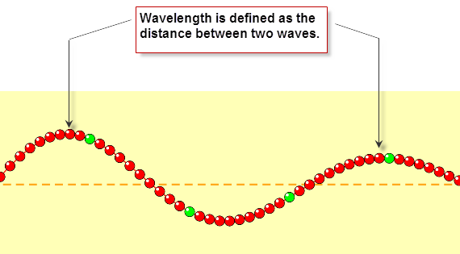

Skill 11.01 Problem 2
Navigate to the wave on a string simulator.

http://phet.colorado.edu/sims/html/wave-on-a-string/latest/wave-on-a-string_en.html

Once there, select the “No end” option and the “Oscillate” option
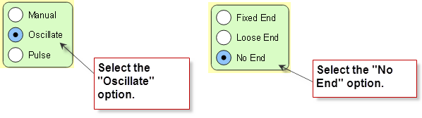

- Locate the frequency slider. Move it back and forth and observe how the wavelength changes.

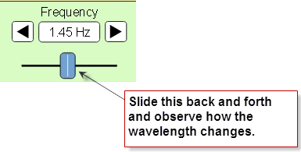
- When you increase the frequency, what happens to the wavelength? Does it increase or decrease?

- When you decrease the frequency, what happens to the wavelength? Does it increase or decrease?

- What is the relationship between frequency and wavelength? Is it inverse or direct?

Skill 11.01 Problem 3
Refer to the colors below. Sort the colors from low to high with respect to frequency.

Color Range | Order of frequency (1 = lowest)
Reds

Oranges

Yellows

Greens

Blues

Violets

Skill 11.01 Problem 4
  - Are the wavelengths of ultra-violet light longer or shorter than that of visible light?

  - Are the frequencies of ultra-violet light longer or shorter than that of visible light?

  - Are the wavelengths of infra-red light longer or shorter than that of visible light?

  - Are the frequencies of infra-red light longer or shorter than that of visible light?

Skill 11.02: Understand the relationship between energy, wavelength, and frequency

Skill 11.02 Problem 1
Now return to the simulator (http://phet.colorado.edu/sims/html/wave-on-a-string/latest/wave-on-a-string_en.html) Select the “Manual” option.

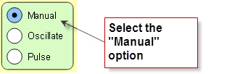
Move the wrench up and down as fast as you can and observe the wavelength. Now move the wrench up and down slowly and observe the wavelength.

- When you moved the wrench up and down quickly (high energy), what happened to the wavelength? Did it increase or decrease?

  - When you moved the wrench up and down slowly (low energy), what happened to the wavelength? Did it increase or decrease?

- What is the relationship between energy and wavelength? Is it inverse or direct?

- What is the relationship between frequency and energy? Is it inverse or direct?

Skill 11.02 Problem 2
Refer to the colors below. Sort the colors from low to high with respect to energy.

Color Range | Order of energy (1 = lowest)
Reds

Oranges

Yellows

Greens

Blues

Violets

Skill 11.03: Explain how the photoelectric effect contradicts the wave nature of light

Skill 11.03 Concepts

The photoelectric effect is a phenomenon that occurs when light shined onto a metal surface causes the ejection of electrons from that metal. It was observed that only certain frequencies of light are able to cause the ejection of electrons. If the frequency of the incident light is too low (red light, for example), then no electrons were ejected even if the intensity of the light was very high or it was shone onto the surface for a long time. If the frequency of the light was higher (green light, for example), then electrons were able to be ejected from the metal surface even if the intensity of the light was very low or it was shone for only a short time. This minimum frequency needed to cause electron ejection is referred to as the threshold frequency.

Classical physics was unable to explain the photoelectric effect. If classical physics applied to this situation, the electron in the metal could eventually collect enough energy to be ejected from the surface even if the incoming light was of low frequency. Einstein used the particle theory of light to explain the photoelectric effect as shown in the Figure below.

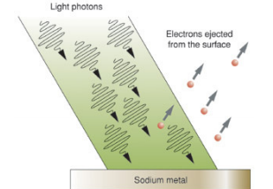

The picture above shows that when a metal receives sufficient energy (packet), electrons can be ejected as packets of energy. The packets of energy absorbed by the metal are referred to as photons.

Skill 11.03 Problem 1
Navigate to the following simulation (be patient, it takes some time to load)

https://phet.colorado.edu/sims/cheerpj/photoelectric/latest/photoelectric.html?simulation=photoelectric

Move the wavelength slider to the red light,

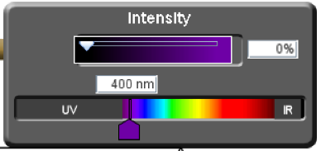

Move the Intensity slider to 100%.

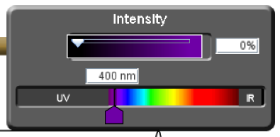
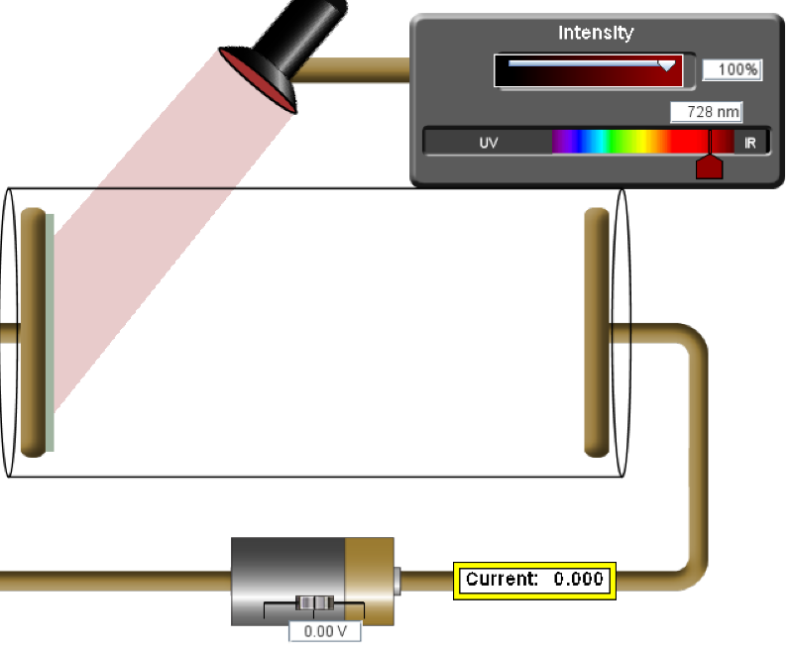
Observe the metal plate that the light is shining on. If electrons are ejected, the current field will be greater than zero.

- Are electrons being emitted when red light shines on the metal? Why not?

- Gradually move the wavelenght slider to the left, until you see electrons begin to fly off the left plate. At what wavelength does this occur?

- Observe the speed of the electrons given off. Now, decrease the Intensity of the light by sliding the Intensity slider to the left, but not all the way to zero. Does the speed of the electrons change? Why or why not?

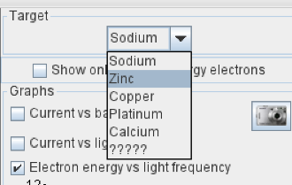
- Use the drop down to change the metal from sodium to zinc. Move the wavelength slider to the left until you see electrons begin to fly off the metal. At what wavelength does this occur?

- Observe the speed of the electrons flying off the metal. Now move the slider all the way to the left. How does this change the speed of the electrons? Why?

- Was the energy required to eject electrons from zinc higher or lower than that of sodium? Propose a theory why?

Skill 11.03 Problem 2
How do the findings from the photoelectric effect contradict the classical view of the wave like nature of light?
What do the findings from the photoelectric effect say about how atoms absorb energy?

