Set 13. Quantum Model of the Atom

Skill 13.01: Construct Bohr models for atoms, define the Principle Quantum Number (n), and identify the maximum number of electrons that each principle energy level can hold
Skill 13.02: Define the Angular Momentum quantum number and identify the possible values
Skill 13.03: Define the Magnetic quantum number and identify the possible values
Skill 13.04: State Hund’s rule, state the Pauli exclusion principle, define the Spin quantum number (m_{s}) and identify its possible values and arrangements
Skill 13.05: Identify whether an atom is diamagnetic or paramagnetic

Skill 13.01: Construct Bohr models for atoms, define the Principle Quantum Number (n), and identify the maximum number of electrons that each principle energy level can hold

Skill 13.01 Concepts

To account for the line spectra produced by elements, Bohr proposed that electrons could only be located in certain orbits. Since each orbit has a particular energy associated with it, the energies associated with an electron is fixed (or quantized). Bohr assigned each of his quantized electron orbits, called shells, a principal quantum number (n), starting with n=1 for the shell closet to the nucleus, n=2 for the next shell out from the nucleus, and so on (figure 1).

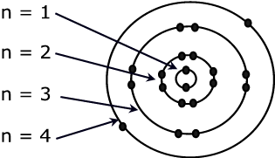 | The letter ‘n” is used to denote the energy level the electron is located. As the electron’s distance from the nucleus increases so too does its potential energy.
Figure 1. Bohr model.

All the electrons in an atom want to occupy the n=1 shell, because it is the shell closest to the nucleus. But electrons repel each other, so there is a maximum number of electrons that each shell can hold. The further out from the nucleus, the larger the shell, and the more electrons that can be accommodated.

The maximum number of electrons that each shell can hold is equal to 2n², where n is the principle quantum number of the shell.

Skill 13.01 Problem 1
Draw Bohr models for the following atoms:

- H, Li, Na
- Be, Mg, Ca
- C, Si, Ge
- Ne, Ar, Kr

What does each group of atoms have in common?
Group I | H | Li | Na
Group II | Be | Mg
Group IV | C | Si
Group VIII | Ne | Ar

Skill 13.02: Define the Angular Momentum quantum number and identify the possible values

Skill 13.02 Concepts

Later experiments with light showed that the arrangement of electrons in the atom was much more complex than what the Bohr model was able to explain.

Recall that Bohr suggested that when the electron absorbs a photon of energy it jumps to a higher energy level. When the electron drops to a lower energy level, it releases a photon of energy in the form of light BUT, later experiments showed that the bands of light Bohr observed were actually made up of multiple bands (figure 2).

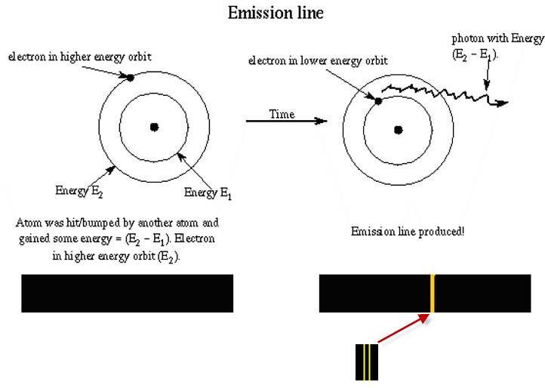
Figure 2. Notice that the broad band is actually made up of smaller bands.

In order to explain this observation, the Bohr model had to be revised. Scientist suggested that within each main energy level are sub-energy levels. Consider the following model shown to the right of the Bohr model.

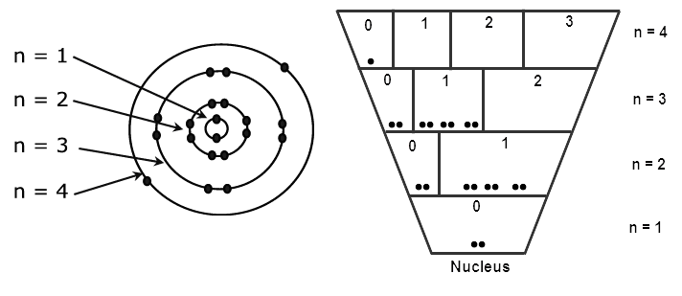
On the n=2 main energy level there are two sub-energy levels. Their values are “0” and “1”.
Figure 3. Refined Bohr model.

Notice that each main energy level is broken up into sub-energy levels. The sub-energy levels (also referred to as subshells) are denoted with the letter l. The size of the sub-energy level in which the electron resides is important, because the energy of the electron is dependent upon the space in which it is likely to exist (larger spaces for example provide the electron more space to move around and contain lower energy electrons). The values of the subshells (l) depend on the value of the principal quantum number, n. Can you spot the pattern?

Skill 13.02 Problem 1
- For the n=2, main energy level,
- How many sub-energy levels exist?

- What are their values?

- For the n=3, main energy level,
  - How many sub-energy levels exist?

  - What are their values?

- For the n=5, main energy level,
  - How many sub-energy levels exist?

  - What are their values?

For a given value of n, l has possible integral values of 0 to (n-1).

To avoid confusing main energy levels with sub-energy levels, the value of l is assigned a letter as follows:

l | 0 | 1 | 2 | 3 | 4 | 5
Name of orbital | s | p | d | f | g | h

Each letter also corresponds to a “shape” or region in which the electron is likely to exist:

Figure 4.
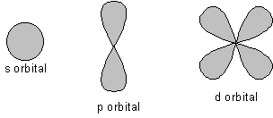

Skill 13.02 Problem 2
a. What are the letter designations for the possible subshells on the n=2 main energy level?

- What are the letter designations for the possible subshells on the n=3 main energy level?

Skill 13.03: Define the Magnetic quantum number (m_{l}) and identify the possible values

Skill 13.03 Concepts

The region in which the electron exists (figure 4) can have multiple orientations. To account for the regions, scientists further refined their model. Consider the following,

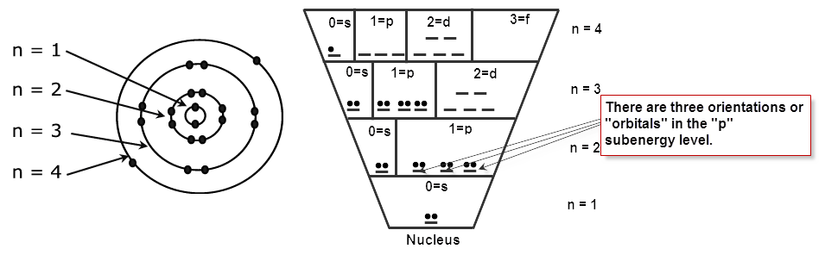
Notice that within each sub-level, there are specific locations in which the electrons can reside. These locations actually correspond to the number of possible orientations the sub-energy level can produce and are referred to as orbitals.

Skill 13.03 Problem 1
How many orientations are possible for each sub-energy level?
(a) l=s | (b) l=p | (c) l=d | (d) l=f

The magnetic quantum number (m_{l}) is used to describes the possible orientations. For example,

For l=s or l=0, the number of allowed orientations is “1”. The orbital is assigned the value of 0.
For l=p or l=1, the number of allowed orientations is “3”. The orbital values are -1,0,+1.
For l=d or l=2, the number of allowed orientations is “5”. The orbital values are -2,-1,0,+1,+2

Can you spot the pattern?

Skill 13.03 Problem 2
List the possible values of m_{l} for the l=f or l=3 sub-energy level.

The magnetic quantum number (m_{l}) describes the possible orientations. The orientations are also referred to as orbitals. The magnetic quantum number depends on the orbital (l) it describes. For a certain value of l, there are (2l+1) possible m_{l} values that range from -l to +l.

Skill 13.03 Problem 3
Complete the n=4 main energy level. For each sub-energy level indicate the number of orientations (aka orbitals) with a “__”. Write the corresponding number below.
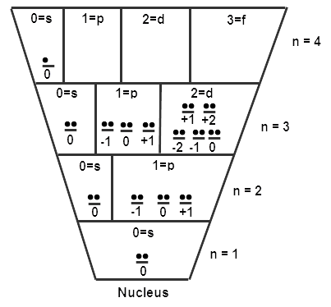

Skill 13.04: State Hund’s rule, state the Pauli exclusion principle, define the Spin quantum number (m_{s}) and identify its possible values and arrangements

Skill 13.04 Concepts

It was known that many elements had magnetic properties. It was also known that a spinning electron induced a magnetic field. In order to account for the observed magnetic properties and the fact that electrons repel one another, Hund proposed that the most stable arrangement of electrons in a subshell is the one with the greatest number of parallel spins. For example, a p subshell (which corresponds to l=p=1) contains 2l+1 = 3 orbitals which range in values from –l to +l , -1, 0, +1. For a three electron system the arrangement of electrons would be as follows:

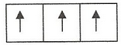

Accounting for the spin quantum number, our atomic model now takes on the following form,
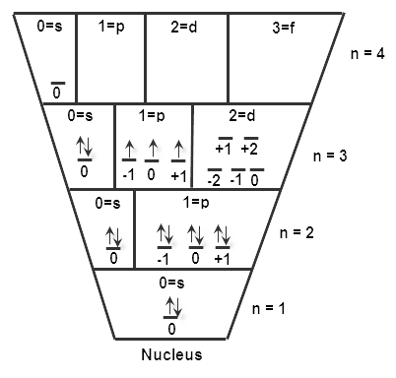
According to Hund’s rule, electrons want to maximize their distance from one another. Notice that we put 1 electron in each orbital before we begin pairing them.

Each electron in this subshell has a spin value of +1/2 because it is pointing up.
Notice in the above model some electrons are spinning up while others are spinning down. For many-electron atoms, we use the Pauli exclusion principle to justify this. This principle states that no two electrons in an atom can have the same four quantum numbers. If two electrons in an atom should have the same n, l, and m_{l} values (that is, two electrons in the same atomic orbital), then they must have different values of m_{s}

Spinning charges generate magnetic fields. Because electrons spin, they act like tiny magnets. The direction of the magnetic field is either up or down. If the electron is pointing up, it has a value of +1/2. If it is pointing down, it has a value of -1/2. The spin is also referred to as the spin quantum number (m_{s}).

Skill 13.04 Problem 1
This electron has the following values:

n=3; l=1; m_{l}=+1; m_{s}= +1/2

Or we can also write it using the following short hand notation.

(3, 1, +1, +1/2)

The values in the shorthand method correspond to the following quantum numbers,

(n, l, m_{l}, m_{s})
Consider the atomic model of the atom shown above.
  - How many electrons are in this atom?

  - Assuming the atom is neutral, that is it has equal numbers of protons and electrons. What atom is represented by the diagram?

(c) What are the values of n, l, m_{l}, and m_{s} for each electron on the 3rd main energy level? List their values for each electron using the short hand method shown above.

Skill 13.05: Identify whether an atom diamagnetic or paramagnetic

Skill 13.05 Concepts

As mentioned previously, when an electron spins, it induces a magnetic field. When two electrons are spinning parallel, the magnetic fields are reinforced. Such an arrangement would cause the atom to be attracted to a magnet (paramagnetic). Likewise, when two electrons are spinning opposite, their magnetic fields are cancelled. This arrangement would cause the atom to be repelled by a magnetic (diamagnetic). In order to determine whether an atom is diamagnetic or paramagnetic look for unpaired electrons. If there are no unpaired electrons (e.g., Ar, Ne, Be) then the atom is diamagnetic, otherwise it is paramagnetic.

Skill 13.05 Problem 1
(a) Show the filling of electrons for phosphorus in the diagram below.
(b) Predict whether phosphorus is paramagnetic or diamagnetic.
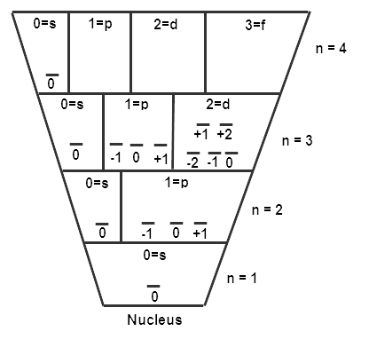

Skill 13.05 Problem 2
(a) Draw atomic diagrams for each of the following atoms.
(b) Predict whether each atom is paramagnetic or diamagnetic.
(a) Helium

(b) Nitrogen

(c) Chlorine

(d) Magnesium

