Set 36: Gas Stoichiometry

Skill 36.01: solve volume-volume stoichiometry problems
Skill 36.02: solve volume-mole stoichiometry problems
Skill 36.03: solve volume-mass stoichiometry problems
Skill 36.04: solve mole-volume stoichiometry problems
Skill 36.05: solve mass-volume stoichiometry problems

Figure 1. Steps for solving gas stoichiometry problems
Type | Description | Steps
volume –volume | In volume-volume problem, you are given the volume of one substance and asked to calculate the volume of another substance in the chemical reaction. | volume given → volume unknown
volume-mole | In a volume-mole problem, you are given the volume of one substance and asked to find the moles of another substance in the chemical reaction | volume given → moles given → moles unknown
volume – mass | In a volume-mass problem, you are given the volume of one substance and asked to find the mass of another substance in the chemical reaction | volume given → moles given → moles unknown → mass unknown
moles –volume | In a mole-volume problem, you are given the moles of one substance and asked to find the volume of another in the chemical reaction | moles given → moles unknown → volume unknown
mass –volume | In a mass-volume problem, you are given the mass of one substance and asked to find the volume of another in the chemical reaction | mass given → moles given → moles unknown → volume unknown

Skill 36.01: solve volume-volume stoichiometry problems

Skill 36.01 Concepts

For gaseous reactants, or products, the coefficients in chemical equations not only indicate molar amounts and mole ratios, but also reveal volume ratios. Consider the reaction of hydrogen and oxygen to give water.

2H₂ + O₂ → 2H₂O

The following four expressions are true for the above reaction:

- 2 molecules hydrogen + 1 molecule oxygen → 2 molecules water
- 2 moles hydrogen + 1 mole oxygen → 2 moles water
- 4 grams hydrogen + 32 g oxygen → 36 g water
- 2 volumes hydrogen (L) + 1 volume oxygen (L) → 2 volumes water (L)

Although expressions (1) thru (3) are true whether the species in the reaction are gaseous, solids, or liquids, expression (4) is ONLY true when the species are gases.

Skill 36.01 Problem 1
The following mixture of gases is confined to a flexible container. A spark causes the mixture to react forming H₂O. Assuming STP conditions and no resistance from the container,

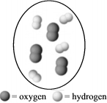
- What are the total moles of gases in the container after the reaction is complete?
- What is the final volume?

The following example illustrates how volume ratios can be used to solve volume-volume stoichiometry problems

Example

Propane C₃H₈ completely combusts according to the following equation,

C₃H₈ + 5O₂ → 3CO₂ + 4H₂O

What volume, in liters, of oxygen are required to completely combust 0.350 L of propane?

Solution

Step 1: identify the unknown: O₂

Step 2: identify the given: 0.350 L C₃H₈

Step 3: identify the volume ratio between the unknown and the given:

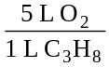

Step 4: multiply the volume of given by the volume ratio:

0.350 L C₃H₈ x = 1.75 moles O₂
Skill 36.01 Problem 2
Propane C₃H₈ completely combusts according to the following equation,

C₃H₈ + 5O₂ → 3CO₂ + 4H₂O

What will be the volume of carbon dioxide produced in the reaction?

Skill 36.02: solve volume-mole stoichiometry problems

Skill 36.02 Concepts

In volume-mole stoichiometry problems, you are asked to calculate the moles of one substance given the volume of another. According to figure 1, the steps involved are as follows:

volume given → moles given → moles unknown

According to the “steps” above, in order to calculate the moles of unknown, an equation that relates the moles of given the volume of given is needed, and a conversion factor that relates the moles of unknown to the moles of given is needed

The following example, illustrates how this is done:

Example

Phosphorous readily reacts with atmospheric oxygen to form diphosphorous pentaoxide gas as shown below:

P₄ + 5O₂ → 2P₂O₅

If 2.0 L of oxygen gas react at 25ºC and 1 atm, how much, in moles, of diphosphorous pentaoxide gas can be produced?

Solution

Step 1: identify the unknown: P₂O₅

Step 2: identify the given: 2.0 moles O₂

Step 3: identify the equation that relates the moles of given to the volume of given

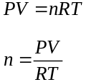

Step 4: identify the mole ratio between the unknown and the given:

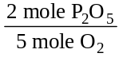

Step 5: calculate the moles of given using the ideal gas equation, then multiply the result by the mole ratio

To calculate the moles, the ideal gas equation is needed,
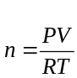

P = 1 atm
V = 2.0 L
R = 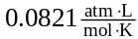
T = 25+273 = 298 K

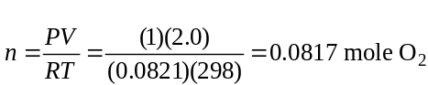

multiply the result by the mole ratio to find the moles of unknown,

0.0817 mol O₂ x = 0.0327 mole P₂O₅

Skill 36.02 Problem 1
Methanol readily combusts as follows,

2CH₃OH(g) + 3O₂(g) → 2CO₂(g) + 4H₂O(g)

If 5.0 L of methanol reaction, how much, in moles, of water vapor will be produced?

Skill 36.03: solve volume-mass stoichiometry problems

Skill 36.03 Concepts

In volume-mass stoichiometry problems, you are asked to calculate the mass of one substance given the volume of another. According to figure 1, the steps involved are as follows:

volume given → moles given → moles unknown → mass unknown

According to the “steps” above, in order to calculate the moles of unknown, an equation that relates the moles of given to the volume given is needed, a conversion factor that relates moles unknown to moles given is needed, and a conversion factor that relates the mass of unknown to the moles of unknown is needed

The following example, illustrates how this is done:

Example

Phosphorous readily reacts with atmospheric oxygen to form diphosphorous pentaoxide gas as shown below:

P₄ + 5O₂ → 2P₂O₅

How much, in grams, of phosphorous will react with 2.0 L of oxygen gas react at 25ºC and 1 atm,

Solution

Step 1: identify the unknown: P₄

Step 2: identify the given: 2.0 moles O₂

Step 3: identify the equation that relates the moles of given to the volume of given

Step 4: identify the mole ratio between the unknown and the given:

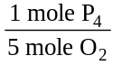

Step 5: identify the conversion factor that relates the mass of unknown to the moles of unknown

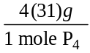

**notice that this is just the molar mass of the unknown

Step 6: calculate the moles of given using the ideal gas equation, multiply the result by the mole ratio and the mass-mole conversion factor

To find the moles of given, the ideal gas equation is needed,

P = 1 atm
V = 2.0 L
R =
T = 25+273 = 298 K

multiply the result by the mole ratio and the mass-mole conversion factor,

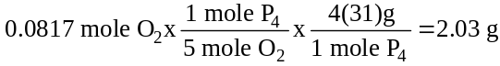

Skill 36.03 Problem 1
Sodium reacts with water through single replacement as follows,

2Na(s) + 2H₂O(l) → 2NaOH(s) + H₂(g)

How much sodium is required to produce 500. L of hydrogen gas?

Skill 36.04: solve mole-volume stoichiometry problems

Skill 36.04 Concepts

In mole-volume stoichiometry problems, you are asked to calculate the volume of one substance given the moles of another. According to figure 1, the steps involved are as follows:

moles given → moles unknown → volume unknown

According to the “steps” above, in order to calculate the volume of unknown, a conversion factor that relates the moles of unknown to the moles of given is needed, and an equation that relates the volume of unknown to the moles of unknown is needed.

The following example, illustrates how this is done:

Example

Phosphorous readily reacts with atmospheric oxygen to form diphosphorous pentaoxide gas as shown below:

P₄ + 5O₂ → 2P₂O₅

If 3.0 moles of phosphorus react at 25ºC and 1 atm, how much, in liters, of diphosphorous pentaoxide gas can be produced?

Solution

Step 1: identify the unknown: P₂O₅

Step 2: identify the given: 3.0 moles P₄

Step 3: identify the mole ratio between the unknown and the given:

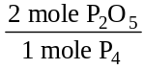

Step 4: identify the equation that relates the volume of unknown to the moles of unknown

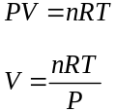

Step 5: multiply the moles of given by the mole ratio, then solve for volume using the ideal gas equation

3.0 moles P₄ x = 6.0 moles P₂O₅

To find the volume, the ideal gas equation is needed,
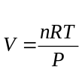

n = 6.0 moles
R =

T = 25+273 = 298 K
P = 1 atm

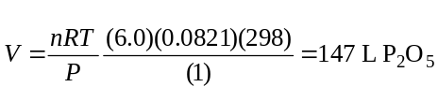

Skill 36.04 Problem 1
Sodium reacts with water through single replacement as follows,

2Na(s) + 2H₂O(l) → 2NaOH(s) + H₂(g)

If 2.5 moles of sodium react, what volume of hydrogen gas will be produced?

Skill 36.05: solve mass-volume stoichiometry problems

Skill 36.05 Concepts

In mass-volume stoichiometry problems, you are asked to calculate the volume of one substance given the mass of another. According to figure 1, the steps involved are as follows:

mass given → moles given → moles unknown → volume unknown

According to the “steps” above, in order to calculate the volume of unknown, a conversion factor that relates the moles of given to the mass of given is needed, a conversion factor that relates the moles of unknown to the moles of given is needed, and an equation that relates the volume of unknown to the moles of unknown is needed.

The following example, illustrates how this is done:

Example

Phosphorous readily reacts with atmospheric oxygen to form diphosphorous pentaoxide gas as shown below:

P₄ + 5O₂ → 2P₂O₅

If 1.0 gram of phosphorus react at 25ºC and 1 atm, how much, in liters, of diphosphorous pentaoxide gas can be produced?

Solution

Step 1: identify the unknown: P₂O₅

Step 2: identify the given: 1.0 g P₄

Step 3: identify the conversion factor that relates the moles of given to the mass of given

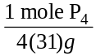

**notice that this is just the molar mass of the given

Step 4: identify the mole ratio between the unknown and the given:

Step 5: identify the equation that relates the volume of unknown to the moles of unknown

Step 6: multiply the moles of given by the mole-mass conversion factor and the mole ratio, then solve for volume using the ideal gas equation

1.0 g P₄ x x = 0.0161 moles P₂O₅

To find the volume, the ideal gas equation is needed,

n = 0.0161 moles
R =

T = 25+273 = 298 K
P = 1 atm

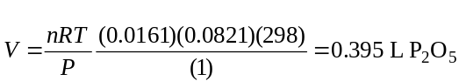

Skill 36.05 Problem 1
Sodium reacts with water through single replacement as follows,

2Na(s) + 2H₂O(l) → 2NaOH(s) + H₂(g)

If 2.0 g of sodium react, what volume of hydrogen gas will be produced?

Set 36.0 Summary

In the early stages of solving stoichiometry problems it is useful to know what steps to combine for a given type of problem. For this reason, I have provided figure 2. Keep in mind however, you will not be permitted to use this on quizzes or exams. Only through practice will you acquire independence from this guide.

Figure 2. How to solve gas stoichiometry problems
Type | Steps
volume-volume | volume given x 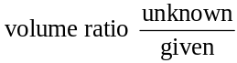= volume unknown
volume-moles | Use PV=nRT to find moles from volume  moles given x 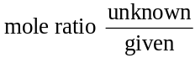 = moles unknown
volume – mass | Use PV=nRT to find moles from volume  moles given x x 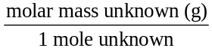= mass unknown (g)
mole - volume | moles given x = moles unknown  use PV=nRT to find volume from moles
mass - volume | mass given x 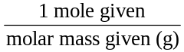x = moles unknown  use PV=nRT to find volume from moles

