Set 12. Bohr Model

Skill 12.01: Describe Bohr’s theory of the hydrogen atom and how it accounts for line spectra
Skill 12.02: Interpret the relationship between electron transitions and the types of energy produced Skill 12.03: Describe the effect of nuclear charge on the energy an atom emits

Skill 12.01: Describe Bohr’s theory of the hydrogen atom and how it accounts for line spectra

Skill 12.01 Concepts

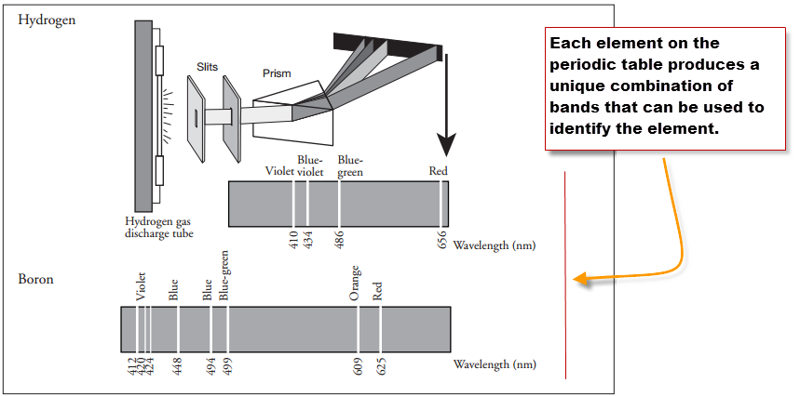
Experiments showed that the light emitted from individual elements did not produce the rainbow observed by the separation of white light.
Instead, when the light from individual elements were separated with a prism, only light of specific wavelengths appeared.

Notice in the picture to the left, when the light from hydrogen is separated with a prism only 4 light bands appear. When the light from boron is separated with a prism, 8 bands of light appear.

Skill 12.01 Problem 1
Refer to the diagram below to complete the following
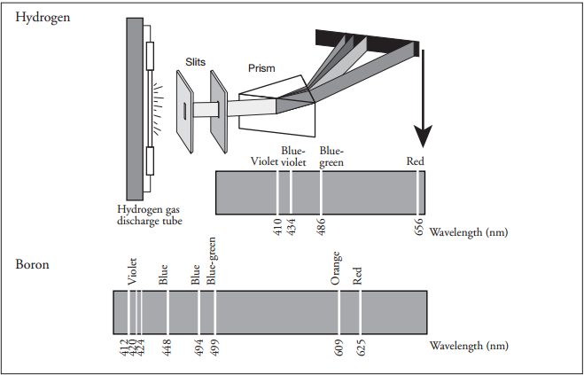
(a) Use colored pencils to color the hydrogen and boron spectral lines within their respective spectra.

(b) List the spectral lines for hydrogen gas by color and corresponding wavelength. Sort the colors from low to high with respect to energy.

Color | Wavelength | Order of energy (1 = lowest)

To account for the line spectra produced by elements, Bohr proposed that electrons could only be located in certain orbits. Since each orbit has a particular energy associated with it, the energies associated with an electron is fixed (or quantized). Bohr suggested that when the electron absorbs a photon of energy it jumps to a higher energy level. When the electron drops to a lower energy level, it releases a photon of energy in the form of light as shown in the figure below.

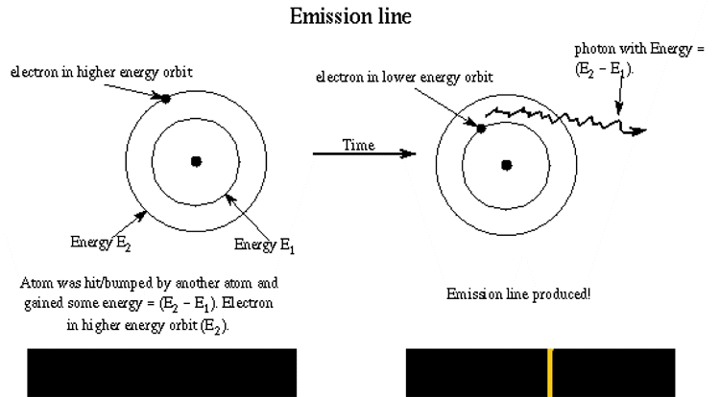

Skill 12.01 Problem 2
Navigate to the following link,

https://sites.google.com/a/boiseschools.org/bohratom/

Navigate through the tutorial then complete the following questions.
- Is energy absorbed or released for the electron transition shown in the diagram to the right? How do you know? | 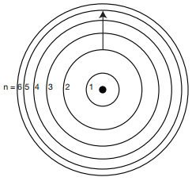
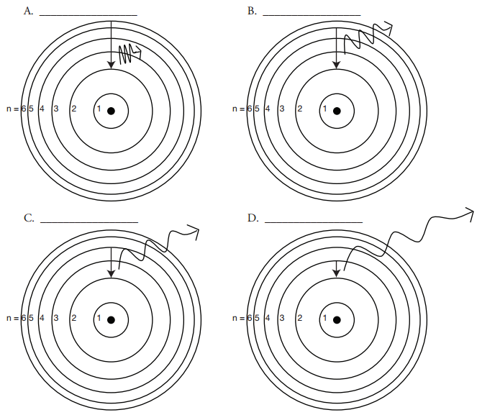
- The diagram above shows the allowed transitions in the hydrogen atom.

- For the transitions shown, is light being absorbed or emitted? How do you know?

- Complete the following table. Refer to the spectrum you colored in “Skill 8.02 Problem 1” to identify the color of emitted for each transition.
Picture | Transition | Color of light | Order of energy (1 = lowest)
A | n= to n=
B | n= ___ to n= ____
C | n= ___ to n= ____
D | n= ___ to n= ____

- What is the relationship between the transition and energy of light emitted? In other words, as the length of the transition increases, does the energy that is emitted increase or decrease?

Skill 12.02: Interpret the relationship between electron transitions and the types of energy produced

Skill 12.02 Concepts

Up until now we have only been concerned with transitions that produce energies that are visible to us. But there are other types of energies that are produced that we cannot see. The diagram shows the various energies that can be produced as electrons undergo transitions in an atom. Notice that we can only see a small sliver of this energy.

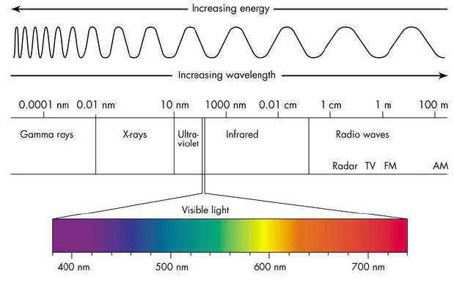
Skill 12.02 Problem 1
Refer to the diagram above then rank the following from low to high with respect to energy.
Energy | Order of energy (1 = lowest)
Gamma rays
X-rays
Radio waves
Visible light
Ultra-violet
Infrared

Skill 12.02 Problem 2
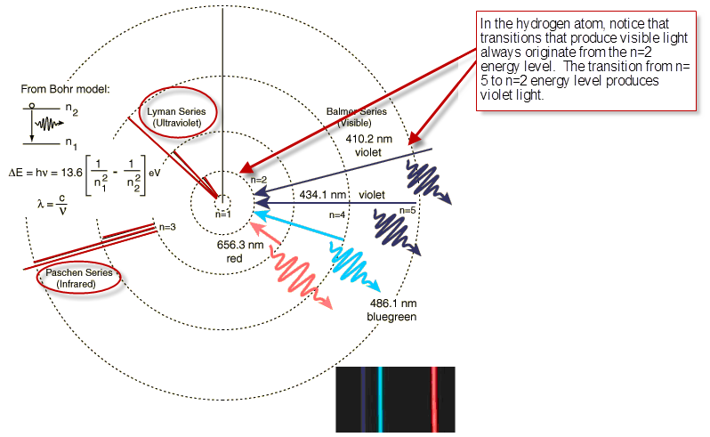
- The diagram above shows transitions that result in Infrared energy, Ultra Violet energy, and Visible energy. Notice that visible always originates from the n=2 energy level. From which energy level does.

- Infrared energy originate?

- Ultraviolet energy originate?

- Complete the follow table. Rank each energy according to the energy level from which the electron originated. Rank each from high to low with respect to energy.

Energy | Distance from the nucleus (1 = closest) | Order of energy (1 = lowest)
Ultra violet
Infrared
Visible

- What is the relationship between the distance from which an electron originates and its energy. In other words, do electrons that originate closer to nucleus have higher or lower energy than electrons that originate farther from the nucleus? Write a sentence that describes this relationship.

Skill 12.03: Describe the effect of nuclear charge on the energy an atom emits

Skill 12.03 Concepts

As you previously learned, atoms have protons and electrons. And because protons have a positive charge and electrons have a negative charge, it follows that they are attracted to one another. Binding energy, is the energy required to remove an electron from an atom.

Skill 12.03 Problem 1
The graph below shows the relationship between the mass number of an atom and the binding energy.
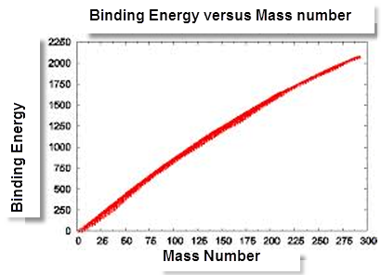
  - According to the graph, is the relationship between binding energy inverse or direct? In other words as the mass number increases does the binding energy increase or decrease?

  - Is the relationship between the number of protons in an atom and the binding energy inverse or direct?

  - Consider the following atoms, rank the atoms from low to high with respect to binding energy: H, He⁺, Ne²⁺

  - Now consider the following transition.

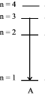
Complete the table to show how the energy released compares between different atoms.
Atom | Order of energy (1 = lowest)
He⁺
Li²⁺
H
Be³⁺

.

