Set 34: Ideal Gas Law

Skill 34.01: State Avogadro’s principle and use it to calculate volume – mole changes at fixed pressure and temperature
Skill 34.02: State the ideal gas law and derive the ideal gas constant
Skill 34.03: Using the ideal gas law, calculate pressure, volume, temperature, or the amount of gas, when give the other three are known.

Skill 34.01: State Avogadro’s principle and use it to calculate volume – mole changes at fixed pressure and temperature

Skills 34.01 Concepts

As gas is added to a balloon, its volume expands. The relationship between the quantity of a gas and its volume follows from the work of Joseph Louis Gay-Lussac (1778-1823) and Amedeo Avogadro (1776-1856). Gay-Lussac observed the law of combining volumes: At a given pressure and temperature, the volumes of gases that react with one another are in the ratios of small whole numbers. For example, two volumes of hydrogen gas react with one volume of oxygen gas to form two volumes of water vapor.

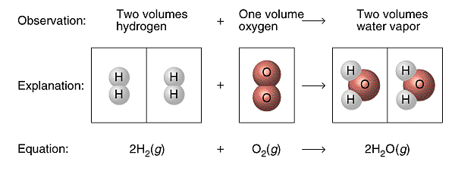
Figure 1. Law of combining volumes

Three years later Amedeo Avogadro interpreted Gay-Lussac’s observation by proposing what is now known as Avogadro’s hypothesis: Equal volumes of gases at the same temperature and pressure contain equal numbers of molecules. For example, experiments show that 22.4 L of any gas at 0ºC and 1 atm contain 6.022 x 1023 gas molecules (that is, 1 mol).

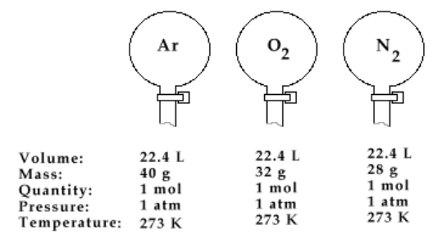
Figure 2. Avogadro’s hypothesis

Avogadro’s law follows from Avogadro’s hypothesis: The volume of a gas maintained at constant temperature and pressure is directly proportional to the number of moles of gas (Figure 3).
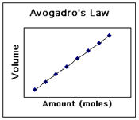
Figure 3. Avogadro’s law

Skill 34.01 Problem 1
Gas is confined to the cylinder shown below,

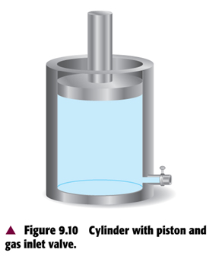

If additional gas is injected into the cylinder through the gas inlet valve, indicate how this change affects the
- average distance between the molecules

- the average energy of the molecules

- the pressure of the gas

(d) the number of moles of gas in the cylinder

Skill 34.01 Problem 2
The picture shows hydrogen (light) and oxygen (dark) molecules at the start of a reaction. The container in which the molecules are confined is flexible. The molecules react to form water. At the “start” of the reaction, the volume of the reactant mixture is 6.0 L.
- What is the volume of the products at the “finish” of the reaction?
- Draw a picture that represents the reaction mixture and at the “finish” of the reaction.
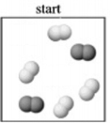

Skill 34.01 Problem 3
(a) According to figure 2, what does one mole of gas occupy at STP? (Molar volume)

(b) A chemical reaction is expected to produce 0.0680 mol of oxygen gas. What volume in liters will be occupied by this gas sample at STP?

(c) What is the mass in grams occupied by 11.2 L of oxygen gas (O₂)?

(d) What volume in liters is occupied by 14.0 g of nitrogen gas (N₂)?

Skill 34.02: State the ideal gas law and derive the ideal gas constant

Skill 34.02 Concepts

Combining Boyle’s law, Charles’s law, Gay-lussac’s law, and Avogadro’s principle into a single expression gives a general equation which relates the four measurable quantities: pressure, volume, temperature, and moles of a gas. This general equation, also called the ideal gas law, can be used to calculate the unknown information about gas sample,

PV = nRT

In the above equation, P is pressure in atmospheres, V is volume in liters, n is moles, and T is temperature in Kelvin. R is called the ideal gas constant. Solving for R,

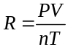

The below example illustrates how the value of R can be determined.

Skill 34.02 Problem 1
Potassium chlorate decomposes upon heated according to the following equation,

2KClO₃ → KCl + 3O₂

A student conducted an experiment and recorded the data shown below,

Mass KClO₃ (g) | 5.0
Mass KCl recovered (g) | 1.7
Temp water (ºC) | 23
Volume O₂ (mL) | 2500
Pressure (atm) | 1.0

What is R, the ideal gas constant?

Skill 34.03: Using the ideal gas law, calculate pressure, volume, temperature, or the amount of gas, when give the other three are known.

Skill 34.03 Concepts

In the previous example you determined the ideal gas law constant, R. The actual value of the ideal gas law constant is 0.0821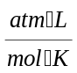. Now that the ideal gas constant R is known, the relationship, PV = nRT can be used to calculate the pressure, volume, temperature, or the amount of gas, when give the other three are known.

Consider the following example,

Example

What is the pressure in atmospheres exerted by a 0.500 mol sample of nitrogen in a 10.0 L container at 298K

Solution

Given: V = 10.0 L; n = 0.500 mol; T = 298 K
Unknown: P

Substituting and solving,

PV = nRT

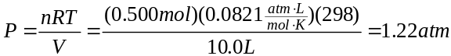

Skill 34.03 Problem 1
What is the volume in liters of 1.00 mol of N₂ gas at a STP. (Recall STP stands for Standard Temperature and Pressure. That is where P = 1 atm and T = 273 K)

Skill 34.03 Problem 2
What is the pressure of 8.00 g of oxygen gas (O₂) when the pressure is 758 mm Hg and the temperature is 25ºC?

