Set 7.0: Chemical Changes and Matter

Skill 7.01: Distinguish between chemical and physical changes at the observational, symbolic, and molecular representational levels
Skill 7.02: Classify matter as a pure substance or mixture
Skill 7.03: Classify a mixture as homogenous or heterogeneous at the observational and molecular levels.
Skill 7.04: Classify a pure substance as either an element or compound at the symbolic and molecular representational levels
Skill 7.05: Describe how to separate a mixture given its physical properties

Skill 7.01: Distinguish between chemical and physical changes at the observational, symbolic, and molecular representational levels

Skill 7.01 Concepts

We have already discussed physical changes. A physical change of a pure substance is one that leaves it as the same substance but in a different physical state. The bonds holding the atoms together in the original compound(s) are NOT broken.

An example of a physical change is the change from one state to another. For example when water evaporates it remains water. This transformation can be represented as follows:

H₂O(l) → H₂O(g)

A chemical change is one that changes the identity of the substance. Bonds are either broken or formed between atoms.

An example of a chemical change is the formation of water. This change can be represented in at least 3 different ways. The first way is the observational level: as one reacts hydrogen and oxygen, one can see the evolution of heat and light. These are both indicators of chemical change. The second way is the symbolic level: one can write a chemical equation that represents the process.

O₂(g) + 2H₂(g) → 2H₂O(l)

The third way is at the molecular level: one can draw molecules to represent the process:

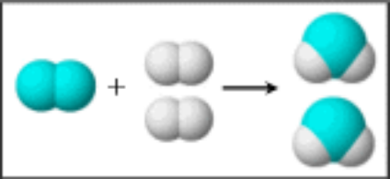

Skill 7.01 Example 1
(i) Classify each of the following as physical or chemical
(ii) Draw picture to represent each process.
(a) water evaporating

(b) water melting

(c) magnesium (Mg) burning in oxygen gas (O₂) to form magnesium oxide (MgO)

(d) Water decomposing to form hydrogen gas (H₂) and oxygen gas (O₂)

Skill 7.01 Example 2
Classify each of the following as physical or chemical
(a)
+
+

(b)

(c) S₂(s) + 2Zn(s) → 2ZnS(s)
(c) NaCl(s) → Na⁺(aq) + Cl⁻(aq)
(d) CO₂(s) → CO₂(g)

Skill 7.01 Exercise 1

Skill 7.02: Classify matter as a pure substance or mixture

Skill 7.02 Concepts

Matter is “stuff” – matter has mass, occupies space, and has energy

Matter can be divided into two broad types: pure substances and mixtures

In a pure substance, only a single type of matter is present. In other words, only a single element or compound is present.

In a mixture, two or more pure substances are mixed.

Skill 7.02 Example 1
Classify the following as either a pure substance or mixture:
- Distilled water | - Table salt | - sugar and water | - table sugar

Skill 7.02 Exercise 1

Skill 7.03: Classify a mixture as homogenous or heterogeneous at the observational and molecular levels.

Skill 7.03 Concepts

Mixtures can be further subdivided into two groups: homogeneous mixtures and heterogeneous mixtures (figure 1)

A homogeneous mixture is uniform throughout. Another name for a homogeneous mixture is a solution.

A heterogeneous mixture is not the same throughout. The individual constituents are visibly distinguishable.

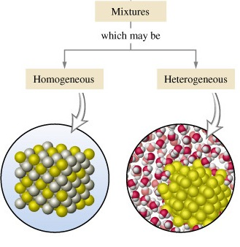
Figure 1. Homogeneous and heterogeneous mixtures

Skill 7.03 Example 1
Which of the following could be classified as solutions?
- Food coloring and water | - salt and pepper | - pepper and water | - oil and water

Skill 7.03 Example 2
Refer to the illustration below to answer the following.
(A) 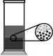 (B) 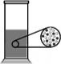
(C) 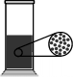 (D) 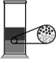

- Which drawing or drawings represents a heterogeneous mixture? (Explain)

- Which drawing or drawings present a homogeneous mixture? (Explain)

- Which drawing best represents the mixture that results when oil is added to water? (Explain) (The light circles represent water molecules, and the dark circles represent oil molecules.)

- Food coloring is added to water to make a solution. Which drawing will best represent the solution? (Explain) (The light circles represent water molecules, and the dark circles represent food coloring molecules.)

Skill 7.03 Exercise 1

Skill 7.04: Classify a pure substance as either an element or compound at the symbolic and molecular representational levels

A pure substance can be classified as either an element or a compound.

Elements are the basic building blocks of matter. Examples include, Ag, Na, O₂, S₈

Compounds are pure substances made from two or more different elements.
The symbol for a chemical compound contains the symbols that represent the elements along with the how many of each element.

C₁₂H₂₂O₁₁ for example, contains 12 carbons, 22 hydrogens, and 11 oxygens

Skill 7.04 Example 1
Which of the following are compounds?
- iron oxide Fe₂O₃
- table salt - sodium chloride (NaCl)
- sucrose (C₁₂H₂₂O₁₁)
- Carbon (C₆₀)
- Phosphorous (P₄)

Skill 7.04 Example 2
Refer to the illustration below to answer the following.
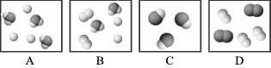
- Which figure or figures best represents a mixture of two pure substances?

- Which figure or figures best represents a pure substance?

Skill 7.04 Exercises 1 & 2

Skill 7.05: Describe how to separate a mixture given its physical properties

Skill 7.05 Concepts

A useful schema for classifying a substance as a heterogeneous mixture, a homogeneous mixture, element, or compound is given below.
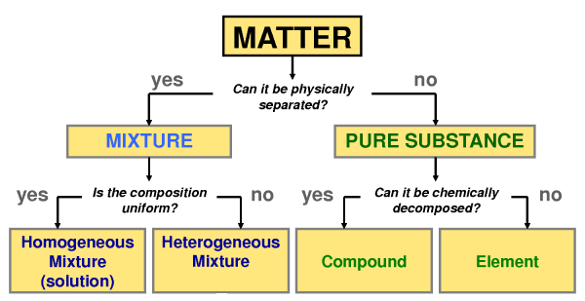
Figure 2. Classification of matter

According to the figure above, the fundamental difference between pure substances and mixtures is the ability to separate the components using physical means. If a substance can be separated by physical means it is classified as mixture; if it cannot, it is classified as a pure substance. Two techniques that can be applied to separate the components of a mixture are described below.

Separation by filtration

Recall that heterogeneous mixtures have particles that are visibly distinguishable (think toppings a pizza) or sand in water.

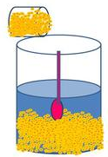
Figure 3. Sand and water

A technique for separating insoluble components from a liquid is filtration. Filtration is a mechanical or physical process applied to separate insoluble particulates from a liquid. For example many acids dissolve iron but not gold. Thus if we put our mixture into an appropriate acid, the acid would dissolve the iron and the gold would be left behind. The two could then be separated by filtration (figure 4)

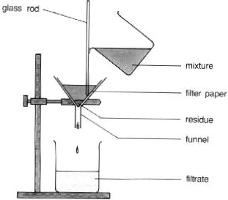
Figure 4. Filtration procedure

Separation by evaporation

Evaporation is another useful technique for separating a mixture. This process is illustrated below (Figure 5). When the salt water solution is heated, the water evaporates, leaving the salt behind.

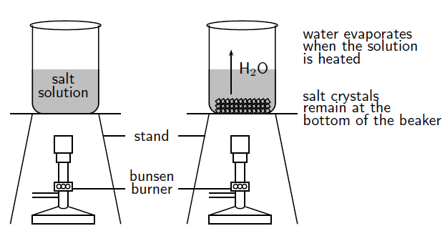

Skill 7.05 Example 1
Use the information below to propose a method for separating out a mixture of sand, salt, and sugar.

 | Sand | Salt | Sugar
Ethanol | Insoluble | Insoluble | Soluble
Water | Insoluble | Soluble | Soluble

Skill 7.05 Exercise 1

