Set 26.0: Chemical Reactions Part I

Skill 26.01: Be able to identify the indicators of a chemical reaction
Skill 26.02: Be able to write a chemical reaction using the correct symbols given the word equation

Skill 26.01: Be able to identify the indicators of a chemical reaction

Skill 26.01 Concepts

Reactions occur when bonds are broken or formed between atoms. We can visually see evidence of chemical reactions in the form of heat, light, or the production of a gas. The video below is illustrative.

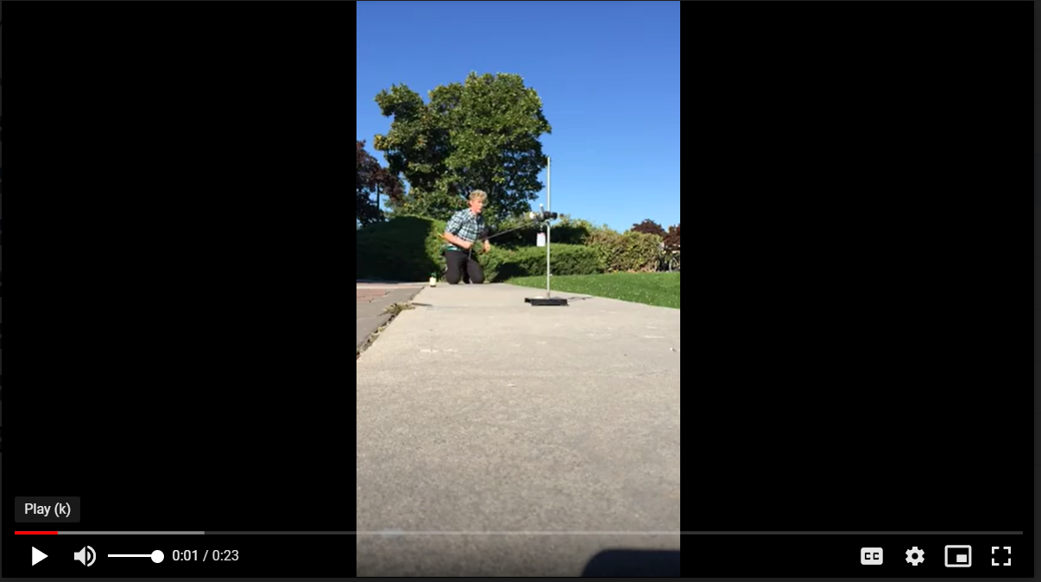
https://drive.google.com/file/d/0B04OwGwP8oO_dF9DS2dpaDdQZWs/view?usp=sharing

Another indicator of a chemical reaction is the formation of a precipitate - A precipitate is a solid that is produced because of a chemical reaction that takes place in a solution. The video illustrates an example,

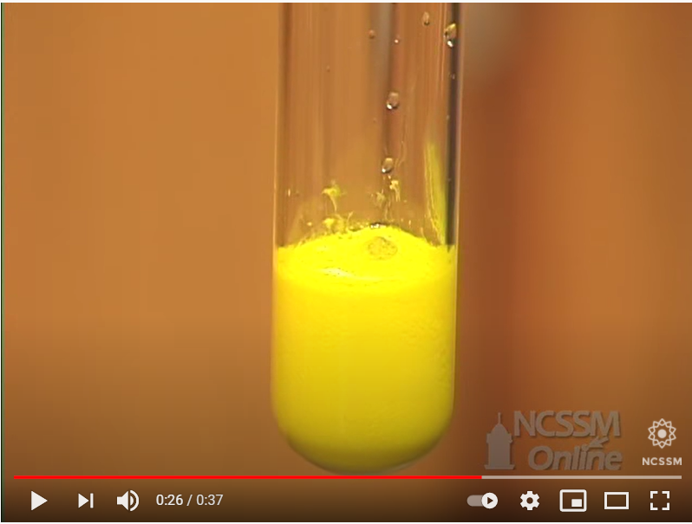
https://youtu.be/X2mB-q2NQXY

Skill 26.02: Be able to write a chemical reaction using the correct symbols given the word equation

Skill 24.02 Concepts

A written chemical reaction should represent the laboratory situation under which it occurred. The states of the elements should therefore be appropriately indicated. The symbols used to indicate these states are shown in table 1. There are three basic states in which elements can exist: solids (s), liquids (l), and gases (g). When an element is dissolved in water is said to be aqueous (aq).

There are several elements on the periodic table, which are bonded to one another under typical laboratory conditions. For example oxygen is most commonly found bonded to itself. Therefore one would not write O for oxygen in a chemical reaction, but rather O₂. Furthermore, you should notice that oxygen is also a gas under normal laboratory conditions. Oxygen can therefore be more completely described as O₂(g). Other elements, which are commonly found bonded to themselves include: Cl₂, I₂, F₂, Br₂, O₂, H₂, N₂. These elements are also referred to as “diatomic molecules”. An easy way to remember these is by the acronym: ClIF BrOHN.

Table 1. Common symbols used in chemical reactions
Symbol | Explanation
(s) | Solid, also used to indicate precipitate
↓ | Used to indicate precipitate
↑ | Used to indicate gaseous product
(l) | Liquid
(aq) | Dissolved in water
(g) | Gas
 | Indicates reversible reaction
→ | Indicates yields

Skill 26.02 Problem 1
Write the chemical symbol to represent the following under normal laboratory conditions:

Silver, mercury, bromine, hydrogen, calcium

The overall anatomy of a chemical reaction is shown below:

Substances on the right are called products
Substances on the left are called reactants

CH₄(g) + 2O₂(g) → CO₂(g) + 2H₂O(g)
The coefficient specifies the relative number of moles of substance
The arrow is read as yields

The state is denoted in parentheses

Example I

Write the chemical equation for the following

Aqueous Sodium chloride + Aqueous Silver Nitrate → Silver Chloride Precipitate + Aqueous Sodium Nitrate

Solution

NaCl(aq) + AgNO₃(aq) → AgCl(s) + NaNO₃(aq)

Example II

Translate the following in a sentence:

2Al(s) + 3ZnCl₂(aq) → 3Zn(s) + 2AlCl₃(aq)

Solution

2 moles of solid aluminum reacts with 3 moles of aqueous zinc chloride to produce 3 moles of solid zinc and 2 moles of aqueous aluminum chloride

Skill 26.02 Problem 2
Write the reaction for each of following laboratory situations
- A piece of sodium metal (Na) is placed in water and produces hydrogen gas (H₂) and sodium hydroxide (NaOH)

- When zinc metal (Zn) is added to an aqueous solution of copper chloride (CuCl₂), solid copper (Cu) precipitates and aqueous zinc chloride (ZnCl₂) is produced.

- When solid carbon (C) combusts in a limited supply of oxygen (O₂), carbon monoxide (CO) gas is produced.

- When methane gas (CH₄) is burned, carbon dioxide (CO₂) gas and water (H₂O) vapor are produced.

Skill 26.02 Problem 3
For each reaction, write a suitable word equation
- (Barium Hydroxide) Ba(OH)₂(s) + (Silver Nitrate) AgNO₃(aq) → (Barium Nitrate) Ba(NO₃)₂(aq) + (Silver Hydroxide) AgOH(s)

- (Sodium) Na(s) + (water) H₂O(l) → (Sodium Hydroxide) NaOH(aq) + (Hydrogen) H₂(g)

