Set 5. Statistics

Skill 5.01: Differentiate between precision and accuracy
Skill 5.02: Be able to calculate the accuracy (percent error) of a data set
Skill 5.03: Be able to calculate the mean (average) of a data set
Skill 5.04: Be able to calculate the standard deviation of data set Google Sheets
Skill 5.05: Be able to calculate the precision of a data set

Skill 5.01: Differentiate between precision and accuracy

Skill 5.01 Concepts

Accuracy is the ability to provide a fine, sharp, clear, valid one time measurement. And, as we have already seen, some instruments are better at providing accurate measurements than others. Consider the graduated cylinders shown below.

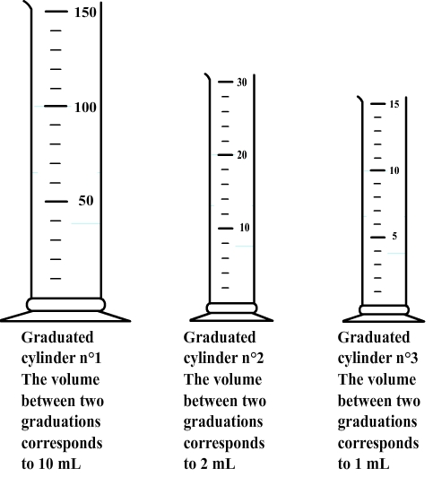 | Graduated lines improve accuracy. In the illustration, notice that as more lines (graduations) are added, the more accurate the device becomes.  Graduated lines reduce uncertainty. The more graduated lines a measuring device provides, the less uncertain the resulting measurement. A measurement taken with graduated cylinder 1 has an uncertainty of +/-2. A measurement taken with graduated cylinder 2 has an uncertainty of +/-0.2. A measurement taken with graduated cylinder 3 has an uncertainty of +/-0.1

Precision is the ability to obtain the same measurement under the same circumstances repeatedly. To measure precision, multiple measurements therefore must be made. The closer the measurements are to one another, the more precise the measurements. This concept is illustrated below,

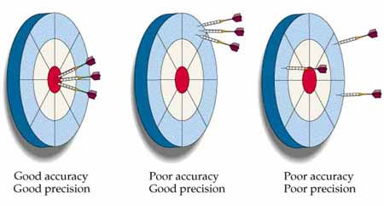
The dart hit target (good accuracy). The target was hit repeatedly (goo precision) | The dart did not hit the target (poor accuracy). The darts repeatedly hit the same place (good precision) | The dart did not hit the target (poor accuracy). The darts did not repeatedly hit the same place (poor precision)

Skill 5.01 Exercise 1

Skill 5.02: Be able to calculate the accuracy (percent error) of a data set

Skill 5.02 Concepts

Percent error is often used to describe the accuracy of a measurement or a set of measurements.

Percent error = 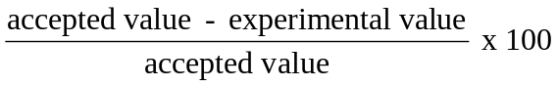

The smaller the percent error, the better the accuracy. In other words, the closer the experimental value is to an accepted value, the better the accuracy. The following example is illustrative,

A student determined experimentally the density of water to be 1.02 g/mL. The accepted value is 1.00 g/mL. The percent error is:

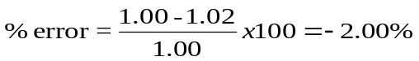
Notice in the example, the Percent Error is negative. This occurs when the experimental value is larger than the accepted.

Skill 5.02 Example 1
A student measured the temperature of boiling water and got an experimental reading of 97.5ºC. What is the percent error?
Skill 5.02 Exercise 1

Skill 5.03: Be able to calculate the mean (average) of a data set

Skill 5.03 Concepts

The mean, or average, result of a data set is calculated by summing the measurements in a data set and dividing by the total number of measurements. The following example is illustrative,

A student measure the length of five different sticks and reported the following values:

491 cm, 401 cm, 500. cm, 483 cm, 471 cm

The average of these values should be reported as,

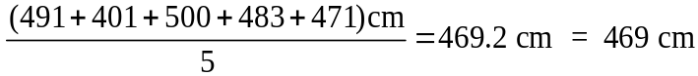

Notice in the example above, the final result was rounded to 3 significant figures to reflect the number of significant figures in each measurement. We did not round to the 5, which has 1 significant figure, because 5 is referred to as “exact number”, or a number which resulted from counting.

Skill 5.03 Example 1
Joe measured the volume of an object 5 times, and got results of 34.5 mL, 34.9 mL, 34.2 mL, and 35.9 mL. What is his average experimental result?

Skill 5.03 Exercise 1

Skill 5.04: Be able to calculate the standard deviation of data set Google Sheets

Skill 5.04 Concepts

The standard deviation of a data set is the degree that the measurements vary from one another. This statistic is useful for evaluating precision.

The smaller the standard deviation of a data set, the better the precision.

Consider an example of students who took an exam and everyone received a 90% or better on the exam. One could conclude that the standard deviation of the exam scores was small – and hence the precision was good. On the other hand, if half the class received less than a 50%, the variation in the scores would be much larger, that is the standard deviation would be higher – and the precision would be poor.

Google Sheets makes finding the standard deviation of data set very easy. The following example is illustrative,

A student measured the length of 5 sticks and reported the following values:

491 cm, 401 cm, 500. cm, 483 cm, 471 cm

What is the standard deviation? To find the standard deviation using Excel:

Step 1: Open Google Sheets
Step 2: type in the data (without units) into column “A”
Step 3: place the cursor in the row beneath the last entry (cell A6)
Step 4: type the following: =stdev(a1:a5)
Step 5: Click enter

The standard deviation for the above data according to Google Sheets = 39.6 cm

Skill 5.04 Example 1
Joe measured the volume of an object 5 times, and got results of 34.5 mL, 34.9 mL, 34.2 mL, and 35.9 mL. What is the standard deviation

Skill 5.04 Exercise 1

Skill 5.05: Be able to calculate the precision of a data set

Skill 5.05 Concepts

As previously mentioned, Precision refers to the closeness of a set of measurements to one another. It can be calculated as follows,

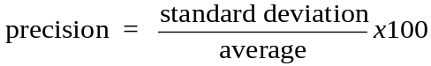

The lower the value using this calculation, the better the precision.

The following example is illustrative,

A student measure the length of 5 sticks and obtained the following values:

491 cm, 401 cm, 500. cm, 483 cm, 471 cm

What is the precision?

Using the average and standard deviation calculated previously,

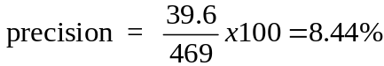

Note that the precision does not depend on how close the measurements are to an accepted value. Precision only depends on the closeness of the values to each other. To evaluate the precision, multiple measurements must be taken.

Accuracy depends on the closeness of the values to an accepted value. Accuracy does not depend on the closeness of the values to each other. To evaluate accuracy, only one measurement is needed.

Both, precision and accuracy are needed to adequately communicate the quality of our results in the lab.

Skill 5.05 Example 1
Joe measured the volume of an object 5 times, and got results of 34.5 mL, 34.9 mL, 34.2 mL, and 35.9 mL. What is his precision?

Skill 5.05 Exercise 1

