Set 33: Combined Gas Law

Skill 33.01: Define pressure, explain how it is measured
Skill 33.02: Be able to define and convert between, atm, torr, and mm Hg
Skill 33.03: Define standard temperature and pressure
Skill 33.04: State Boyle’s law and use it to calculate volume – pressure changes at fixed temperature.
Skill 33.05: State Charles’s law and use it to calculate volume – temperature changes at fixed pressure.
Skill 33.06: State Gay-Lussac’s law and use it to calculate pressure-temperature changes at fixed volume
Skill 33.07: Use the combined gas law to calculate volume-temperature-pressure changes

Skill 33.01: Define pressure, explain how it is measured

Skill 33.01 Concepts

Pressure is defined as the force per unit area on a surface (force/area). A barometer is an instrument used for measuring pressure (figure 1)

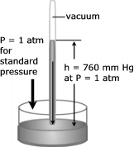 | Figure 1. A barometer is constructed by filling a glass tube with liquid mercury and inverting it in a dish of mercury. Notice that a large quantity of mercury stays in the tube. In fact, at sea level the height of this column of mercury averages 760 mm.

Skill 33.01 Problem 1
What is the height, h, of the column of mercury in the figure?
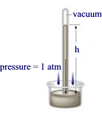
How would the height of the mercury in the barometer change

- On Mount Rainier?
- 66 feet below the surface of the ocean?

Skill 33.02: Be able to define and convert between, atm, torr, and mm Hg

Skill 33.02 Concepts

A number of different units are used to measure pressure. Some pressure units are based on force per unit area, some on mass per unit area, and others on the height of a liquid column. Because atmospheric pressure is traditionally measured by a mercury barometer scientist often express pressure in terms of the height of a column of mercury. Thus a common unit of pressure is millimeters of mercury (mm Hg). The average atmospheric pressure at sea level and 0ºC is 760 mm Hg. To honor Torricelli for his invention of the barometer, a pressure unit named after him, the torr, has been introduced. By definition 1 torr=1 mm Hg.

High pressures are often measured in units of atmospheres. One atmosphere of pressure (atm) is defined as being equal to the average sea level pressure at 0ºC. Thus 1 atm = 760 mm Hg = 760 torr. These units of pressure are summarized in table 1.

Table 1. Units of pressure
Unit | Symbol | Definition
Millimeter of mercury | mm Hg | Pressure that supports a 1-mm mercury column in a barometer
Torr | Torr | 1 torr = 1 mm Hg
Atmosphere | Atm | 1 atm = 760 mm Hg = 760 torr

Skill 33.02 Problem 1
The atmospheric pressure in Denver, Colorado, on the average is 0.830 atm. Express this pressure in
- mm Hg
- torr
If the pressure reading is given as 273 mm Hg, what would this be in atmospheres?
If the pressure reading is given as 2.1 atm, what would this be in torr?

Skill 33.03: Define standard temperature and pressure

Skill 33.03 Concepts

The volume of a gas depends upon temperature and pressure. Therefore, in order to compare volumes of gases, it is necessary to know the temperature and pressure at which the volumes are measured. To aid in such comparisons, scientist have agreed upon standard conditions of exactly 1 atm and 0ºC. These conditions are standard temperature and pressure and are commonly abbreviated STP.

Skill 33.03 Problem 1
Which of the following indicate STP conditions,
- 273 K and 760 mm Hg
- 0 K and 1 torr
- 0ºC and 760 torr
- 273 K and 760 torr

Skill 33.04: State Boyle’s law and use it to calculate volume – pressure changes at fixed temperature.

Skill 33.04 Concepts

The first quantitative experiments on gases were performed by Robert Boyle. Using a J-shaped tube like that shown below, he studied the relationship between the pressure of a trapped gas and its volume.

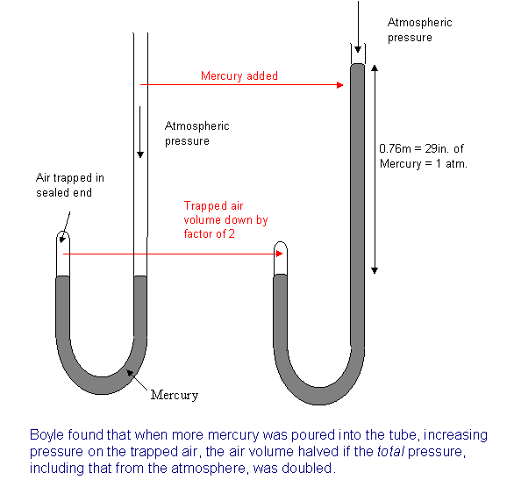
Figure 2. Boyle’s Apparatus

Robert Boyle discovered that the volume of a fixed mass of gas varies inversely with the pressure at constant temperature. In other words, he found that doubling the pressure on a sample of gas (by adding more mercury) at constant temperature reduced its volume one-half; tripling the gas pressure reduced its volume to one-third; while, reducing the pressure on a gas by one-half allowed the volume of the gas to double. This relationship is shown graphically in figure 3.

Figure 3. The variation of volume with pressure at constant temperature
100
50
Pressure
volume
20
40
60

In order to make the plot in figure appear linear, on simply needs to plot the inverse of one of the variables. This shown in figure 4.

Figure 4. The variation of volume with pressure at constant temperature
100
50
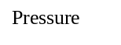
1/volume
20
40
60
Point 1
Point 2

In figure 4, the slope is a constant value equal to the following expression,

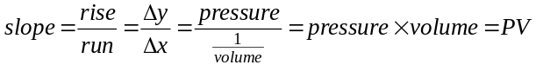

Notice that the slope is constant regardless of the point on the line. In other words

slope at point 1 = slope at point 2

OR

P₁V₁=P₂V₂ (Boyle’s Law)
The use of the relationship above, known as Boyles Law, is illustrated below.

Example

If 1.0 L of gas at 1.0 atm is allowed to expand at constant temperature to 5.0 L what is the new pressure?

Solution

The initial conditions of the gas are defined as follows:

P₁ = 1.0 atm
V₁ = 1.0 L

The final conditions of the gas are defined as follows:

P₂ = ?
V₂ = 5.0 L

Substituting into Boyle’s Law equation and solving,

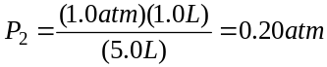

Skill 33.04 Problem 1
A sample of oxygen gas collected in the laboratory occupies a volume of 150 mL when its pressure is 720 mm Hg. What volume will the gas occupy at a pressure of 750 mm Hg if the temperature remains constant?

Skill 33.05: State Charles’s law and use it to calculate volume – temperature changes at fixed pressure.

Skill 33.05 Concepts

The French scientist Jacques Charles discovered that the volume of a gas varies directly with its temperature at constant pressure. In other words, he found that doubling the temperature of a sample of gas at constant pressure doubled its volume; tripling the gas temperature, tripled its volume; while, reducing the temperature of a gas by one-half caused the volume of the gas to reduce proportionally. This relationship is shown graphically in figure 5.

Figure 5. The variation of volume with temperature at constant pressure
100
50
Temperature (K)
273
546
819
Point 1
Point 2
volume

In figure 5, the slope is a constant value equal to the following expression,

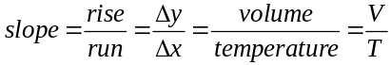

Notice that the slope is constant regardless of the point on the line. In other words

slope at point 1 = slope at point 2

OR

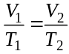 (Charles’s Law)

The relationship above is known as Charles’s Law. Keep in mind, when using Charles’s law, the temperature must be expressed in Kelvin. Recall the conversion factor between Kelvin and Celsius temperatures is as follows,

K = 273.15 + ºC

Skill 33.05 Problem 1
A sample of neon gas occupies a volume of 752 mL at 0ºC. What volume will the gas occupy if the temperature is doubled?

Skill 33.06: State Gay-Lussac’s law and use it to calculate pressure-temperature changes at fixed volume

Skill 33.06 Concepts

Joseph Gay-Lussac is credited for recognizing that a quantity of gas at a fixed volume is directly proportional to its temperature in Kelvin. In other words, he found that doubling the temperature of a sample of gas at constant volume doubled its pressure; tripling the gas temperature, tripled its pressure; while, reducing the temperature of a gas by one-half reduced the pressure of the gas proportionally. This relationship is shown graphically in figure 6.

Figure 6. The variation of volume with temperature at constant pressure
100
50
Temperature (K)
273
546
819
Point 1
Point 2
pressure

In figure 6, the slope is a constant value equal to the following expression,

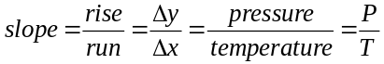

Notice that the slope is constant regardless of the point on the line. In other words

slope at point 1 = slope at point 2

OR

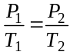 (Gay-Lussac’s Law)

The relationship above is known as Gay-Lussac’s Law. Keep in mind, when using Gay-Lussac’s law, the temperature must be expressed in Kelvin.

Skill 33.06 Problem 1
The gaseous contents in an aerosol can are under a pressure of 3.00 atm at 25ºC. Directions on the can caution the user to keep the can in a place where the temperature does not exceed 52ºC. What would the pressure of the gas in the aerosol can be at 52ºC?

Skill 33.07: Use the combined gas law to calculate volume-temperature-pressure changes

Skill 33.07 Concepts

A gas sample often undergoes simultaneous changes in temperature, pressure, and volume. When this happens, three variables must be dealt with at once. Boyle’s law, Charles’s law, and Gay-Lussac’s law can be combined into a single expression that describes a relationship that is useful in such situations. This relationship, known as the combined gas law, expresses the relationship between pressure, volume, and temperature of a gas when the amount of gas is fixed,

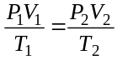

P₁, V₁, T₁ are the initial pressure, volume, and temperature of the gas respectively.
P₂, V₂, T₂ are the final pressure, volume and temperature of the gas respectively.

Example

A helium filled balloon has volume of 50.0 L at 25ºC and 820 mm Hg. What volume will it occupy at 650 mm Hg and 10ºC?

Solution

Step 1: Identify all the variables which are given in the problem. P₁ = 820 mm Hg, V₁ = 50.0 L, and T₁ = 25ºC + 273 = 298 K, P₂ = 650 mm Hg, T₂ = 10ºC + 273 = 283 K

Step 2: Identify you unknown. The problem asks for the final pressure, V₂

Step 3: substitute and solve,

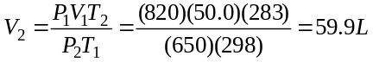

Skill 33.07 Problem 1
The volume of a gas is 27.5 mL at 22.0ºC and 740. mm Hg pressure. What will be its volume at 15ºC and 755 mm Hg pressure?

Skill 33.07 Problem 2
A helium-filled balloon has a volume of 30.0 L at 25ºC and 1.00 atm. What volume will it have at 0.900 atm and 15ºC?

Skill 33..07 Problem 3
A 700. mL gas sample at STP (STP means standard temperature and pressure: temperature = 273 K and P = 1 atm) is compressed to a volume of 200. mL, and the temperature is increased to 30.0ºC. What is the new pressure of the gas?

Table 2. Gas law summary
Law | Conditions | Equation
Boyle’s | Constant temperature | P₁V₁=P₂V₂
Charles’s | Constant pressure
Gay-Lussac’s | Constant volume
Combined gas law | -

